Supplement Figure 1. Collection of plasma samples at baseline (C1D1), on treatment (C1D8 to C19D1), at RECIST progression (Prog), and 30 days post-progression (30Day). Each tick mark represents the time of collection of a plasma sample in days from baseline (C1D1).

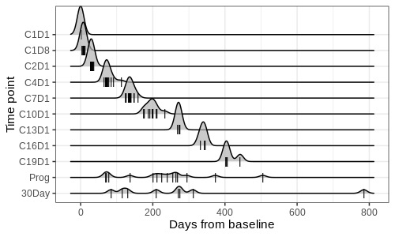

Supplement Figure 2. Quality of baseline FFPE tumor samples. A) Tumor fraction estimation. Dashed line denotes threshold for exclusion from the analysis cohort. Each dot represents a tumor sample that was above (gray) or below (red) this threshold and therefore included (gray) or excluded (red) from the analysis. B) Fragment length distribution for samples that were included (gray) or excluded (red) from the analysis.

A. B.
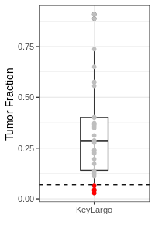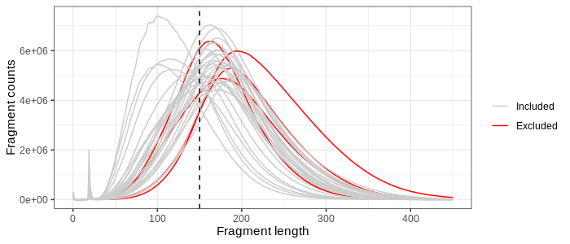

Supplement Figure 3. Simulation of non-ultrasensitive method for ctDNA detection. Kaplan-Meier and univariable Cox regression analysis of A) PFS and B) OS for patients split by simulated ctDNA clearance (PPM ≤ 100) between baseline and C7D1.

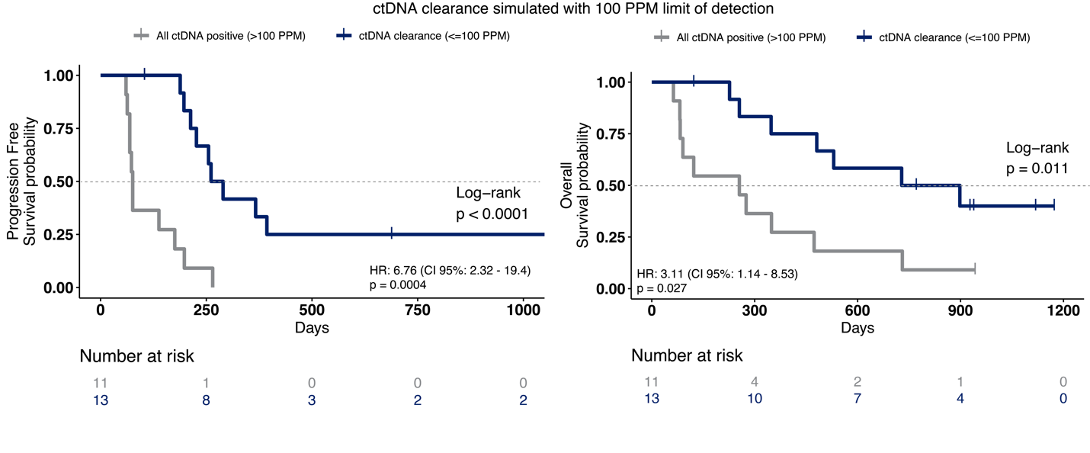

Supplemental Table 1. Patient characteristics.
Demographics | Total patients in KeyLargo study  (n=36) | Patients in KeyLargo ctDNA analysis  (n=25)
Age, median (range) | 60  (34-78) | 61  (34-76)
Male, n (%)  Female, n (%) | 30 (83)  6 (17) | 21 (84)  4 (16)
Primary Site, n (%)  Esophagus  GEJ  Gastric  Not available | 9 (26)  18 (53)  7 (21)  2 | 5 (22)  15 (65)  3 (13)  2
Sites of metastasis, n (%)  Lymph node  Liver  Lung  Carcinomatosis  LN only  Other | 29 (81)  16 (44)  9 (25)  4 (11)  4 (11)  11 (31) | 20 (80)  13 (52)  7 (28)  2 (8)  2 (8)  7 (28)
Primary in place, n (%) | 23 (64) | 16 (64)

Supplement Table 2. Quality of DNA extracted from FFPE tumor specimens. BOR: best overall response; DIN: DNA integrity number.

Patient ID | BOR | Total DNA amount post-extraction (ng) | DIN | Tumor content | Status
109 | CR | 2126.1 | 5.6 | 0.5565
111 | CR | 874.95 | 5.1 | 0.7374
131 | NA | 1479.15 | 6 | 0.1318
118 | PD | 178.98 | 3.9 | 0.365
127 | PD | 3927.3 | 5.5 | 0.357
133 | NA | 334.59 | 5.4 | 0.2234
135 | PD | 556.89 | 2.3 | 0.2401
139 | PD | 1151.4 | 5.6 | 0.5756
140 | PD | 1721.4 | 5.5 | 0.229
106 | PR | 157.89 | 2.8 | 0.6498
108 | PR | 2063.4 | 3.5 | 0.2765
117 | PR | 2257.2 | 4.4 | 0.3122
119 | PR | 4400.4 | 3.8 | 0.2874
122 | PR | 145 | 3.5 | 0.3686
125 | PR | 97.19 | 4.9 | 0.4013
129 | PR | 909.15 | 5.8 | 0.8872
132 | PR | 5517.6 | 4.4 | 0.5745
136 | PR | 176.7 | 4.7 | 0.04789
141 | PR | 1037.4 | 4.2 | 0.2384
501 | PR | 308.09 | 2.5 | 0.4037
502 | PR | 440.04 | 4.1 | 0.1957
503 | PR | 211.47 | 2.6 | 0.2856
121 | SD | 957.6 | 5.5 | 0.3731
128 | SD | 3049.5 | 3.1 | 0.9094
130 | SD | 114 | 2.4 | 0.1226
120 | PD | 133.2 | 3.4 | 0.04154 | LOW TUMOR CONTENT
114 | PR | 479.37 | 5.1 | 0.06468 | LOW TUMOR CONTENT
101 | CR | 31.12 | 3.3 | NA | INSUFFICIENT DNA
105 | CR | 46.97 | 3 | NA | INSUFFICIENT DNA
112 | CR | NA | NA | NA | INSUFFICIENT DNA
126 | CR | 14.82 | 3.5 | NA | INSUFFICIENT DNA
103 | PR | 1 | 0 | NA | INSUFFICIENT DNA
107 | PR | NA | NA | NA | NO BLOCK
123 | PR | NA | NA | NA | NO BLOCK
134 | PR | NA | NA | NA | NO BLOCK
104 | SD | NA | NA | NA | NO BLOCK

