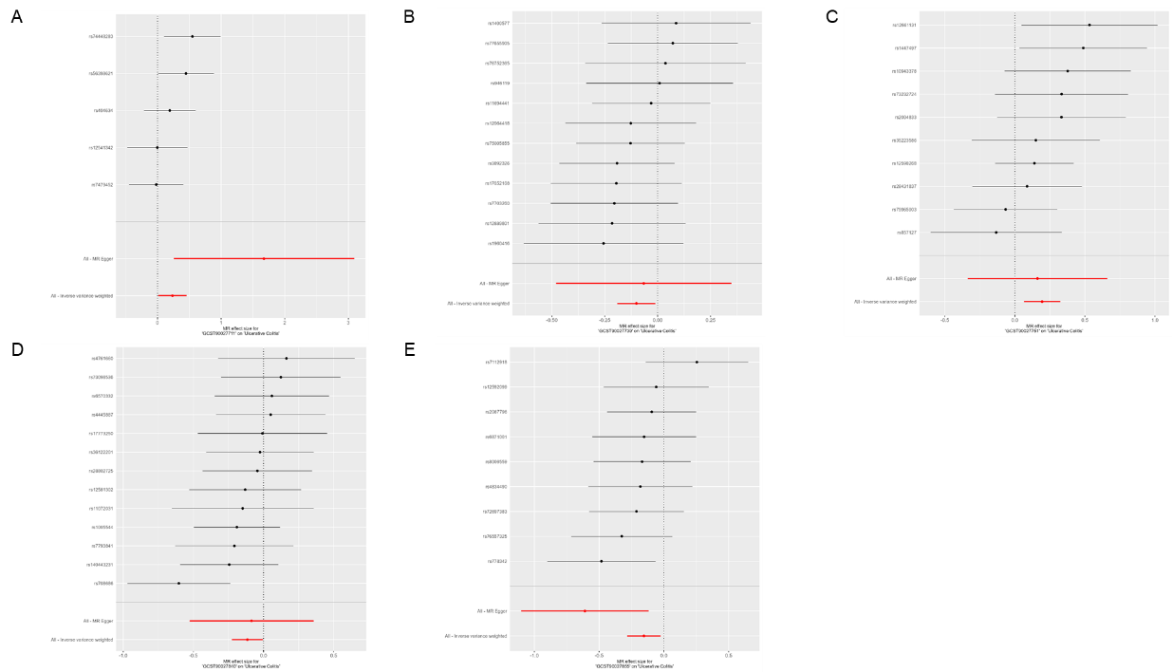
Supplementary Figures (S1~S8)
Figure S1. Forest plots of MR analysis of gut microbiota on UC. (A)Effect of Genus Dorea on UC. (B)Effect of Order Lactobacillales on UC. (C)Effect of Phylum Proteobacteria on UC. (D)Effect of Species Ruminococcus obeum on UC. (E)Effect of Species Roseburia intestinalis on UC. There were insufficient instrumental variables for the Species Streptococcus parasanguinis to generate a meaningful plot.
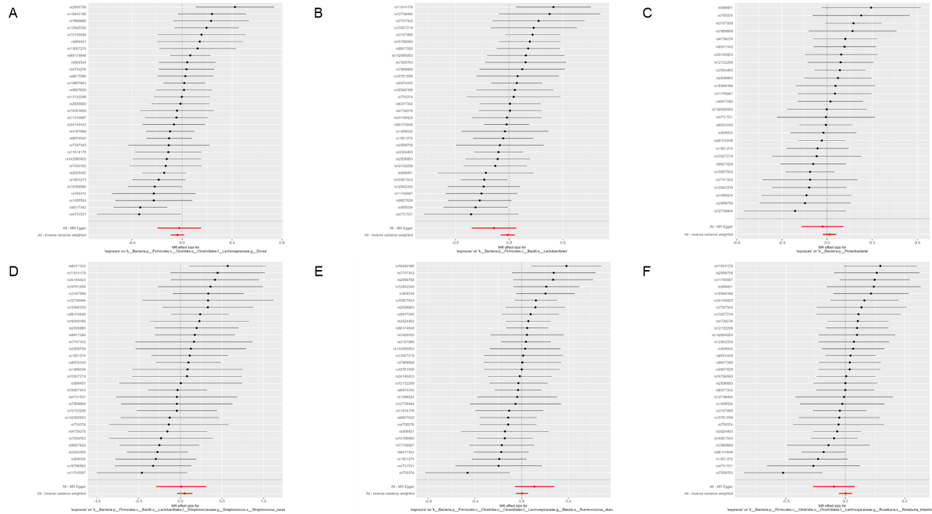
Figure S2. Forest plots of MR analysis of UC on gut microbiota.
(A)Effect of UC on Genus Dorea. (B) Effect of UC on Order Lactobacillales. (C) Effect of UC on Phylum Proteobacteria. (D) Effect of UC on Species Streptococcus_parasanguinis. (E) Effect of UC on Species Ruminococcus obeum. (F) Effect of UC on Species Roseburia intestinalis

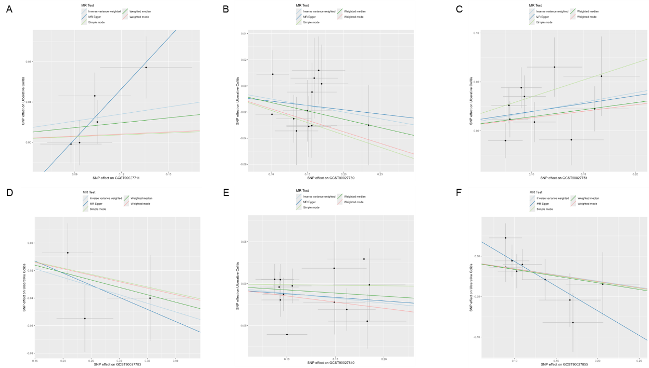
Figure S3. Scatter plots of MR analysis of gut microbiota on UC. (A)Effect of Genus Dorea on UC. (B)Effect of Order Lactobacillales on UC. (C)Effect of Phylum Proteobacteria on UC. (D) Effect of Species Streptococcus_parasanguinis on UC. (E)Effect of Species Ruminococcus obeum on UC. (F)Effect of Species Roseburia intestinalis on UC.
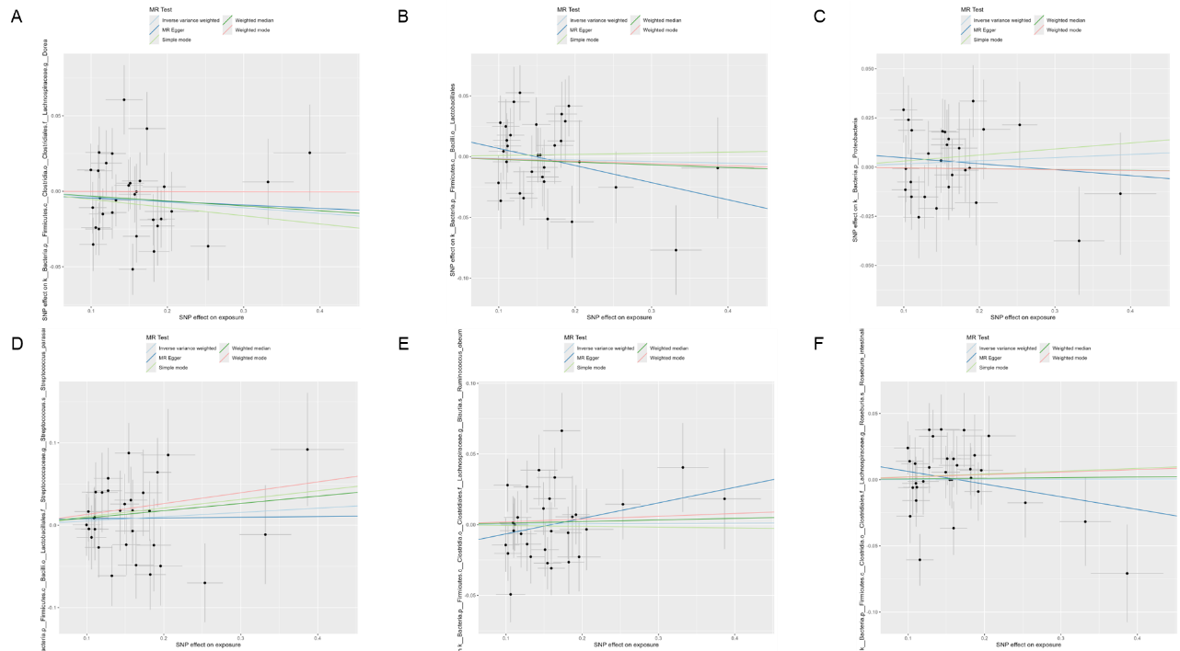
Figure S4. Scatter plots of MR analysis of UC on gut microbiota.
(A)Effect of UC on Genus Dorea. (B) Effect of UC on Order Lactobacillales. (C) Effect of UC on Phylum Proteobacteria. (D) Effect of UC on Species Streptococcus_parasanguinis. (E) Effect of UC on Species Ruminococcus obeum. (F) Effect of UC on Species Roseburia intestinalis

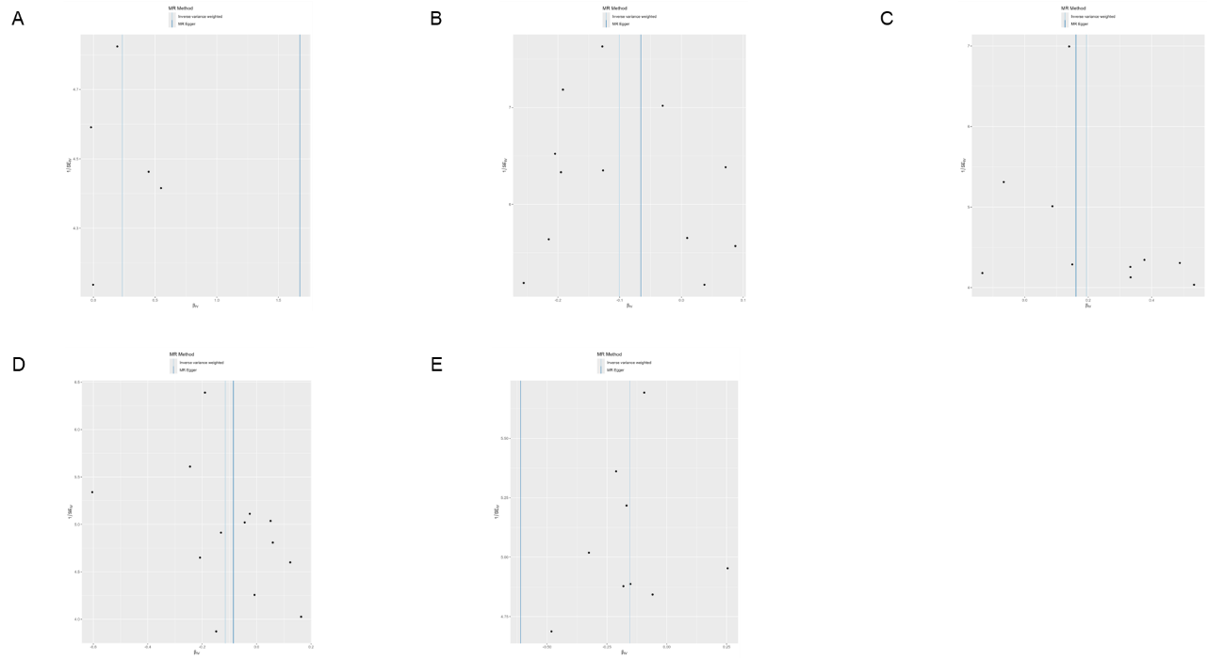
Figure S5. Funnel plots of MR analysis of gut microbiota on UC. (A)Effect of Genus Dorea on UC. (B)Effect of Order Lactobacillales on UC. (C)Effect of Phylum Proteobacteria on UC. (D)Effect of Species Ruminococcus obeum on UC. (E)Effect of Species Roseburia intestinalis on UC. There were insufficient instrumental variables for the Species Streptococcus parasanguinis to generate a meaningful plot.
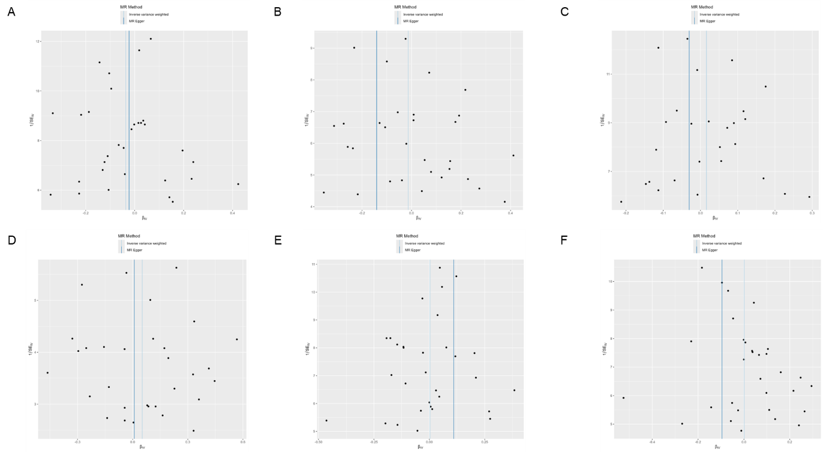
Figure S6. Funnel plots of MR analysis of UC on gut microbiota.
(A)Effect of UC on Genus Dorea. (B) Effect of UC on Order Lactobacillales. (C) Effect of UC on Phylum Proteobacteria. (D) Effect of UC on Species Streptococcus_parasanguinis. (E) Effect of UC on Species Ruminococcus obeum. (F) Effect of UC on Species Roseburia intestinalis

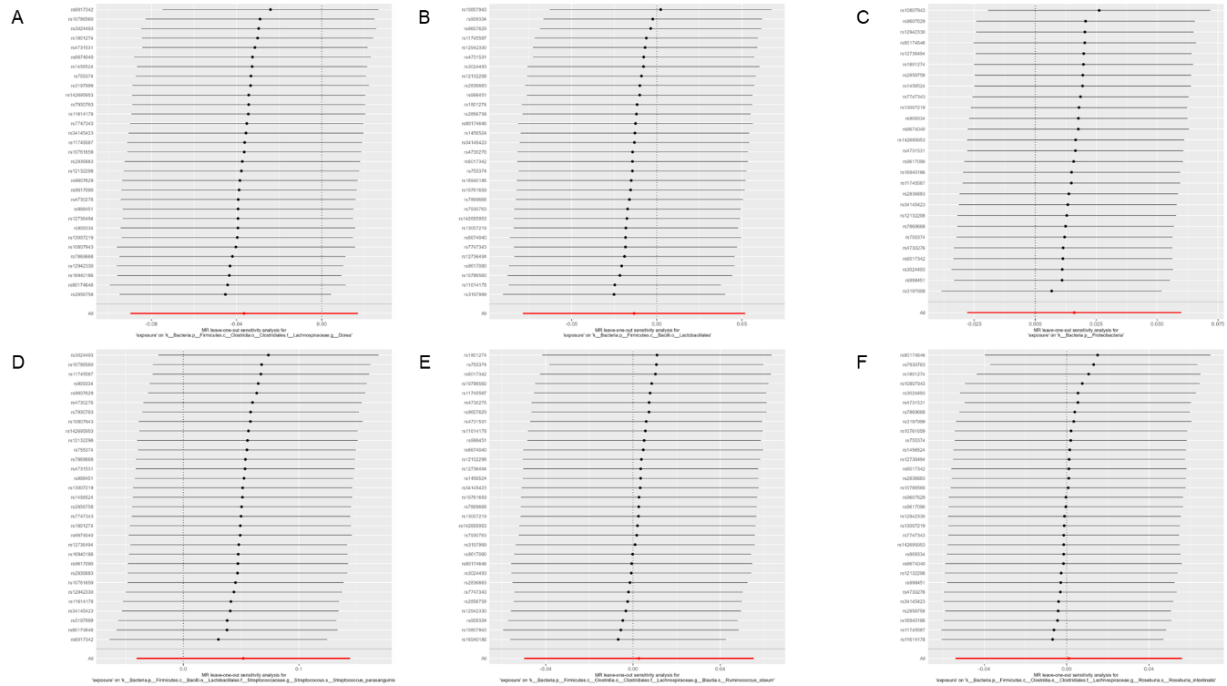
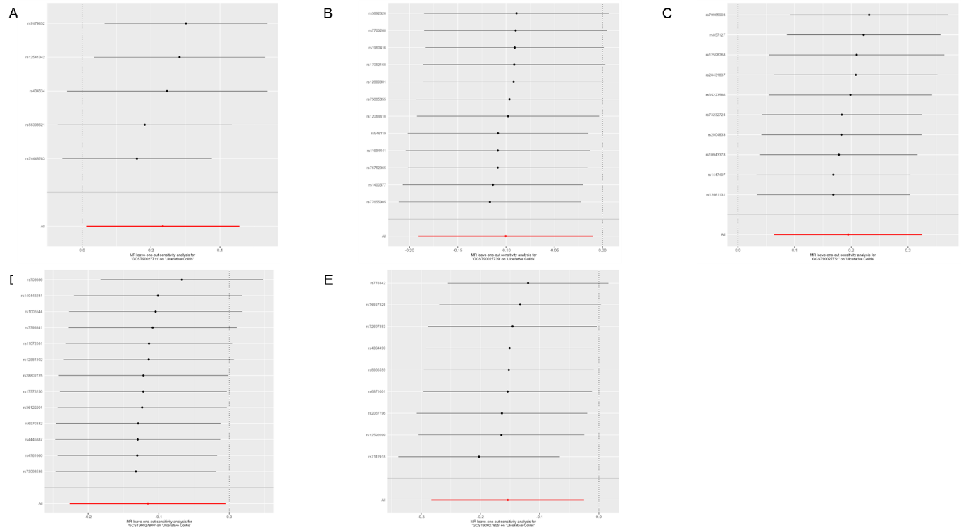
Figure S7. Leave-one-out plots of MR analysis of gut microbiota on UC. (A)Effect of Genus Dorea on UC. (B)Effect of Order Lactobacillales on UC. (C)Effect of Phylum Proteobacteria on UC. (D)Effect of Species Ruminococcus obeum on UC. (E)Effect of Species Roseburia intestinalis on UC. There were insufficient instrumental variables for the Species Streptococcus parasanguinis to generate a meaningful plot.
Figure S8. Leave-one-out plots of MR analysis of UC on gut microbiota.
(A)Effect of UC on Genus Dorea. (B) Effect of UC on Order Lactobacillales. (C) Effect of UC on Phylum Proteobacteria. (D) Effect of UC on Species Streptococcus_parasanguinis. (E) Effect of UC on Species Ruminococcus obeum. (F) Effect of UC on Species Roseburia intestinalis

