Supplementary Materials

Evaluation Metrics
We use the standard evaluation metric for human pose estimation task: mean average precision ($mAP$) scores to evaluate network’s detection accuracy. This metric measures the network’s ability to correctly localize keypoints while minimizing false positives. The higher the 𝐴𝑃, the robust the network is. There are five steps to compute $mAP$: 1) Compute the OKS score of a predicted pose, 2) Compute the confusion matric of the True positive, False positive, False negative, 3) Compute the precision and recall metrics, 4) Compute the area under the precision-recall curve (AUC), 5) Derive the average precision (𝐴𝑃).

Given a predicted pose 𝑃, containing a set of keypoints 𝐾 (e.g, 𝐾 = 17), we denote the Object Keypoint Similarity (OKS) in Equation 6:
$$OKS\left(P\right)=OKS\left(K, K_{gt}\right)=\sum_{i=1}^{N}{\frac{\exp\left(\frac{∥K_{i}-K_{i}^{gt}∥}{2s^{2}a_{i}^{2}}\right)δ\left(v_{i}>0\right)}{\sum_{i=1}^{N}{δ\left(v_{i}>0\right)}}} (6)$$
where 𝑁 denotes the number of keypoints defined in a pose, 𝐾𝑖 denotes the $i^{th}$ predicted poses, $K_{i}^{gt}$denotes the $i^{th}$ ground-truth keypoint, $∥K_{i}-K_{i}^{gt}∥$denotes the Euclidian distance between predicted keypoint and ground-truth keypoint, $v_{i}$is the visibility of the ground-truth keypoint, 𝑠 is the human scale, and $a_{i}$ is the per-keypoint constant that controls fall-off.

The Object Keypoint Similarity (OKS) score evaluates the localization accuracy of predicted poses by calculating the average displacement of each predicted 2-D keypoint from its corresponding ground-truth keypoint. As a result, we obtain the confusion matrix:
$$True positive \left(TP\right)= OKS\left(P\right)> OKS^{*}$$
$$False positive \left(FP\right)= OKS^{*} > OKS\left(P\right)> 0$$
$$False Negative (FN) = OKS(P) < 0$$
where $OKS^{*}$ ∈ [0,1] denotes a threshold, a predefined value. In our evaluation, we set this threshold in range of [0.5, 0.95] with 0.05 increment. In this case, a pose is considered correctly predicted if the $OKS$ between the predicted pose and the true pose is greater than these thresholds.
The precision and recall are defined in Equation 7 and Equation 8, respectively:
$$Precision=\frac{\sum_{n=1}^{S}{TP_{n}}}{\sum_{n=1}^{S}{TP_{n}+\sum_{n=1}^{N-S}{FP_{n}}}}=\frac{\sum_{n=1}^{S}{TP_{n}}}{all detection} (7)$$
$$Recall= \frac{\sum_{n=1}^{S}{TP_{n}}}{\sum_{n=1}^{S}{TP_{n}+\sum_{n=1}^{G-S}{FN_{n}}}}=\frac{\sum_{n=1}^{S}{TP_{n}}}{all ground truth} (8)$$
where 𝑆 denotes the total number of correctly detected poses, 𝑁 denotes the total number of pose detection, including correct detection and incorrect detection, 𝐺 denotes the total number of ground-truth poses.

For each predicted pose 𝑃, the model generates a precision score at various levels of recall (i.e., $OKS^{*}$ threshold). To compute average precision 𝐴𝑃, it is equivalent to the area under the precision and recall curve (AUC). In our study, we report $AP^{0.5},AP^{0.75}$, which is the 𝐴𝑃 when the $OKS^{*}$is equal to 50 (i.e., loose threshold), and 75 (i.e., strict threshold) respectively. Our network performance analysis is mainly evaluated on 𝑚𝐴𝑃, where $mAP = AP^{[.50::.05.0.95]}$, which is the mean from $AP^{0.5}$ to $AP^{0.95}$ with 0.5 increment. 𝑚𝐴𝑃 represents the overall performance. It gives a more holistic view of the network’s performance across different levels of difficulty. In addition, we also report $AP^{M}$and $AP^{L}$, which denote the median and large pose in terms of the original image size.

Dataset Information Mentioned in The Study
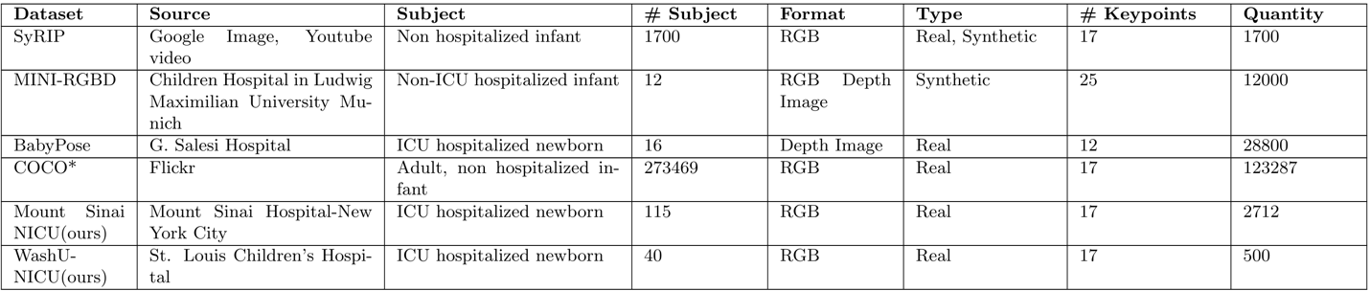
This table summarizes detailed information for all datasets referenced in this study, including sources, subjects, number of subjects, color format, image type, number of annotated keypoints, and total annotated images.

