Appendix

Tests of Normal Distribution
 | Kolmogorov-Smirnov |  |  | Shapiro-Wilk
 | D-Statistic | p-Value |  | W-Statistic | p-Value
Polymerase Chain Reaction | 0.7273 | 0.0025 |  | 0.91 | 0.014
Patents CRISPR/Cas 9 | 0.63 | 0.000003 |  | 0.84 | 0.034
Correlation
 | Pearson Correlation |  |  | Spearman Correlation
Polymerase Chain Reaction | 0.52 |  |  | 0.57
Patents CRISPR/Cas 9 | 0.18 |  |  | 0.23
Mean value comparison
 | Students T-Test
 | Mean _{Patent} | Mean _{Literature} | p-Value | 95%-CI
Polymerase Chain Reaction | 14.3667 | 61.133 | 0.0001 | [-63.55, -29.99]
Patents CRISPR/Cas 9 | 1.3636 | 22.3636 | 0.0079 | [-35.15, -6.85]
 | Wilcoxon-Mann-Whitney-Test
 | W-Statistic |  |  | p-Value
Polymerase Chain Reaction | 186 |  |  | 9.72E-05
Patents CRISPR/Cas 9 | 24.5 |  |  | 0.018
Table 2: Statistical analysis of PCR and CRISPR datasets.

 | Mean | Median | Std^ | Min | Max
Impact Factor of the Publication
Polymerase Chain Reaction | 7.89 | 5.32 | 11.40 | 0.15 | 286.13
CRISPR/Cas9 | 11.63 | 7.67 | 14.20 | 0,90 | 176.08
Table 3: Impact factor of the Publication.
The table displays the statistical evaluation of the impact factor of the publications sorted by technology.

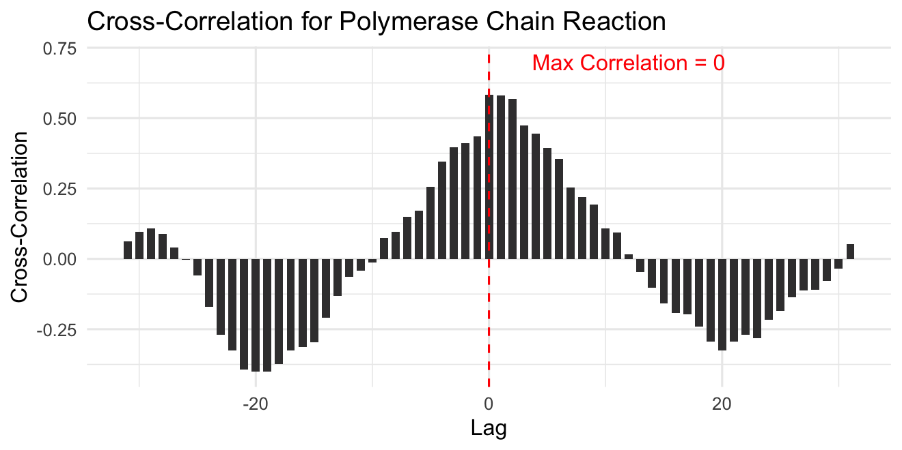
Figure 3: Cross-Correlation of PCR-Publication and PCR-Patents.
The analysis shows a dynamic correlation between patents and publications over time. The highest correlation coefficient occurs at a lag of 0 years, suggesting a simultaneous relationship between patents and publications. However, the correlation varies across different lags, illustrating the nuanced nature of their relationship. Statistically, both the mean and median of the lags are 0 years, indicating the absence of an average lag. However, the standard deviation of approximately 18.3303 years shows considerable variability in lag values around the mean, indicating a wide dispersion in the temporal alignment between patents and publications. A positive lag value indicates that the values of the first time series (patent applications) are ahead of the values of the second time series (publications). Conversely, a negative lag value means that the values of the second time series (publications) precede the values of the first time series (patent)

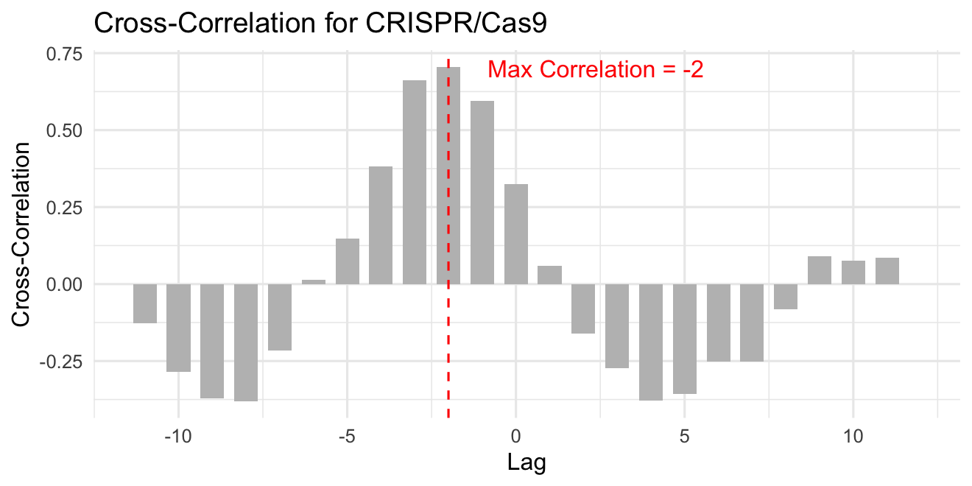
Figure 4: Cross-Correlation of CRISPR-Patents and CRISPR-Publications.
The available data demonstrate a time-dependent correlation between publications and patents. The highest correlation coefficient, which occurs at a lag of -1 year, indicates that the correlation between publications and patents is strongest when the publication time series is one year ahead of the patent time series. This suggests that changes or values in the publication time series have an influence on the patent time series that becomes evident over a period of one year. Key statistical metrics reveal a mean and median lag of 0 years, indicating an average absence of time lag. However, the standard deviation of approximately 5.63 years highlights significant variability in lag values around the mean. A positive lag value denotes instances where the values of the first time series (patents) precede those of the second time series (publications), while a negative lag value indicates that the values of the second time series (publications) precede those of the first time series (patents).

Country | Polymerase Chain Reaction |  |  | CRISPR/Cas9
Country | Patents | Literature |  | Patents | Literature
Australia | 6 | 71 |  | 0 | 16
Brazil | 2 | 23 |  | 1 | 2
Canada | 3 | 31 |  | 1 | 30
China | 17 | 435 |  | 24 | 109
Europe | 10 | 231 |  | 0 | 97
Israel | 4 | 12 |  | 1 | 4
India | 21 | 52 |  | 0 | 11
Japan | 17 | 43 |  | 5 | 12
South Korea | 6 | 42 |  | 7 | 12
United States of America | 206 | 165 |  | 27 | 247
Worldwide | 112 | 387 |  | 34 | 80
Table 4: Patents and publications sorted by country.
The table compares the patents and publications by activity of the countries for the respective technology.

 | Mean | Median | Std | Min | Max
PCR-Related Prior Art Citations in US Patents
Total Time Span of Articles Referenced by Patents | 23,4 | 22 | 14,8 | 0 | 47
Total Citations of Articles by Patents | 66,1 | 31 | 112,8 | 1 | 420
Diversity of Referenced Journals | 39,2 | 23 | 58 | 1 | 220
Impact factor | 26,3 | 25,1 | 16,4 | 3,6 | 66
Peak Year of Publications | 4 | 3 | 8 | 20 | -5,5
Citations | 1486 | 877 | 1934 | 57 | 6866
Literature post-Priority | 2,1 | 2 | 2,8 | -2 | 7
Literature pre-Priority | 21,7 | 19 | 15,5 | 0 | 49
Table 5: Descriptive statistics of the non-patent references.
The Total Time Span of Articles Referenced by Patents shows the difference between the oldest and most recently cited articles in patents. Total Citations of Articles by Patents shows the number of articles cited by patents, with a higher average compared to the median. Diversity of Referenced Journals provides information on the breadth of cited journals in patents. The impact factor serves as a measure of the importance of the cited journals, with high mean and median values being found. The Peak Year of Publications describes how many years before publication most citations of patents were published. Citations indicate the total number of citations for the articles analyzed, with a high average and a large spread. Finally, Literature post-priority describes the number of articles published after the priority date of the patent.
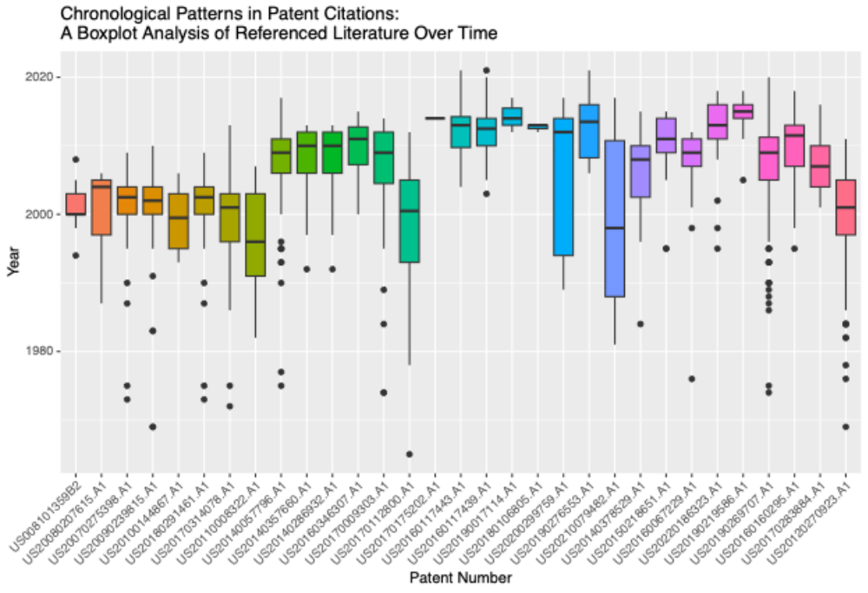
Figure 5: Chronological Patterns in Patent Citations (1990-2023).
The figure titled depicts the chronological patterns of literature citations within patents using boxplots. Spanning from 1990 to 2023, each series of boxplots represents a specific time period, visually illustrating the distribution of citations across these intervals. This analysis provides insights into temporal patterns and trends in patent references, allowing for the identification of potential innovations or technological developments over time.

Top 10 Journals
 | Name | Count | Percentage | Impact Factor | Country
1 | CANCER RESEARCH | 71 | 4,66% | 13,31 | US
2 | PNAS | 61 | 4,00% | 12,78 | US
3 | Nature | 50 | 3,28% | 69,50 | UK
4 | CLINICAL CANCER RESEARCH | 44 | 2,89% | 13,80 | US
5 | Science | 42 | 2,75% | 63,71 | US
6 | New England Journal of Medicine | 37 | 2,43% | 176,08 | US
7 | Journal of clinical Oncology | 33 | 2,16% | 50,72 | US
8 | Nucleic Acids Research | 28 | 1,84% | 19,16 | UK
9 | Journal of Biological Chemistry | 25 | 1,64% | 5,49 | US
10 | Cell | 24 | 1,57% | 66,85 | US
 | Total | 415 | 27%
Table 6: Top 10 most cited journals in the field of PCR research.

Citated publications in Patents | Number of publications
Cited once | 1345
cited twice | 158
Cited more than three times | 22
Table 7: Number of publications cited in the patents analysed.
Only 22 articles were cited 3 or more times. The seven publications were cited a total of 7 times.

