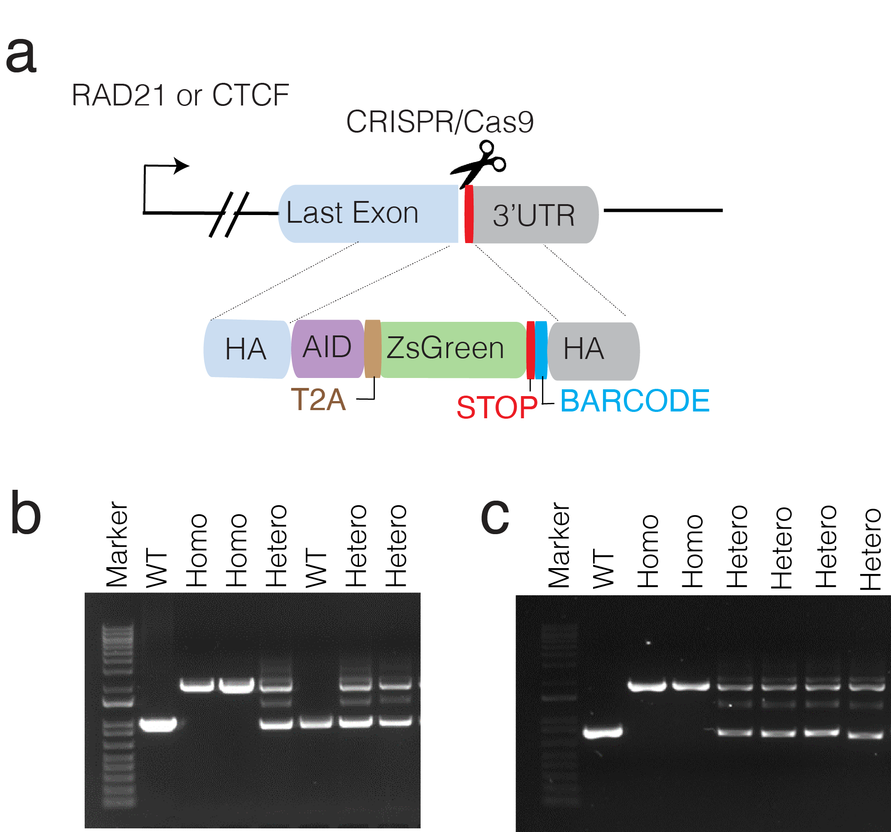
Supplementary Figure 1: Knocking in (KI) miniAID degron into C-terminal regions of RAD21 and CTCF using CRISPR/Cas9 technology. a) Schematic of knock-in (KI) donor templates containing miniAID degron into C-terminal regions. b-c) The homozygous knocked-in clones are identified by PCR for RAD21 (b) and CTCF (c) C-terminal region.

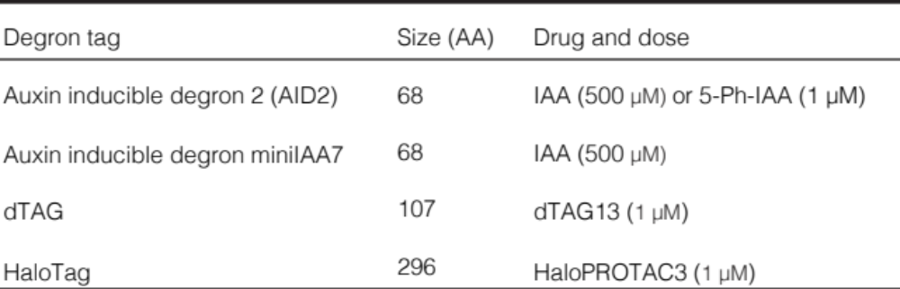

Supplementary Figure 2: The table shows the degron tags, their sizes and the ligand concentrations for the four major degron-based technologies evaluated in this study.

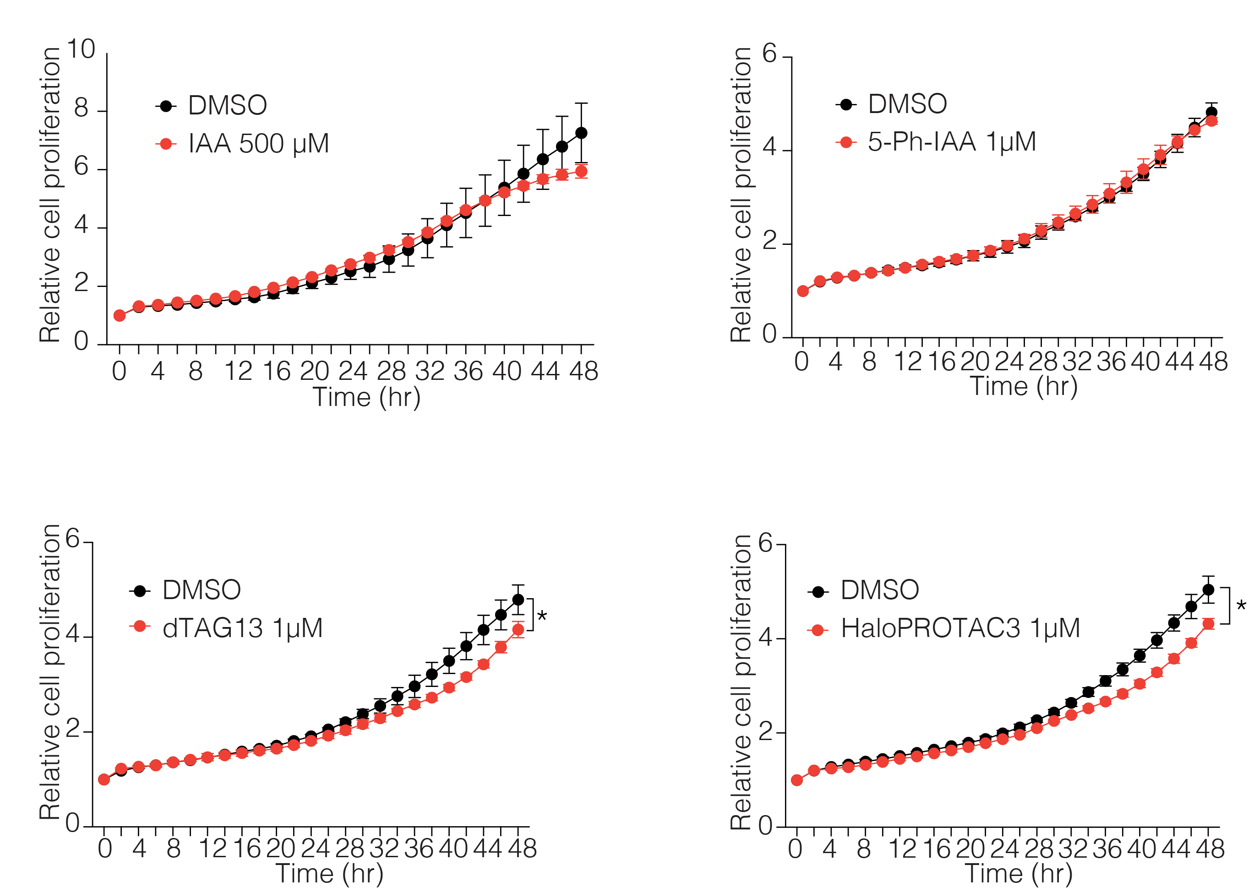
Supplementary Figure 3: Incucyte live cell imaging results show relative proliferation rates of iPSC in the presence of a defined ligand. Error bars indicate the standard deviations of the mean values. n = 3 independent experiments, * indicate p<0.01, two-tailed t-test.

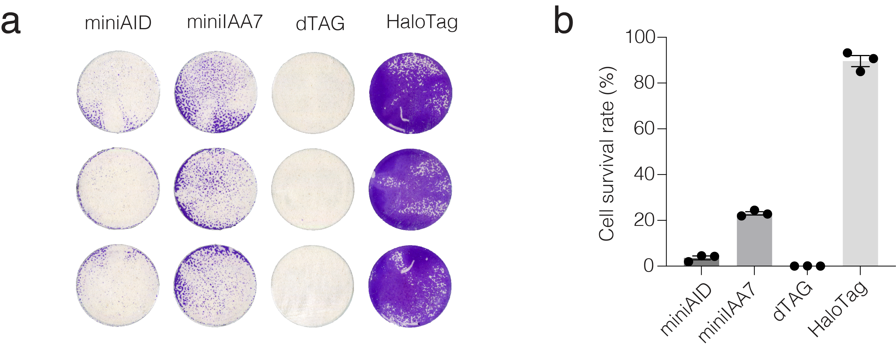
Supplementary Figure 4: Colony formation assay of degron-tagged-RAD21 recovery rates in iPSCs after protein depletion. a) Degron-tagged RAD21 cell lines were treated with each ligand for 6 hrs (complete degradation), then the ligands were washed out using PBS and replaced with fresh medium. Colonies were stained with crystal violet. b) Quantification of relative survived colony numbers using ImageJ. Data and error bars indicate the means ± SD (n = 3 independent biological replicates)
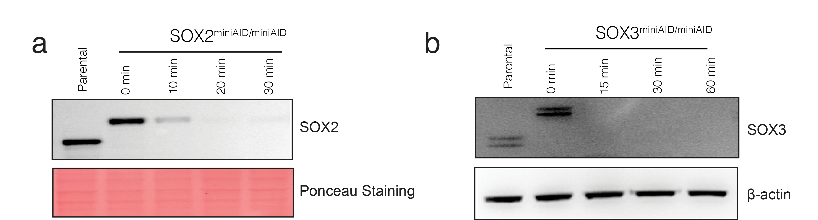
Supplementary Figure 5: Western blots show the kinetics of depletion of two endogenous genes in iPSCs expressing OsTIR1 (F74A) after treatment with 1 μM 5-Ph-IAA.
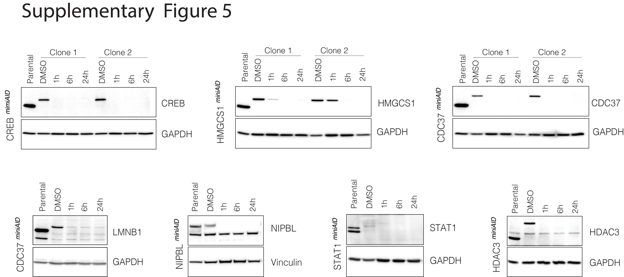

Supplementary Figure 6: Western blots show basal and inducible degradation kinetics of various endogenous proteins in iPSCs expressing AID2.0 degron system. Cells were treated with 1 μM 5-Ph-IAA.

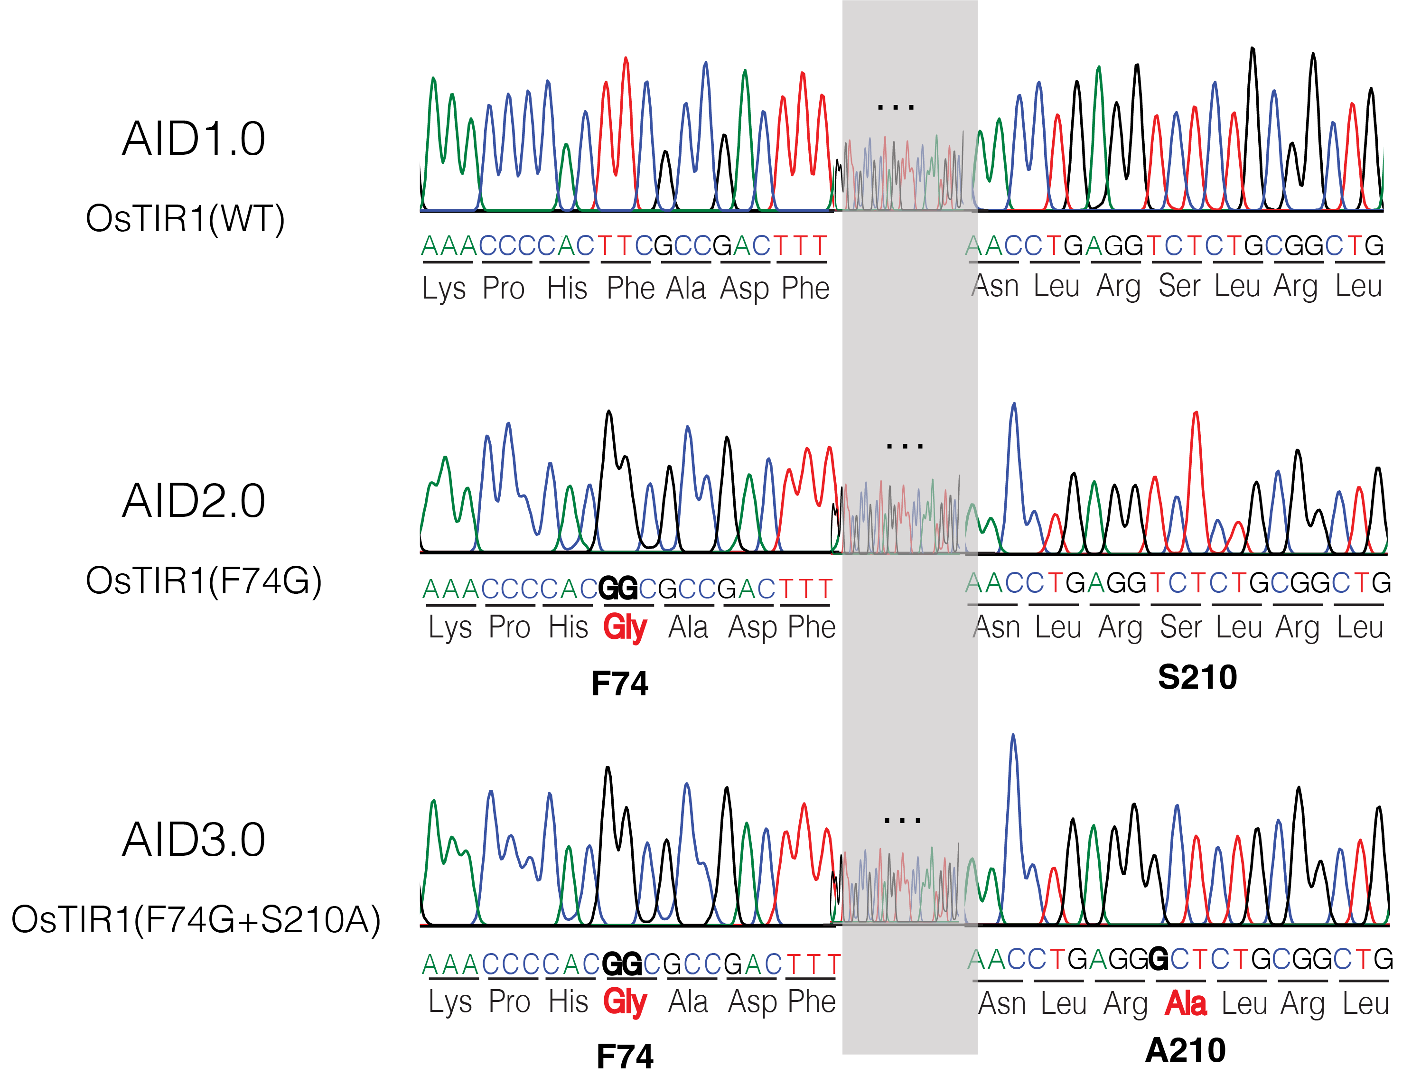
Supplementary Figure 7: Sanger sequencing show mutant positions of OsTIR1 in AID 1.0 (WT OsTIR), AID 2.0 (OsTIR ^{F74G}) and AID 3.0 (OsTIR ^{F74G+S210A}).

