Supplementary Information for
Expanding the spectrum of canine Diffuse Large B-cell Lymphoma (cDLBCL) genetic aberrations through whole genome sequencing (WGS) analysis
Antonella Fanelli¹, Eugenio Mazzone¹, Diana Giannuzzi², Laura Marconato³, Luca Aresu^{1*}

¹ Department of Veterinary Sciences, University of Turin, Grugliasco, Turin, Italy.
² Department of Agronomy, Food, Natural Resources, Animals and Environment (DAFNAE), University of Padua, Legnaro, Padua, Italy.
³ Department of Veterinary Medical Sciences, University of Bologna, Ozzano dell'Emilia, Bologna, Italy.
*correspondence: luca.aresu@unito.it

Supplementary Fig.1. Median time to progression (TTP) and lymphoma-specific survival (LSS) of the whole cohort. The Kaplan-Meier (KM) curves present median TTP (left) and LSS (right) of the whole cohort of 10 dogs with cDLBCL.

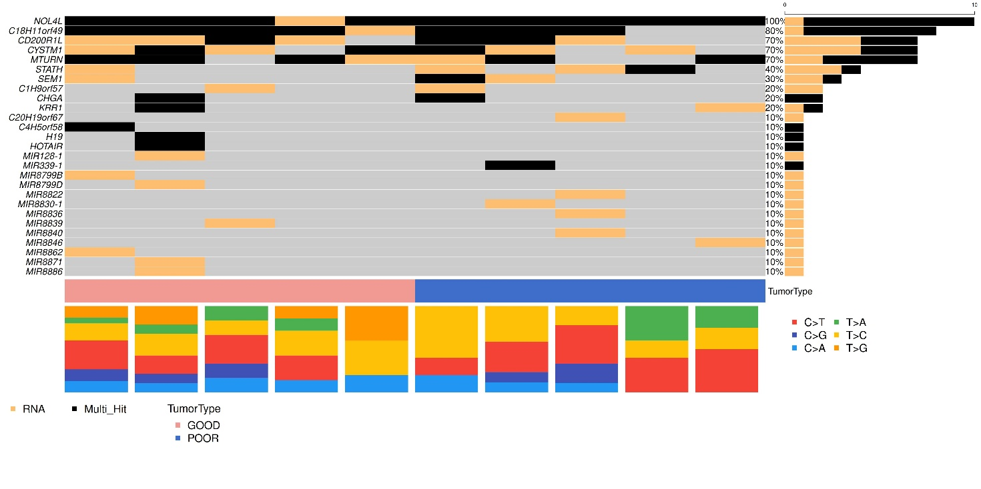
Supplementary Fig.2. Oncoplot of non-coding (nc) transcripts mutated in 10 cDLBCL. Genes specific for ncRNAs (excluding LOCs) are reported in descending order of mutation frequency. The top 10 genes were retrieved in both groups, while the remaining were reported in a single case from poor or good responders (indicated with the blue and the pink bar at the bottom, respectively) each. The distribution of single nucleotide substitutions is also depicted.

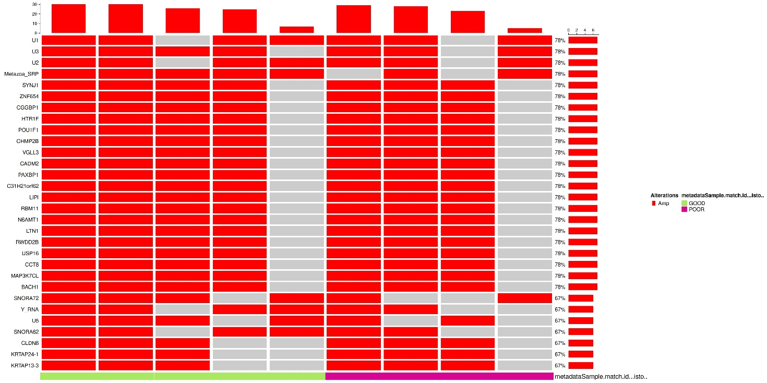
Supplementary Fig.3. Oncoplot of amplified genes. Amplified genes are reported in descending order of frequency of amplification. Poor and good responders are indicated as purple and green bars at the bottom, respectively. For sample #5 it was not possible to extract copy numbers because of insufficient sequencing depth.

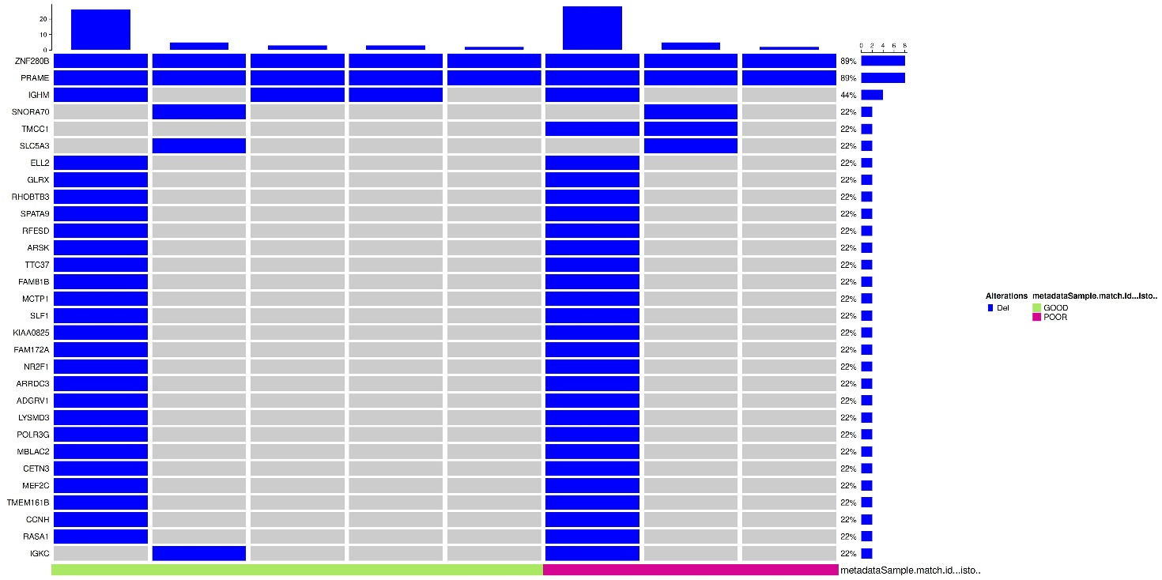
Supplementary Fig.4. Oncoplot of deleted genes. Deleted genes are reported in descending order of frequency of deletion. Poor and good responders are indicated as purple and green bars at the bottom, respectively. For sample #5 it was not possible to extract copy numbers because of insufficient sequencing depth.

