Supporting Information
MXene-based mild photothermal therapy synergizes STING activation to enhance the efficacy of cancer vaccines post-cryoablation

Fuming Wang^{1*}, Xiaodong Zhu^{2*}, Qianwen Zhang^{3*}, Minghui Xie¹, Lei He², Jiahao Guo², Ang Li², Qingsong Yang^{1†}, Jijin Yang^{1†}, Wei Li^{2†}

¹Department of Interventional Radiology, Changhai Hospital, Naval Medical University, Shanghai 200433, China
²Department of Nanomedicine, Naval Medical University, Shanghai 200433, China
³Department of Radiology, Changhai Hospital, Naval Medical University, Shanghai 200433, China

†Corresponding E-mails: Qingsong Yang, doctoryangqingsong@163.com; Jijin Yang, jijinyang@sina.com; Wei Li, liwei_dds@163.com.
*These authors contributed equally to this work.

Supporting Tables and Fig.s
Table S1. Primer sequence for RT-PCR detection of gene expression
Gene | Forward (5′→3′) | Reverse (5′→3′)
iNOS | GTTCTCAGCCCAACAATACAAGA | GTGGACGGGTCGATGTCAC
IL-10 | TTGAATTCCCTGGGTGAGAAG | TCCACTGCCTTGCTCTTATTT
TNF-α | CCTGTAGCCCACGTCGTAGC | AGCAATGACTCCAAAGTAGACC
Arg-1 | CCACAGTCTGGCAGTTGGAAG | GGTTGTCAGGGGAGTGTTGATG
β-actin | CGTTGACATCCGTAAAGACC | ACCAGTCCGCCTAGAAGCAC

Table S2. The EE and LC of DMXAA in TAPD nanosheets at different weight-feeding ratio
Weight-feeding ratio  (DMXAA : Ti₃C₂@Au-PEG) | Encapsulation efficiency  (EE) | Loading capacity  (LC)
1:1 | 38.68 ± 3.45% | 27.88 ± 2.98%
2:1 | 29.20 ± 3.54% | 36.87 ± 4.24%
5:1 | 14.18 ± 5.12% | 41.49 ± 4.42%

Fig. S1 Example of the abscopal effect in clinic, the advanced cancer patient with multiple intrapulmonary metastases who underwent lung cryoablation, resulting in sustained resolution of unablated lesions.

Fig. S2 Graph of Ti₃C₂ and Ti₃C₂@Au nanosheets (concentration of 80 µg mL⁻¹) dissolved in ultrapure water, PBS and DMEM medium, respectively.

Fig. S3 (A) UV-vis spectra of free DMXAA dissolved in H₂O. (B) UV-Vis spectra of free DMXAA dissolved in methanol. (C) UV-Vis spectra of different concentrations of free DMXAA dissolved in methanol. (D) Standard curve of free DMXAA dissolved in methanol.

Fig. S4 (A) DLS, (B) zeta potential, (C) PDI and (D) size distribution of functional nanosheets prepared from different weight feeding ratio (DMXAA: Ti₃C₂@Au-PEG).

Fig. S5 (A) UV-Vis spectra of functional nanosheets prepared from different weight-feeding ratio dissolved in methanol. (B) UV-Vis spectra of functional nanosheets prepared from different weight-feeding ratio dissolved in methanol after sodium hydroxide treatment.

Fig. S6 DMXAA release rates from functional nanosheets under different PH conditions in PBS for 72 h (PH = 4.5, PH = 6.5 and PH = 7.4).
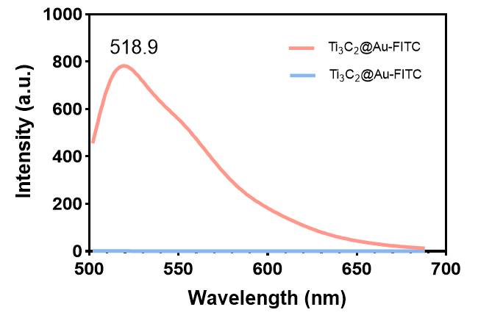
Fig. S7 Fluorescence wavelength and intensity of Ti₃C₂@Au nanosheets labeled with FITC fluorescent probe.

Fig. S8 CCK-8 assay of 4T1 cells after treatment with (A) Ti₃C₂@Au nanosheets or (B) free DMXAA of different concentrations for 24 h (n = 5).

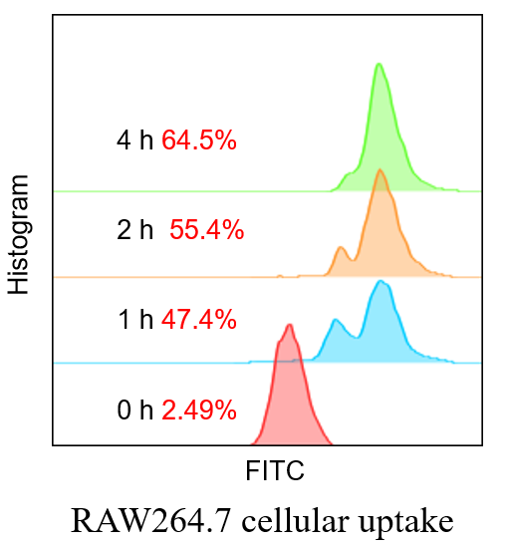

Fig. S9 Quantitative FCM analysis of RAW264.7 cell’s uptake of functional nanosheets TAP-FITC at different times.

Fig. S10 (A) Immunofluorescence staining (including CD31 and TUNEL) and Immunohistochemical staining Ki 67 of tumor sections of mice at 3 days post mPTT treatment (scale bar: 100 μm). (B) Quantitative analysis of CD31 positive blood vessels and TUNEL in tumor sections after different treatments according to (A) (n = 3). *P < 0.05, **p < 0.01, ***P < 0.001, ****P < 0.0001, respectively.
Fig. S11 Quantification of the percentage of (A) CD4⁺, (B) CD8⁺, (C) CD86⁺ cells in the tumor and the expression of (D) CRT or (E) TNF-α in the tumor after different treatments corresponding to immunofluorescence of tumor sections according to Fig. 7 (A), (n = 3). *P < 0.05, **p < 0.01, ***P < 0.001, ****P < 0.0001, respectively.
Fig. S12 FCM analysis of percentages of CD3⁺ T cells (gated on CD45⁺) in tumors of mice at 3 days post mPTT treatment (n = 3). (B) Quantitative analysis of CD3⁺ T cells in tumor sections after different treatments according to (A) (n = 3). (C) Quantitative analysis of the ratio of CD8⁺/CD4⁺ T cells in tumor after different treatments according to (Fig. 7B). *P < 0.05, **p < 0.01, ***P < 0.001, ****P < 0.0001, respectively.

Fig. S13 Quantification of the CD8/FOXP3 and CD86/CD206 ratio in the tumor corresponding to immunofluorescence of tumor sections according to Fig. 7C, (n = 3). *P < 0.05, **p < 0.01, ***P < 0.001, ****P < 0.0001, respectively.

Fig. S14 (A) The cryoablation systerm (Accu target) used for the cryoablation treatment procedure in this study, (B) and the graph of the ice ball formed in the saline during the 60 s.

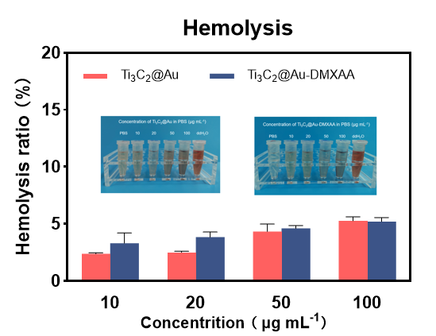
Fig. S15 Hemolysis percentage of the mouse RBCs treated with TAP and TAPD nanosheets of different concentrations for 3 h (n = 3). Water and normal saline (NS) were used as positive and negative controls, respectively.

Fig. S16 Representative H&E-stained sections of vital organs collected from tumor-bearing mice after different treatments for 21 days (Scale bar: 50 μm).

Fig. S17 The blood routines analysis including (A) WBC, (B) RBC and(C) PLT of healthy mice at 7 days post different treatments (n = 5).

Fig. S18 The serum biochemistry analysis including (A) ALT, (B) AST, (C) Bilirubin and (D) Urea of healthy mice at 7 days post different treatments (n = 5).

