Cold, creeping things: Deep phylogeographic structure in a naturally fragmented cool-adapted skink (Scincidae; Anepischetosia) from south-eastern Australia
Author list:
Rhiannon Schembri^{1,2,†}, Renee A. Catullo^{2,3}, Glenn Shea^{4,5}, Paul M. Oliver^{6,7}
¹School of Natural Sciences, Faculty of Science and Engineering, Macquarie University, Sydney.
²Ecology and Evolution Division, Research School of Biology, Australian National University, Canberra.
³School of Biological Sciences, University of Western Australia, Perth.
⁴Sydney School of Veterinary Science, University of Sydney, Sydney.
⁵ Australian Museum Research Institute, Australian Museum, Sydney.
⁶Centre for Planetary Health and Food Security, Griffith University, Brisbane.
⁷Biodiversity and Geosciences Program, Queensland Museum, Brisbane.
†Corresponding author: rhiannon.schembri@hdr.mq.edu.au, 205A Culloden Rd, Macquarie University, NSW, Australia 2109.

Supplementary information file

Supplementary Figures
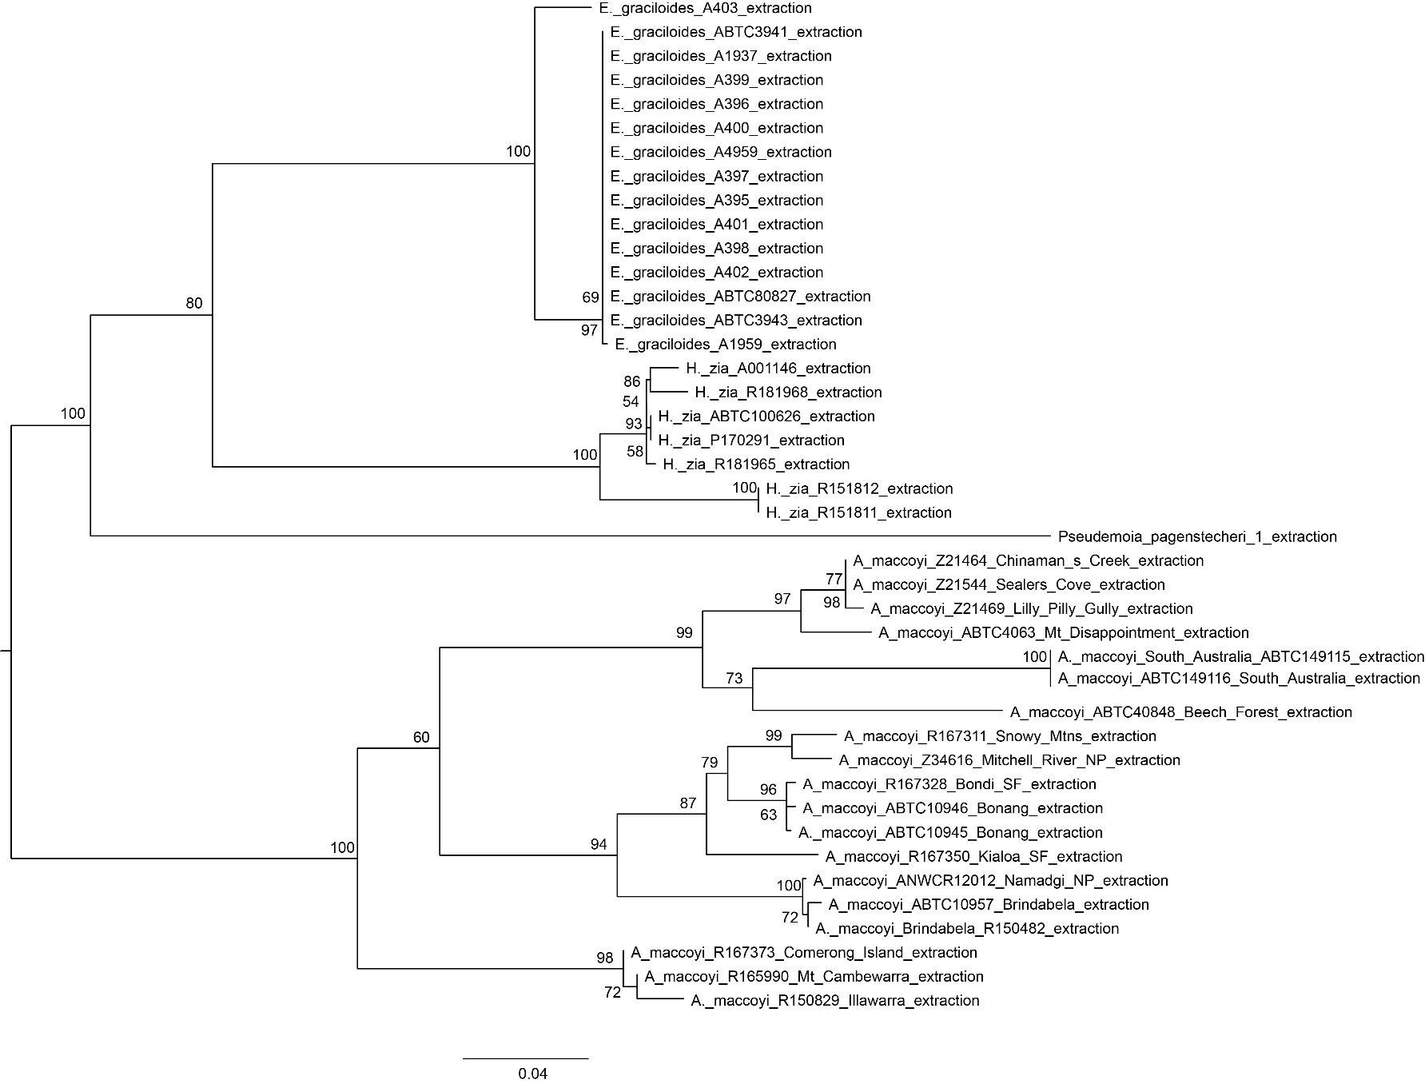

Figure S1 – Maximum likelihood phylogeny of mitochondrial ND4 gene. Figure shows the full phylogeny presented in Fig. 1b of the main text, with outgroup (E. graciloides, H. zia, and P. pagenstecheri) clades expanded, with midpoint rooting. Node labels show percent support from 1000 ultrafast bootstraps.
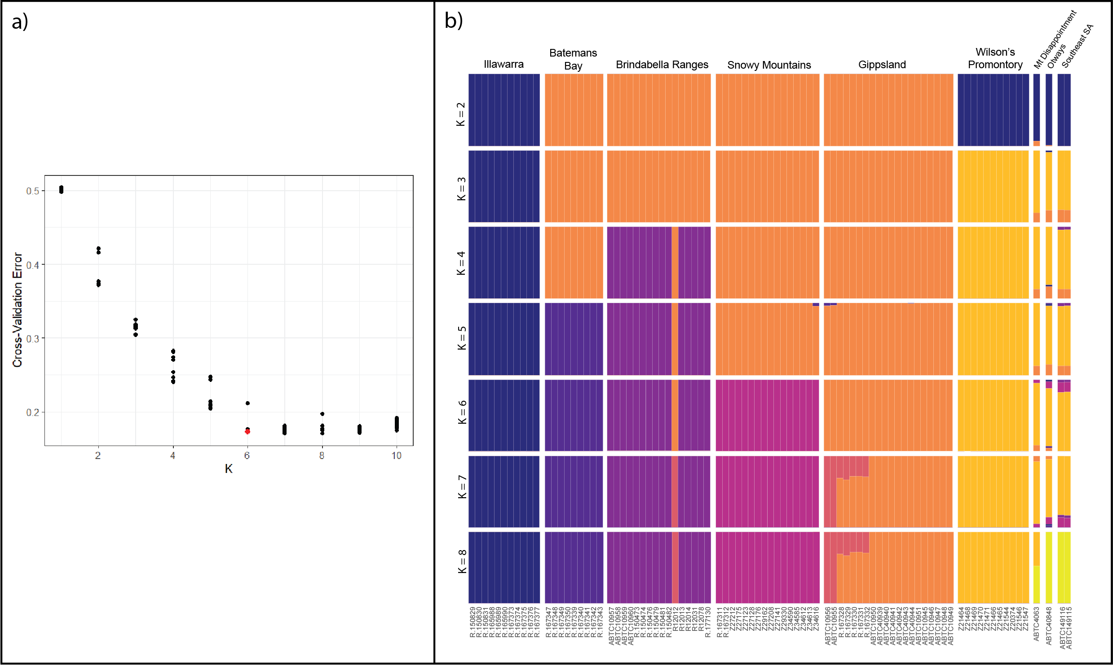
Figure S2 – Model selection and full results for ADMIXTURE analyses of Anepischetosia populations. a) Cross-validation (CV) error plot for all ADMIXTURE analyses. The analysis was run for different numbers of inferred population clusters (K) from 1 to 10, with ten replicates each. The best model (highlighted in red) was chosen based on the minimum CV for K=6, the smallest value of K at the CV plateau. Models for K=7 and K=8 have similar if not slightly lower CV error estimates, however we chose K=6 as it has fewer parameters. b) Estimated ancestry proportions of all individuals in ADMIXTURE analyses for values of K from 2 to 8. The results shown here are the best model (i.e., lowest CV error) model for a given value of K from ten replicate analyses. Results for K=9 and K=10 are incoherent and are not shown. Samples are sorted first by geographic region and then by latitude. Each colour represents a single inferred “ancestral population” or genetic cluster. The colour scheme has been chosen to aid visual comparability between rows without causing confusion with the population clusters described in the main text (which are specifically for K=6, the best model).
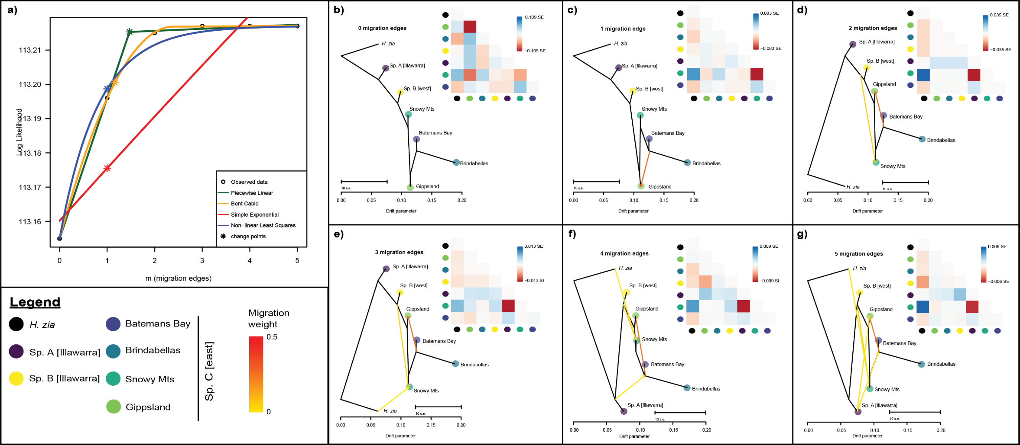
Figure S3 – Model selection and full results for TreeMix analyses of Anepischetosia populations. TreeMix population mixture models were run for the six identified population clusters of Anepischetosia, with phylogenies manually rooted on H. zia, for 0-5 migration edges with five replicates each. a) Model selection for the optimum number of migration edges (m) was performed with the R packaged OptM. Change points, shown with an asterisk, indicate the optimum number of migration edges inferred with each of four methods in OptM; the best model has a single migration edge in all methods. Inferred phylogenetic networks for different numbers of migration edges are shown in panels (b) through (g). Branch length in the horizontal direction is proportional to the amount of genetic drift inferred for that population. Residual pairwise relatedness between populations is shown by the heatmap in the top right corner of each panel: higher residual values (blue) indicate that observed relatedness between populations is greater than the network model can account for, and visa versa for lower residual values (red). Note that the scale of the residuals, in standard error units (SE), becomes narrower with increasing values of m as a greater proportion of the variance in the data is explained. Across all models, the total amount of unexplained variance is very low, indicating that tree-like evolution is a good fit for the data and there is little evidence for reticulation or introgression between populations. Legend (bottom left) applies to panels (b) through (g).

Supplementary Tables
Table S1 – Sample metadata
Prefix | Tissue ID | Tissue Institution | Voucher ID | Voucher Institution | Genus | Species | Collection date | State | Locality | Latitude | Longitude | SNP lineage | mtDNA lineage
QM | A001146 | Queensland Museum | J81824 | Queensland Museum | Harrisoniascincus | zia | 20/01/2005 | Queensland | nr O'Reilly's Rainforest Guesthouse | -28.2331 | 153.1369 | NA | NA
ABTC | ABTC100626 | South Australian Museum | J86645 | Queensland Museum | Harrisoniascincus | zia | 24/10/2007 | Queensland | Nixon Creek, Lamington NP | -28.219 | 153.1981 | NA | NA
ABTC | ABTC106214 | South Australian Museum | R55124 | South Australian Museum | Anepischetosia | maccoyi | 8/03/2001 | South Australia | 9 km SW Millicent | -37.6272 | 140.265 | NA | NA
ABTC | ABTC10945 | South Australian Museum | R.104785 | Australian Museum | Anepischetosia | maccoyi | 12/04/1982 | Victoria | Bonang, 4km S - Orbust Rd, at Rubbish Tip | -37.672 | 148.473 | sp. C [east] Gippsland | sp. C [east] Gippsland
ABTC | ABTC10946 | South Australian Museum | R.104781 | Australian Museum | Anepischetosia | maccoyi | 12/04/1982 | Victoria | Bonang, 4km S - Orbust Rd, at Rubbish Tip | -37.672 | 148.473 | sp. C [east] Gippsland | sp. C [east] Gippsland
ABTC | ABTC10947 | South Australian Museum | R.104782 | Australian Museum | Anepischetosia | maccoyi | 12/04/1982 | Victoria | Bonang, 4km S - Orbust Rd, at Rubbish Tip | -37.672 | 148.473 | sp. C [east] Gippsland | NA
ABTC | ABTC10948 | South Australian Museum | R.104783 | Australian Museum | Anepischetosia | maccoyi | 12/04/1982 | Victoria | Bonang, 4km S - Orbust Rd, at Rubbish Tip | -37.672 | 148.473 | sp. C [east] Gippsland | NA
ABTC | ABTC10949 | South Australian Museum | R.104784 | Australian Museum | Anepischetosia | maccoyi | 12/04/1982 | Victoria | Bonang, 4km S - Orbust Rd, at Rubbish Tip | -37.672 | 148.473 | sp. C [east] Gippsland | NA
ABTC | ABTC10950 | South Australian Museum | R.111783 | Australian Museum | Anepischetosia | maccoyi | 12/04/1982 | Victoria | Bonang Tip | -37.183 | 148.733 | sp. C [east] Gippsland | NA
ABTC | ABTC10951 | South Australian Museum | R.102749 | Australian Museum | Anepischetosia | maccoyi | 12/04/1982 | Victoria | Bonang, 4km S - Orbust Rd, at Rubbish Tip | -37.216 | 148.716 | sp. C [east] Gippsland | NA
ABTC | ABTC10955 | South Australian Museum | R.112326 | Australian Museum | Anepischetosia | maccoyi | 10/12/1982 | New South Wales | Coolangubra State Forest | -37 | 149.47 | sp. C [east] Gippsland | NA
ABTC | ABTC10956 | South Australian Museum | NA | NA | Anepischetosia | maccoyi | unknown | New South Wales | Coolangabra SF | -36.998 | 149.46 | sp. C [east] Gippsland | NA
ABTC | ABTC10957 | South Australian Museum | R.104197 | Australian Museum | Anepischetosia | maccoyi | 8/12/1982 | New South Wales | Brindabella Range, Coree Flats | -35.2839 | 148.8131 | sp. C [east] Brindabellas | sp. C [east] Brindabellas
ABTC | ABTC10958 | South Australian Museum | R.104198 | Australian Museum | Anepischetosia | maccoyi | 8/12/1982 | New South Wales | Brindabella Range, Coree Flats | -35.2839 | 148.8131 | sp. C [east] Brindabellas | NA
ABTC | ABTC10959 | South Australian Museum | R.104199 | Australian Museum | Anepischetosia | maccoyi | 8/12/1982 | New South Wales | Brindabella Range, Coree Flats | -35.2839 | 148.8131 | sp. C [east] Brindabellas | NA
ABTC | ABTC10960 | South Australian Museum | R.104200 | Australian Museum | Anepischetosia | maccoyi | 8/12/1982 | New South Wales | Brindabella Range, Coree Flats | -35.2839 | 148.8131 | sp. C [east] Brindabellas | NA
ABTC | ABTC149115 | South Australian Museum | R70262 | South Australian Museum | Anepischetosia | maccoyi | 29/10/2016 | South Australia | Woolwash Native forrest Reserve | -37.7161 | 140.5892 | sp. B [west] | sp. B [west]
ABTC | ABTC149116 | South Australian Museum | R70263 | South Australian Museum | Anepischetosia | maccoyi | 29/10/2016 | South Australia | Woolwash Native forrest Reserve | -37.7139 | 140.5867 | sp. B [west] | sp. B [west]
ABTC | ABTC3941 | South Australian Museum | NA | NA | Eroticoscincus | graciloides | unknown | Queensland | 8k W McAfees Lookout | -27.43 | 152.8 | NA | NA
ABTC | ABTC3943 | South Australian Museum | NA | NA | Eroticoscincus | graciloides | unknown | Queensland | 8k W McAfees Lookout | -27.43 | 152.8 | NA | NA
ABTC | ABTC4063 | South Australian Museum | D60918 | Museums Victoria | Anepischetosia | maccoyi | unknown | Victoria | Mt Disappointment | -37.426 | 145.136 | sp. B [west] | sp. B [west]
ABTC | ABTC40848 | Australian Biological Tissue Collection | D62066 | Museums Victoria | Anepischetosia | maccoyi | 20/02/1998 | Victoria | Otway Ranges, 2k E Beech Forest | -38.63 | 143.53 | sp. B [west] | sp. B [west]
ABTC | ABTC40939 | South Australian Museum | D62103 | Museums Victoria | Anepischetosia | maccoyi | 28/02/1988 | Victoria | Bonang tip | -37.2 | 148.72 | sp. C [east] Gippsland | NA
ABTC | ABTC40940 | South Australian Museum | D62104 | Museums Victoria | Anepischetosia | maccoyi | 28/02/1988 | Victoria | Bonang tip | -37.2 | 148.72 | sp. C [east] Gippsland | NA
ABTC | ABTC40941 | South Australian Museum | D62105 | Museums Victoria | Anepischetosia | maccoyi | 28/02/1988 | Victoria | Bonang tip | -37.2 | 148.72 | sp. C [east] Gippsland | NA
ABTC | ABTC40942 | South Australian Museum | D62106 | Museums Victoria | Anepischetosia | maccoyi | 28/02/1988 | Victoria | Bonang tip | -37.2 | 148.72 | sp. C [east] Gippsland | NA
ABTC | ABTC40943 | South Australian Museum | D62107 | Museums Victoria | Anepischetosia | maccoyi | 28/02/1988 | Victoria | Bonang tip | -37.2 | 148.72 | sp. C [east] Gippsland | NA
ABTC | ABTC40944 | South Australian Museum | D62108 | Museums Victoria | Anepischetosia | maccoyi | 29/02/1988 | Victoria | Bonang tip | -37.2 | 148.72 | sp. C [east] Gippsland | NA
PMO | PMO-291 | unknown | P170291 | unknown | Harrisoniascincus | zia | 1/02/2019 | Queensland | Lamington National Park, Border Ranges Track, Binna Burra Entrance | -28.253 | 153.203 | NA | NA
AMS | R.150473.001 | Australian Museum | R.150473 | Australian Museum | Anepischetosia | maccoyi | 17/12/1996 | New South Wales | Yass Valley, Coree Flats | -35.3 | 148.82 | sp. C [east] Brindabellas | NA
AMS | R.150474.001 | Australian Museum | R.150474 | Australian Museum | Anepischetosia | maccoyi | 17/12/1996 | New South Wales | Yass Valley, Coree Flats | -35.3 | 148.82 | sp. C [east] Brindabellas | NA
AMS | R.150476.001 | Australian Museum | R.150476 | Australian Museum | Anepischetosia | maccoyi | 17/12/1996 | Australian Capital Territory | 2 Km N Picadilly Circus | -35.37 | 148.82 | sp. C [east] Brindabellas | NA
AMS | R.150479.001 | Australian Museum | R.150479 | Australian Museum | Anepischetosia | maccoyi | 17/12/1996 | Australian Capital Territory | 2 Km N Picadilly Circus | -35.37 | 148.82 | sp. C [east] Brindabellas | NA
AMS | R.150481.001 | Australian Museum | R.150481 | Australian Museum | Anepischetosia | maccoyi | 17/12/1996 | Australian Capital Territory | 2 Km N Picadilly Circus | -35.37 | 148.82 | sp. C [east] Brindabellas | NA
AMS | R.150482.001 | Australian Museum | R.150482 | Australian Museum | Anepischetosia | maccoyi | 17/12/1996 | Australian Capital Territory | 2 Km N Picadilly Circus | -35.37 | 148.82 | sp. C [east] Brindabellas | sp. C [east] Brindabellas
AMS | R.150829.001 | Australian Museum | R.150829 | Australian Museum | Anepischetosia | maccoyi | 24/02/1997 | New South Wales | Shell Harbour, Macquarie Pass National Park, End of Clover Hill Rd, About 2km Sw Illawarra Hwy | -34.5675 | 150.6467 | sp. A [Illawarra] | sp. A [Illawarra]
AMS | R.150830.001 | Australian Museum | R.150830 | Australian Museum | Anepischetosia | maccoyi | 24/02/1997 | New South Wales | Shell Harbour, Macquarie Pass National Park, End of Clover Hill Rd, About 2km Sw Illawarra Hwy | -34.5675 | 150.6467 | sp. A [Illawarra] | NA
AMS | R.150831.001 | Australian Museum | R.150831 | Australian Museum | Anepischetosia | maccoyi | 24/02/1997 | New South Wales | Shell Harbour, Macquarie Pass National Park, End of Clover Hill Rd, About 2km Sw Illawarra Hwy | -34.5675 | 150.6467 | sp. A [Illawarra] | NA
AMS | R.165988.001 | Australian Museum | R.165988 | Australian Museum | Anepischetosia | maccoyi | 12/06/2006 | New South Wales | Mt Cambewarra | -34.7953 | 150.5767 | sp. A [Illawarra] | NA
AMS | R.165989.001 | Australian Museum | R.165989 | Australian Museum | Anepischetosia | maccoyi | 12/06/2006 | New South Wales | Mt Cambewarra | -34.7953 | 150.5767 | sp. A [Illawarra] | NA
AMS | R.165990.001 | Australian Museum | R.165990 | Australian Museum | Anepischetosia | maccoyi | 12/06/2006 | New South Wales | Mt Cambewarra | -34.7953 | 150.5767 | sp. A [Illawarra] | sp. A [Illawarra]
AMS | R.167311.001 | Australian Museum | R.167311 | Australian Museum | Anepischetosia | maccoyi | 17/04/2006 | New South Wales | Snowy Mtns. Hwy., 1.5km east of Tantangara road t/o | -35.9344 | 148.6289 | sp. C [east] Snowy Mts | sp. C [east] Snowy Mts
AMS | R.167312.001 | Australian Museum | R.167312 | Australian Museum | Anepischetosia | maccoyi | 17/04/2006 | New South Wales | Snowy Mtns. Hwy., 1.5km east of Tantangara road t/o | -35.9344 | 148.6289 | sp. C [east] Snowy Mts | NA
AMS | R.167328.001 | Australian Museum | R.167328 | Australian Museum | Anepischetosia | maccoyi | 23/04/2006 | Victoria | Bondi State Forest, 2km south of junction of Coast Road with No.5 Road and Chinamans Creek Road | -37.1767 | 149.1003 | sp. C [east] Gippsland | sp. C [east] Gippsland
AMS | R.167329.001 | Australian Museum | R.167329 | Australian Museum | Anepischetosia | maccoyi | 23/04/2006 | Victoria | Bondi State Forest, 2km south of junction of Coast Road with No.5 Road and Chinamans Creek Road | -37.1767 | 149.1003 | sp. C [east] Gippsland | NA
AMS | R.167330.001 | Australian Museum | R.167330 | Australian Museum | Anepischetosia | maccoyi | 23/04/2006 | Victoria | Bondi State Forest, 2km south of junction of Coast Road with No.5 Road and Chinamans Creek Road | -37.1767 | 149.1003 | sp. C [east] Gippsland | NA
AMS | R.167331.001 | Australian Museum | R.167331 | Australian Museum | Anepischetosia | maccoyi | 23/04/2006 | Victoria | Bondi State Forest, 2km south of junction of Coast Road with No.5 Road and Chinamans Creek Road | -37.1767 | 149.1003 | sp. C [east] Gippsland | NA
AMS | R.167332.001 | Australian Museum | R.167332 | Australian Museum | Anepischetosia | maccoyi | 23/04/2006 | Victoria | Bondi State Forest, 2km south of junction of Coast Road with No.5 Road and Chinamans Creek Road | -37.1767 | 149.1003 | sp. C [east] Gippsland | NA
AMS | R.167339.001 | Australian Museum | R.167339 | Australian Museum | Anepischetosia | maccoyi | 24/04/2006 | New South Wales | Benamberah State Forest, just south of Benamberah rest area | -35.6583 | 150.2333 | sp. C [east] Batemans Bay | NA
AMS | R.167340.001 | Australian Museum | R.167340 | Australian Museum | Anepischetosia | maccoyi | 24/04/2006 | New South Wales | Benamberah State Forest, just south of Benamberah rest area | -35.6583 | 150.2333 | sp. C [east] Batemans Bay | NA
AMS | R.167341.001 | Australian Museum | R.167341 | Australian Museum | Anepischetosia | maccoyi | 24/04/2006 | New South Wales | Benamberah State Forest, just south of Benamberah rest area | -35.6583 | 150.2333 | sp. C [east] Batemans Bay | NA
AMS | R.167342.001 | Australian Museum | R.167342 | Australian Museum | Anepischetosia | maccoyi | 24/04/2006 | New South Wales | Benamberah State Forest, just south of Benamberah rest area | -35.6583 | 150.2333 | sp. C [east] Batemans Bay | NA
AMS | R.167343.001 | Australian Museum | R.167343 | Australian Museum | Anepischetosia | maccoyi | 24/04/2006 | New South Wales | Benamberah State Forest, just south of Benamberah rest area | -35.6583 | 150.2333 | sp. C [east] Batemans Bay | NA
AMS | R.167347.001 | Australian Museum | R.167347 | Australian Museum | Anepischetosia | maccoyi | 24/04/2006 | New South Wales | Kialoa State forest, vicinity of 'Old Blotchy' Spotted Gum | -35.5064 | 150.3361 | sp. C [east] Batemans Bay | NA
AMS | R.167348.001 | Australian Museum | R.167348 | Australian Museum | Anepischetosia | maccoyi | 24/04/2006 | New South Wales | Kialoa State forest, vicinity of 'Old Blotchy' Spotted Gum | -35.5064 | 150.3361 | sp. C [east] Batemans Bay | NA
AMS | R.167349.001 | Australian Museum | R.167349 | Australian Museum | Anepischetosia | maccoyi | 24/04/2006 | New South Wales | Kialoa State forest, vicinity of 'Old Blotchy' Spotted Gum | -35.5064 | 150.3361 | sp. C [east] Batemans Bay | NA
AMS | R.167350.001 | Australian Museum | R.167350 | Australian Museum | Anepischetosia | maccoyi | 24/04/2006 | New South Wales | Kialoa State forest, vicinity of 'Old Blotchy' Spotted Gum | -35.5064 | 150.3361 | sp. C [east] Batemans Bay | sp. C [east] Batemans Bay
AMS | R.167373.001 | Australian Museum | R.167373 | Australian Museum | Anepischetosia | maccoyi | 24/04/2006 | New South Wales | Comerong Island, Shoalhaven | -34.8711 | 150.745 | sp. A [Illawarra] | sp. A [Illawarra]
AMS | R.167374.001 | Australian Museum | R.167374 | Australian Museum | Anepischetosia | maccoyi | 24/04/2006 | New South Wales | Comerong Island, Shoalhaven | -34.8711 | 150.745 | sp. A [Illawarra] | NA
AMS | R.167375.001 | Australian Museum | R.167375 | Australian Museum | Anepischetosia | maccoyi | 24/04/2006 | New South Wales | Comerong Island, Shoalhaven | -34.8711 | 150.745 | sp. A [Illawarra] | NA
AMS | R.167376.001 | Australian Museum | R.167376 | Australian Museum | Anepischetosia | maccoyi | 24/04/2006 | New South Wales | Comerong Island, Shoalhaven | -34.8711 | 150.745 | sp. A [Illawarra] | NA
AMS | R.167377.001 | Australian Museum | R.167377 | Australian Museum | Anepischetosia | maccoyi | 24/04/2006 | New South Wales | Comerong Island, Shoalhaven | -34.8711 | 150.745 | sp. A [Illawarra] | NA
AMS | R.177130.001 | Australian Museum | R.177130 | Australian Museum | Anepischetosia | maccoyi | 4/12/2011 | New South Wales | Kosciuszko NP, approx. 27 km along Long Plain Rd from Snowy Mtns Hwy, Tumut Shire | -35.5319 | 148.6239 | sp. C [east] Brindabellas | NA
ANWC | R12012 | Australian National Wildlife Collection | R12012 | Australian National Wildlife Collection | Anepischetosia | maccoyi | 28/11/2018 | Australian Capital Territory | Mount Franklin Road, Namadgi National Park | -35.3722 | 148.8042 | sp. C [east] Gippsland | sp. C [east] Brindabellas
ANWC | R12013 | Australian National Wildlife Collection | R12013 | Australian National Wildlife Collection | Anepischetosia | maccoyi | 28/11/2018 | Australian Capital Territory | Mount Franklin Road, Namadgi National Park | -35.3722 | 148.8042 | sp. C [east] Brindabellas | NA
ANWC | R12014 | Australian National Wildlife Collection | R12014 | Australian National Wildlife Collection | Anepischetosia | maccoyi | 28/11/2018 | Australian Capital Territory | Mount Franklin Road, Namadgi National Park | -35.3722 | 148.8042 | sp. C [east] Brindabellas | NA
ANWC | R12031 | Australian National Wildlife Collection | R12031 | Australian National Wildlife Collection | Anepischetosia | maccoyi | 30/11/2018 | Australian Capital Territory | Mount Franklin, Namadgi National Park | -35.4889 | 148.7687 | sp. C [east] Brindabellas | NA
ANWC | R12078 | Australian National Wildlife Collection | R12078 | Australian National Wildlife Collection | Anepischetosia | maccoyi | 5/02/2018 | Australian Capital Territory | Smokey Trail, Namadgi National Park | -35.5299 | 148.9321 | sp. C [east] Brindabellas | NA
MV | Z20374 | Museums Victoria | NA | NA | Anepischetosia | maccoyi | 23/10/2011 | Victoria | Refuge Cove - track, South Gippsland | -39.0253 | 146.4664 | sp. B [west] | NA
MV | Z20853 | Museums Victoria | D74829 | Museums Victoria | Anepischetosia | maccoyi | 1/06/2003 | Victoria | Hamilton Rail Reserve | -38.2 | 142.37 | sp. B [west] | NA
MV | Z21464 | Museums Victoria | NA | NA | Anepischetosia | maccoyi | 18/10/2011 | Victoria | Chinamans Creek (on Five Mile Road), South Gippsland | -38.9212 | 146.3923 | sp. B [west] | sp. B [west]
MV | Z21465 | Museums Victoria | NA | NA | Anepischetosia | maccoyi | 17/10/2011 | Victoria | Track to Lilly Pilly Gully, South Gippsland | -39.0208 | 146.3292 | sp. B [west] | NA
MV | Z21466 | Museums Victoria | NA | NA | Anepischetosia | maccoyi | 17/10/2011 | Victoria | Track to Lilly Pilly Gully, South Gippsland | -39.0172 | 146.3389 | sp. B [west] | NA
MV | Z21468 | Museums Victoria | NA | NA | Anepischetosia | maccoyi | 18/10/2011 | Victoria | Chinamans Creek (on Five Mile Road), South Gippsland | -38.9212 | 146.3923 | sp. B [west] | NA
MV | Z21469 | Museums Victoria | NA | NA | Anepischetosia | maccoyi | 18/10/2011 | Victoria | Lilly Pilly Gully, South Gippsland | -39.0145 | 146.3397 | sp. B [west] | sp. B [west]
MV | Z21470 | Museums Victoria | NA | NA | Anepischetosia | maccoyi | 18/10/2011 | Victoria | Lilly Pilly Gully, South Gippsland | -39.0145 | 146.3397 | sp. B [west] | NA
MV | Z21471 | Museums Victoria | NA | NA | Anepischetosia | maccoyi | 18/10/2011 | Victoria | Lilly Pilly Gully, South Gippsland | -39.0145 | 146.3397 | sp. B [west] | NA
MV | Z21544 | Museums Victoria | NA | NA | Anepischetosia | maccoyi | 22/10/2011 | Victoria | Sealers Cove - Camp Site, South Gippsland | -39.0228 | 146.4444 | sp. B [west] | sp. B [west]
MV | Z21546 | Museums Victoria | NA | NA | Anepischetosia | maccoyi | 23/10/2011 | Victoria | Refuge Cove - track, South Gippsland | -39.0253 | 146.4664 | sp. B [west] | NA
MV | Z21547 | Museums Victoria | NA | NA | Anepischetosia | maccoyi | 23/10/2011 | Victoria | Refuge Cove - track, South Gippsland | -39.0253 | 146.4664 | sp. B [west] | NA
MV | Z27123 | Museums Victoria | D75883 | Museums Victoria | Anepischetosia | maccoyi | 18/11/2013 | Victoria | Alpine National Park, Native Dog Flat, hill above campsite | -36.8956 | 148.0911 | sp. C [east] Snowy Mts | NA
MV | Z27128 | Museums Victoria | D75886 | Museums Victoria | Anepischetosia | maccoyi | 18/11/2013 | Victoria | Alpine National Park, Native Dog Flat, hill above campsite | -36.8956 | 148.0911 | sp. C [east] Snowy Mts | NA
MV | Z27141 | Museums Victoria | D75882 | Museums Victoria | Anepischetosia | maccoyi | 19/11/2013 | Victoria | Alpine National Park, Rams Horn Track, approximately 3km from Limestone Road | -36.9106 | 148.1304 | sp. C [east] Snowy Mts | NA
MV | Z27175 | Museums Victoria | D75637 | Museums Victoria | Anepischetosia | maccoyi | 20/11/2013 | Victoria | Alpine National Park, Native Dog Creek headwaters, heathland | -36.8809 | 148.1504 | sp. C [east] Snowy Mts | NA
MV | Z27176 | Museums Victoria | D75638 | Museums Victoria | Anepischetosia | maccoyi | 18/11/2013 | Victoria | Alpine National Park, Native Dog Flat, hill above campsite | -36.8956 | 148.0911 | sp. C [east] Snowy Mts | NA
MV | Z27208 | Museums Victoria | D75670 | Museums Victoria | Anepischetosia | maccoyi | 23/11/2013 | Victoria | Alpine National Park, Rams Horn track rocky outcrop | -36.9016 | 148.12 | sp. C [east] Snowy Mts | NA
MV | Z27212 | Museums Victoria | D75673 | Museums Victoria | Anepischetosia | maccoyi | 20/11/2013 | Victoria | Alpine National Park, Davies Plain Hut and Campground | -36.6515 | 148.1255 | sp. C [east] Snowy Mts | NA
MV | Z29162 | Museums Victoria | D75718 | Museums Victoria | Anepischetosia | maccoyi | 24/11/2013 | Victoria | Alpine National Park, Native Dog Flat | -36.8967 | 148.0898 | sp. C [east] Snowy Mts | NA
MV | Z29330 | Museums Victoria | D75724 | Museums Victoria | Anepischetosia | maccoyi | 25/11/2013 | Victoria | Alpine National Park, Forlorn Hope Track | -36.9376 | 148.1373 | sp. C [east] Snowy Mts | NA
MV | Z34585 | Museums Victoria | D77451 | Museums Victoria | Anepischetosia | maccoyi | 26/11/2014 | Victoria | Gippsland Lakes, Mitchell River National Park | -37.6163 | 147.3663 | sp. C [east] Gippsland | NA
MV | Z34590 | Museums Victoria | D77447 | Museums Victoria | Anepischetosia | maccoyi | 26/11/2014 | Victoria | Gippsland Lakes, Mitchell River National Park, Galvi Track | -37.6112 | 147.3728 | sp. C [east] Gippsland | NA
MV | Z34612 | Museums Victoria | D77461 | Museums Victoria | Anepischetosia | maccoyi | 25/11/2014 | Victoria | Gippsland Lakes, Mitchell River National Park, Scrubby Creek | -37.698 | 147.3884 | sp. C [east] Gippsland | NA
MV | Z34613 | Museums Victoria | D77460 | Museums Victoria | Anepischetosia | maccoyi | 25/11/2014 | Victoria | Gippsland Lakes, Mitchell River National Park, Scrubby Creek | -37.698 | 147.3884 | sp. C [east] Gippsland | NA
MV | Z34616 | Museums Victoria | D77457 | Museums Victoria | Anepischetosia | maccoyi | 25/11/2014 | Victoria | Gippsland Lakes, Mitchell River National Park, Scrubby Creek | -37.698 | 147.3884 | sp. C [east] Gippsland | sp. C [east] Gippsland

Table S2 – Adapter sequences
Name | Sequence
adapter_front_5’ | CTTATGTAAGGTTGCAG
adapter_tail_3’ | AGATCGGAAGAGCGGTTCAGCAGGAATGCCGAGACCGATCTCGTATGCCGTCTTCTGCTTG

