Tables
Table 1. Guaranteed analysis of DCM dam’s feed (Winbak Original 14 Custom Cube, McCauley Bros., Versailles, KY), which the foal had access to throughout the study period.
Crude Protein, min | 14.0%
Crude Fat, min | 3.5%
Crude Fiber, max | 12.0%
Calcium, min | 1.0%
Calcium, max | 1.5%
Phosphorus, min | 0.75%
Copper, min | 30 ppm
Selenium, min | 0.4 ppm
Zinc, min | 100 ppm
Vitamin A, min | 4000 IU/lb
Vitamin D, min | 800 IU/lb
Vitamin E, min | 100 IU/lb

Table 2. Highly significantly different groups at the family level between SFM and DCM foals (Kruskal-Wallis, p<0.01). Taxa are shown in the group in which they were enriched. 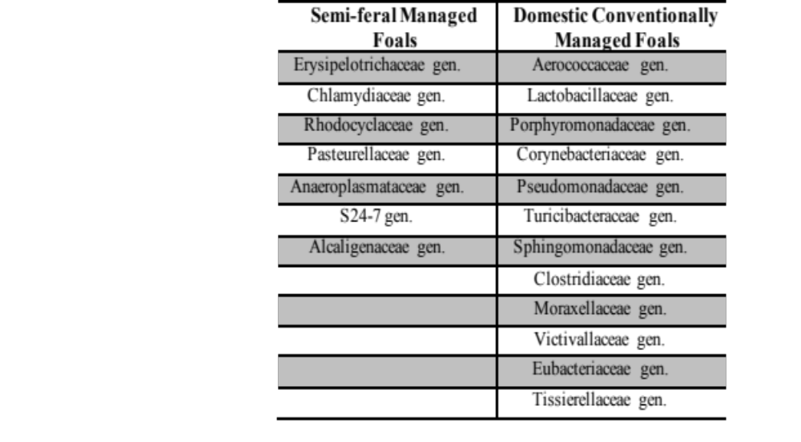
Table 3. Significantly enriched taxa at the family, genus and species level found in SFM foals from ages 1 to 6 weeks (p<0.05, Kruskal-Wallis, LDA score>2.0) compared with all other weeks.
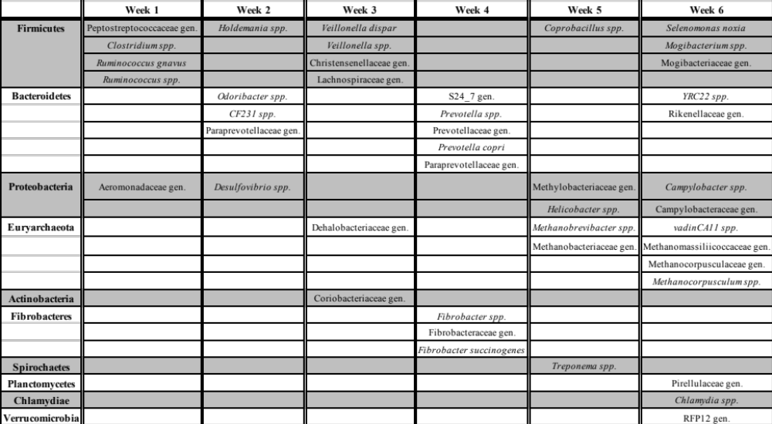

Table 4. Significantly enriched taxa at the family, genus and species level found in DCM foals from ages 1 to 6 weeks (p<0.05, Kruskal-Wallis, LDA score>2.0) compared with all other weeks.
