Persistence of fluoxetine, escitalopram, and sertraline for depression in children and adolescents: a nationwide population-based study in South Korea
Shorten title: Cause-specific discontinuation of SSRIs
Dong Yun Lee, MD¹, SangHun Cha, BS², Rae-Wong Park, MD, PhD ¹, Soo Min Jeon, PharmD, PhD^{3*}

¹Department of Biomedical Informatics, Ajou University School of Medicine, Suwon, South Korea
²Department of Statistics, College of Natural Sciences, Kyungpook National University, Daegu, South Korea
³Jeju Research Institute of Pharmaceutical Science, College of Pharmacy, Jeju National University, Jeju, South Korea

Table S1. ATC codes for medications and ICD-10 codes for psychiatric comorbid disorders ª
ATC codes for medications
Classification | ATC code | Agents in the classification
Antidepressants | N06A | Fluoxetine, Citalopram, Paroxetine, Sertraline, Fluvoxamine, Escitalopram, Venlafaxine, Milnacipran, Duloxetine, Desvenlafaxine, Clomipramine, Amitriptyline, Doxepin, Amoxapine, Moclobemide, Trazodone, Mirtazapine, Bupropion, Tianeptine
Antipsychotics | N05A
Typical antipsychotics |  | Chlorpromazine, Levomepromazine, Perphenazine, Haloperidol, Molindone, Chlorprothixene, Pimozide
Atypical antipsychotics |  | Blonanserin, Ziprasidone, Clozapine, Olanzapine, Quetiapine, Sulpiride, Amisulpride, Risperidone, Zotepine, Aripiprazole, Paliperidone
ATC codes for psychiatric disorders
Psychiatric disorder | ICD-10 code
Schizophrenia | F20-F29
Bipolar disorder | F31
Autism spectrum disorder | F84
Psychosis | F09, F53
Tic disorder | F95
Intellectual disability | F70–F79

Table S2. The list of code for the medications and diagnosis used as covariates
Other mental disorders
Classification |  |  |  | ICD-10 code
Anxiety disorder |  |  |  | F40, F41
ADHD |  |  |  | F90
Somatoform disorder |  |  |  | F45
Reaction to severe stress and adjustment disorder |  |  |  | F43
Other neurotic disorders |  |  |  | F48
Other behavior and emotional disorders with onset generally occurring in childhood and adolescence |  |  |  | F98
Emotional disorders with onset specific to childhood |  |  |  | F93
Nonorganic disorder |  |  |  | F51
Conduct disorder |  |  |  | F91
Substance use disorder |  |  |  | F10-F19
Obsessive-compulsive disorder |  |  |  | F42
Self-harm/suicide attempts |  |  |  | X60-X84, Y87
Prescription of other psychotropic medications
Classification | ATC code |  | Agents in that classification
Anxiolytics | N05B |  | Diazepam, Chlordiazepoxide, Lorazepam, Bromazepam, Clobazam, Alprazolam, Ethyl loflazepate, Etizolam, Clotiazepam, Tofisopam, Hydroxyzine, Buspirione
Methylphenidate | N06B |  | Methylphenidate
Nonstimulants for ADHD | N06B |  | Modafinil, Atomoxetine, Clonidine
Antiepileptic drugs | N03A |  | Phenobarbital, Primidone, Phenytoin, Fosphenytoin, Ethosuximide, Clonazepam, Carbamazepine, Oxcarbazepine, Rufinamide, Valproic acid, Vigabatrin, Lamotrigine, Topiramate, Gabapentin, Levetiracetam, Zonisamide, Pregabalin, Stiripentol, Lacosamide
Lithium | N06A |  | Lithium
Anticholinergic drugs | N04A |  | Trihexyphenidyl, Biperiden, Procyclidine, Benztropine
Comorbidities of general clinical conditions
Classification |  | ICD-10 code
Neurologic and neuromuscular disorders |  | Q00, Q01, Q02, Q03, Q04, Q05, Q06, Q07, G901, E750, E751, E752, E754, G111, G112, G113, G114, G118, G119, G120, G121, G122, G128, G129, G310, G318, ,G328, G938, G939, G94, G911, G319, G253, G951, G958, G909, G851, G80, G371, G372, G378, G81, G82, G83, G931, G935, R402, I63, I635, G71, G72, G10, G20, G210, G211, G218, G230, G231, G232, G238, G240, G248, G253, G254, G255, G258, G259, G803, T850, T851, Z982
Cardiovascular disorders |  | Q20, Q21, Q22, Q23, Q24, Q25, Q26, Q282, Q283, Q289, I340, I348, I360, I368, I370, I378, I42, I43, I515, I44, I45, I47, I48, I490, I491, I492, I493, I494, I495, I498, I499, R001, I270, I271, I272, 278, I279, I509, I517, I518, I631, I632, Z951, T825, T821, T820, T822, T826, T827, Z450, Z950, Z952, Z953, Z958, Z959, T862, Z941
Respiratory disorders |  | Q30, Q31, Q32, Q33, Q34, P280, G473, I278, I43, J841, J961, Z902, E84, J950, J958, Z430, Z930, Z990, Z991, Z942
Renal and urologic diosrders |  | Q60, Q61, Q62, Q63, Q64, N18, Z905, Z906, G834, N312, N319, Z935, Z936, Z992, Z435, Z436, Z466, T861, Z940
Gastrointestinal disorders |  | Q390, Q391, Q392, Q393, Q394, Q41, Q42, Q43, Q44, Q45, K73, K74, K754, K760, K761, K762, K763, K765, K768, K50, K51, I820, K551, K562, K593, Z980, Z903, Z904, Z931, Z932, Z933, Z934, Z431, Z432, Z433, Z434, Z465, T864, Z944
Hematologic or immunologic disorders |  | D55, D56, D57, D58, D60, D61, D71, D80, D81, D82, D83, D84, D85, D86, D87, D88, D89, D720, M303, M359, D66, D682, D694, D70, D761, D762, D763, D86, B20, B21, B22, B23, B24, M300, M310, M311, M313, M314, M316, M321, M339, M340, M341, M349
Metabolic disorders |  | E700, E702, E703, E708, E709, E710, E711, E712, E713, E714, E715, E720, E721, E722, E723, E724, E728, E729, E740, E741, E742, E743, E744, E748, E749, E75, E770, E771, E780, E781, E782, E783, E784, E785, E786, E787, E788, E789, E881, E888, E760, E761, E762, E763, E85, E791, E798, E804, E805, E806, E807, E830, E831, E833, E834, D841, E88, H498, E009, E230, E232, E222, E233, E237, E240, E242, E243, E248, E249, E268, E250, E258, E259, Z4681, Z9641
Other congenital or genetic defects |  | Q90, Q91, Q92, Q93, Q94, Q95, Q96, Q97, Q98, Q99, E343, M410, M412, M4130, M418, M419, M4330, M965, Q722, Q750, Q752, Q759, Q760, Q761, Q762, Q764, Q765, Q766, Q767, Q77, Q78, K449, Q790, Q791, Q792, Q793, Q794, Q795, Q799, Q81, Q871, Q872, Q873, Q874, Q878, Q897, Q899, Q992
Malignancy |  | C00, C01, C02, C03, C04, C05, C06, C07, C08, C09, C10, C11, C12, C13, C14, C15, C16, C17, C18, C19, C20, C21, C22, C23, C24, C25, C26, C27, C28, C29, C30, C31, C32, C33, C34, C35, C36, C37, C38, C39, C40, C41, C42, C43, C44, C45, C46, C47, C48, C49, C50, C51, C52, C53, C54, C55, C56, C57, C58, C59, C60, C61, C62, C63, C64, C65, C66, C67, C68, C69, C70, C71, C72, C73, C74, C75, C76, C77, C78, C79, C80, C81, C82, C83, C84, C85, C86, C87, C88, C89, C90, C91, C92, C93, C94, C95, C96, D00, D01, D02, D03, D04, D05, D06, D07, D08, D09, D37, D38, D39, D40, D41, D42, D43, D44, D45, D46, D47, D48, Q850, T860, Z948
Premature and neonatal disorders |  | P050, P051, P052, P059, P070, P072, P100, P101, P104, P524, P528, P115, P210, P219, P250, P251, P252, P253, P258, P270, P271, P278, P916, P950, p350, P351, P252, P560, P570, P578, P613, P614, P77, P832, P912,
Others |  | T840, T841, T844, T845, T846, T847, T868, T869, T870, T871, T872, Y831, Y833, Z998, T868, T869

Figure S1. Flow chart of study population selection
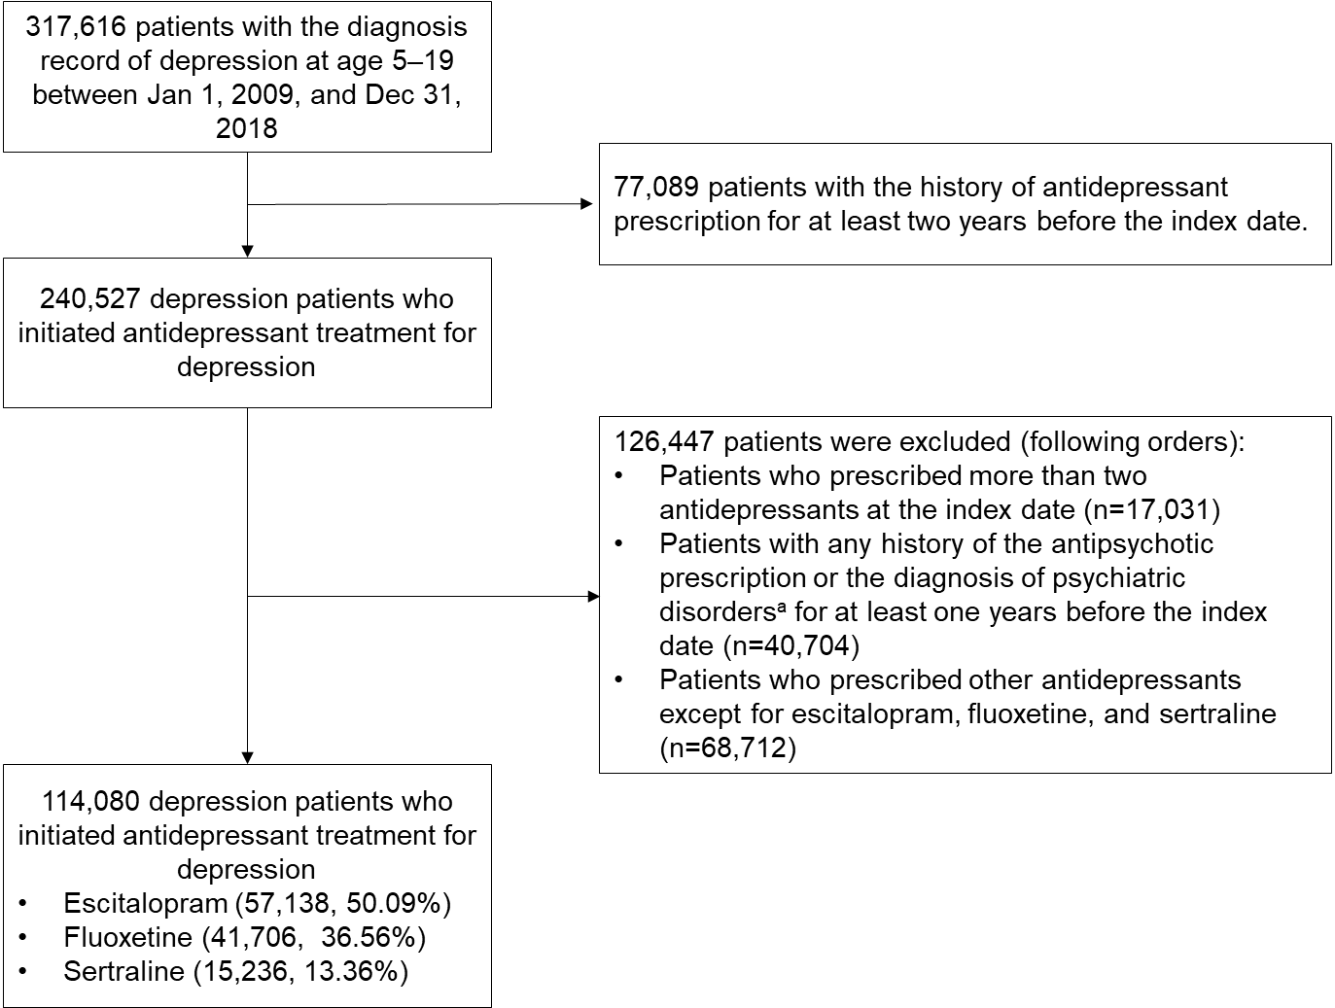
a. Psychiatric disorders included the schizophrenia, bipolar disorder, psychosis, autism spectrum disorder, tic disorders, or intellectual disability.

Table S3. Persistence duration of index antidepressant use for fluoxetine, escitalopram, and sertraline in children and adolescents
 | All patients (n=114,080) | Fluoxetine (n=41,706) | Escitalopram (n=57,138) | Sertraline (n=15,236)
Mean (SD) | 72.94 (96.15) | 74.55 (97.40) | 71.28 (94.79) | 74.73 (97.64)
Median (IQR days) | 29 (10–91) | 30 (10–93) | 28 (10–88) | 31 (11–91)
<30 days | 57249 (50.18) | 20683 (49.59) | 29062 (50.86) | 7504 (49.25)
30~<60 days | 18193 (15.95) | 6577 (15.77) | 9153 (16.02) | 2463 (16.17)
60~<90 days | 9826 (8.61) | 3630 (8.70) | 4824 (8.44) | 1372 (9.00)
90~<120 days | 6269 (5.50) | 2322 (5.57) | 3111 (5.44) | 836 (5.49)
≥120 days | 18383 (19.76) | 8494 (20.37) | 10988 (19.23) | 3061 (20.09)
*Comparison of durations showed significant differences as observed by ANOVA test (p < 0.001)

Figure S2. Distribution of specific causes of treatment changes by the index antidepressant in children and adolescents

Table S4. Adjusted hazard ratios for cause of change in the first-line antidepressant within one year
 | Simple discontinuation | Switching | Augmentation | Initiation of antipsychotics
Index antidepressant
Fluoxetine | ref | ref | ref | ref
Escitalopram | 1.00 (0.98–1.02) | 0.88 (0.86–0.91) | 1.08 (1.02–1.15) | 1.23 (1.18–1.28)
Sertraline | 0.93 (0.91–0.96) | 1.08 (1.03–1.12) | 0.90 (0.82–0.99) | 1.24 (1.17–1.31)
Sex
Male | ref | ref | ref | ref
Female | 1.09 (1.08–1.11) | 1.31 (1.27–1.34) | 1.18 (1.12–1.25) | 0.99 (0.96–1.03)
Age (years)
5–9 | ref | ref | ref | ref
10–14 | 1.08 (1.05–1.12) | 1.60 (1.49–1.72) | 1.79 (1.48–2.15) | 0.94 (0.87–1.01)
15–19 | 1.14 (1.11–1.18) | 1.92 (1.79–2.07) | 2.73 (2.28–3.28) | 0.82 (0.76–0.89)
Insurance type
Health insurance | ref | ref | ref | ref
Medicaid | 0.96 (0.93–0.99) | 0.98 (0.93–1.02) | 0.88 (0.80–0.98) | 0.95 (0.89–1.02)
Psychiatric inpatients (ref=none) | 0.68 (0.55–0.84) | 0.75 (0.54–1.05) | 1.12 (0.62–2.04) | 1.14 (0.77–1.69)
Psychiatric comorbid disorder (ref=none)
Anxiety disorder | 0.87 (0.85–0.88) | 0.94 (0.91–0.97) | 1.01 (0.95–1.07) | 0.99 (0.94–1.03)
ADHD | 0.77 (0.74–0.79) | 0.78 (0.73–0.83) | 0.79 (0.69–0.91) | 0.94 (0.86–1.01)
SSD | 0.94 (0.90–0.99) | 1.02 (0.95–1.10) | 0.87 (0.75–1.02) | 0.73 (0.64–0.83)
RSSAD | 1.05 (1.02–1.07) | 0.89 (0.86–0.93) | 0.89 (0.82–0.96) | 0.95 (0.90–1.00)
Other neurotic disorders | 1.00 (0.94–1.07) | 1.07 (0.97–1.18) | 1.11 (0.91–1.34) | 0.94 (0.80–1.11)
OBED-C&A | 0.83 (0.78–0.89) | 0.75 (0.67–0.85) | 0.86 (0.67–1.12) | 1.09 (0.95–1.26)
EOSD | 0.87 (0.84–0.91) | 0.84 (0.77–0.91) | 1.21 (1.03–1.42) | 0.88 (0.79–0.97)
NOSD | 1.11 (1.07–1.15) | 1.36 (1.29–1.44) | 1.69 (1.53–1.86) | 1.19 (1.10–1.30)
CD | 1.06 (1.01–1.12) | 1.00 (0.90–1.10) | 1.08 (0.87–1.32) | 1.45 (1.30–1.62)
SUD | 1.26 (1.14–1.39) | 1.09 (0.90–1.31) | 1.44 (1.07–1.95) | 1.24 (0.97–1.58)
OCD | 0.74 (0.71–0.78) | 0.85 (0.79–0.92) | 1.13 (0.98–1.30) | 1.30 (1.18–1.42)
Self-harm/suicide attempts | 0.98 (0.61–1.58) | 1.08 (0.48–2.39) | 1.75 (0.56–5.44) | 2.26 (1.08–4.75)
Use of other psychotropic medications (ref=none)
Anticholinergics | 0.74 (0.56–0.98) | 1.02 (0.68–1.54) | 1.09 (0.49–2.43) | 0.93 (0.51–1.68)
Anxiolytics | 1.13 (1.11–1.15) | 1.32 (1.28–1.35) | 1.43 (1.35–1.51) | 1.17 (1.13–1.22)
Methylphenidate | 0.91 (0.88–0.94) | 0.81 (0.75–0.86) | 0.60 (0.52–0.70) | 0.77 (0.71–0.84)
Non stimulants for ADHD | 0.87 (0.82–0.93) | 0.94 (0.83–1.06) | 0.81 (0.60–1.08) | 1.12 (0.98–1.28)
Antiepileptics | 0.91 (0.88–0.94) | 0.97 (0.92–1.02) | 1.18 (1.08–1.30) | 1.42 (1.33–1.52)
Lithium | 1.21 (1.09–1.34) | 1.20 (0.99–1.44) | 1.06 (0.71–1.59) | 1.17 (0.89–1.54)
Physical comorbid disorders (ref=none)
Neuromuscular disorders | 0.85 (0.75–0.95) | 0.90 (0.75–1.09) | 1.15 (0.83–1.59) | 0.70 (0.52–0.95)
Cardiovascular disorder | 0.91 (0.84–0.99) | 0.95 (0.83–1.09) | 1.07 (0.83–1.36) | 0.79 (0.64–0.98)
Respiratory disorder | 0.72 (0.56–0.93) | 0.88 (0.59–1.30) | 0.39 (0.13–1.23) | 0.99 (0.61–1.62)
Renal disorder | 0.88 (0.79–0.98) | 1.09 (0.92–1.28) | 1.14 (0.83–1.57) | 1.23 (0.99–1.54)
Gastric intestinal disorder | 0.97 (0.90–1.04) | 0.98 (0.86–1.10) | 1.01 (0.80–1.28) | 1.11 (0.94–1.32)
Haemato-immunology | 0.95 (0.70–1.29) | 1.33 (0.84–2.12) | 1.66 (0.74–3.69) | 0.91 (0.43–1.90)
Metabolic disorder | 0.89 (0.85–0.92) | 1.00 (0.94–1.07) | 1.21 (1.07–1.36) | 1.02 (0.93–1.12)
Congenital and genetic disorder | 0.89 (0.84–0.94) | 0.99 (0.91–1.09) | 1.04 (0.86–1.26) | 0.98 (0.85–1.12)
Malignancy | 0.97 (0.74–1.27) | 0.51 (0.28–0.96) | 1.15 (0.51–2.57) | 0.48 (0.20–1.14)
Neonatal disorders | 0.81 (0.39–1.70) | 0.60 (0.15–2.42) | 1.65 (0.23–11.76) | 3.88 (1.74–8.65)
Other | 1.35 (0.73–2.52) | 0.49 (0.07–3.45) | 1.45 (0.20–10.36) | 0.65 (0.09–4.62)
ADHD, attention deficit hyperactivity disorder; CD, conduct disorder; EOSD, emotional disorders with onset specific to childhood; NOSD, nonorganic sleep disorder; OCD, obsessive-compulsive disorder; RSSAD, reaction to severe stress and disorder; SSD, somatic symptom disorder; SUD, substance use disorder;

Table S5. Association between specific causes of treatment discontinuation and index antidepressants, stratified by sex
 | Simple discontinuation |  | Switching |  | Augmentation |  | Initiation of antipsychotics
 | aHR (95% CI)ª | p-value | aHR (95% CI)ª | p-value | aHR (95% CI)ª | p-value | aHR (95% CI)ª | p-value
Male
Fluoxetine | ref (1.00) |  | ref (1.00) |  | ref (1.00) |  | ref (1.00)
Escitalopram | 0.99 (0.97-1.02) | 0.4868 | 0.86 (0.82-0.90) | <.0001 | 1.16 (1.05-1.27) | 0.0032 | 1.26 (1.18-1.34) | <.0001
Sertraline | 0.94 (0.91-0.98) | 0.0008 | 1.05 (0.99-1.12) | 0.1262 | 0.94 (0.81-1.09) | 0.3973 | 1.33 (1.22-1.44) | <.0001
Female
Fluoxetine | ref (1.00) |  | ref (1.00) |  | ref (1.00) |  | ref (1.00)
Escitalopram | 1.01 (0.99-1.03) | 0.4199 | 0.90 (0.87-0.93) | <.0001 | 1.03 (0.96-1.11) | 0.3984 | 1.21 (1.14-1.28) | <.0001
Sertraline | 0.93 (0.90-0.96) | <.0001 | 1.09 (1.04-1.15) | 0.0009 | 0.88 (0.78-0.99) | 0.0302 | 1.16 (1.07-1.26) | 0.0004
Adjusted hazard ratios, aHR; confidence intervals, CI
a. In this analysis, we adjusted sex, age group, health insurance type, psychiatric and physical comorbidity, and the concomitant use of psychotropic medications.

Table S6. Association between specific causes of treatment discontinuation and index antidepressants, stratified by age group
 | Simple discontinuation |  | Switching |  | Augmentation |  | Initiation of antipsychotics
 | aHR (95% CI)ª | p-value | aHR (95% CI)ª | p-value | aHR (95% CI)ª | p-value | aHR (95% CI)ª | p-value
Age group of 5 to 9
Fluoxetine | ref (1.00) |  | ref (1.00) |  | ref (1.00) |  | ref (1.00)
Escitalopram | 1.05 (0.98-1.12) | 0.1479 | 0.84 (0.72-0.98) | 0.0027 | 0.96 (0.65-1.40) | 0.8141 | 1.30 (1.11-1.51) | 0.001
Sertraline | 1.05 (0.96-1.14) | 0.3148 | 1.25 (1.05-1.49) | 0.9577 | 0.85 (0.51-1.41) | 0.5189 | 1.73 (1.45-2.07) | <.0001
Age group of 10 to 14
Fluoxetine | ref (1.00) |  | ref (1.00) |  | ref (1.00) |  | ref (1.00)
Escitalopram | 1.05 (1.02-1.08) | 0.0027 | 0.88 (0.83-0.93) | <.0001 | 1.08 (0.95-1.23) | 0.2474 | 1.27 (1.18-1.37) | <.0001
Sertraline | 1.00 (0.96-1.04) | 0.9577 | 1.09 (1.01-1.17) | 0.0265 | 0.93 (0.77-1.12) | 0.4255 | 1.16 (1.05-1.29) | 0.0047
Age group of 15 to 19
Fluoxetine | ref (1.00) |  | ref (1.00) |  | ref (1.00) |  | ref (1.00)
Escitalopram | 0.98 (0.96-1.30) | 0.0732 | 0.88 (0.85-4.91) | <.0001 | 1.08 (1.01-1.15) | 0.0293 | 1.18 (1.12-1.25) | <.0001
Sertraline | 0.89 (0.86-7.92) | <.0001 | 1.05 (0.99-1.19) | 0.0531 | 0.89 (0.80-1.99) | 0.0286 | 1.20 (1.11-1.29) | <.0001
Adjusted hazard ratios, aHR; confidence intervals, CI
a. In this analysis, we adjusted sex, age group, health insurance type, psychiatric and physical comorbidity, and the concomitant use of psychotropic medications.

