Supporting Materials
Table. S1. Correlation coefficients between environmental factors and fungi alpha diversity indices.
 | Moisture content |  | NH₄⁺-N | NO₃⁻-N | DOC | DON | TP | STN | SOC | pH
JT
Number of Unigenes |  | 0.21 | 0.43* | 0.32 | 0.08 | 0.16 | 0.18 | 0.40* | 0.38 | -0.14
Shannon |  | -0.15 | 0.64** | -0.14 | -0.11 | 0.29 | -0.15 | 0.41* | 0.47* | 0.05
Simpson |  | -0.31 | 0.56** | -0.29 | -0.22 | 0.26 | -0.28 | 0.34 | 0.43* | 0.17
Chao1 |  | -0.13 | 0.27 | 0.31 | -0.10 | -0.15 | -0.26 | 0.24 | 0.26 | -0.23
Richness |  | 0.02 | 0.29 | 0.39* | 0.03 | -0.08 | -0.13 | 0.27 | 0.25 | -0.28
QM
Number of Unigenes |  | 0.25 | -0.159 | 0.25 | 0.052 | 0.145 | 0.062 | 0.13 | 0.103 | -0.258
Shannon |  | -0.16 | -0.02 | -0.04 | -0.05 | 0.21 | -0.43* | 0.20 | 0.05 | 0.59**
Simpson |  | -0.17 | 0.02 | -0.07 | -0.01 | 0.22 | -0.43* | 0.21 | 0.06 | 0.58**
Chao1 |  | -0.11 | 0.30 | -0.32 | 0.34 | 0.06 | 0.30 | -0.01 | -0.09 | -0.05
Richness |  | 0.19 | 0.16 | -0.06 | 0.44* | 0.15 | 0.17 | 0.01 | -0.05 | -0.29
DS
Number of Unigenes |  | 0.07 | -0.01 | -0.27 | 0.17 | 0.18 | 0.27 | 0.11 | 0.22 | -0.30
Shannon |  | -0.08 | 0.30 | -0.42* | -0.34 | -0.25 | -0.10 | -0.30 | -0.24 | 0.10
Simpson |  | -0.14 | 0.42* | -0.44* | -0.50** | -0.33 | -0.16 | -0.30 | -0.28 | 0.18
Chao1 |  | -0.21 | -0.49* | -0.04 | 0.33 | -0.02 | 0.34 | 0.05 | 0.13 | -0.42*
Richness |  | 0.15 | -0.15 | -0.10 | 0.28 | 0.29 | 0.25 | 0.21 | 0.38 | -0.45*
*indicates significant difference at P=0.05. **indicates significant difference at P=0.01.

Table. S2. Correlation coefficients between edaphic properties, and fungi groups (phylum).

Phylum(a) | Moisture content |  | NH₄⁺-N | NO₃⁻-N | DOC | DON | TP | SON | STC | pH
JT
Ascomycota |  | 0.63** | -0.15 | 0.65** | 0.52** | 0.02 | 0.49** | 0.05 | -0.03 | -0.66**
Basidiomycota |  | 0.34 | -0.26 | 0.54** | 0.42* | -0.05 | 0.09 | 0.01 | -0.05 | -0.65**
Glomeromycota |  | 0.52** | 0.07 | 0.47* | 0.56** | 0.25 | 0.34 | 0.18 | 0.15 | -0.76**
Microsporidia |  | 0.60** | -0.10 | 0.51** | 0.54** | 0.12 | 0.48* | -0.02 | -0.12 | -0.51**
QM
Ascomycota |  | -0.16 | -0.40* | -0.09 | -0.19 | -0.19 | 0.55** | -0.28 | -0.26 | -0.19
Basidiomycota |  | -0.41* | -0.26 | -0.13 | -0.57** | -0.36 | 0.40* | -0.29 | -0.30 | 0.38*
Glomeromycota |  | 0.32 | 0.07 | 0.13 | 0.10 | -0.06 | 0.24 | -0.12 | -0.04 | -0.64**
Microsporidia |  | -0.27 | -0.18 | -0.28 | -0.05 | 0.02 | -0.13 | -0.23 | -0.35 | 0.43*
DS
Ascomycota |  | 0.43** | 0.12 | 0.41** | 0.29** | 0.30** | 0.42** | 0.36** | 0.26* | -0.55**
Basidiomycota |  | 0.09 | 0.06 | 0.46** | 0.01 | -0.04 | 0.26* | 0.35** | 0.31** | -0.37**
Glomeromycota |  | 0.12 | 0.35** | 0.30** | -0.06 | 0.03 | 0.41** | 0.39** | 0.37** | -0.44**
Microsporidia |  | 0.13 | 0.06 | 0.11 | -0.06 | 0.29 | -0.04 | 0.17 | 0.12 | 0.29
*indicates significant difference at P=0.05. **indicates significant difference at P=0.01.

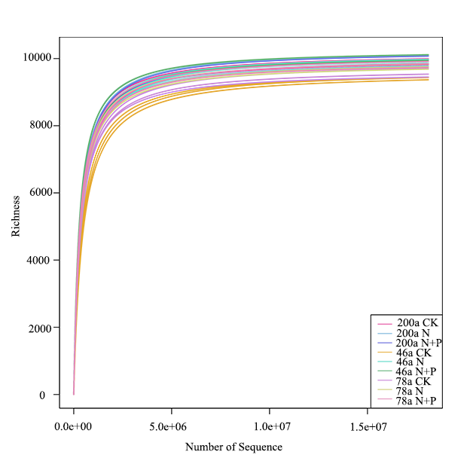

Fig. S1 Rarefaction curves of fungal communities.

Fig. S2 Interactive effects of treatment and stand age on the unigene abundance of soil fungal dominate phylum. Treatments are control (CK), nitrogen addition (N), and N and phosphorus addition (N+P). Values are bootstrapped means ± 95% confidence intervals (CIs) for individual samples and their sum. Difference between time since closure classes or soil layers is significant at P = 0.05 if their CIs do not overlap the other’s mean.
Fig. S3 Interactive effects of treatment and stand age on the unigene abundance of dominant soil fungal class. Treatments are control (CK), nitrogen addition (N), and N and phosphorus addition (N+P). Values are bootstrapped means ± 95% confidence intervals (CIs) for individual samples and their sum. Difference between time since closure classes or soil layers is significant at P =0.05 if their CIs do not overlap the other’s mean.

Fig. S4 Interactive effects of treatment and stand age on the unigene abundance of dominant soil fungal genus. Treatments are control (CK), nitrogen addition (N), and N and phosphorus addition (N+P). Values are bootstrapped means ± 95% confidence intervals (CIs) for individual samples and their sum. Difference between time since closure classes or soil layers is significant at P =0.05 if their CIs do not overlap the other’s mean.
Fig. S5 Interactive effects of treatment and stand age on the unigene abundance of dominant soil fungal species. Treatments are control (CK), nitrogen addition (N), and N and phosphorus addition (N+P). Values are bootstrapped means ± 95% confidence intervals (CIs) for individual samples and their sum. Difference between time since closure classes or soil layers is significant at P =0.05 if their CIs do not overlap the other’s mean.

Fig. S6 Interactive effects of treatment and stand age on soil factors. Treatments are control (CK), nitrogen addition (N), and N and phosphorus addition (N+P). Values are bootstrapped means ± 95% confidence intervals (CIs) for individual sample layers and their sum. Difference between time since closure classes, or soil layers is significant at α =0.05 if their CIs do not overlap the other’s mean.

Fig. S7 Interactive effects of treatment and stand age on the unigene abundance ratio of Ascomycota and Basidiomycota. Treatments are control (CK), nitrogen addition (N), and N and phosphorus addition (N+P). Values are bootstrapped means ± 95% confidence intervals (CIs) for individual sample layers and their sum. Difference between time since closure classes or soil layers is significant at α =0.05 if their CIs do not overlap the other’s mean.

