- List of finite elements program specimens
Specimen | Reinforcement | Shape
B1 | Primary reinforcements 8 bar Ø 20 mm  stirrups Ø 12 mm @ 100 mm C/C | 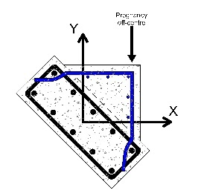
B2 | Primary reinforcements 8 bar Ø 16 mm  stirrups Ø 12 mm @ 200 mm C/C
B3 | Primary reinforcements 8 bar Ø 12 mm  stirrups Ø 12 mm @ 300 mm C/C
B4 – N | Primary reinforcements 8 bar Ø 20 mm  stirrups Ø 12 mm @ 100 mm C/C
B4 | Primary reinforcements 8 bar Ø 20 mm  stirrups Ø 12 mm @ 100 mm C/C | 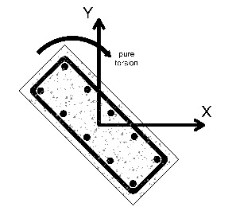
B5 | Primary reinforcements 8 bar Ø 16 mm  stirrups Ø 12 mm @ 200 mm C/C
B6 | Primary reinforcements 8 bar Ø 12 mm  stirrups Ø 12 mm @ 300 mm C/C
B7 | Primary reinforcements 8 bar Ø 20 mm  stirrups Ø 12 mm @ 100 mm C/C | 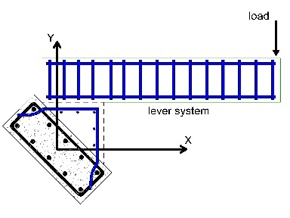
B8 | Primary reinforcements 8 bar Ø 16 mm  stirrups Ø 12 mm @ 200 mm C/C
B9 | Primary reinforcements 8 bar Ø 12 mm  stirrups Ø 12 mm @ 300 mm C/C
B.R.L  - Beam reference lever | Primary reinforcements 8 bar Ø 20 mm  stirrups Ø 12 mm @ 100 mm C/C  no tilt angle  same lever arm  same boundary conditions | 