Supporting Information

Schiff base functionalized 1,2,4-Triazole and Pyrene derivatives for selective and sensitive detection of Cu²⁺ in the mixed organic- aqueous media
Nam Gyu Choi¹, Balasaheb D. Vanjare¹, Prasad G. Mahajan², Rajendran Nagarajan¹,
Hyang Im Ryoo¹, Ki Hwan Lee¹*
¹Department of Chemistry, Kongju National University, Gongju, Chungnam 32588, Republic of Korea
²Vidya Pratishthan's Arts, Science & Commerce College, Vidyanagari, Baramati, Maharshtra, India. 413133
E-mail: khlee@kongju.ac.kr

Fig. S1: IR spectrum of Probe TP

Fig. S2: ¹H NMR spectrum of Probe TP
Fig. S3: ¹³C NMR spectrum of Probe TP

Fig. S4: LCMS spectrum of Probe TP

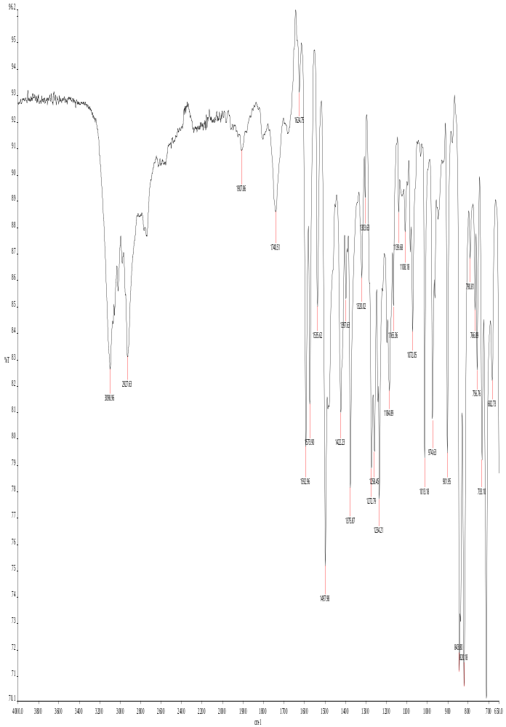Fig. S1
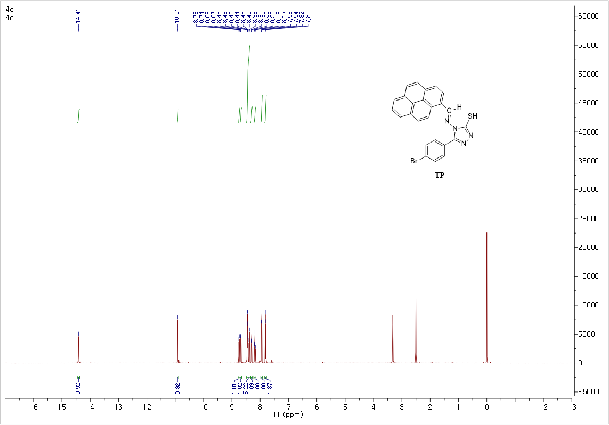
Fig. S2

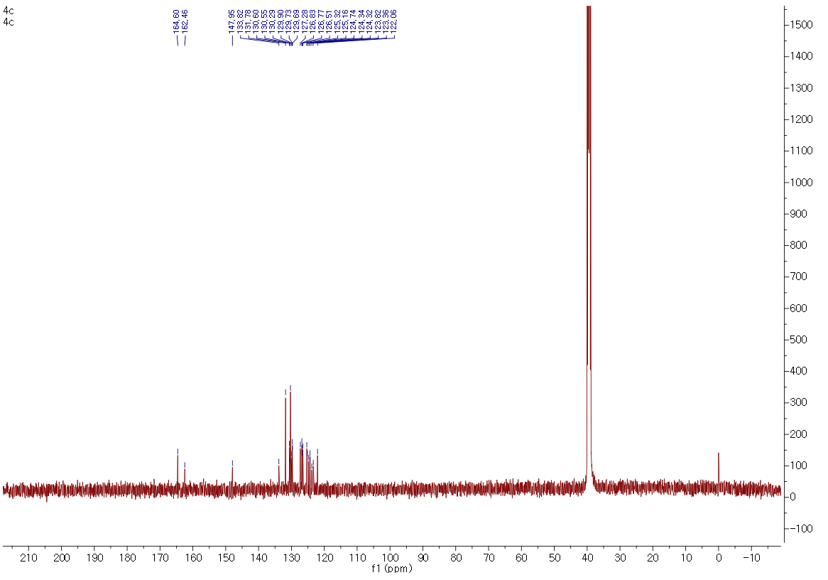

Fig. S3

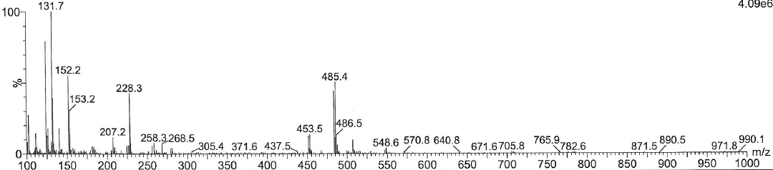

Fig. S4

