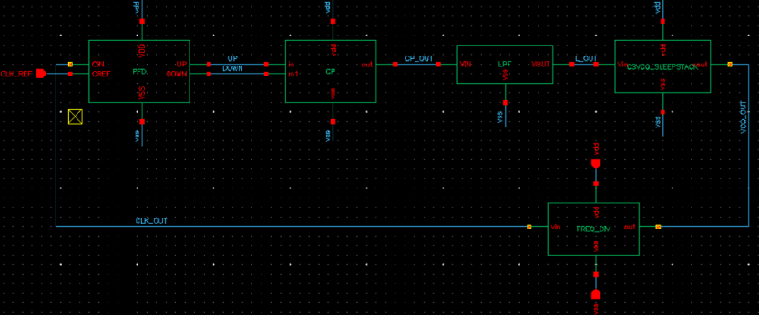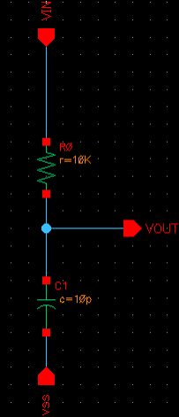
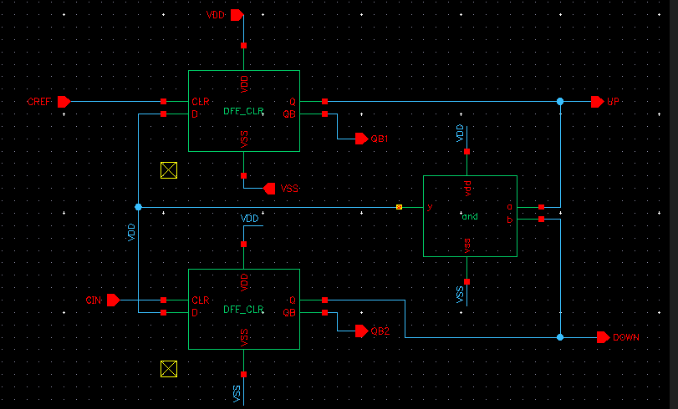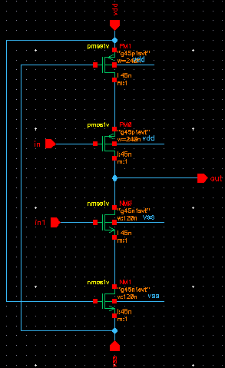

Figure 1: PLL Internal blocks PFD, LPF, CP & FD with current starved VCO
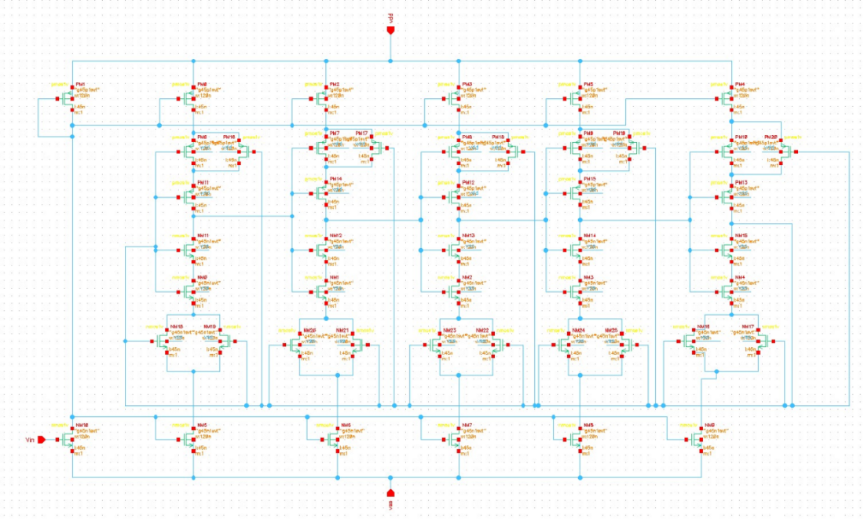
Figure 2. CSVCO using Sleepy Stack Technique with 45NM Technology
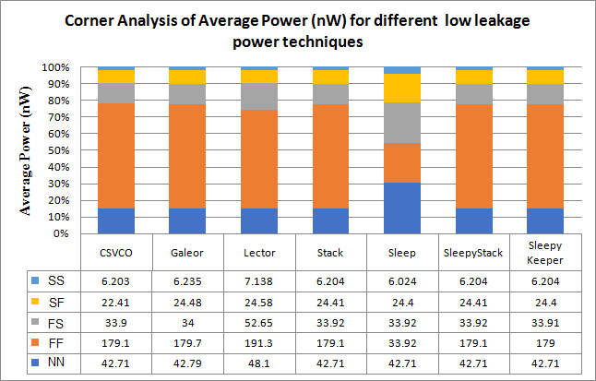

Figure 3. Corner Analysis of P avg for CSVCO applied with different low leakage techniques.

