SUPPLEMENTARY MATERIALS

Mutational landscapes of brain metastases across various histological subtypes of lung cancer

Marcin Nicoś, Tomasz Stokowy, Katarzyna Reszka, Anna Kowalczyk, Natalia Galant, Rafał Pęksa, Bożena Jarosz, Renata Duchnowska, Janusz Milanowski, Paweł Krawczyk, Jacek Jassem & Nicola Crosetto

1. Supplementary Figures pg. 2
2. Supplementary Tables pg. 6

1. Supplementary Figures

Supplementary Figure 1

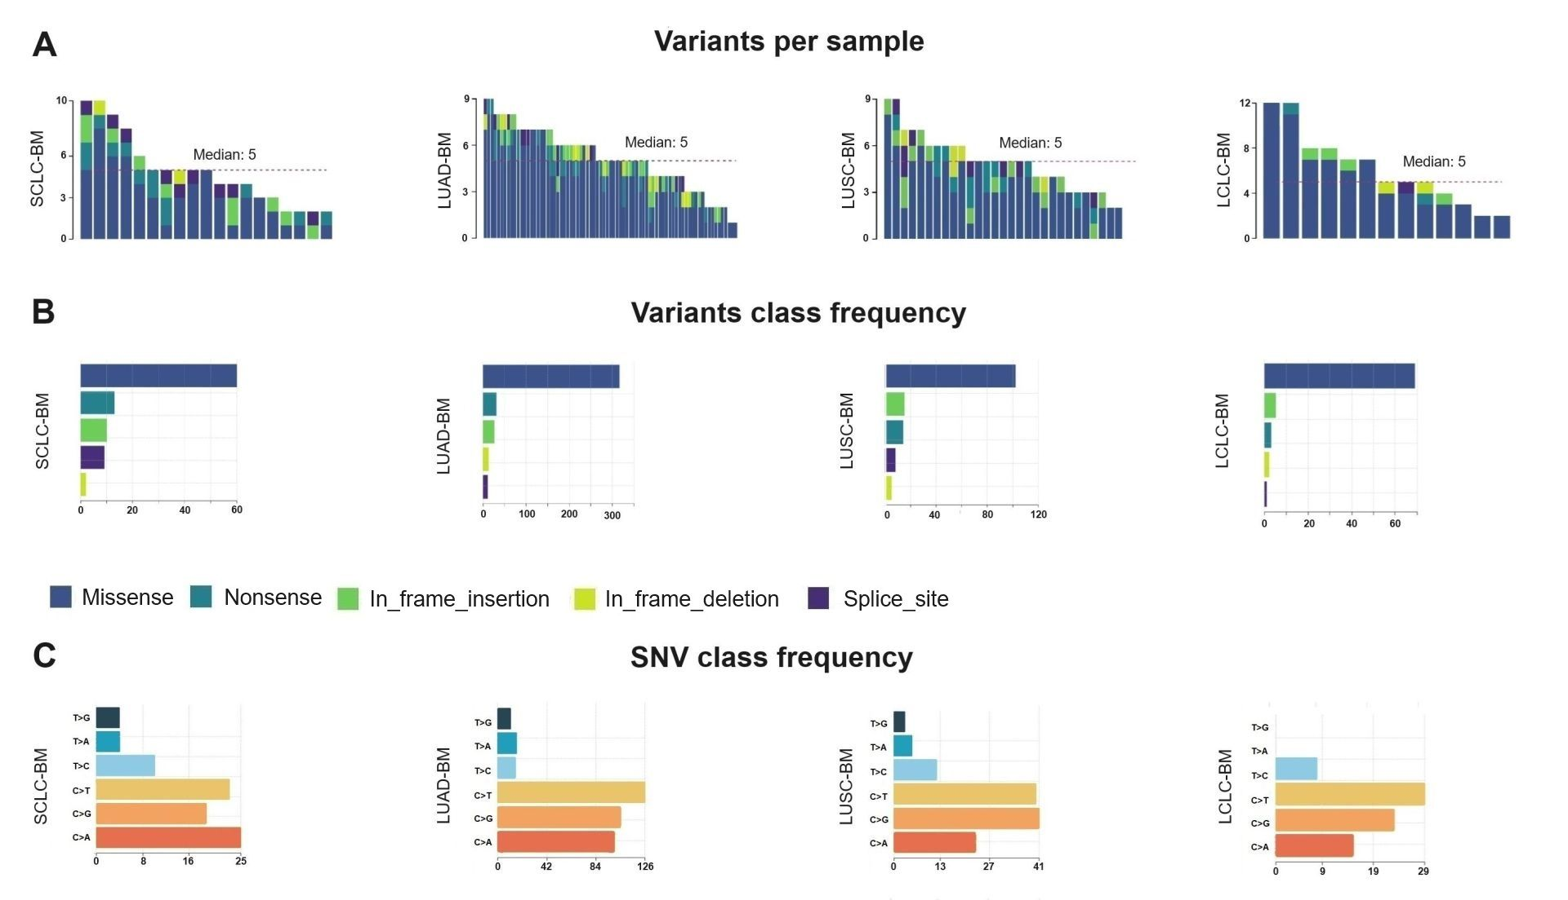

Supplementary Figure 1: The overview indicates that the median number of variants per sample was equal regardless of the studied cohort (A). Further, in each studied BM, the missense and nonsense variants were the most common following in-frame insertion or deletion (B). According to a class of single nucleotide variations (SNVs), we observed that C>T, C>G, and C>A changes were the most common within the studied cohorts, while LCLC-BM did not harbour T>G classes (C)

Supplementary Figure 2

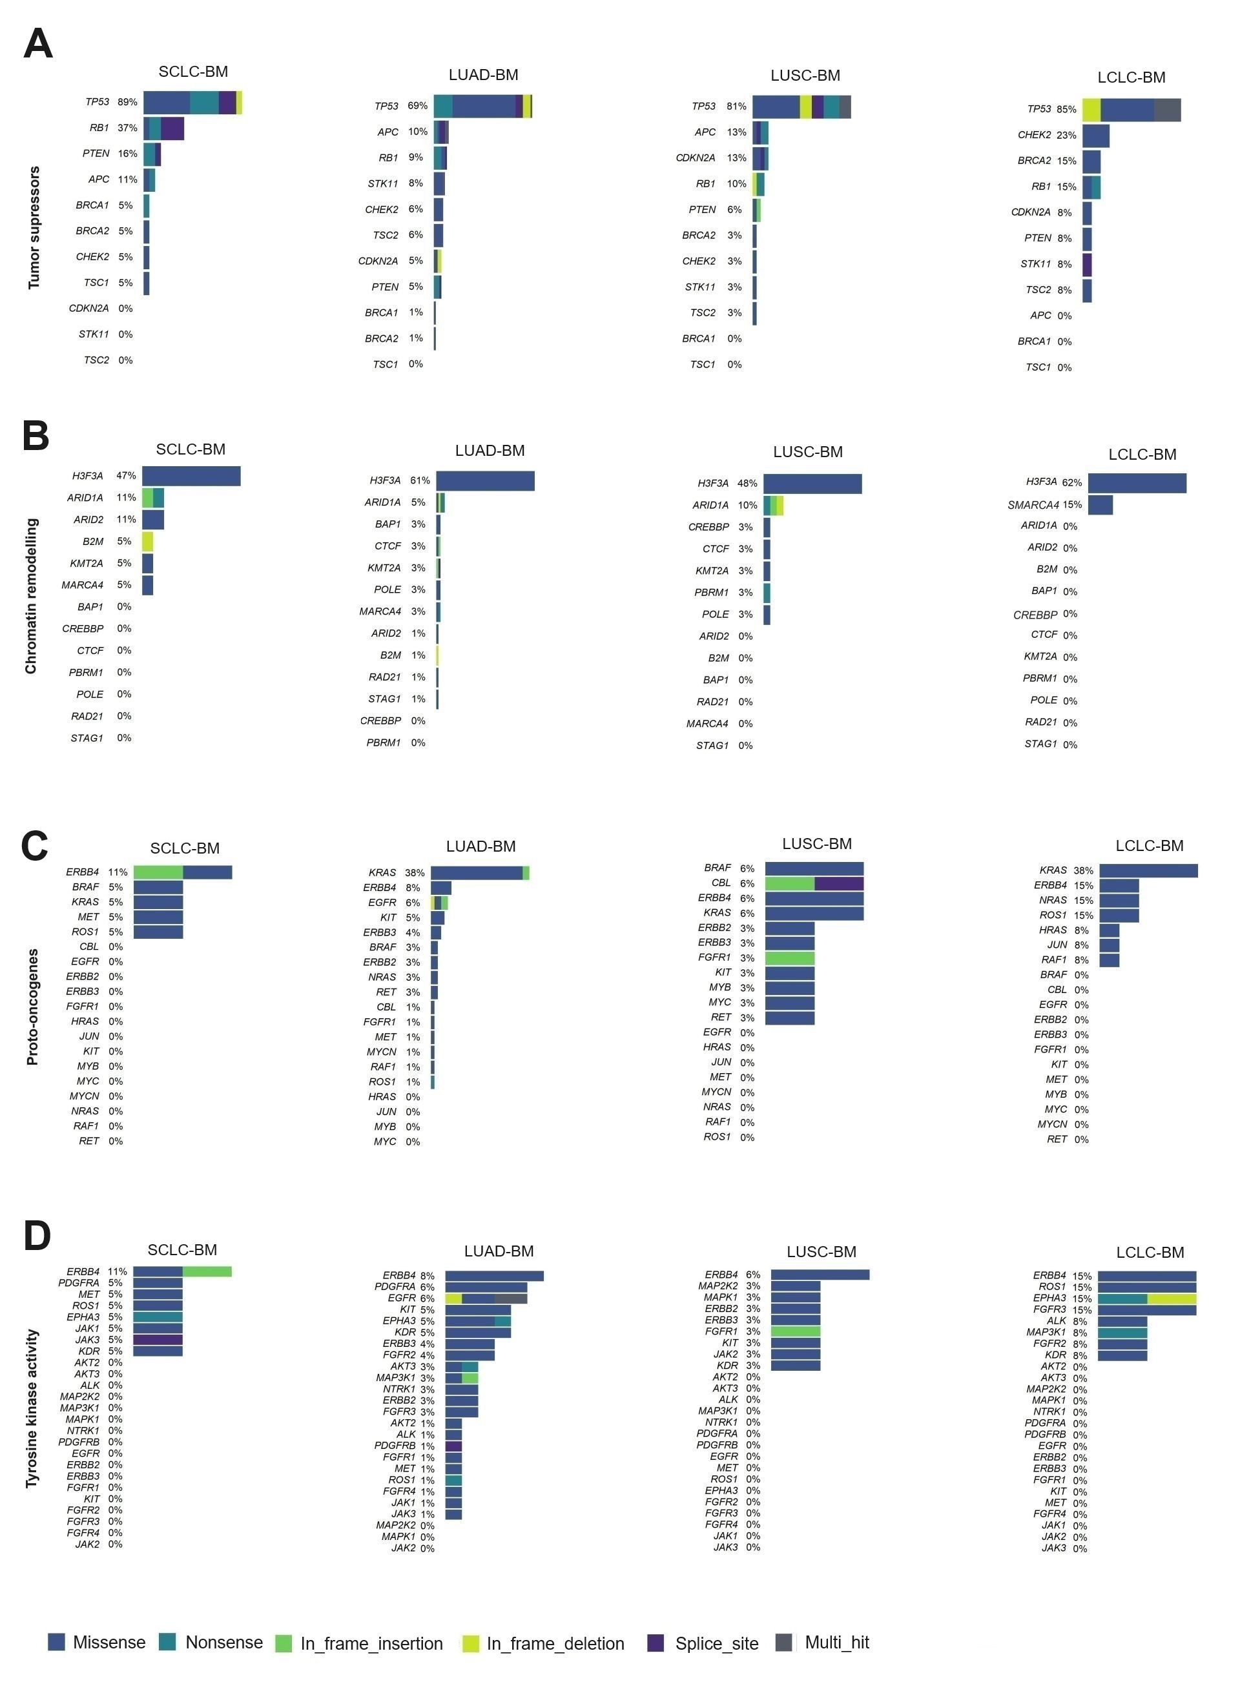
Supplementary Figure 2: The overview of mutation frequency within tumor suppressors (A), chromatin remodelling genes (B), proto-oncogenes (C) and genes with tyrosine kinase activity across BM developed from SCLC, LUAD, LUSC and LCLC.

Supplementary Figure 3

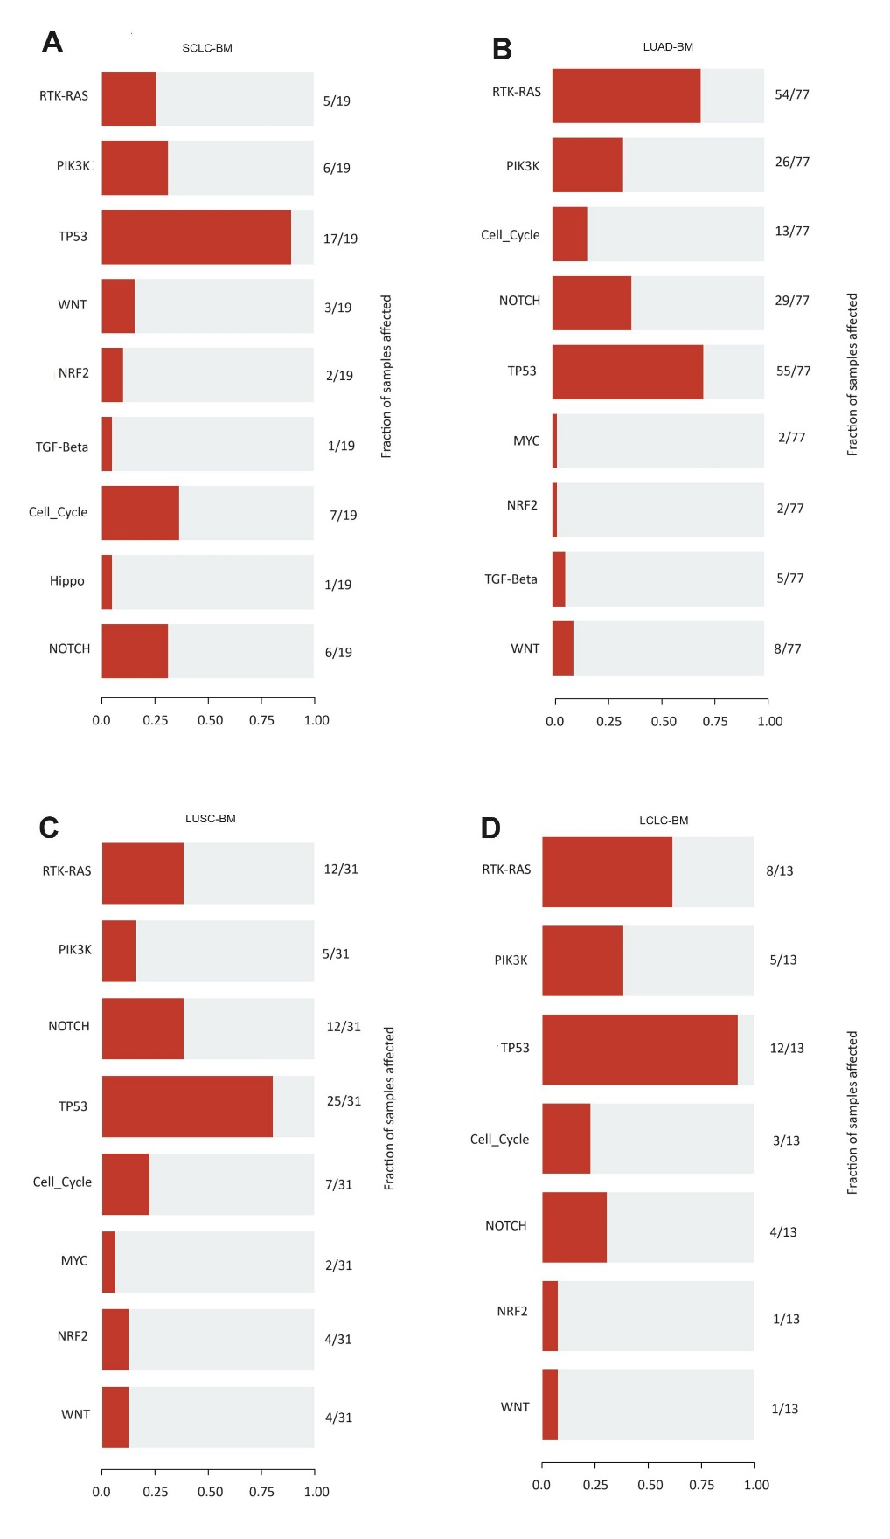

Supplementary Figure 3: The overview of oncogenic pathways altered within SCLC-BM (A), LUAD-BM (B), LUSC-BM (C) and LCLC-BM (D)

2. Supplementary Tables

Because of their size, all tables are provided as separate Excel files.

Supplementary Table 1. The detailed clinical and demographic data summary of the studied group.

Supplementary Table 2. The list of genes covered by SureSelect CD Glasgow Cancer Core Panel.

Supplementary Table 3. The list of filtered variants in studied types and subtypes of lung cancer.

Supplementary Table 4. The final list of selected variants for further analysis, in the mutation annotated format (MAF).

Supplementary Table 5. The summary of variants classification, variant types, and SNP class across all subtypes of lung cancer BMs.

Supplementary Table 6. The abbreviations od cancer cohorts according to TCGA Study Abbreviations.

Supplementary Table 7. The APOBEC enrichement related to genes in LUAD-BM.

Supplementary Table 8. The incidence of genes detected in our cohorts and their frequency reported in the TCGA database in primary lung cancer lesions.

Supplementary Table 9. Division of genes depending on their function.

Supplementary Table 10. The overview of NGS based studies on lung cancer brain metastases.

