Supplementary information

Bias-Switchable Photomultiplication and Photovoltaic Dual-Mode Flexible Near-Infrared Organic Photodetector
Yijun Huang^{†1}, Lin Shao^{†1}, Yazhong Wang†*^{1,2}, Lu Hao¹, Xi Luo¹, Jie Zheng¹, Yunhao Cao¹, Shuaiqi Li¹, Zhaohong Tan¹, Shuai Li¹, Wenkai Zhong¹, Sheng Dong², Xiye Yang², Johannes Benduhn³, Chunchen Liu*¹, Karl Leo³, Fei Huang*¹

¹State Key Laboratory of Luminescent Materials and Devices, Guangdong Basic Research Center of Excellence for Energy & Information Polymer Materials, Institute of Polymer Optoelectronic Materials and Devices, School of Materials Science and Engineering, South China University of Technology, Guangzhou 510640, P.R. China
²Lumidar Technology Co., Ltd., Guangzhou, 510530, P. R. China.
³Dresden Integrated Center for Applied Physics and Photonic Materials (IAPP) and Institute of Applied Physics, Technische Universität Dresden, Nöthnitzer Str. 61, 01187 Dresden, Germany
*Email: yazhong.wang@lumidartech.com, mscliu@scut.edu.cn, msfhuang@scut.edu.cn

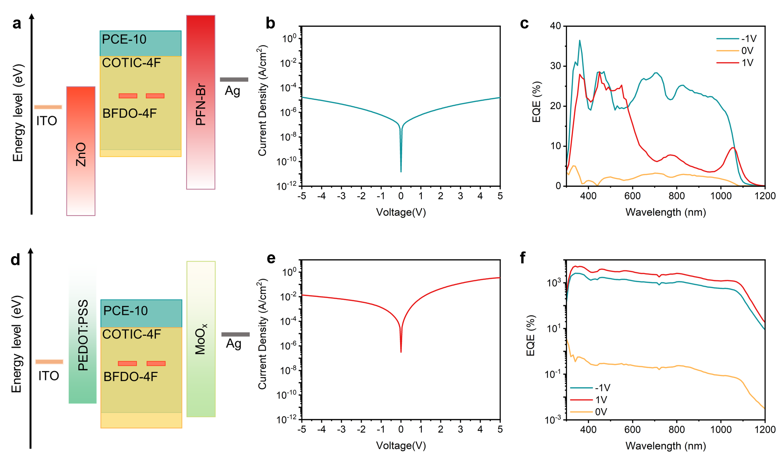
Supplementary Fig. 1 a Device architecture, b dark J-V curve, and c EQE spectra of electron-only device. d Device architecture, e dark J-V curve, and f EQE spectra of hole-only device.

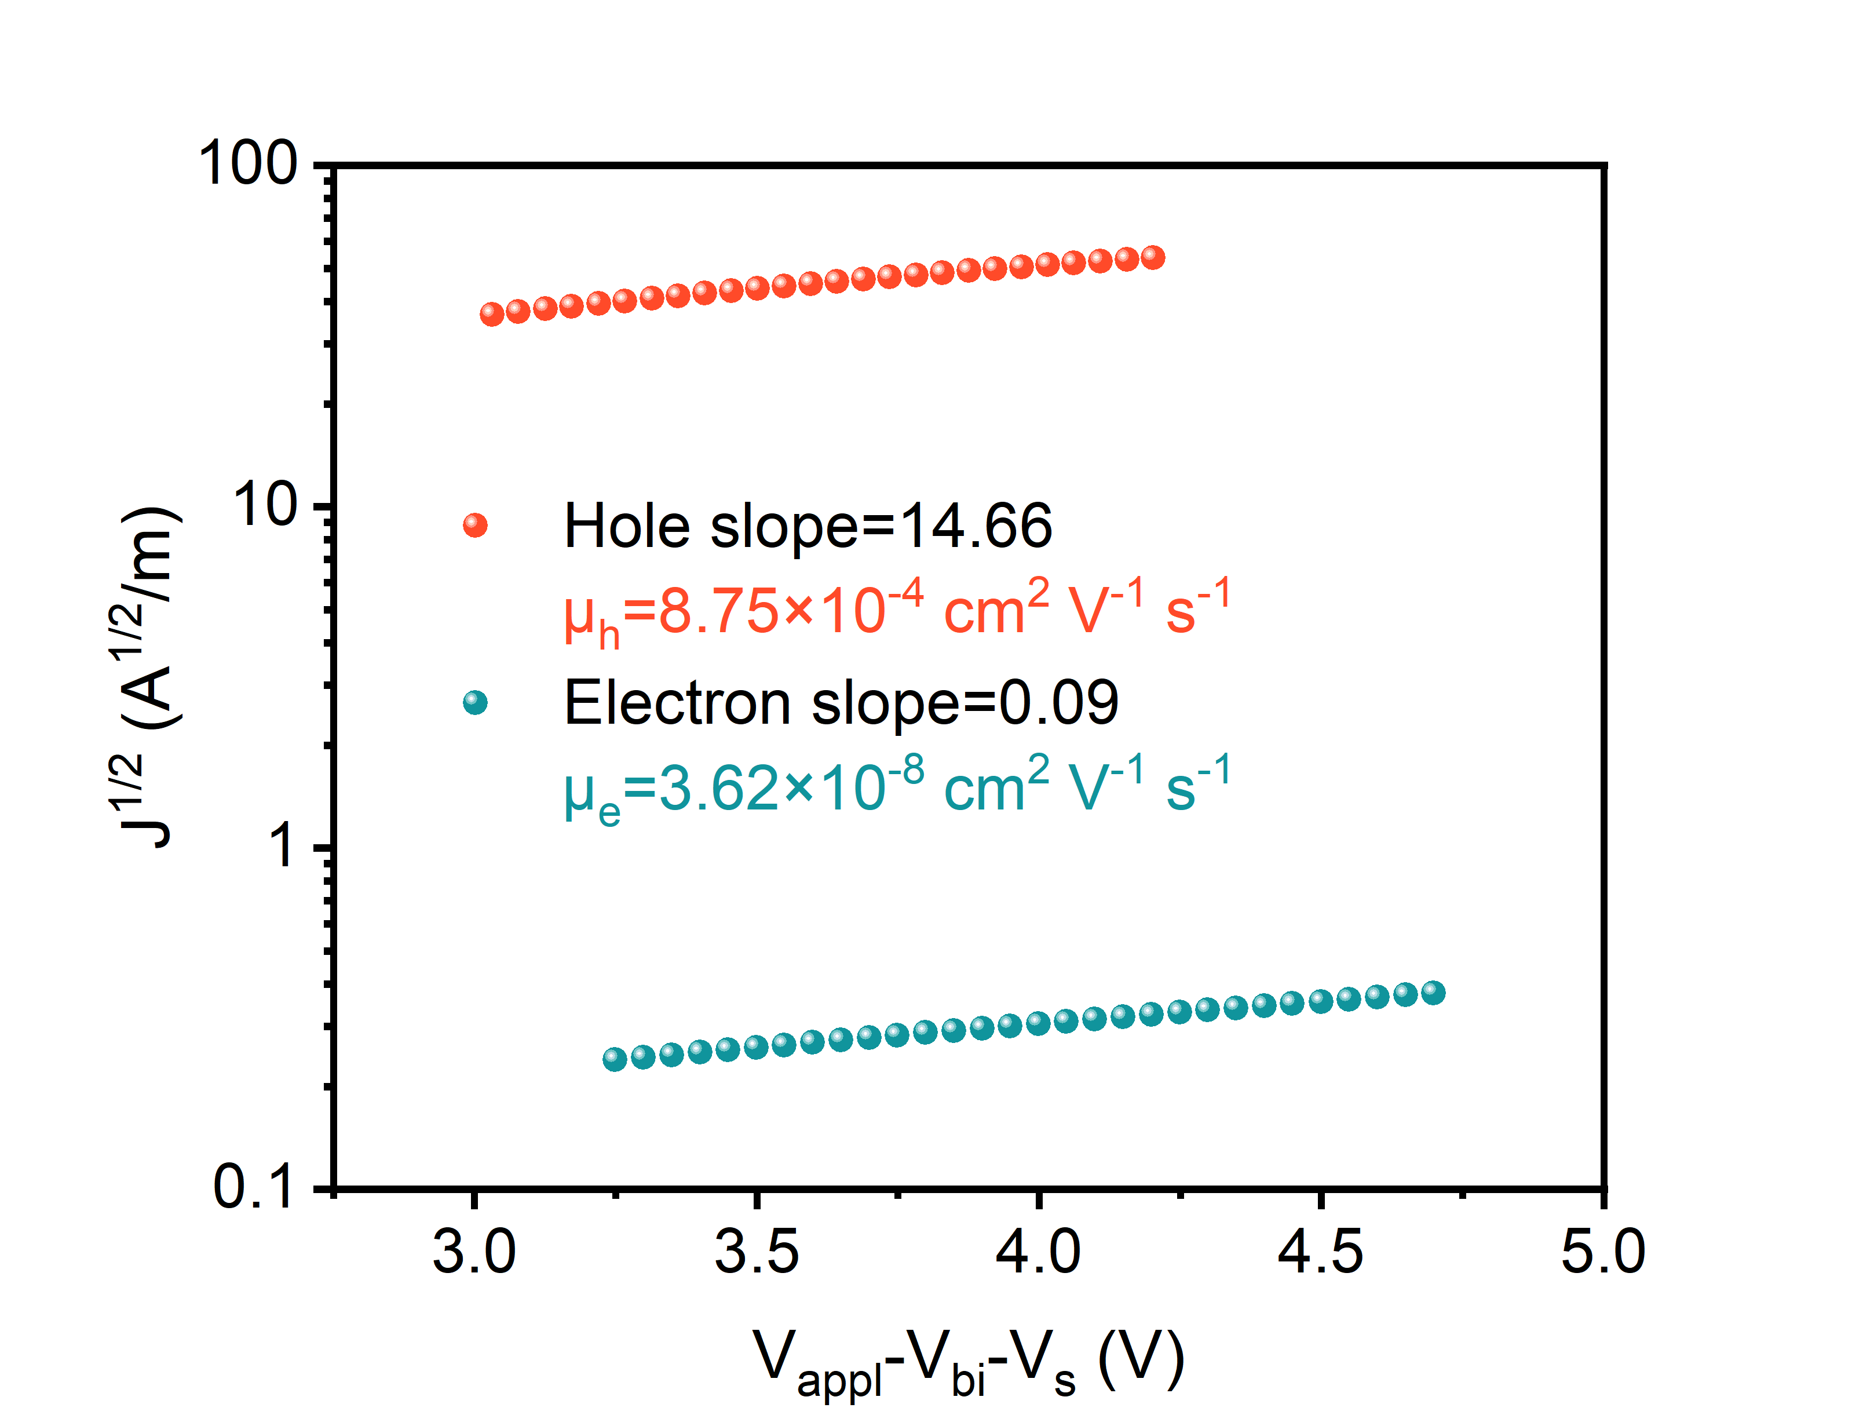
Supplementary Fig. 2 Carrier mobilities of the ternary blends.

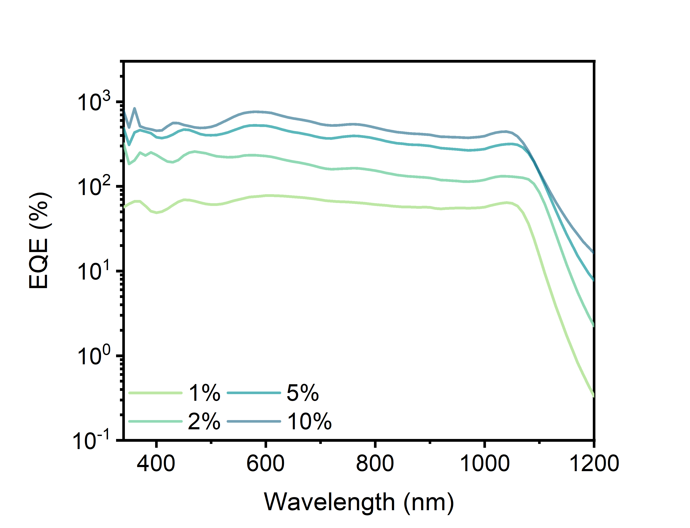
Supplementary Fig. 3 EQE spectrum of dual-mode OPDs with different concentration of BFDO-4F under reverse bias of -15 V.

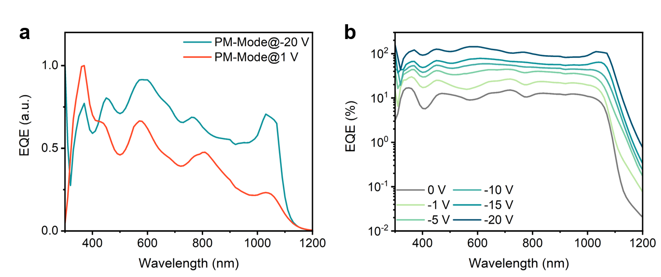
Supplementary Fig. 4 a Normalized EQE spectra of the dual-mode OPD under different PM-modes. b EQE spectra of the dual-mode OPD under different reverse biases.

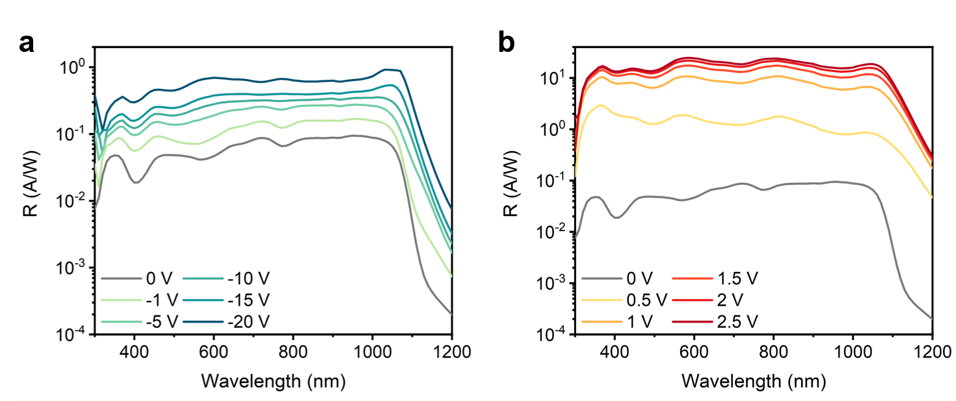
Supplementary Fig. 5 Responsivity of the dual-mode OPD with 1wt% BFDO-4F under varied a reverse biases, and b forward biases.

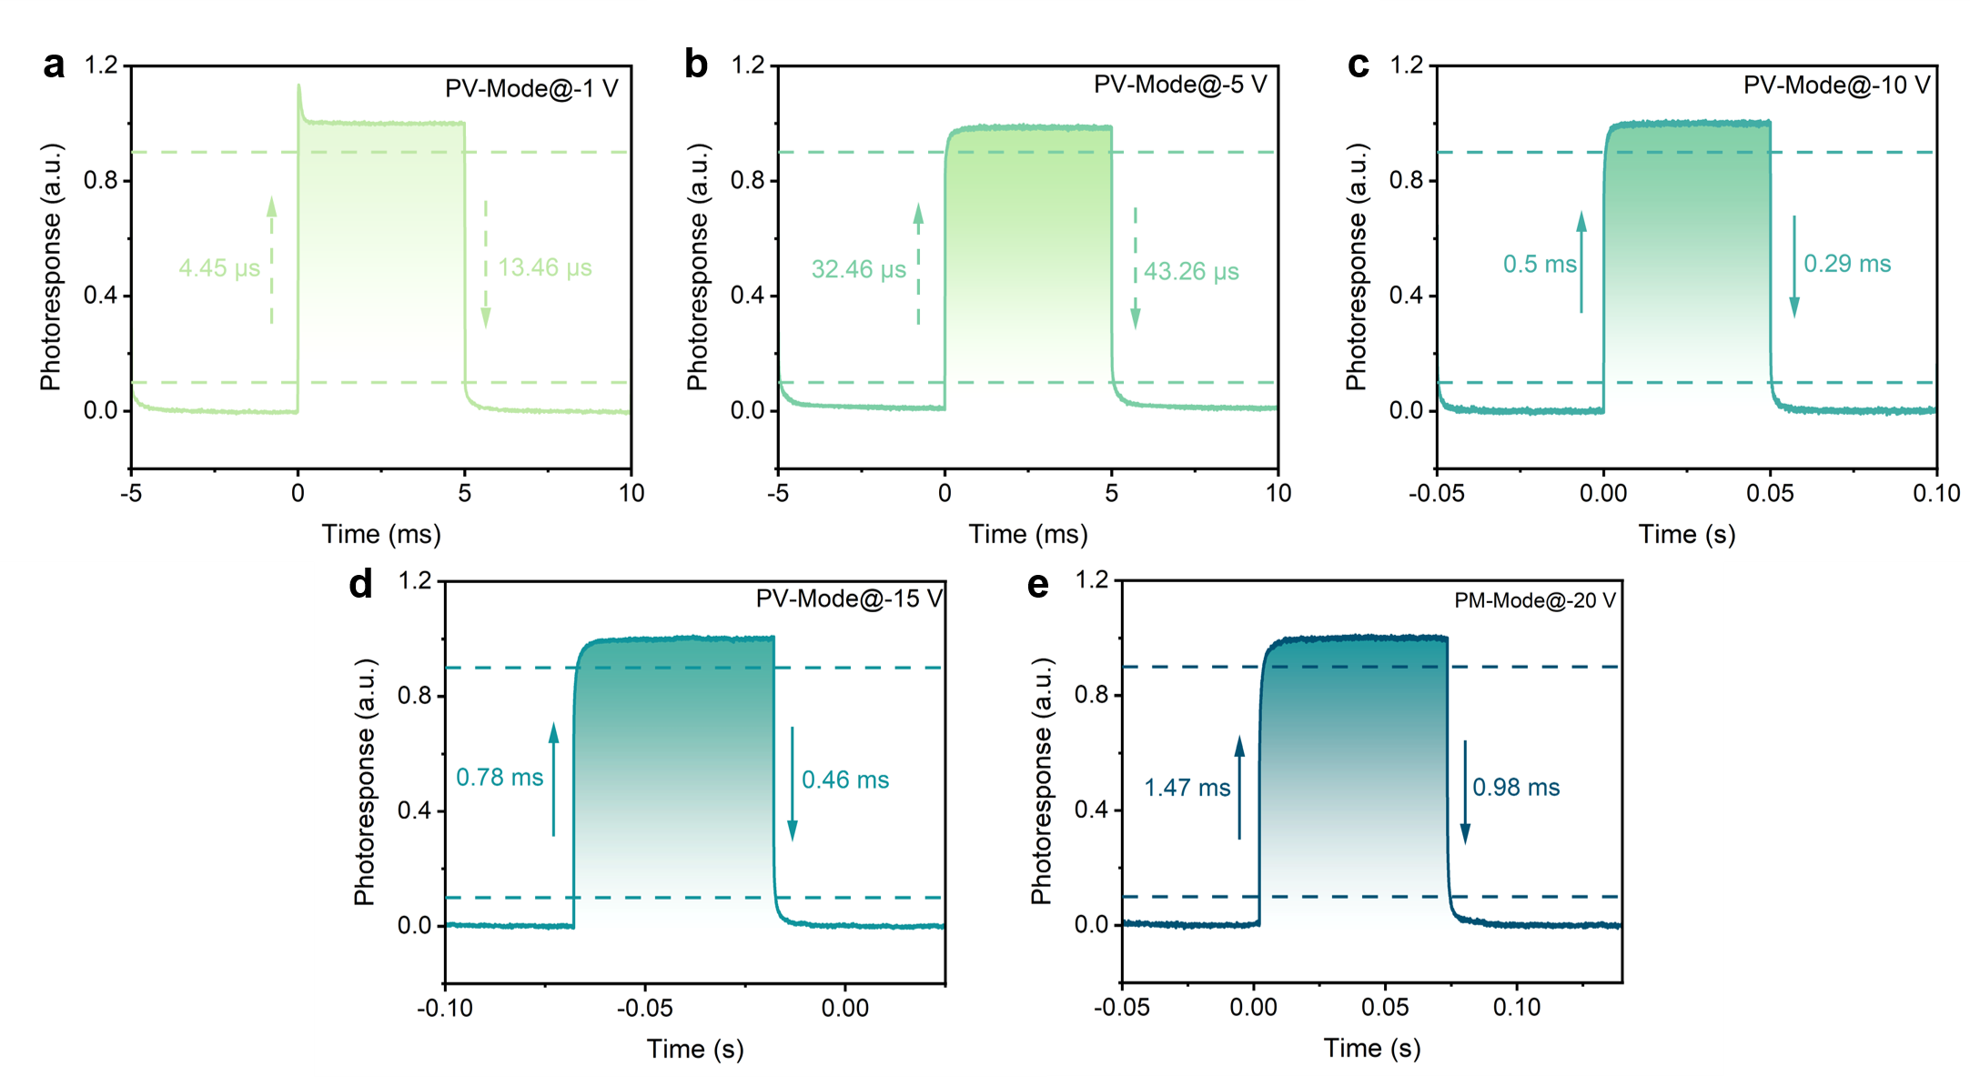
Supplementary Fig. 6 Normalized transient photocurrent for 1 wt% BFDO-4F device at a -1 V, b -5 V, c -10 V, d -15 V, and e -20 V bias under the illumination of a LED with peak wavelength at 1050 nm.

Supplementary Table 1 Performance comparison of recently reported PM-OPDs.
Device Structure | Spectral range (nm) | D* (Jones)  @ bias (V) | t_{r}/t_{f} (ms) | Single/Dual Mode | Ref.
ITO/TAPC/BT-ATPEPH:C₆₀/MoO_{X}:C₇₀/BCP/Ag | 350–850 | 3.08×10¹²  @ -6 V | 1.69/10 | Single | 1
ITO/PEDOT: PSS/ P3HT: ETBI/Al | 400–850 | 9.5×10¹²  @ −20 V | 2.2/4.1 | Single | 2
ITO/ZnPc:C₆₀/HATNA-Cl₆/Al | 400–850 | 2.2×10¹²  @ -2.5 V | 0.06/0.28 | Single | 3
ITO/PEDOT:PSS/poly-TPD: P3HT:PC₆₁BM/Al | 300–900 | 9.1×10¹¹  @ -20 V | 51/20 | Single | 4
ITO/PEDOT:PSS/PDBD-FBT: ITIC/Ag | 300–800 | 3.82×10¹²  @ -10 V | 0.5/3 | Single | 5
ITO/PEDOT: PSS/P3HT:P-TPD/P3HT:PC₇₁BM//Al | 300–800 | 6.4×10¹¹  @ -10 V | 200/600 | Single | 6
ITO/ZnO:PEIE/P3HT: TAPC:PC₆₁BM/MoO_{X}/Ag | 360–720 | 1.04×10¹²  @ -10 V | / | Single | 7
ITO/ZnO/TPD-3:Y6-Se-HD/Ag | 340–1100 | 6.48×10¹²  @ -1V | 0.022 | Single | 8
ITO/ZnO/PBDB-T:Y6/ MoO_{X}/Ag | 340–1000 | 4.23×10¹²  @ 2 V | 0.05/3.03 | Dual-PM | 9
ITO/ZnO/PBDB-T:Y6/ MoO_{X}/Ag | 340–1000 | ~1×10¹²@  -2 V | 0.00864/0.01114 | Dual-PV | 9
ITO/Zn_{x}O: D149/PBDB-T: ITIC-Th/e-ZnO/Ag | 400–900 | ~1.5×10¹²@  2 V | 0.03958/0.37614 | Dual-PM | 10
ITO/Zn_{x}O:D149/PBDB-T: ITIC-Th/e-ZnO/Ag | 400–900 | ~5.5×10¹²@  -1 V | 0.02952/0.04635 | Dual-PV | 10
ITO/ZnO/PCE-10:COTIC-4F:BFDO-4F/MoO_{X}/Ag | 300–1200 | 1.13×10¹²  @ 1 V | 2.37/0.58 | Dual-PM | This work
ITO/ZnO/PCE-10: COTIC-4F:BFDO-4F/MoO_{X}/Ag | 300–1200 | 1.92×10¹²@  0 V | 0.00283/0.00443 | Dual-PV | This work

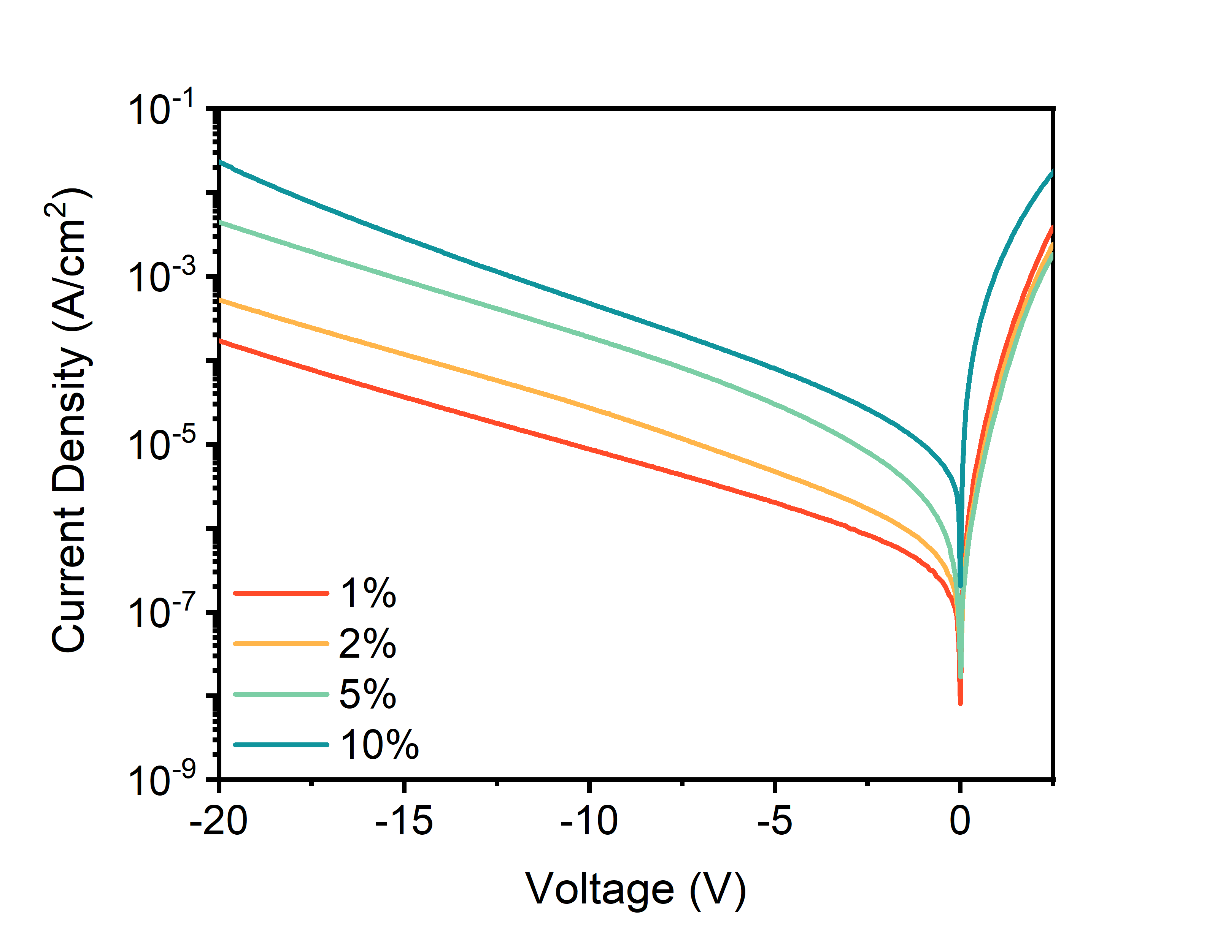
Supplementary Fig. 7 Dark J–V curves of OPDs based on different concentration of BFDO-4F.

Supplementary Table 2 Device parameters of dual-mode OPDs based on different concentration of BFDO-4F.
 | V_{OC} (V) | FF (%) | J_{SC} (mA/cm²)
1% | 0.30 | 41.56 | 5.23
2% | 0.27 | 38.56 | 3.26
5% | 0.26 | 36.86 | 1.81
10% | 0.20 | 36.37 | 1.45

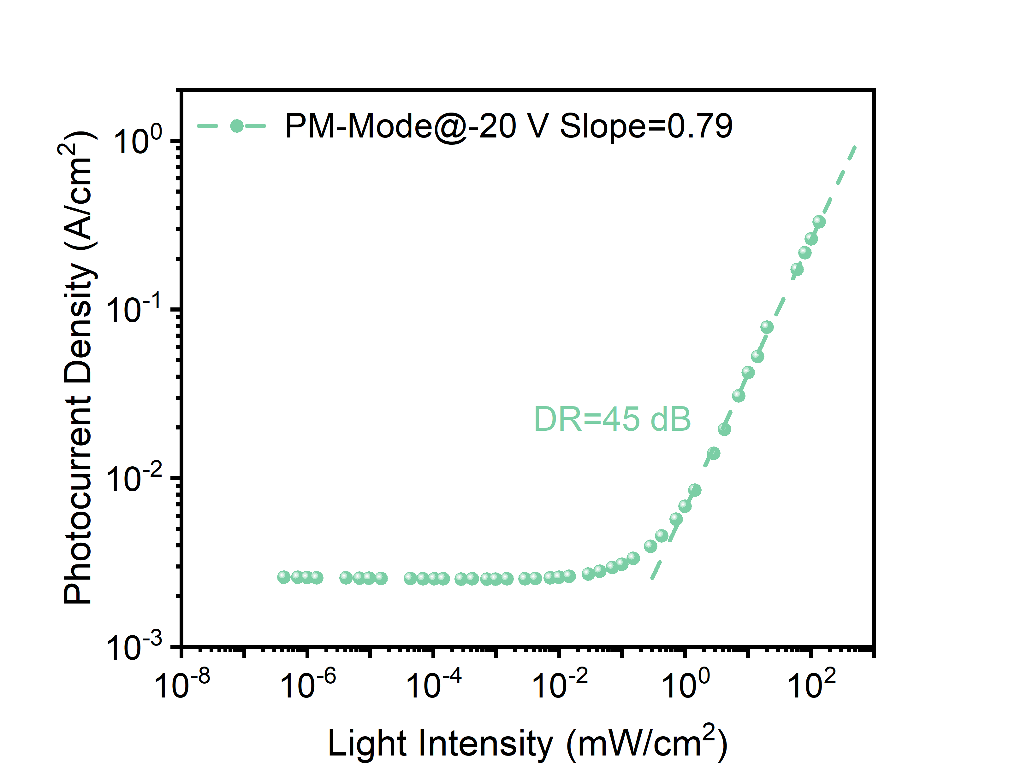
Supplementary Fig. 8 Dynamic range of the optimized dual-mode OPD with 1 wt% BFDO-4F under bias of -20 V.

Supplementary Table 3 Detailed information from 1D GIWAXS profiles for active layers with different weight ratio of BFDO-4F.
Direction | Parameters | 1%  BFDO-4F | 2%  BFDO-4F | 5%  BFDO-4F | 10% BFDO-4F
Out of  plane | Q (Å⁻¹) | 1.845 | 1.872 | 1.858 | 1.865
Out of  plane | FWHW (Å⁻¹) | 0.251 | 0.263 | 0.280 | 0.295
Out of  plane | d-spacing (Å) | 3.405 | 3.357 | 3.382 | 3.369
Out of  plane | CCL (nm) | 2.255 | 2.148 | 2.020 | 1.916
In plane | Q (Å⁻¹) | 0.328 | 0.335 | 0.331 | 0.330
In plane | FWHW (Å⁻¹) | 0.118 | 0.117 | 0.113 | 0.108
In plane | d-spacing (Å) | 19.125 | 18.777 | 19.008 | 19.068
In plane | CCL (nm) | 4.799 | 4.844 | 5.018 | 5.234

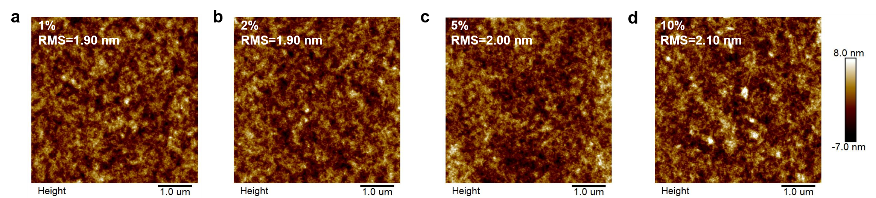
Supplementary Fig. 9 AFM analysis of blend films with different concentration of BFDO-4F.

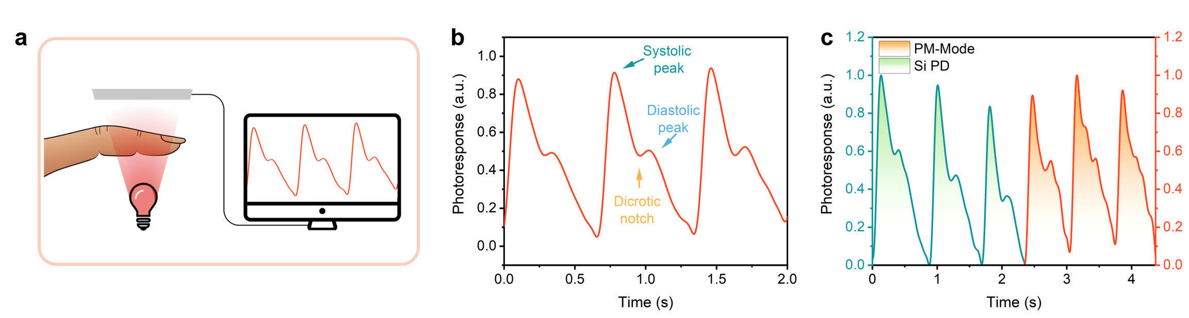
Supplementary Fig. 10 a Schematic overview of PPG measurement. b Enlargement of the PPG waveform. c Comparison of the normalized waveforms of Si PD and dual-mode OPD (PM-mode).

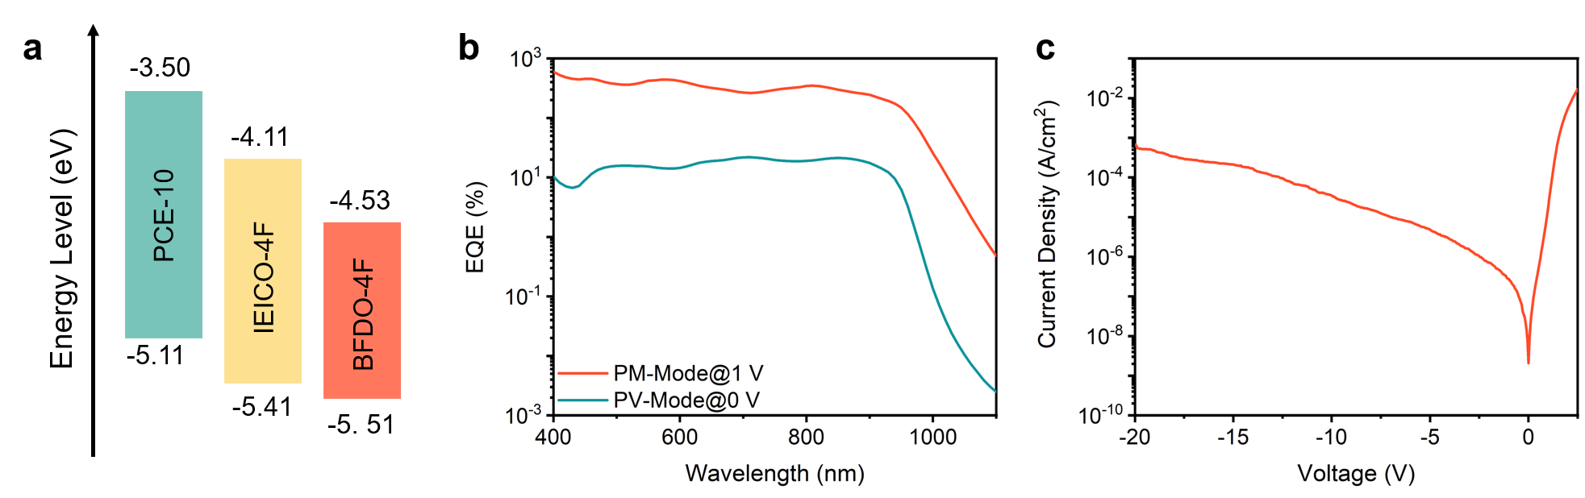
Supplementary Fig. 11 a Energy level of utilized materials. b EQE and c current density for 1% BFDO-4F device based on PCE-10: IEICO-4F: BFDO-4F system.

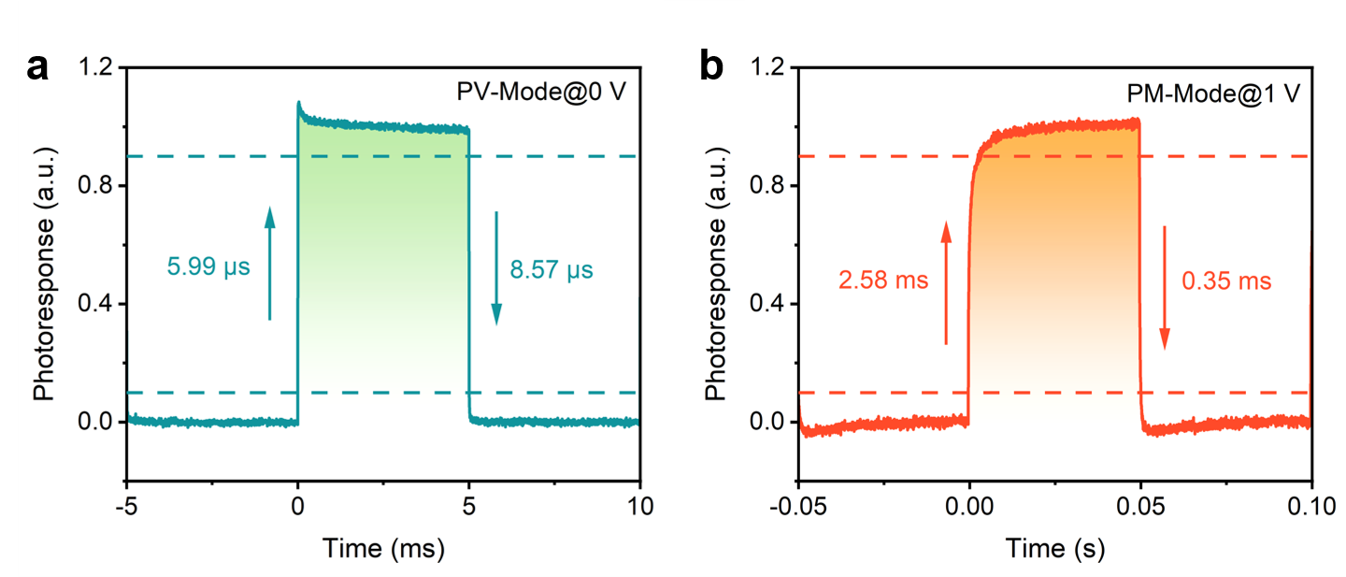
Supplementary Fig. 12 Normalized photoresponse for the devices at a PV-mode and b PM-mode under the illumination of 940 nm LED.

Material synthesis: Compound BFDO-Br was synthesized according to procedures outlined in the literature¹¹.
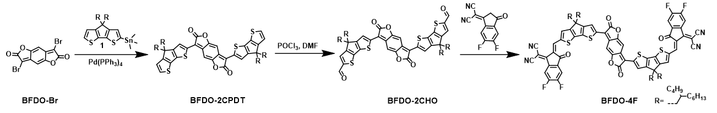
Supplementary Scheme 1 Synthesis process of BFDO-4F.
Synthesis of BFDO-2CPDT: Compound 1 (2.5 eq), BFDO-Br (1.0 eq), and Pd(PPh₃)₄ (0.1 eq) were added in a 100 mL two-necked flask and degassed with N₂ three times. Then, 30 mL of toluene was injected, and the mixture was then reacted 8 h at 110 °C. After cooling to room temperature, the solution was concentrated under reduced pressure. The crude product was purified by silica gel column chromatography with a mixture of PE: DCM (3:1, v/v) as the eluent, yielding compound (52%). ¹H-NMR (400 MHz, CDCl₃): 7.96 (s, 2H), 7.34-7.36 (d, J = 8.0 Hz, 2H), 7.07 (s, 2H), 6.99-7.00 (d, J = 4.0 Hz, 2H), 1.96-1.98 (d, J = 4.0 Hz, 8H), 0.83-0.97 (m, 68H), 0.73-0.78 (m, 24H).
Synthesis of BFDO-2CHO: 5 mL of 1,2-dichloroethane was mixed with anhydrous DMF (5.0 eq) in a 100 mL two-necked flask at 0 °C. After stirring for 15 minutes, POCl₃ (6.0 eq) was slowly added. After 30 minutes of reaction, a solution of BFDO-2CPDT (1.0 eq) in anhydrous 1,2-dichloroethane was added, and the mixture was then reacted for 12 hours at 60 °C. After cooling to room temperature, the reaction was quenched with KOH solution, and extracted three times with DCM (30 mL × 3). The combined organic phase was dried with anhydrous sodium sulfate, filtered, and concentrated under reduced pressure. The crude product was purified by silica gel column chromatography with a mixture of PE: DCM (1:1, v/v) as the eluent, yielding BFDO-2CHO (83%). ¹H-NMR (400 MHz, CDCl₃): ¹H-NMR (400 MHz, CDCl₃): 9.90 (s, 2H), 8.03 (s, 2H), 7.62 (s, 2H), 7.10 (s, 2H), 2.01-2.02 (d, J = 4.0 Hz, 8H), 0.90-0.99 (m, 68H), 0.73-0.77 (m, 24H).
Synthesis of BFDO-4F: BFDO-2CHO (1.0 eq), 2-(5,6-difluoro-3-oxo-2,3-dihydro-1H-inden-1ylidene) malononitrile (4.0 eq), 1 mL of pyridine, and 50 mL of CHCl₃ were added in a 250 mL two-necked flask and degassed with N₂ three times. The mixture was then reacted at 65 °C for 12 hours. After cooling to room temperature, the reaction mixture was s purified by silica gel column chromatography with a mixture of PE: DCM (1:1, v/v) as the eluent, yielding BFDO-4F (72%). ¹H-NMR (400 MHz, CDCl₃): δ 8.91 (s, 2H), 8.54-8.58 (m, 2H), 8.08 (s, 2H), 7.71-7.74 (m, 4H), 7.13 (s, 2H) 2.04 (s, 8H), 0.93-1.15 (m, 68H), 0.74-0.79 (m, 24H).

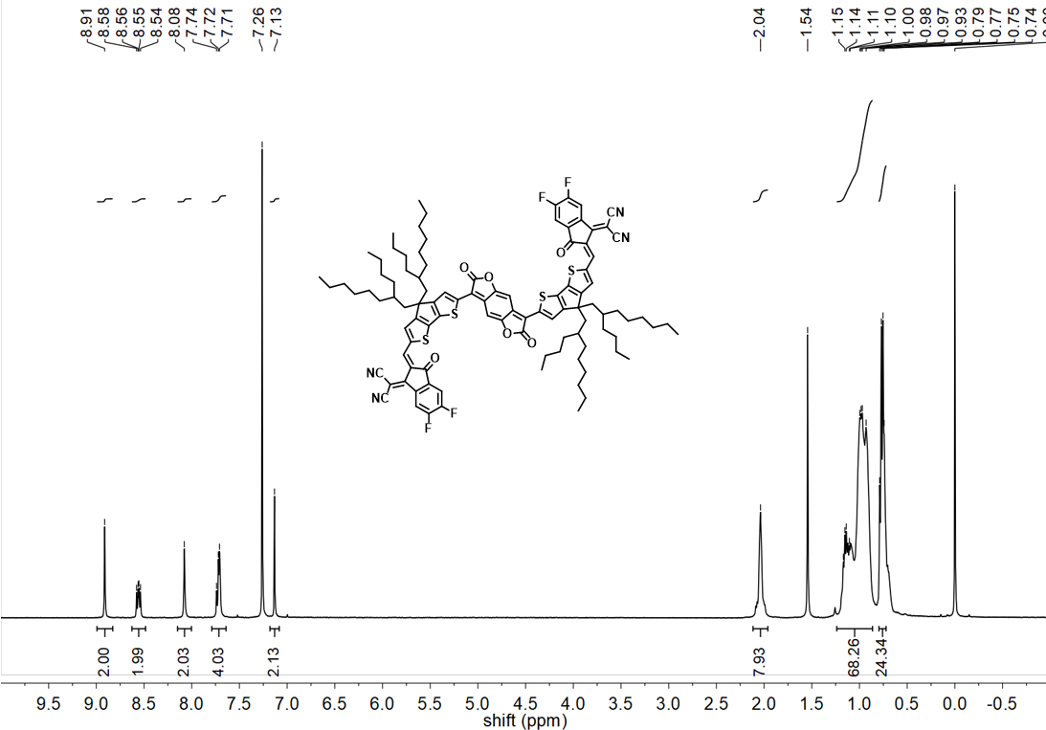
Supplementary Fig. 13 ¹H NMR spectrum of BFDO-4F.

Supplementary References
1. Guo, D. et al. Structure design and performance of photomultiplication-type organic photodetectors based on an aggregation-induced emission material. Nanoscale 12, 2648–2656 (2020).
2. Yoon, S. et al. End-Group Functionalization of Non-Fullerene Acceptors for High External Quantum Efficiency over 150 000% in Photomultiplication Type Organic Photodetectors. Adv. Funct. Mater. 31, 2006448 (2021).
3. Kublitski, J. et al. Enhancing sub-bandgap external quantum efficiency by photomultiplication for narrowband organic near-infrared photodetectors. Nat. Commun. 12, 4259 (2021).
4. Yang, K. et al. Smart Strategy: Transparent Hole-Transporting Polymer as a Regulator to Optimize Photomultiplication-type Polymer Photodetectors. ACS Appl. Mater. Interfaces 13, 21565–21572 (2021).
5. Kim, J. et al. A regioregular donor–acceptor copolymer allowing a high gain–bandwidth product to be obtained in photomultiplication-type organic photodiodes. Mater. Horiz. 8, 276–283 (2021).
6. Zhao, Z. et al. Highly Sensitive Narrowband Photomultiplication‐Type Organic Photodetectors Prepared by Transfer‐Printed Technology. Adv. Funct. Mater. 31, 2106009 (2021).
7. Bai, S. et al. Transient analysis of photomultiplication-type organic photodiodes. Appl. Phys. Rev. 9, 021405 (2022).
8. Suthar, G. et al. Morphological Effects on the Performance of Broadband Organic Photomultiplication Photodetectors Containing Selenium Substituted Non‐Fullerene Acceptors. Adv. Funct. Mater. 33, 2301538 (2023).
9. Liu, Q. et al. Organic photodiodes with bias-switchable photomultiplication and photovoltaic modes. Nat. Commun. 14, 6935 (2023).
10. Xiao, J. et al. Bias‐Switchable Dual‐Mode Organic Photodiodes Enabled by Manipulation of Interface Layers. Adv. Funct. Mater. 34, 2404711(2024).
11. Cai, H. et al. An n-Type Open-Shell Conjugated Polymer with High-Spin Ground-State and High Intrinsic Electrical Conductivity. Angew. Chem. Int. Ed. 63, e202402375 (2024).

