Increased maternal consumption of methionine as its hydroxyl analog contributed to improved placental angiogenesis and antioxidative capacity in a sow model

Rui Zhou,† Shanshan Lai,† Li Zhe,† Peiqiang Yuan,† Yves Mercier,& Liang Hu,‡ Lunxiang Yang,† Xiaoling Zhang,† Yong Zhuo,† Shengyu Xu,† Yan Lin,† Bin Feng,† Lianqiang Che,† De Wu,† Zhengfeng Fang†, *

†Key Laboratory for Animal Disease-Resistance Nutrition of China Ministry of Education, Animal Nutrition Institute, Sichuan Agricultural University, 211 Huimin Road, Wenjiang District, Chengdu, 611130, People’s Republic of China; &Adisseo France S.A.S., CERN, Commentry, France. ‡Key Laboratory of Agricultural Product Processing and Nutrition Health, Ministry of Agriculture and Rural Affairs, College of Food Science, Sichuan Agricultural University, Ya’an 625014, People’s Republic of China
*Correspondence: fangzhengfeng@hotmail.com

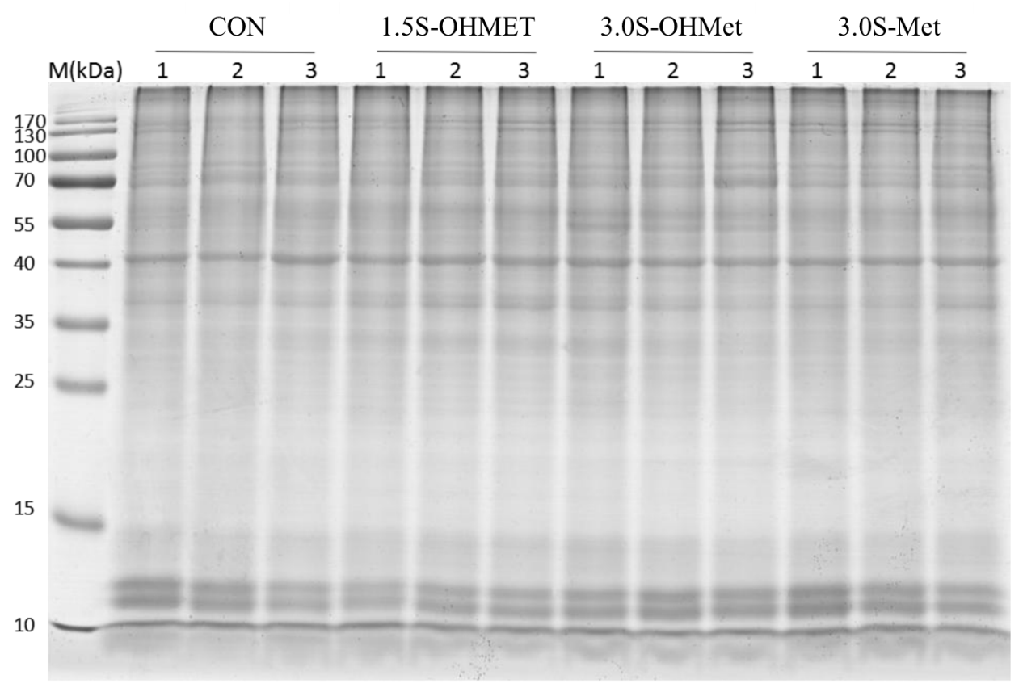
Fig. S1. Protein detection of placental samples.

