Supplementary Methods
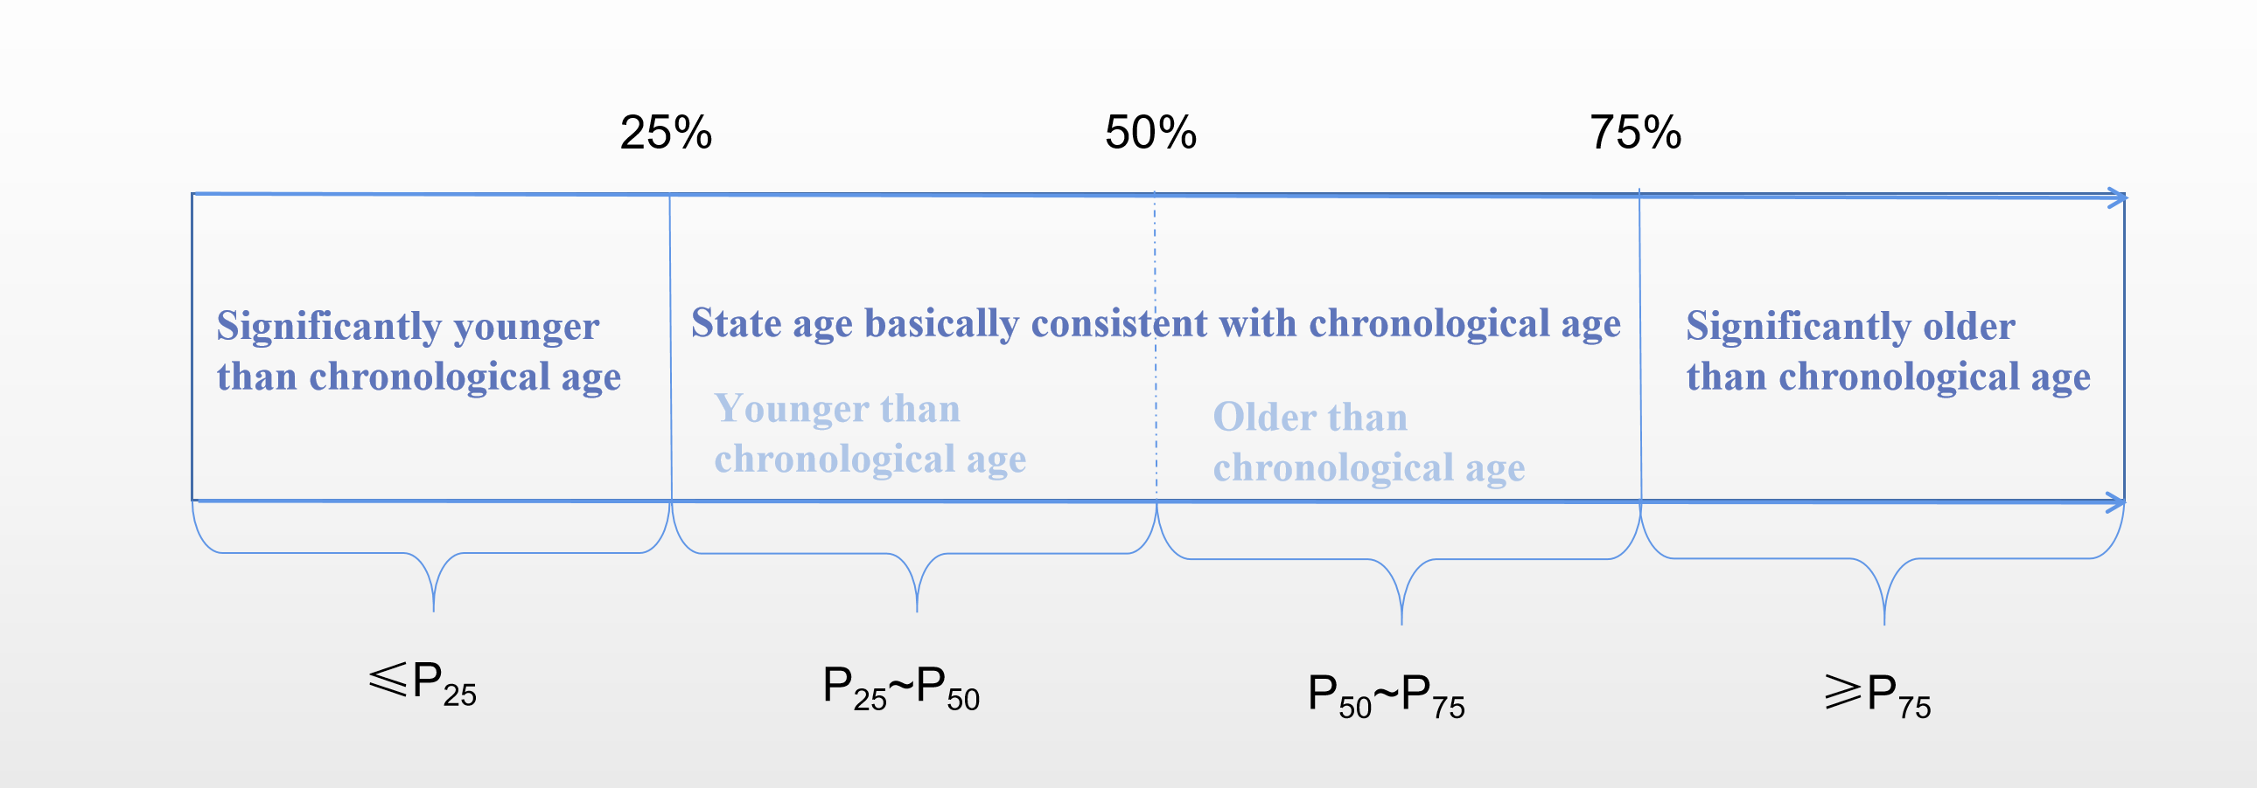
Supplementary Fig. 1 Semi-quantitative judgment ruler of state age of participants in the same chronological age group based on percentile method
The PPSHAS scale is equipped with a ruler for state age judgment, which can divide people of the same chronological age group into four categories, and in this study, the population located in P₂₅ to P₇₅ is combined, that is, the state age and chronological age are basically consistent; ≤ P₂₅ is "significantly younger" than chronological age; ≥ P₇₅ is significantly older.

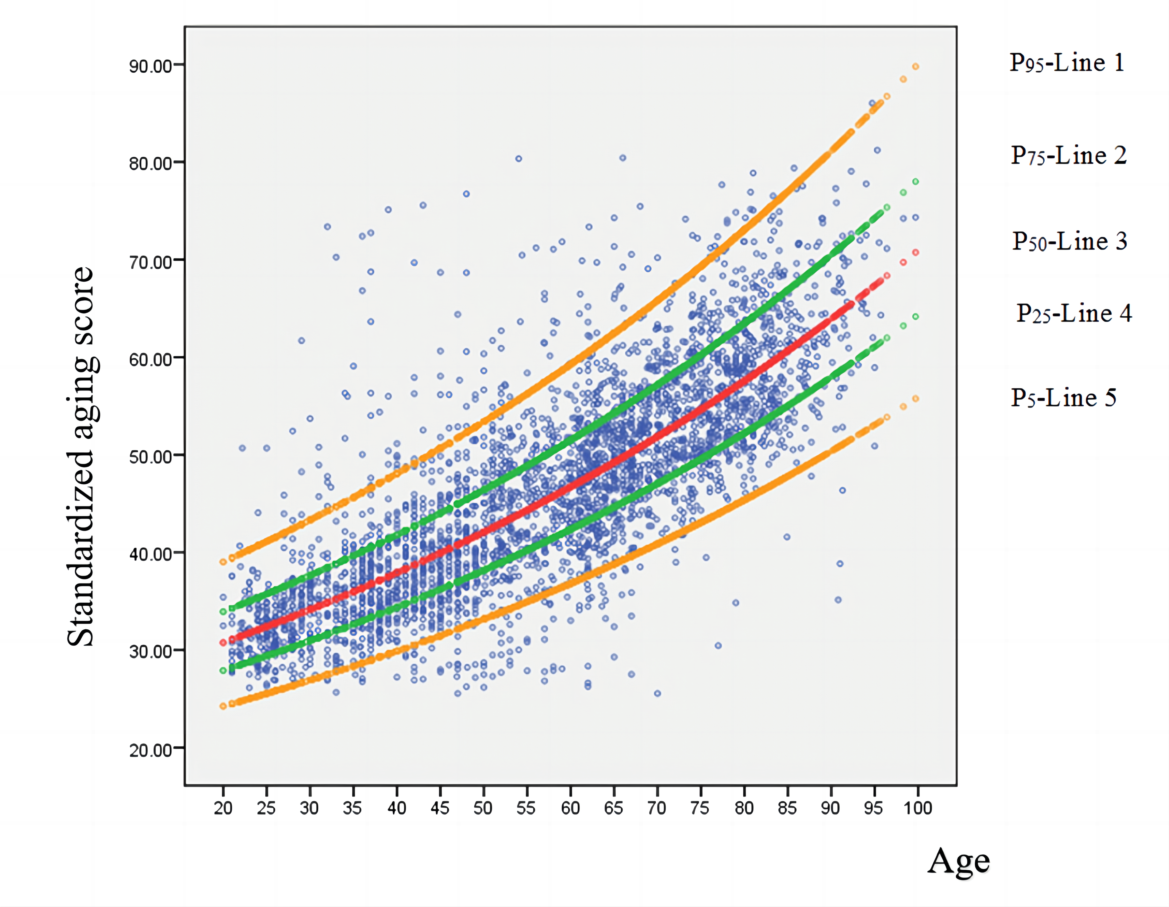
Supplementary Fig. 2 Growth model fitting curve between the normalized total aging scores(Y) and chronological age(X)
Line 3 is the standard curve of the total aging score to fit chronological age, the area between line 2 and line 4 marks the 50% reference range of the aging score in the population, and the area between line 1 and line 5 marks the 90% reference range of the aging score in the population.
The growth curve regression equation is $Y=℮^{(3.217+0.010x)}$.

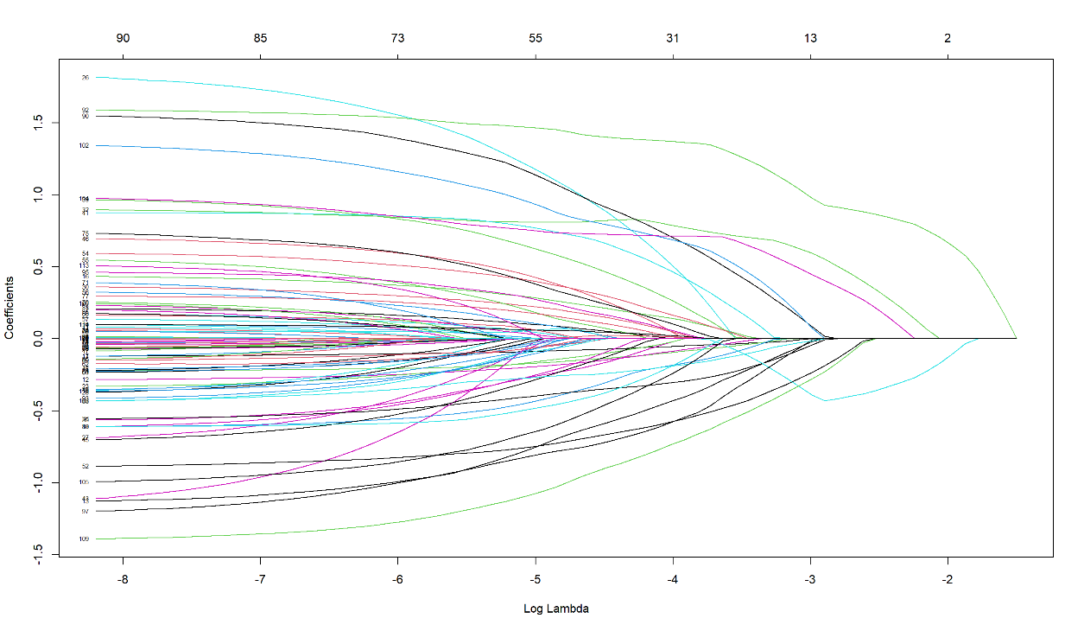
Supplementary Fig. 3 The independent variable coefficient path of Lasso classification regularization index screening

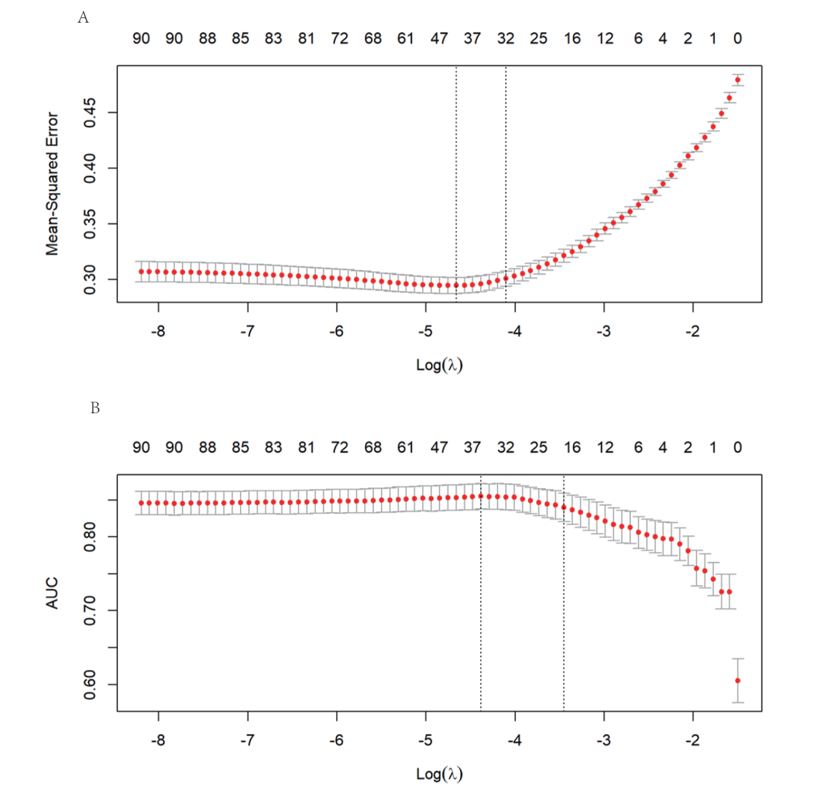
Supplementary Fig. 4 Mean-squared error (A) and AUC variation (B) for Lasso10 fold cross-verification
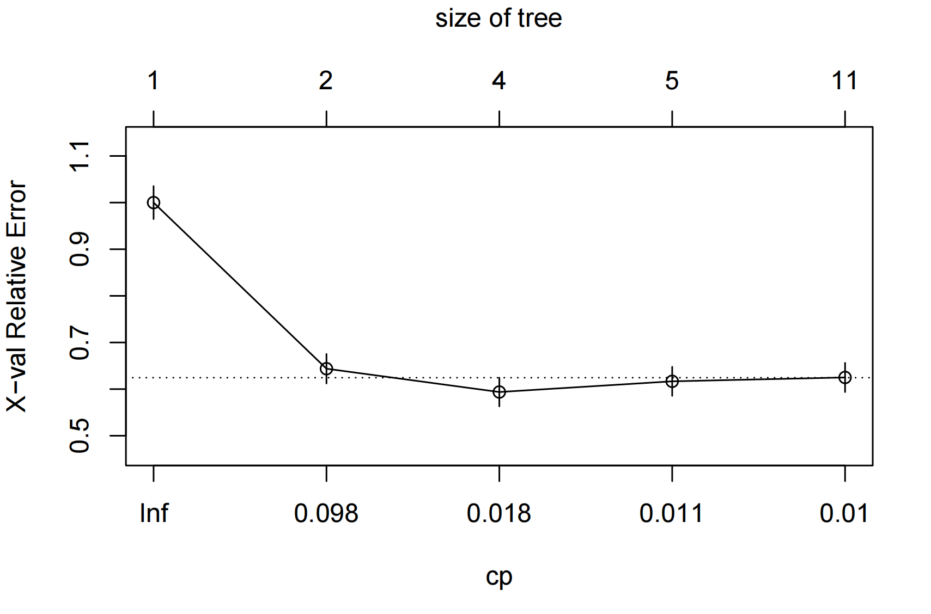
Supplementary Fig. 5 The variation of X-val relative error with CP value

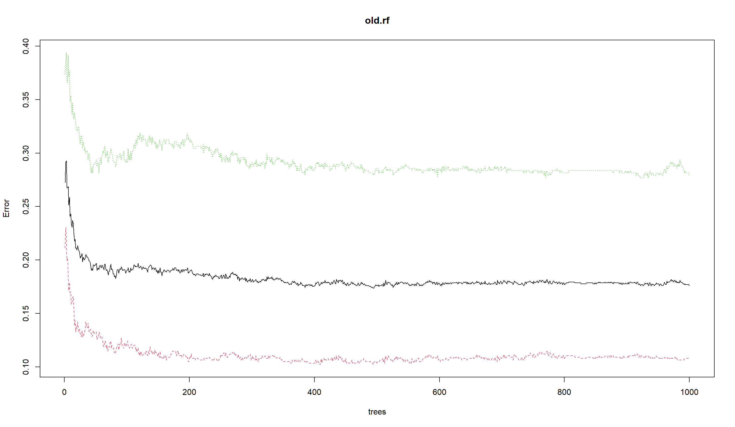
Supplementary Fig. 6 Random forest model error vs. tree number relationship

Supplementary Table 1 Demographic characteristics and comparison of middle-aged and elderly female in southern and northern China
Variable | South China |  |  | North China |  |  |  | Total |  |  | Overall comparison
Variable | N | % |  | N |  | % |  | N | % |  | Statistics | P
Age(years) |  |  |  |  |  |  |  |  |  |  | -4.673 | ＜0.001
40~ | 82 | 8.69 |  | 139 |  | 17.91 |  | 221 | 12.85 |  | -4.673 | ＜0.001
50~ | 105 | 11.12 |  | 105 |  | 13.53 |  | 210 | 12.21 |  | -4.673 | ＜0.001
55~ | 143 | 15.15 |  | 101 |  | 13.02 |  | 244 | 14.19 |  | -4.673 | ＜0.001
60~ | 174 | 18.43 |  | 103 |  | 13.27 |  | 277 | 16.10 |  | -4.673 | ＜0.001
65~ | 166 | 17.58 |  | 139 |  | 17.91 |  | 305 | 17.73 |  | -4.673 | ＜0.001
70~ | 121 | 12.82 |  | 110 |  | 14.18 |  | 231 | 13.43 |  | -4.673 | ＜0.001
75~ | 74 | 7.84 |  | 45 |  | 5.80 |  | 119 | 6.92 |  | -4.673 | ＜0.001
80~ | 79 | 8.37 |  | 34 |  | 4.38 |  | 113 | 6.57 |  | -4.673 | ＜0.001
Education |  |  |  |  |  |  |  |  |  |  | -3.027 | ＜0.001
Elementary school and below | 504 | 53.39 |  | 452 |  | 58.25 |  | 956 | 55.58 |  | -3.027 | ＜0.001
Junior middle school | 217 | 22.99 |  | 213 |  | 27.45 |  | 430 | 25.00 |  | -3.027 | ＜0.001
Senior middle school | 163 | 17.27 |  | 67 |  | 8.63 |  | 230 | 13.37 |  | -3.027 | ＜0.001
College and above | 60 | 6.36 |  | 44 |  | 5.67 |  | 104 | 6.05 |  | -3.027 | ＜0.001
Occupation |  |  |  |  |  |  |  |  |  |  | 359.461 | ＜0.001
Worker | 299 | 31.67 |  | 109 |  | 14.05 |  | 408 | 23.72 |  | 359.461 | ＜0.001
Farmer | 285 | 30.19 |  | 571 |  | 73.58 |  | 856 | 49.77 |  | 359.461 | ＜0.001
Cadre | 124 | 13.14 |  | 56 |  | 7.22 |  | 180 | 10.47 |  | 359.461 | ＜0.001
Self-employed | 97 | 10.28 |  | 40 | 5.15 |  |  | 137 | 7.97 |  | 359.461 | ＜0.001
Others | 139 | 14.72 |  | 0 | 0.00 |  |  | 139 | 8.08 |  | 359.461 | ＜0.001
Marital status |  |  |  |  |  |  |  |  |  |  | 41.726 | ＜0.001
Married | 730 | 77.33 |  | 692 | 89.18 |  |  | 1422 | 82.67 |  | 41.726 | ＜0.001
Unmarried | 12 | 1.27 |  | 5 | 0.64 |  |  | 17 | 0.99 |  | 41.726 | ＜0.001
Widowhood and divorce | 202 | 21.40 |  | 79 | 10.18 |  |  | 281 | 16.34 |  | 41.726 | ＜0.001
Total | 944 | 54.88 |  | 776 | 45.12 |  |  | 1720 | 100.00 |  | -

Supplementary Table 2 Analysis and comparison of characteristics in 1720 subjects of different regions and ages
Variable | Significantly younger |  |  | Basically consistent |  |  | Significantly older |  | Overall comparison
Variable | N | % |  | N | % |  | N | % | Statistics | P
Age(years) |  |  |  |  |  |  |  |  | 29.305 | 0.010
40~ | 21 | 9.50 |  | 92 | 41.63 |  | 108 | 48.87 | 29.305 | 0.010
50~ | 29 | 13.81 |  | 109 | 51.90 |  | 72 | 34.29 | 29.305 | 0.010
55~ | 25 | 10.25 |  | 117 | 47.95 |  | 102 | 41.80 | 29.305 | 0.010
60~ | 33 | 11.91 |  | 138 | 49.82 |  | 106 | 38.27 | 29.305 | 0.010
65~ | 54 | 17.70 |  | 139 | 45.57 |  | 112 | 36.72 | 29.305 | 0.010
70~ | 40 | 17.32 |  | 94 | 40.69 |  | 97 | 41.99 | 29.305 | 0.010
75~ | 24 | 20.17 |  | 45 | 37.82 |  | 50 | 42.02 | 29.305 | 0.010
80~ | 19 | 16.81 |  | 50 | 44.25 |  | 44 | 38.94 | 29.305 | 0.010
Region |  |  |  |  |  |  |  |  | 33.182 | <0.001
South China | 147 | 15.57 |  | 476 | 50.42 |  | 321 | 34.00 | 33.182 | <0.001
North China | 98 | 12.63 |  | 308 | 39.69 |  | 370 | 47.68 | 33.182 | <0.001
Total | 245 | 14.24 |  | 784 | 45.58 |  | 691 | 40.17 | -

Supplementary Table 3 Dietary type and average intake in three stage age groups ($\overline{x}$±SD)
Dietary type | Significantly younger (n=245) | Basically consistent (n=784) | Significantly older (n=691) | Overall comparison
 |  |  |  | $$F$$ | $$P$$
Staple food(g/d) | 247.55±149.29 | 325.19±244.74 | 369.75±267.34 | 18.260▲ | <0.001
Vegetarian dishes(g/w)
Leafy vegetables | 799.66±499.49 | 709.87±452.92 | 612.20±426.15 | 17.424▲ | <0.001
Root and stem vegetables | 482.63±360.91 | 398.77±325.62 | 375.36±290.51 | 10.371 | <0.001
Solanaceous fruit vegetables | 472.76±342.53 | 402.88±307.27 | 339.50±264.94 | 19.204▲ | <0.001
Melon vegetables | 411.53±356.94 | 351.18±297.20 | 296.14±248.59 | 14.750▲ | <0.001
Legume vegetables | 373.48±303.96 | 318.79±227.56 | 289.01±201.40 | 6.674 | <0.001
Meat dishes(g/w)
Livestock | 429.32±343.65 | 372.70±332.97 | 316.54±206.00 | 12.282▲ | <0.001
Poultry | 171.03±158.53 | 142.21±110.24 | 139.40±116.49 | 4.574 | 0.010
Fish and shrimp | 194.82±184.38 | 166.26±106.07 | 134.37±123.54 | 13.339▲ | <0.001
Eggs | 270.02±250.86 | 224.86±151.46 | 230.02±157.49 | 3.563▲ | 0.029
Between-meal nibbles(g/w)
Fruits | 642.93±556.14 | 505.19±414.69 | 425.07±330.43 | 17.061▲ | <0.001
Milk | 561.04±354.52 | 478.05±210.30 | 400.22±236.31 | 7.322▲ | <0.001
Nuts | 156.73±85.93 | 110.86±73.43 | 99.43±60.31 | 3.873▲ | 0.021
Daily water intake(ml/d) | 1328.13±571.30 | 1394.46±707.50 | 1249.09±622.79 | 9.015 | <0.001
▲: Uneven variance by Levene's test, Kruskal Wallis H-test was used instead of one-way ANOVA, χ 2 as a statistic; The survey of dietary types and structure referred to China Health and Nutrition Survey, 2018.

Supplementary Table 4 The proportion and comparison of daily intake of seasonings in three stage age groups, n (%)
Seasoning type | Significantly younger (n=245) | Basically consistent (n=784) | Significantly older (n=691) | Overall comparison
 |  |  |  | χ² | P
Oil(g) |  |  |  | 8.627 | 0.196
≤25 | 61(24.9) | 211(26.91) | 157(22.72) | 8.627 | 0.196
25~50 | 104(42.45) | 364(46.43) | 342(49.49) | 8.627 | 0.196
＞50 | 53(21.63) | 148(18.88) | 141(20.41) | 8.627 | 0.196
Unclear | 27(11.02) | 61(7.78) | 51(7.38) | 8.627 | 0.196
Salt(g) |  |  |  | 9.194 | 0.163
＜6 | 121(49.39) | 349(44.52) | 288(41.68) | 9.194 | 0.163
6~10 | 85(34.69) | 316(40.31) | 303(43.85) | 9.194 | 0.163
＞10 | 32(13.06) | 91(11.61) | 85(12.30) | 9.194 | 0.163
Unclear | 7(2.86) | 28(3.57) | 15(2.17) | 9.194 | 0.163
Sugar(g) |  |  |  | 16.870 | 0.010
≤25 | 180(73.47) | 529(67.47) | 433(62.66) | 16.870 | 0.010
25~50 | 39(15.92) | 174(22.19) | 189(27.35) | 16.870 | 0.010
＞50 | 16(6.53) | 49(6.25) | 49(7.09) | 16.870 | 0.010
Unclear | 10(4.08) | 32(4.08) | 19(2.75) | 16.870 | 0.010
Spices |  |  |  | 16.747 | 0.010
Not eat | 20(8.16) | 104(13.27) | 59(8.54) | 16.747 | 0.010
Eat less | 52(21.22) | 203(25.89) | 194(28.08) | 16.747 | 0.010
Eat an average | 107(43.67) | 299(38.14) | 288(41.68) | 16.747 | 0.010
Eat more | 66(26.94) | 178(22.7) | 150(21.71) | 16.747 | 0.010
Spices refer to the intake of ginger, garlic, vinegar, peppercorns, etc.

Supplementary Table 5 Weekly nutrient types and intake in three stage age groups ($\overline{x}$±SD)
Nutrients types | Significantly younger (n=245) | Basically consistent (n=784) | Significantly older (n=691) | Overall comparison
 |  |  |  | $$F$$ | $$P$$
Energy(Kcal) | 13067.32±7031.08 | 14061.41±6843.90 | 14697.08±8201.11 | 4.480▲ | 0.012
Protein(g) | 410.20±180.80 | 405.00±159.14 | 403.08±182.36 | 0.139▲ | 0.870
Fat(g) | 319.53±239.24 | 269.56±189.47 | 246.68±170.31 | 10.470▲ | <0.001
Carbohydrate(g) | 2215.53±1395.41 | 2580.76±1500.15 | 2793.42±1803.19 | 13.185▲ | <0.001
Dietary fiber(g) | 91.45±48.61 | 81.11±42.29 | 75.86±42.65 | 11.834 | <0.001
Vitamins
VA(ug) | 273.40±205.68 | 230.67±191.86 | 194.99±165.74 | 17.238▲ | <0.001
VB(mg) | 80.93±36.36 | 75.31±32.92 | 72.37±35.10 | 5.713 | 0.003
VC(mg) | 741.45±393.39 | 647.59±361.77 | 563.46±335.19 | 23.760▲ | <0.001
VE(mg) | 61.87±51.96 | 49.37±40.47 | 44.11±36.82 | 13.017▲ | <0.001
Macroelements
Ca(mg) | 1995.02±1056.72 | 1700.93±935.12 | 1513.43±840.17 | 23.291▲ | <0.001
P(mg) | 4931.94±2255.92 | 4743.87±1843.80 | 4686.79±2053.10 | 1.373 | 0.254
K(mg) | 9462.64±3883.76 | 8820.04±3282.92 | 8384.40±3378.33 | 9.460 | <0.001
Na(mg) | 2677.88±2796.29 | 2117.10±2022.69 | 1923.34±1771.06 | 8.342▲ | <0.001
Mg(mg) | 1536.05±758.38 | 1502.99±632.07 | 1496.48±713.59 | 0.258 | 0.773
Microelements
Fe(mg) | 38.73±23.52 | 33.44±17.91 | 31.09±16.69 | 15.733 | <0.001
Zn(mg) | 74.16±42.25 | 77.60±38.27 | 80.01±44.27 | 1.766▲ | 0.172
Se(ug) | 229.29±106.92 | 232.10±94.00 | 235.98±110.55 | 0.434▲ | 0.648
Cu(mg) | 8.80±6.15 | 9.25±5.17 | 9.72±5.95 | 2.444▲ | 0.088
Mn(mg) | 47.46±42.10 | 48.16±31.75 | 50.22±34.18 | 0.910 | 0.403
Food water content(g) | 4410.02±1786.82 | 3862.78±1600.54 | 3464.63±1485.94 | 34.142 | <0.001
▲: Uneven variance by Levene's test, Kruskal Wallis H-test was used instead of one-way ANOVA, χ 2 as a statistic; VB intake is the sum of thiamine, riboflavin and niacin; For the calculation of nutrient intake, referred to the 6th China Food Composition Tables Standard Edition.

Supplementary Table 6 Personal life characteristics and comparison in three stage age groups, n (%)
Variable | Significantly younger (n=245) | Basically consistent (n=784) | Significantly older (n=691) | Overall comparison
 |  |  |  | χ² | P
Weekly eating out |  |  |  | 24.932 | 0.002
No | 166(67.76) | 588(75.00) | 508(73.52) | 24.932 | 0.002
Once | 63(25.71) | 130(16.58) | 125(18.09) | 24.932 | 0.002
Twice | 7(2.86) | 38(4.85) | 27(3.91) | 24.932 | 0.002
Thrice | 8(3.27) | 8(1.02) | 20(2.89) | 24.932 | 0.002
Four or more times | 1(0.41) | 20(2.55) | 11(1.59) | 24.932 | 0.002
Importance of dressing |  |  |  | 18.389 | 0.005
Deeply focused | 10(4.08) | 31(3.95) | 10(1.45) | 18.389 | 0.005
Focused | 41(16.73) | 141(17.98) | 92(13.31) | 18.389 | 0.005
Not so focused | 74(30.20) | 205(26.15) | 214(30.97) | 18.389 | 0.005
Unfocused | 120(48.98) | 407(51.91) | 375(54.27) | 18.389 | 0.005
Dressing style |  |  |  | 26.138 | <0.001
Pursuing fashion | 16(6.53) | 34(4.34) | 18(2.60) | 26.138 | <0.001
Follow fashion | 30(12.24) | 64(8.16) | 41(5.93) | 26.138 | <0.001
Adhere to personal style | 56(22.86) | 239(30.48) | 181(26.19) | 26.138 | <0.001
Not to care | 143(58.37) | 447(57.02) | 451(65.27) | 26.138 | <0.001
Duration of hobbies(h) |  |  |  | 254.613 | <0.001
＜0.5 | 30(12.24) | 252(32.14) | 390(56.44) | 254.613 | <0.001
0.5~1 | 63(25.71) | 303(38.65) | 124(17.95) | 254.613 | <0.001
1~2 | 57(23.27) | 108(13.78) | 94(13.60) | 254.613 | <0.001
＞2 | 95(38.78) | 121(15.43) | 83(12.01) | 254.613 | <0.001
Emotion in life |  |  |  | 61.491 | <0.001
Truly satisfied | 100(40.82) | 286(36.48) | 181(26.19) | 61.491 | <0.001
Satisfied | 120(48.98) | 360(45.92) | 366(52.97) | 61.491 | <0.001
Not so satisfied | 20(8.16) | 129(16.45) | 102(14.76) | 61.491 | <0.001
Dissatisfied | 5(2.04) | 9(1.15) | 42(6.08) | 61.491 | <0.001
Religion |  |  |  | 26.666 | <0.001
Unbeliever | 213(86.94) | 607(77.42) | 509(73.66) | 26.666 | <0.001
Buddhism | 5(2.04) | 45(5.74) | 67(9.70) | 26.666 | <0.001
Christianity | 25(10.20) | 122(15.56) | 108(15.63) | 26.666 | <0.001
Others | 2(0.82) | 10(1.28) | 7(1.01) | 26.666 | <0.001
Duration of hobbies refers to the time devoted to healthy hobbies everyday such as calligraphy, painting, music, fishing, dancing, raising flowers, traveling, dating, etc.; Emotion in life refers to the comprehensive perception of the subject's emotional experiences such as husband and wife life, family member relationships, relatives and friends.

Supplementary Table 7 Diet, wine and tea drinking habits in three stage age groups, n (%)
Variable | Significantly younger (n=245) | Basically consistent (n=784) | Significantly older (n=691) | Overall comparison
 |  |  |  | χ² | P
Daily meals |  |  |  | 32.225 | <0.001
3 | 181(73.88) | 672(85.71) | 590(85.38) | 32.225 | <0.001
2 | 53(21.63) | 77(9.82) | 65(9.41) | 32.225 | <0.001
≥3 | 9(3.67) | 22(2.81) | 26(3.76) | 32.225 | <0.001
Unclear | 2(0.82) | 13(1.66) | 10(1.45) | 32.225 | <0.001
Fasting |  |  |  | 3.287 | 0.193
No | 228(93.06) | 744(94.90) | 663(95.95) | 3.287 | 0.193
Yes | 17(6.94) | 40(5.10) | 28(4.05) | 3.287 | 0.193
Satiety level |  |  |  | 15.081 | 0.005
≥90% | 70(28.57) | 297(37.88) | 280(40.52) | 15.081 | 0.005
70~80% | 162(66.12) | 445(56.76) | 362(52.39) | 15.081 | 0.005
≤60% | 13(5.31) | 42(5.36) | 49(7.09) | 15.081 | 0.005
Drinking wine |  |  |  | 18.601 | 0.017
Never | 194(79.18) | 610(77.81) | 513(74.24) | 18.601 | 0.017
Occasionally | 27(11.02) | 108(13.78) | 98(14.18) | 18.601 | 0.017
Frequently | 5(2.04) | 22(2.81) | 38(5.50) | 18.601 | 0.017
Everyday | 14(5.71) | 20(2.55) | 20(2.89) | 18.601 | 0.017
Have quitted | 5(2.04) | 24(3.06) | 22(3.18) | 18.601 | 0.017
Dringking tea |  |  |  | 7.939 | 0.094
Never | 152(62.04) | 505(64.41) | 447(64.69) | 7.939 | 0.094
Occasionally | 41(16.73) | 167(21.30) | 137(19.83) | 7.939 | 0.094
Continuously | 52(21.22) | 112(14.29) | 107(15.48) | 7.939 | 0.094
Tea types |  |  |  | 14.677 | 0.023
Green tea | 33(35.48) | 96(34.41) | 111(45.49) | 14.677 | 0.023
Black tes | 18(19.35) | 55(19.71) | 33(13.52) | 14.677 | 0.023
Scented tea | 36(38.71) | 112(40.14) | 75(30.74) | 14.677 | 0.023
Others | 6(6.45) | 16(5.73) | 25(10.25) | 14.677 | 0.023
Daily consumption of tea |  |  |  | 8.285 | 0.218
＜1 cup | 170(69.39) | 583(74.36) | 531(76.85) | 8.285 | 0.218
2~3 cup | 45(18.37) | 129(16.45) | 107(15.48) | 8.285 | 0.218
4~5 cup | 12(4.90) | 38(4.85) | 25(3.62) | 8.285 | 0.218
＞5 cup | 18(7.35) | 34(4.34) | 28(4.05) | 8.285 | 0.218
"70~80% satiety level" means that each meal eats subjectively feels hungry and full, and there is still a desire to continue eating; "≥90% satiety level" means that each meal eats subjectively feels saturated, and there is no desire to continue eating.

Supplementary Table 8 Sleep, exercise and work conditions in three stage age groups, n (%)
Variable | Significantly younger (n=245) | Basically consistent (n=784) | Significantly older (n=691) | Overall comparison
 |  |  |  | χ² | P
Sleep time point |  |  |  | 43.501 | <0.001
Before 21:00 | 38(15.51) | 111(14.16) | 133(19.25) | 43.501 | <0.001
21-22 o'clock | 110(44.90) | 343(43.75) | 212(30.68) | 43.501 | <0.001
22-23 o'clock | 57(23.27) | 193(24.62) | 165(23.88) | 43.501 | <0.001
After 23:00 | 33(13.47) | 101(12.88) | 128(18.52) | 43.501 | <0.001
Uncertain | 7(2.86) | 36(4.59) | 53(7.67) | 43.501 | <0.001
Night sleep duration |  |  |  | 4.837 | 0.304
＜4 | 86(35.10) | 257(32.78) | 251(36.32) | 4.837 | 0.304
6~ | 121(49.39) | 432(55.10) | 357(51.66) | 4.837 | 0.304
≥8 | 38(15.51) | 95(12.12) | 83(12.01) | 4.837 | 0.304
Nap duration |  |  |  | 52.100 | <0.001
No | 34(13.88) | 154(19.64) | 165(23.88) | 52.100 | <0.001
＜0.5 | 39(15.92) | 102(13.01) | 114(16.50) | 52.100 | <0.001
0.5~ | 61(24.90) | 288(36.73) | 246(35.60) | 52.100 | <0.001
1~ | 93(37.96) | 189(24.11) | 144(20.84) | 52.100 | <0.001
≥2 | 18(7.35) | 51(6.51) | 22(3.18) | 52.100 | <0.001
Exercise frequency |  |  |  | 32.052 | <0.001
Occasionally | 54(22.04) | 231(29.46) | 240(34.73) | 32.052 | <0.001
Every week | 29(11.84) | 149(19.01) | 85(12.30) | 32.052 | <0.001
Everyday | 162(66.12) | 404(51.50) | 366(52.97) | 32.052 | <0.001
Exercise intensity |  |  |  | 54.713 | <0.001
Low-intensity | 151(61.63) | 514(65.56) | 534(77.28) | 54.713 | <0.001
Middle-intensity | 37(15.10) | 170(21.68) | 100(14.47) | 54.713 | <0.001
High-intensity | 57(23.27) | 100(12.76) | 57(8.25) | 54.713 | <0.001
Exercise duration |  |  |  | 48.650 | <0.001
No | 44(17.96) | 171(21.81) | 116(16.79) | 48.650 | <0.001
＜0.5 | 42(17.14) | 211(26.91) | 212(30.68) | 48.650 | <0.001
0.5~1 | 86(35.10) | 287(36.61) | 249(36.03) | 48.650 | <0.001
1~2 | 63(25.71) | 95(12.12) | 84(12.16) | 48.650 | <0.001
＞2 | 10(4.08) | 20(2.55) | 30(4.34) | 48.650 | <0.001
Work self-feeling |  |  |  | 74.935 | <0.001
Relaxed | 103(42.04) | 240(30.61) | 170(24.60) | 74.935 | <0.001
Not so relaxed | 111(45.31) | 415(52.93) | 316(45.73) | 74.935 | <0.001
A little tired | 25(10.20) | 114(14.54) | 150(21.71) | 74.935 | <0.001
Tired | 6(2.45) | 15(1.91) | 55(7.96) | 74.935 | <0.001
Sedentary behavior duration |  |  |  | 32.075 | <0.001
＜4 | 145(59.18) | 374(47.70) | 314(45.44) | 32.075 | <0.001
4~ | 83(33.88) | 285(36.35) | 274(39.65) | 32.075 | <0.001
8~ | 13(5.31) | 98(12.50) | 60(8.68) | 32.075 | <0.001
≥12 | 4(1.63) | 27(3.45) | 43(6.22) | 32.075 | <0.001
Both the duration of sleep, nap, exercise and sedentary behavior are units of hours; Low-intensity refers to walking, middle-intensity refers to brisk walking, cycling, etc., and high-intensity refers to long-distance running, swimming, fitness, etc.

 | Supplementary Table 9 The use of medicine and health products in three stage age groups, n (%)
 | Variable |  | Significantly younger (n=245) |  | Basically consistent (n=784) |  | Significantly older (n=691) |  | Overall comparison
 |  |  |  |  |  |  |  |  | χ² |  | P
Western medicine use |  |  |  |  |  |  |  | 1.806 |  | 0.771
Never |  | 160(65.31) |  | 542(69.13) |  | 468(67.73)
Occasionally |  | 27(11.02) |  | 78(9.95) |  | 78(11.29)
Continuously |  | 58(23.67) |  | 164(20.92) |  | 145(20.98)
Traditional Chinese medicine |  |  |  |  |  |  |  | 25.981 |  | ＜0.001
Never |  | 176(71.84) |  | 662(84.44) |  | 568(82.20)
Occasionally |  | 53(21.63) |  | 79(10.08) |  | 96(13.89)
Continuously |  | 16(6.53) |  | 43(5.48) |  | 27(3.91)
Health-care products use |  |  |  |  |  |  |  | 163.045 |  | ＜0.001
Never |  | 155(63.27) |  | 533(67.98) |  | 551(79.74)
Occasionally |  | 12(4.90) |  | 186(23.72) |  | 79(11.43)
Continuously |  | 78(31.84) |  | 65(8.29) |  | 61(8.83)
Joint use |  |  |  |  |  |  |  | 41.492 |  | ＜0.001
1 |  | 26(28.89) |  | 73(29.80) |  | 62(44.29)
2 |  | 40(44.44) |  | 119(48.57) |  | 23(16.43)
≥3 |  | 24(26.67) |  | 53(21.63) |  | 55(39.29)
Supplementing vitamins and minerals |  |  |  |  |  |  |  | 4.514 |  | 0.105
No |  | 185(75.51) |  | 618(78.83) |  | 564(81.62)
Yes |  | 60(24.49) |  | 166(21.17) |  | 127(18.38)
Preventing CCVD |  |  |  |  |  |  |  | 19.439 |  | ＜0.001
No |  | 194(79.18) |  | 676(86.22) |  | 623(90.16)
Yes |  | 51(20.82) |  | 108(13.78) |  | 68(9.84)
Regulating sleep and relaxing bowel |  |  |  |  |  |  |  | 15.392 |  | ＜0.001
No |  | 204(83.27) |  | 716(91.33) |  | 631(91.32)
Yes |  | 41(16.73) |  | 68(8.67) |  | 60(8.68)
Regulating endocrine |  |  |  |  |  |  |  | 60.051 |  | ＜0.001
No |  | 217(88.57) |  | 652(83.16) |  | 662(95.80)
Yes |  | 28(11.43) |  | 132(16.84) |  | 29(4.20)
CCVD: cardiovascular and cerebrovascular diseases

Supplementary Table 10 The frequency of beauty products usage in three stage age groups, n (%)
Variable | Significantly younger (n=245) | Basically consistent (n=784) | Significantly older (n=691) | Overall comparison
 |  |  |  | χ² | P
Skin-care products |  |  |  | 445.624 | <0.001
Never | 19(7.76) | 146(18.62) | 422(61.07) | 445.624 | <0.001
Occasionally | 18(7.35) | 161(20.54) | 102(14.76) | 445.624 | <0.001
Continuously | 208(84.90) | 477(60.84) | 167(24.17) | 445.624 | <0.001
Number of uses |  |  |  | 114.216 | <0.001
1 | 37(16.37) | 231(36.21) | 147(54.65) | 114.216 | <0.001
2~3 | 105(46.46) | 302(47.34) | 73(27.14) | 114.216 | <0.001
4~5 | 68(30.09) | 77(12.07) | 28(10.41) | 114.216 | <0.001
ALL | 16(7.08) | 28(4.39) | 21(7.81) | 114.216 | <0.001
Sun cream use |  |  |  | 238.291 | <0.001
Never | 149(60.82) | 625(79.72) | 628(90.88) | 238.291 | <0.001
Occasionally | 10(4.08) | 95(12.12) | 44(6.37) | 238.291 | <0.001
Continuously | 86(35.10) | 64(8.16) | 19(2.75) | 238.291 | <0.001
Moisturizing water use |  |  |  | 195.358 | <0.001
Never | 110(44.90) | 492(62.76) | 556(80.46) | 195.358 | <0.001
Occasionally | 10(4.08) | 98(12.50) | 70(10.13) | 195.358 | <0.001
Continuously | 125(51.02) | 194(24.74) | 65(9.41) | 195.358 | <0.001
Milky lotion use |  |  |  | 230.178 | <0.001
Never | 89(36.33) | 445(56.76) | 534(77.28) | 230.178 | <0.001
Occasionally | 13(5.31) | 61(7.78) | 82(11.87) | 230.178 | <0.001
Continuously | 143(58.37) | 278(35.46) | 75(10.85) | 230.178 | <0.001
Eye cream use |  |  |  | 272.698 | <0.001
Never | 137(55.92) | 558(71.17) | 643(93.05) | 272.698 | <0.001
Occasionally | 4(1.63) | 95(12.12) | 19(2.75) | 272.698 | <0.001
Continuously | 104(42.45) | 131(16.71) | 29(4.20) | 272.698 | <0.001
Essence use |  |  |  | 180.308 | <0.001
Never | 160(65.31) | 612(78.06) | 651(94.21) | 180.308 | <0.001
Occasionally | 6(2.45) | 61(7.78) | 24(3.47) | 180.308 | <0.001
Continuously | 79(32.24) | 111(14.16) | 16(2.32) | 180.308 | <0.001
Facial mask use |  |  |  | 126.126 | <0.001
Never | 133(54.29) | 544(69.39) | 590(85.38) | 126.126 | <0.001
Once a week | 15(6.12) | 63(8.04) | 22(3.18) | 126.126 | <0.001
2 times/week | 95(38.78) | 160(20.41) | 69(9.99) | 126.126 | <0.001
≥3 times/week | 2(0.82) | 17(2.17) | 10(1.45) | 126.126 | <0.001
Milky lotion contains face creams.

Supplementary Table 11 Machine learning model variable assignment
Variable | Assignment
Stage age(Y) | 0=Not aging | 1=Aging
Region(X₁) | 1=South China | 2= North China
Leafy vegetable(X₂) | 1=＜350 | 2=350~599 | 3=600~849 | 4=≥850
Solanaceous fruit vegetables(X₃) | 1=＜200 | 2=200~349 | 3=350~499 | 4=≥500
Livestock(X₄) | 1=＜50 | 2=50~99 | 3=100~149 | 4=≥150
Daily drinking water(X₅) | 1=＜500 | 2=500~1199 | 3=1200~1799 | 4=≥1800
Sugar(X₆) | 1=≤25 | 2=25~50 | 3=＞50 | 4=Unclear
Spices(X₇) | 1=Not eat | 2=Eat less | 3=Eat an average | 4=Eat more
Carbohydrate(X₈) | 1=＜1300 | 2=1300~2599 | 3=2600~3899 | 4=≥3900
Weekly eating out(X₉) | 1=No | 2=1 | 3=2 | 4=3 | 5=≥4
Daily meals(X₁₀) | 1=3 | 2=2 | 3=≥3 | 4=Unclear
Importance of dressing(X₁₁) | 1=Deeply focused | 2=Focused | 3=Not so focused | 4=Unfocused
Duration of hobbies(X₁₂) | 1=＜0.5 | 2=0.5~1 | 3=1~2 | 4=＞2
Emotion in life(X₁₃) | 1=Truly satisfied | 2= Satisfied | 3=Not so satisfied | 4=Dissatisfied
Religion(X₁₄) | 1=Unbeliever | 2=Buddhism | 3=Christianity | 4=Others
Sleep time point(X₁₅) | 1=Before 21:00 | 2=21-22 o'clock | 3=22-23 o'clock | 4=After 23:00 | 5=Uncertain
Work self-feeling(X₁₆) | 1=Relaxed | 2=Not so relaxed | 3=A little tired | 4=Tired
Sedentary behavior duration(X₁₇) | 1=＜4 | 2=4~8 | 3=8~12 | 4=≥12
Traditional Chinese medicine(X₁₈) | 1=Never | 2=Occasionally | 3=Continuously
Regulating endocrine(X₁₉) | 1=No | 2=Yes
Skin-care products(X₂₀) | 1=Never | 2=Occasionally | 3=Continuously
Sun cream use(X21) | 1=Never | 2=Occasionally | 3=Continuously
Milky lotion use(X₂₂) | 1=Never | 2=Occasionally | 3=Continuously
Eye cream use(X₂₃) | 1=Never | 2=Occasionally | 3=Continuously
Essence use(X₂₄) | 1=Never | 2=Occasionally | 3=Continuously
The continuous variables (X₂, X₃, X₄, X₅, X₈) were transferred to categorical variables.

Supplementary Table 12 Comparison of AUC differences between three models
Comparison |  | AUC difference | SE | 95%CI | Z | P
LR vs DT | Train set | 0.072 | 0.010 | 0.052,0.092 | 7.028 | ＜0.001
LR vs DT | Test set | 0.046 | 0.015 | 0.017,0.076 | 3.048 | 0.002
LR vs RF | Train set | 0.002 | 0.006 | -0.009,0.014 | 0.415 | 0.678
LR vs RF | Test set | 0.052 | 0.010 | 0.032,0.072 | 5.034 | ＜0.001
DT vs RF | Train set | 0.075 | 0.010 | 0.056,0.093 | 7.827 | ＜0.001
DT vs RF | Test set | 0.098 | 0.015 | 0.069,0.128 | 6.486 | ＜0.001

