Intraoperative hypotension and postoperative risks in non-cardiac surgery: A meta-analysis
Guanchao Qin, #; Ming-cheng Du, #; Ke-xin Yi,; Yuan Gong, PhD*

Institute of Anesthesiology and Critical Care Medicine, China Three Gorges University & Yichang Central People’s Hospital, Yichang, People’s Republic of China

*Corresponding Author: Yuan Gong
Institute of Anesthesiology and Critical Care Medicine
China Three Gorges University & Yichang Central People’s Hospital, Yichang, Hubei 443000, People’s Republic of China
Phone number: +86 0717-6860230
Email: gy-yc@163.com
# These authors contributed equally to the work.

Retrieval formula ：
#1 “hypotension” or “low blood pressure” or “slight pressure”
#2 “intraoperative” or “intra-operative” or “intraoperation” or “perioerative” or “operation” or “surgery” or “surgical” or “procedure”
#3 “target” or “targets” or “targetting” or “targeted” or “management” or “goal” or “mark” or “purpose”
#4 “complication” or “neopathy” or “adverse effect” or “myocardial injury” or “acute renal injury” or “kidney injury” or “death” or “mortality” or “delirium” or “cognitive dysfunction” or “stroke” or “end-organ injury” or “mortality” or “atrial fibrillation” or “myocardial infarction” or “transfusion” or “mechanical ventilation”
#5 #1 and #2 and #3 and #4
Forest plots for the comparison of the primary and secondary outcomes（Supplementary Forest plot S1-S7b）
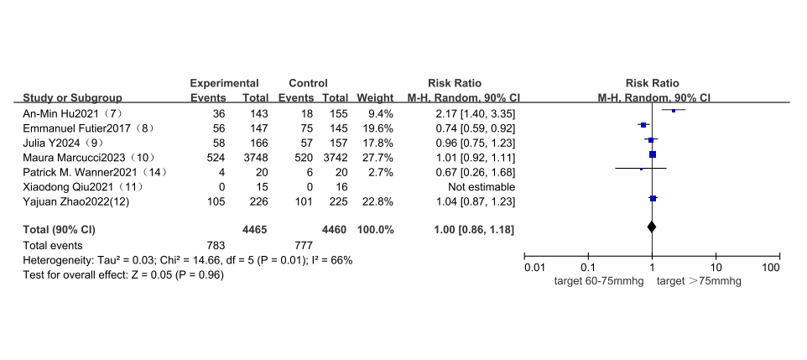
Supplementary Forest plot S1：Comparison of the primary composite outcomes for the major postoperative complications.
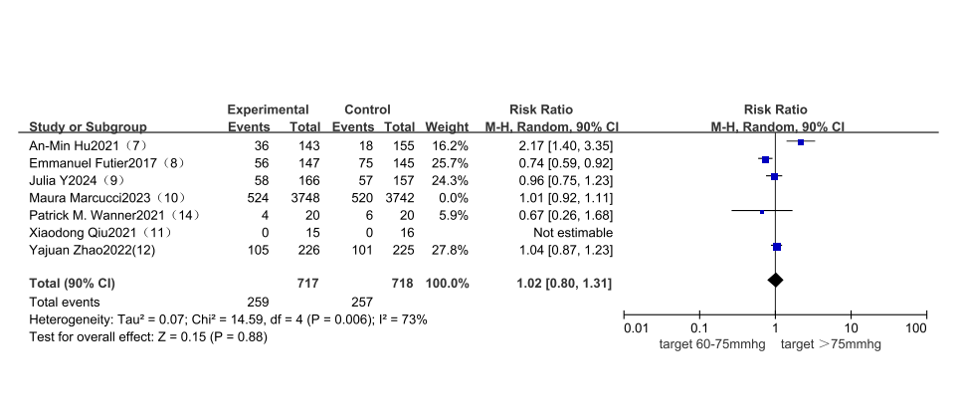
Supplementary Forest plot S1a：Comparison of the primary composite outcomes for the major postoperative complications after a larger sample study (10)was excluded.
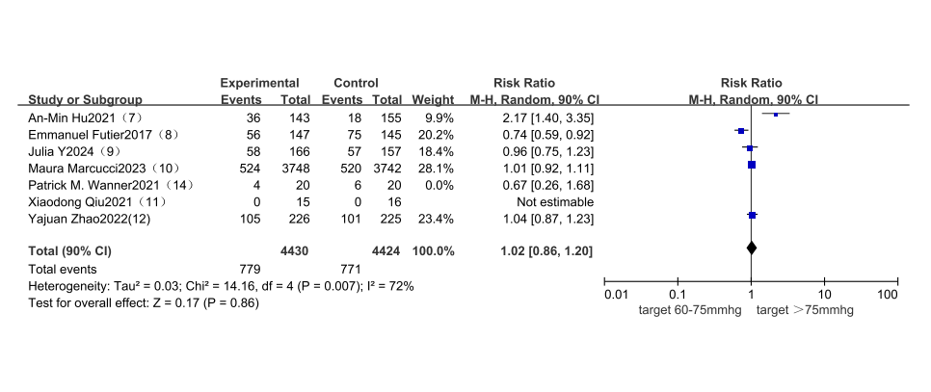
Supplementary Forest plot S1b：Comparison of the primary composite outcomes for the major postoperative complications after two smaller sample study (11,14)was excluded.
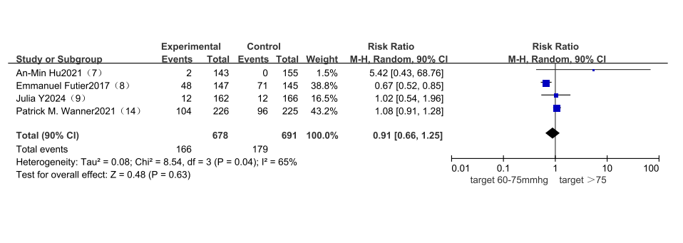
Supplementary Forest plot S2：Comparison of Acute renal function injury postoperative.
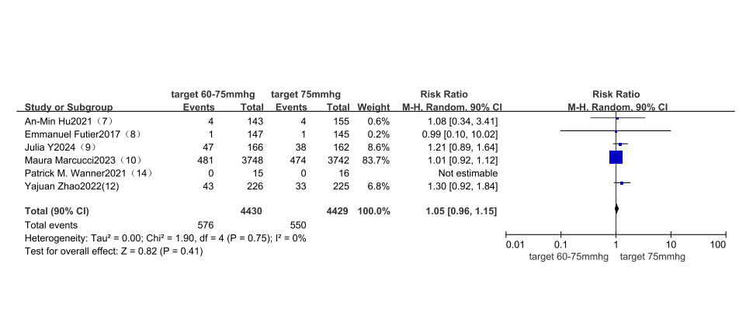
Supplementary Forest plot S3：Comparison of postoperative acute myocardial injury.
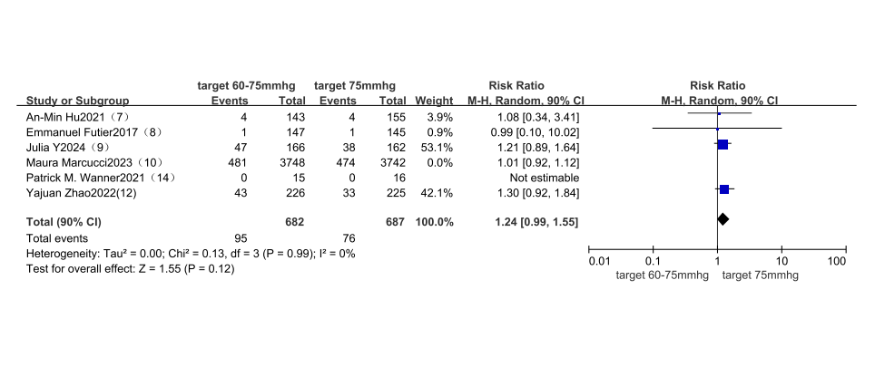
Supplementary Forest plot S3a：Comparison of postoperative acute myocardial injury after a larger sample study (10)was excluded.
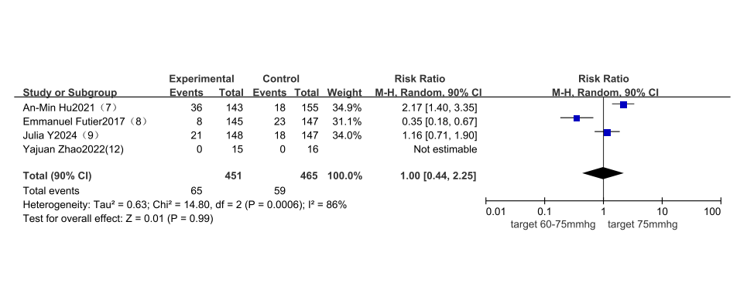
Supplementary Forest plot S4：Comparison of postoperative cognitive function changes
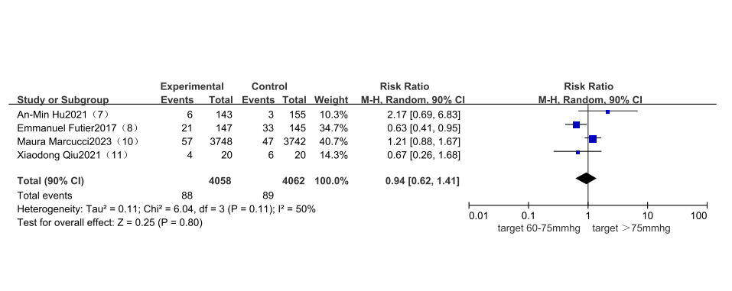
Supplementary Forest plot S5：Comparison of the incidence of postoperative infection.
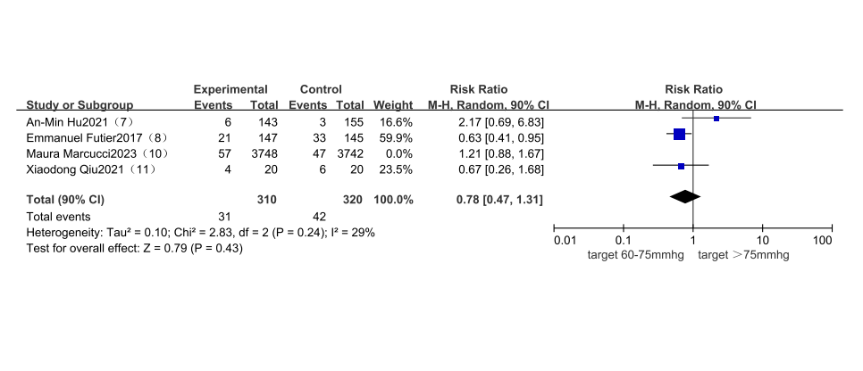
Supplementary Forest plot S5a：Comparison of the incidence of postoperative infection after a larger sample study (10)was excluded.
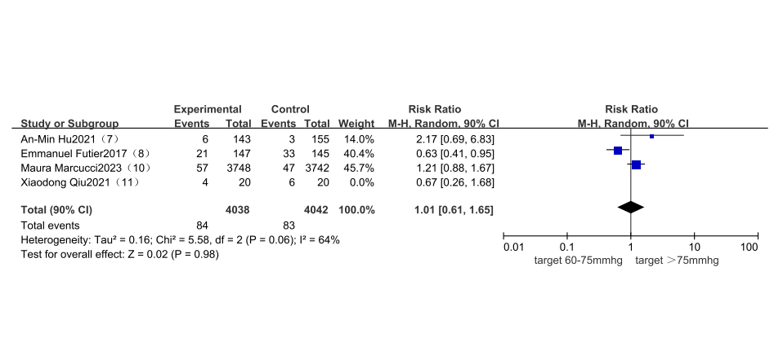
Supplementary Forest plot S5b：Comparison of the incidence of postoperative infection after a smaller sample study (11)was excluded.
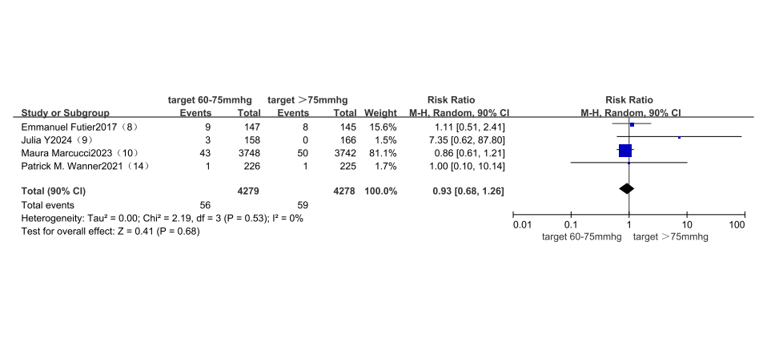
Supplementary Forest plot S6：Comparison of all-cause mortality at 30 days after surgery
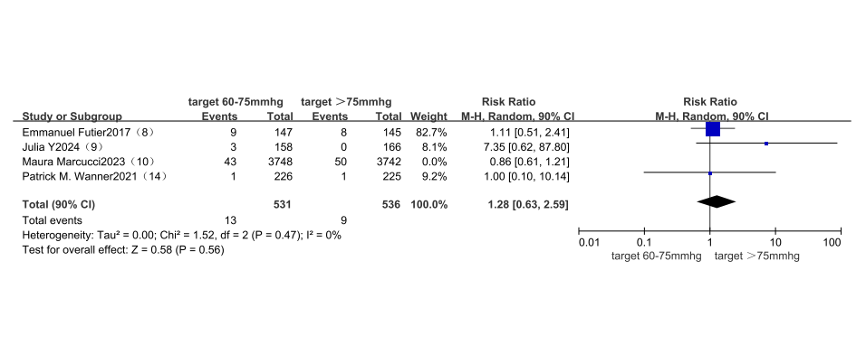
Supplementary Forest plot S6a：Comparison of all-cause mortality at 30 days after surgery after a larger sample study (10)was excluded.
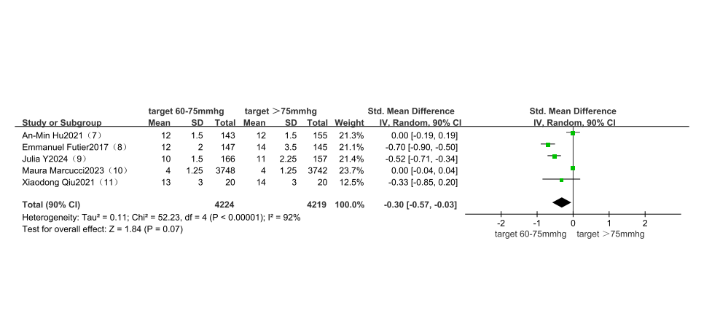
Supplementary Forest plot S7：Comparison of hospital stay length .
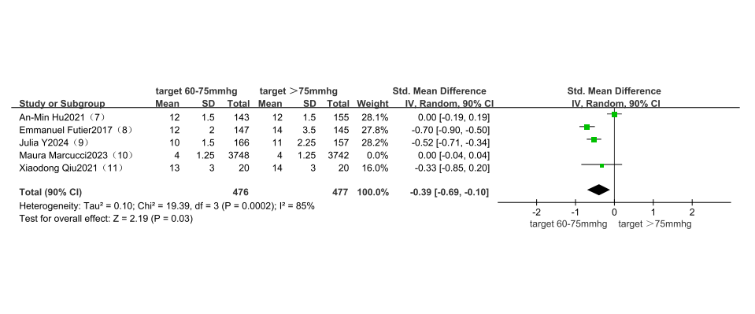
Supplementary Forest plot S7a：Comparison of hospital stay length after a larger sample study (10)was excluded.
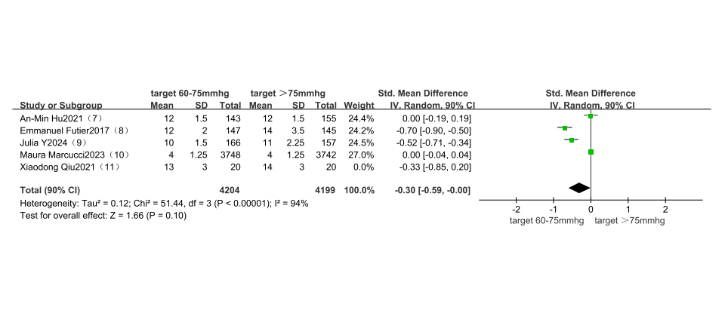
Supplementary Forest plot S7b：Comparison of hospital stay length after a smaller sample study (11)was excluded.

Funnel plots assessing the reporting bias for each comparison
Supplementary Funnel plot S1-S7：
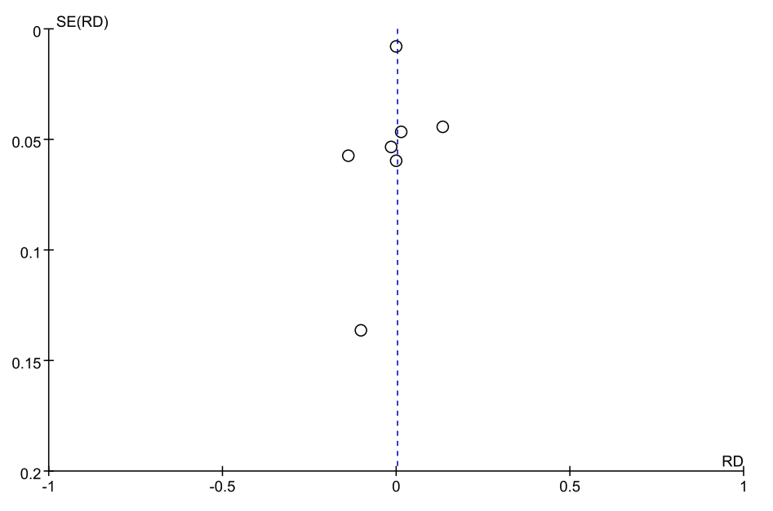
Supplementary Funnel plot S1：the reporting bias assessment for comparison of the primary composite outcomes for the major postoperative complications.
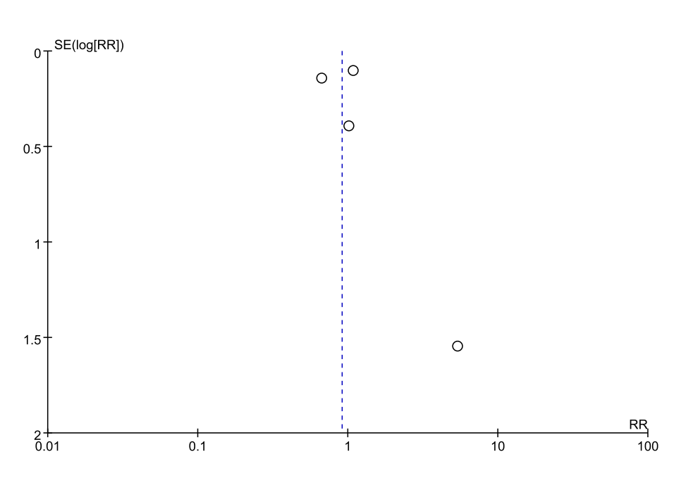
Supplementary Funnel plot S2：the reporting bias assessment for comparison of acute postoperative kidney injury.
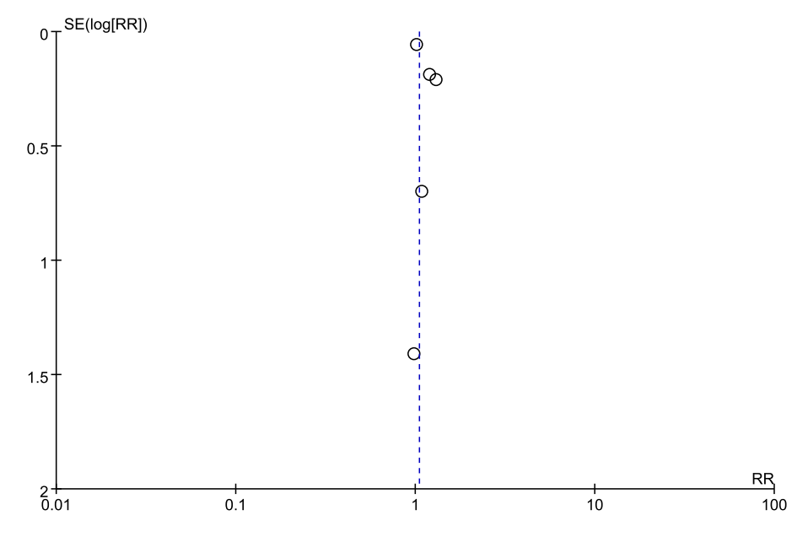
Supplementary Funnel plot S3：the reporting bias assessment for comparison of acute postoperative myocardial injury
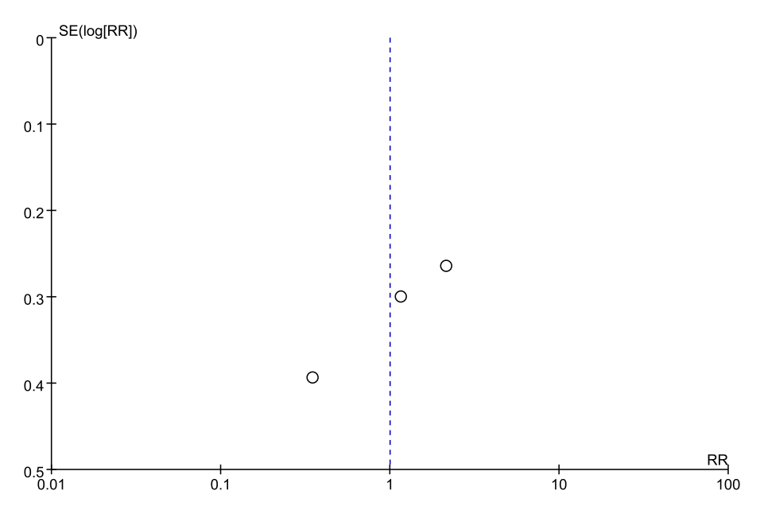
Supplementary Funnel plot S4：the reporting bias assessment for comparison of acute postoperative state of consciousness changes
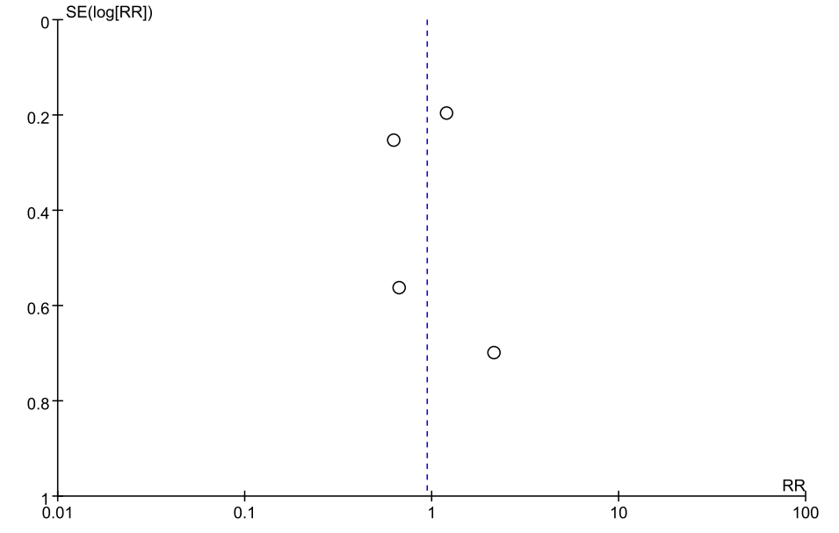
Supplementary Funnel plot S5：the reporting bias assessment for comparison of the incidence of postoperative infection.
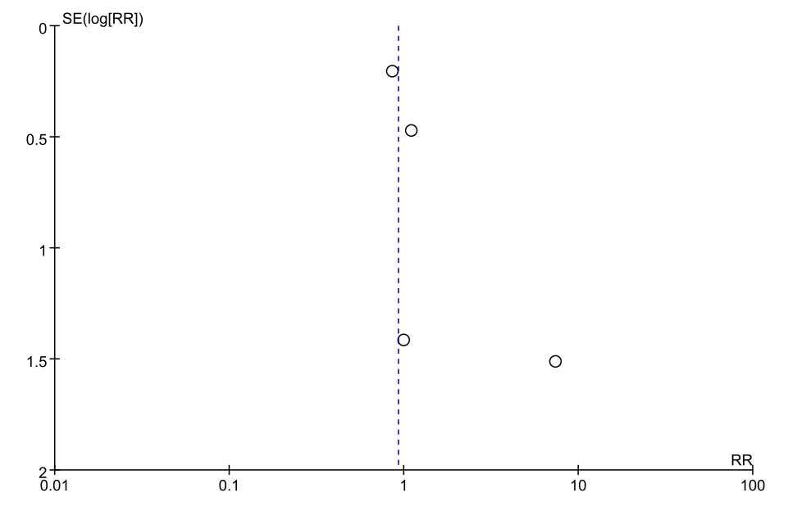
Supplementary Funnel plot S6：the reporting bias assessment for comparison of all-cause mortality at 30 days after surgery

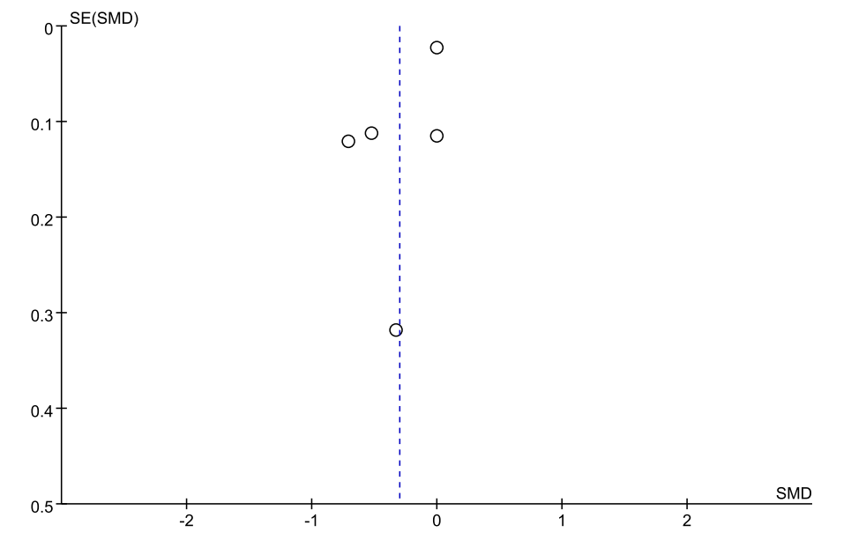
Supplementary Funnel plot S7：the reporting bias assessment for comparison of length of hospitalization.

