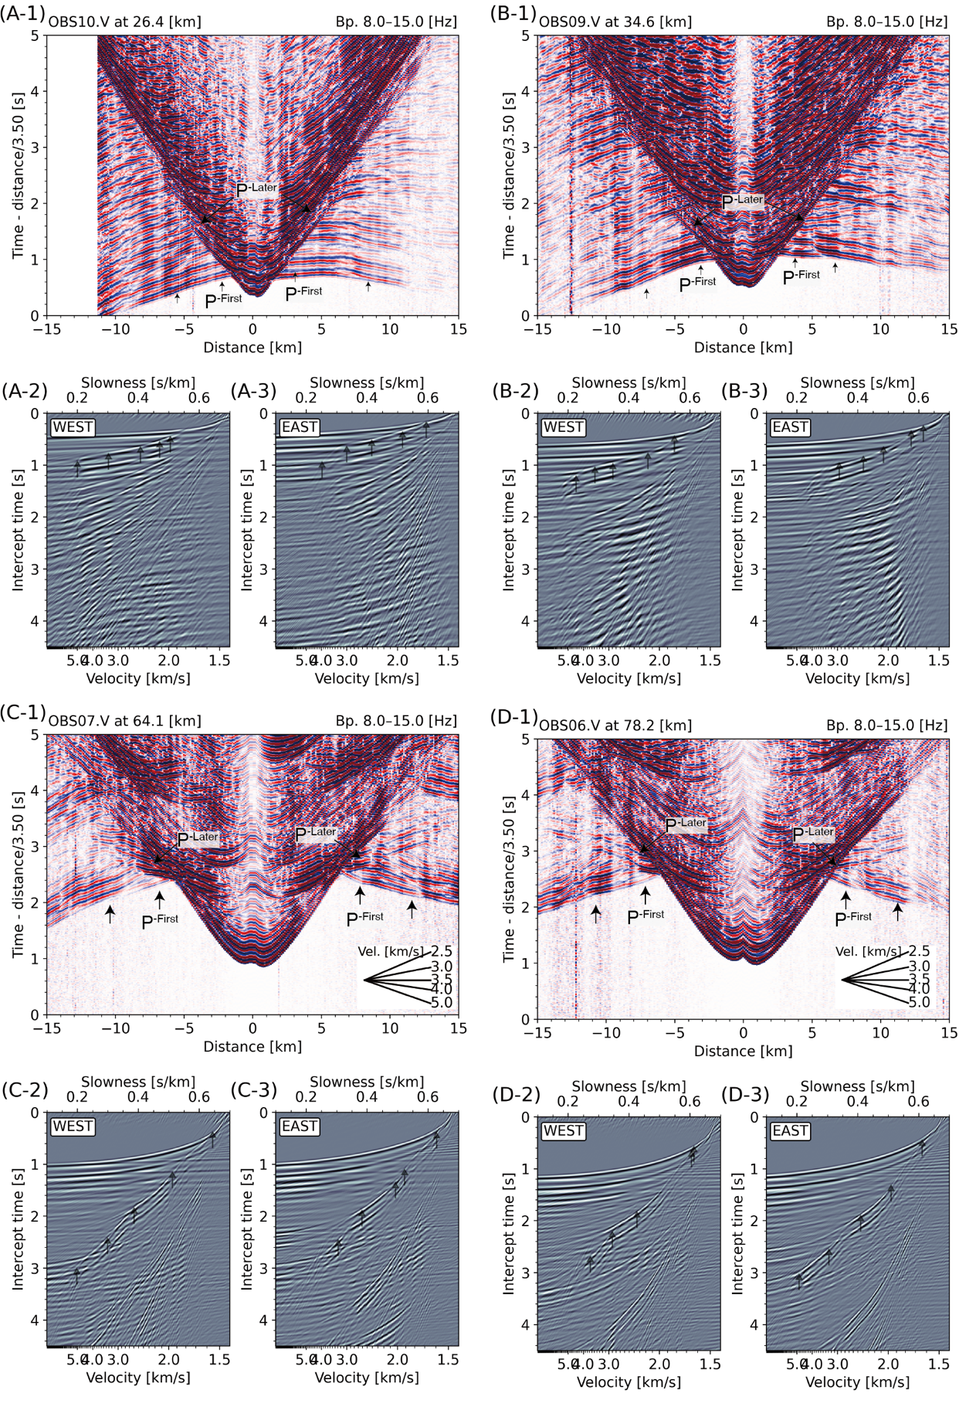
Fig. S1: Same as Fig.2, but for the vertical component data of the pop-up OBS.
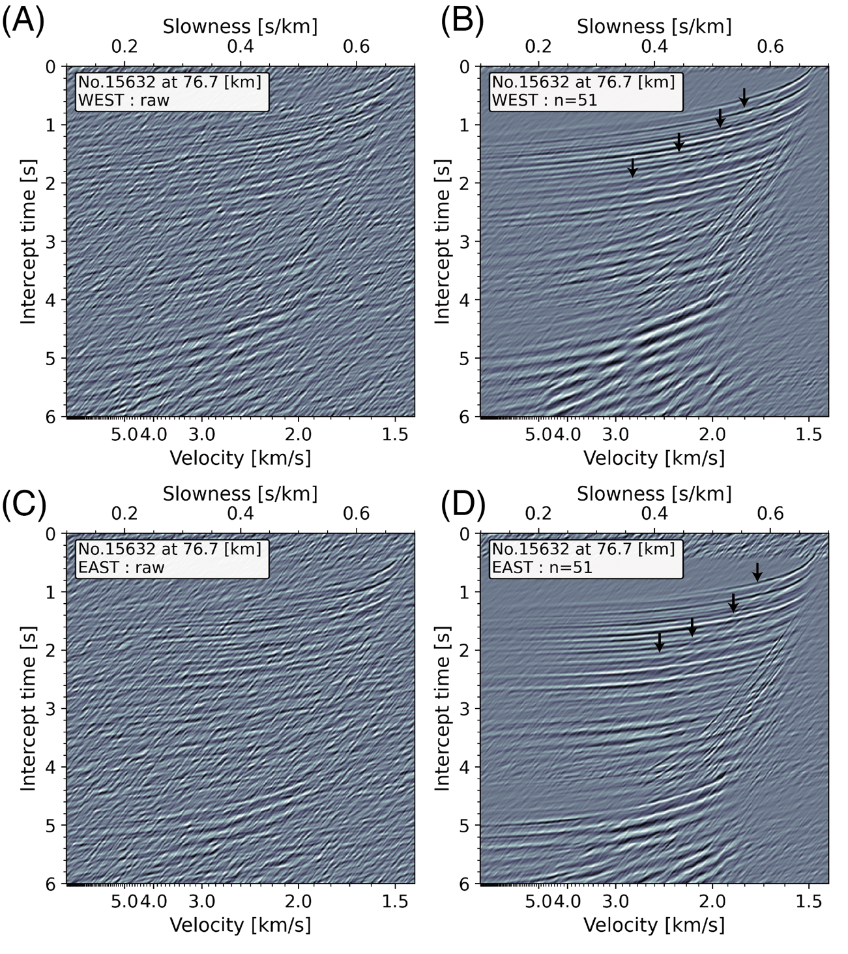
Fig. S2: Comparison of τ-p domain data converted from gathered data from adjacent 51 DAS stations in the T-X domain (B and D) with data from a single DAS station (A and C). (A) and (B) show the τ-p domain data for eastward shooting from a DAS station. (C) and (D) show the τ-p domain data for westward shooting. The gathered data in the τ-p domain has a better signal-to-noise ratio for refracted P-waves, making their trajectories clearer in (B) and (D).

