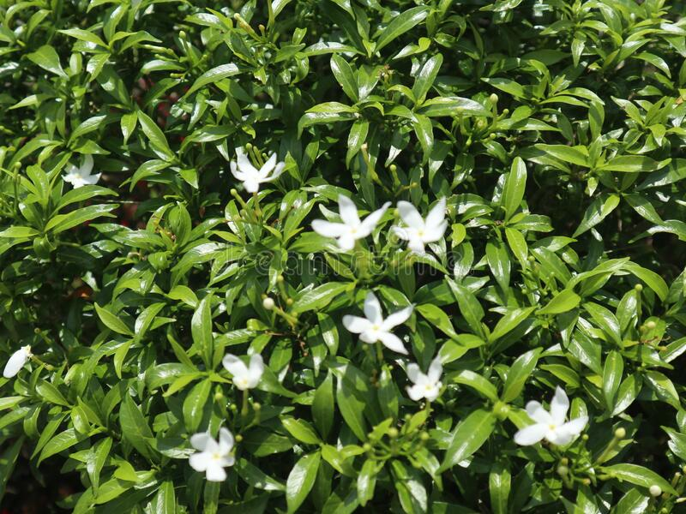
Figure 2.1 Flowering plant of Tabernaemontana divaricata

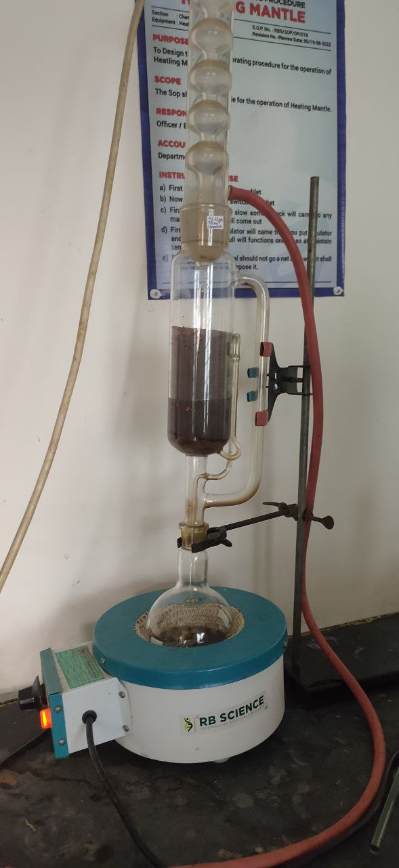

Figure 5.2 Soxhlet extraction process

Figure 6.1 Extraction yield

Figure 6.2 Calibration curve of gallic acid

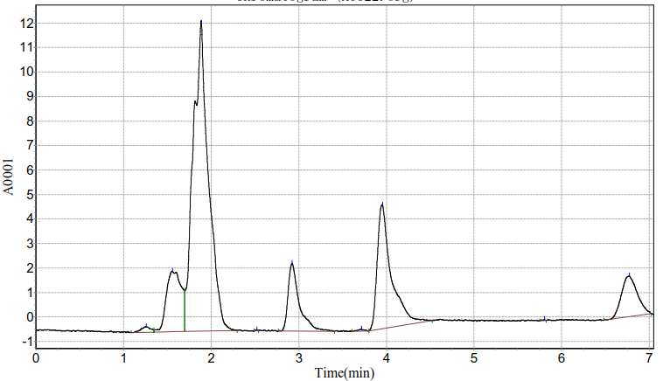

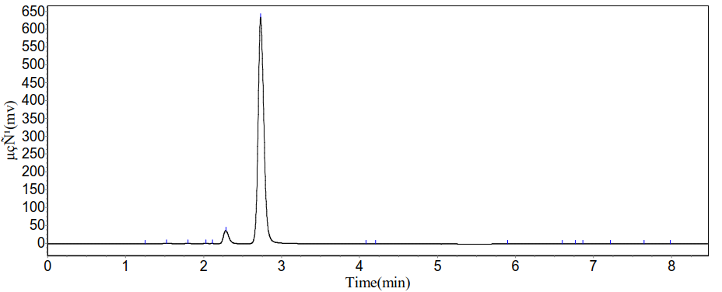

Figure 6.3b HPLC chromatogram of mangiferin

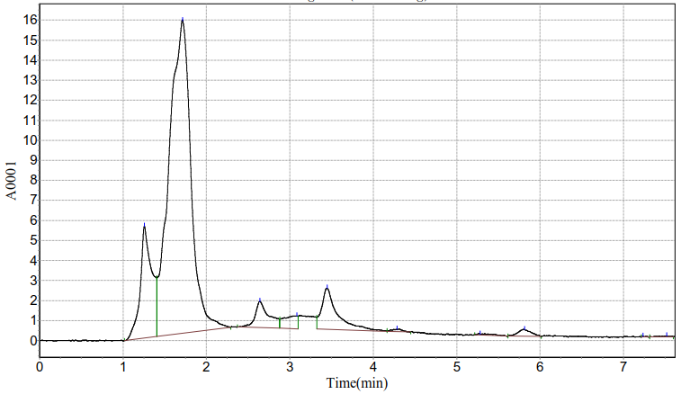

HPLC chromatogram of T. divaricata extract

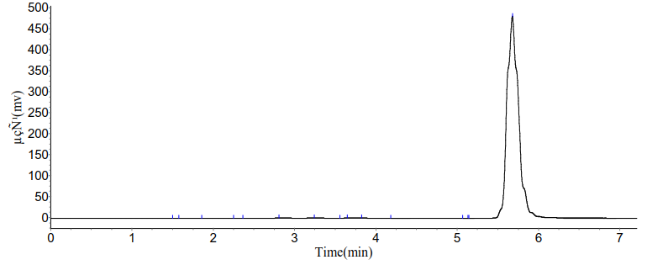

Figure 6.4b HPLC chromatogram of ß-sitosterol

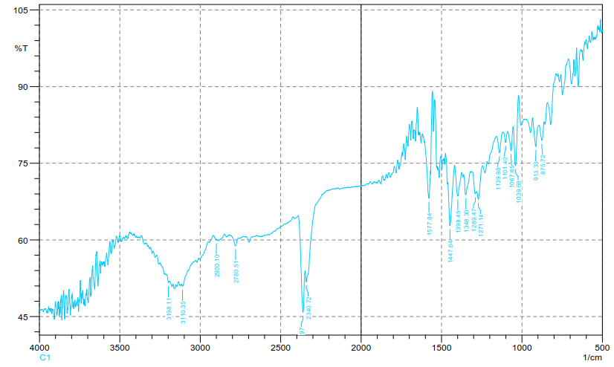
Figure 6.5a FTIR spectra of M. indica extract

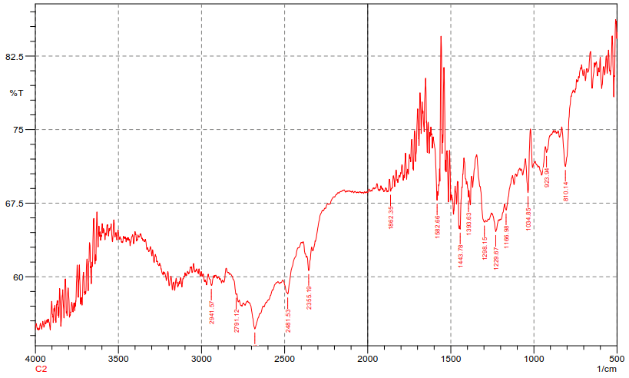
Figure 6.5b FTIR spectra of T. divaricata extracts

Figure 6.6 %DPPH inhibition by mixed and individual extracts

Figure 6.7 % Edema inhibition

