Supplementary Information for
“Has the Hainan plume interacted with the oceanic lithosphere of the South China Sea?”
Yan Li^{1,2}, Judith Bott², Shaowen Liu^{1*}, Pingchuan Tan³, Denis Anikiev²,
Magdalena Scheck-Wenderoth^{2,4}
¹MOE Key Laboratory of Coast and Island Development, School of Geography and Ocean Science, Nanjing University, Nanjing, China.
²Helmholtz Centre Potsdam - GFZ German Research Centre for Geosciences, Potsdam, Germany.
³Key Laboratory of Submarine Geosciences, Ministry of Natural Resources & Second Institute of Oceanography, Ministry of Natural Resources, Hangzhou, China.
⁴Faculty of Georesources and Materials Engineering, RWTH Aachen University, Aachen, Germany.

Context of this file:
1. Supplementary Materials and Methods
1.1 Reflection and refraction seismic profiles (Supplementary Tables, 1-2)
1.2 Time-Depth conversion formulas (Supplementary Table 3)
1.3 Vs tomography data (Supplementary Figure 1)
1.4 Conversion of shear wave velocity to temperature (Supplementary Figure 2)
1.5 Conversion of temperature to density (Supplementary Figure 3)
1.6 Sensitivity analysis (Supplementary Table 4)
1.7 Parameters of 2D thermal modeling (Supplementary Table 5)
- Supplementary Materials and Methods
1.1 Reflection and refraction seismic profiles
Supplementary Table 1: Published MCS profiles (profile locations are shown in Fig. 1 of the main text).
Name of Seismic Lines in reference | Type | Location | Available information | Reference
L1, 2, 3, 4, 5 | MCS | NW Margin | Basement, Moho | Gao et al. (2016) ¹
11e882, 11e005, 11e115, 06e286, 11e335 | MCS | NW Margin | Basement, Moho | Lei & Ren, (2016) ²
L5, 6, 8 | MCS | NW Margin | Basement, Moho | Lei et al. (2020) ³
Fig.4, 5, 6, 7, 8 | MCS | NW Margin | Basement | Mao et al. (2015) ⁴
Fig.2 | MCS | NW Margin | Basement, Moho | Wang et al. (2020) ⁵
L1, L2, L3 | MCS | NW Margin | Basement | Zhao et al. (2018a) ⁶
Line 1 | MCS | NW Margin | Basement, Moho | Zhao et al. (2018b) ⁷
L1, 2, 3, 4, 5 | MCS | NW Margin | Basement, Moho | Qiu et al. (2014) ⁸
fig.17, 18 | MCS | Northern Margin | Basement, Moho | Zhang et al. (2016) ⁹
XX’ | MCS | Northern Margin | Basement, Moho | Deng et al. (2020) ¹⁰
Fig.9 | MCS | Northern Margin | Basement | Ding et al. (2013) ¹¹
L1, 2, 3, 4 | MCS | Northern Margin | Basement, Moho | Gao et al. (2015) ¹²
S1, 2, 3 | MCS | Northern Margin | Basement | Guo et al. (2016a) ¹³
L4, 6, 8 | MCS | Northern Margin | Basement, Moho | Hu et al. (2009) ¹⁴
L5, 6 | MCS | NE Margin | Basement | Lei et al. (2018) ¹⁵
ZJK2012-1-2 | MCS | Northern Margin | Basement, Moho | Lei et al. (2019a) ¹⁶
ZJK2012-3 | MCS | NE Margin | Basement | Lei et al. (2019b) ³
L1, 2, 4 | MCS | Northern Margin | Basement | Leyla et al. (2015) ¹⁷
Fig.5 | MCS | Northern Margin | Basement, Moho | Li et al. (2022) ¹⁸
S1, 2, 3 | MCS | Northern Margin | Basement | Sun et al. (2014a) ¹⁹
Fig.10 | MCS | NE Margin | Basement | Wu et al. (2014) ²⁰
AB; CD | MCS | Northern Margin | Basement | Xie et al. (2019) ²¹
L3, 8 | MCS | Northern Margin | Basement | Xie et al. (2021) ²²
Fig.2 | MCS | Northern Margin | Basement, Moho | Zhang et al. (2021) ²³
AA’, CC’, EE’, GG’ | MCS | Northern Margin | Basement, Moho | Zhao et al. (2020a) ²⁴
Fig.1e, 1d | MCS | Northern Margin | Basement | Zhao et al. (2020b) ²⁵
P1, 2, 3 | MCS | Northern Margin | Basement | Zhu et al. (2012) ²⁶
Line 01, 02, 03 | MCS | Northern Margin | Basement | Dong et al. (2008) ²⁷
BB’ | MCS | Northern Margin | Basement | Sun et al. (2014b) ²⁸
MCS693-6, 693-4, 693-3, 693-1, 689-3a, 689-4 | MCS | NE Margin | Basement | Ku & Hsu, (2009) ²⁹
973G | MCS | NE Margin | Basement | Li et al. (2007) ³⁰
A, B, E | MCS | NE Margin | Basement | Li et al. (2008) ³¹
T1, T2, T3 | MCS | NE Margin | Basement, Moho | Wen et al. (2021) ³²
MCS645-4, 645-3, 645-2, 645-1, 689-1, 689-4b, 689-3a, ACT111, ACT110, 108, 105, 099a, 103, 101, | MCS | NE Margin | Basement | Yeh & Hsu, (2004) ³³
MGL0905-04, 0905-05, 0905-25A, 0908-04 | MCS | NE Margin | Basement, Moho | Yeh et al. (2012) ³⁴
Line1, 2 | MCS | NW Margin | Basement | Gao et al. (2023) ³⁵
SO27-04 | MCS | SW Margin | Basement | Ding et al. (2013) ³⁶
NH973-2 | MCS | S Margin | Basement | Ding et al. (2014) ³⁶
DPS93-2 | MCS | S Margin | Basement | Ding et al. (2015) ³⁷
BGR01-01, 01-02, 01-10, 01-06, 01-07 | MCS,  OBS (01-07) | SW Margin | Basement,  Moho (01-07) | Franke et al. (2008) ³⁸
BGR08-104, 08-109 | MCS | SE Margin | Basement, Moho | Franke et al. (2011) ³⁹
AB, CD, ST, QR, EF, GH, KL, YZ, | MCS | SW Margin | Basement | Hutchison, (2010) ⁴⁰
L1, 2, 3, 4, 5, 6, 7, 8 | MCS | SW Margin | Basement | Peng et al. (2019) ⁴¹
S1, S2 | MCS | SE Margin | Basement, Moho | Peng et al. (2020) ⁴²
Fig.3, 4a, 4b, 6 | MCS | SW Margin | Basement, Moho (4a, 4b) | Steuer et al. (2014) ⁴³
Fig.4, 5, 6, 7A, 7B, 8 | MCS | SE Margin | Basement, Moho (6, 7A, 7B, 8) | Tong et al. (2019) ⁴⁴
L1, 2, 3 | MCS | S Margin | Basement | Wang et al. (2022) ⁴⁵
AA’ | MCS | S Margin | Basement | Xu et al. (2019) ⁴⁶
DZ02 | MCS | SW Margin | Basement | Zhang et al. (2020a) ⁴⁷
M17B | MCS | S Margin | Basement, Moho | Zhang et al. (2020b) ⁴⁸
90N09, 94N07 | MCS | S Margin | Basement | Sun et al. (2011) ⁴⁹
HYML320, HYM390, HYM1010 | MCS | ESB | Basement | Zhao et al. (2022) ⁵⁰
CGN-1 | MCS | NWSB | Basement, Moho | Chao et al. (2021) ⁵¹
Line A, B, C, D, E, F, G | MCS | NWSB | Basement, Moho | Chao et al. (2022) ⁵²
nw1, nw2, nw3 | MCS | NWSB | Basement | Song et al. (2019) ⁵³
SO49-17, SO49-18, SO49-25, 97303 | MCS | NWSB | Basement | Wu et al. (2020) ⁵⁴
Line7, 9 | MCS | SWSB, ESB | Basement | Cao et al. (2017) ⁵⁵
CFT-N | MCS | NW Margin, SWSB | Basement, Moho | Chang et al. (2022) ⁵⁶
N3, 7, 10, 16, 973-1 | MCS | SWSB | Basement | Ding et al. (2016) ⁵⁷
Line A, B | MCS | SWSB | Basement, Moho (A) | Luo et al. (2021) ⁵⁸
Line PKGE 09_09, PKBE 09_08, PKI09_11, PKG09_03, PKG09_09, PKBE09 08_57 | MCS | NW Margin | Basement, Moho | Savva et al. (2013) ⁵⁹
SO49-22, SO49-23 | MCS | SWSB | Basement | Wu et al. (2018) ⁶⁰
Z1 | MCS | SWSB | Basement | Wang et al. (2021) ⁶¹
N3, N4 | MCS | ESB | Basement, Moho | Ding et al. (2018) ⁶²
N2 | MCS | NE Margin | Basement, Moho | Ding et al. (2020) ⁶³
BC, DE, FG | MCS | ESB | Basement | Li et al. (2008) ⁶⁴

Supplementary Table 2: Published OBS profiles (profile locations are shown in Fig. 1 of the main text).

Name of Seismic Lines  in reference | Location | Available information | Reference
ESP-W | NW margin | Basement, Moho | Nissen et al. (1995) ⁶⁵
OBH-IV | NW margin | Basement, Moho | Qiu et al. (2001) ⁶⁶
OBS2006-1 | NW margin | Basement, Moho | Wu et al. (2012) ⁶⁷
OBS2006-2 | NW margin | Basement, Moho | Wang et al. (2020) ⁶⁸
OBS2011-1 | NW margin | Basement, Moho | Huang et al. (2019) ⁶⁹
OBS2013-1 | NW margin | Basement, Moho | Huang et al. (2021) ⁷⁰
OBS2013-3 | NW margin | Basement, Moho | Guo et al. (2016b) ⁷¹
OBS2017-2 | NW margin | Basement, Moho | Li et al. (2021) ⁷²
OBS2011-2 | NW margin | Basement, Moho | Xia et al. (2022) ⁷³
OBS2010-1 | NE margin | Basement, Moho | Cao et al. (2014) ⁷⁴
OBS2010-2 | NE margin | Basement, Moho | Zhu et al. (2018) ⁷⁵
L2 & OBS2015-3D | NE margin | Basement, Moho | Lv et al. (2020) ⁷⁶
OBS1993 | NE margin | Basement, Moho | Yan et al. (2001) ⁷⁷
OBS2006-3 | NE margin | Basement, Moho | Wei et al. (2011) ⁷⁸
OBS2001 | NE margin | Basement, Moho | Wang et al. (2006) ⁷⁹
T3 | NE margin | Basement, Moho | Lester et al., (2014) ⁸⁰
MGL0905_10 & MGL0908_3 | NE margin | Basement, Moho | McIntosh et al. (2014) ⁸¹
OBS2012 | NE margin | Basement, Moho | Wan et al. (2017) ⁸²
OBS2014-3D (NS5, NS7, NS8) | NE margin | Basement, Moho | Fan et al., (2019) ⁸³
OBS2015-1 | NE margin | Basement, Moho | Li et al. (2017) ⁸⁴
OBS2016-2 | NE margin | Basement, Moho | Wan et al. (2019) ⁸⁵
OBS2019-1 | NE margin | Basement, Moho | Liu et al. (2021) ⁸⁶
MGL0905_27 | MT | Basement, Moho | Lester et al. (2013) ⁸⁷
Line T1 (MGL0905_25A) &  Line T2 (MGL0902_23) | MT | Basement, Moho | Eakin et al. (2014) ⁸⁸
T4A & T2933 | MT | Basement, Moho | McIntosh et al. (2013) ⁸⁹
OBS2015-2 | MT | Basement, Moho | Liu et al. (2018) ⁹⁰
OBS973-1 | South margin | Basement, Moho | Qiu et al. (2011) ⁹¹
OBS973-2 | South margin | Basement, Moho | Ruan et al. (2011) ⁹²
PR1 & PR2 | NW/South margin, SWSB | Basement, Moho | Pichot et al. (2014) ⁹³
DZ01 | SW margin | Basement, Moho | Wei et al. (2020) ⁹⁴
OBS2010-3D-T1 | ESB | Basement, Moho | Zhang et al. (2020) ⁹⁵
OBS2011-3D-P4 | ESB | Basement, Moho | Zhao et al. (2018) ⁹⁶
OBS2013-ZN, OBS2014-ZN | ESB | Basement, Moho | Ruan et al. (2016) ⁹⁷

1.2 Time-depth conversion formulas

Supplementary Table 3. Time-Depth Conversion Formulas (a: b.s.f, below seafloor; b: b.s.b, below sediment basement).
Strata | Region | Time to depth formula | Unit (t, z) | Reference
Sedimentary | ESB | z = 0.000188295 t² + 0.695896 t | ms, m b.s.fª | Li et al. (2015)⁹⁸
Sedimentary | SWSB | z = 0.000152626 t² + 0.714658 t | ms, m b.s.f | Li et al. (2015)⁹⁸
Sedimentary | NWSB | z = 0.0003 t² + 0.7155 t – 2.4959 | ms, m b.s.f | Sun et al. (2018)⁹⁹
Sedimentary | Continental Margin | z = 946 t^{1.447} + 124 | s, m b.s.f | Zhou et al. (2008)¹⁰⁰
Crystalline crust | SCS | z = 0.1801t²+2.8533t–0.5807 | ms, km b.s.b^{b} | Huang et al. (2023)¹⁰¹

1.3 Vs tomography data
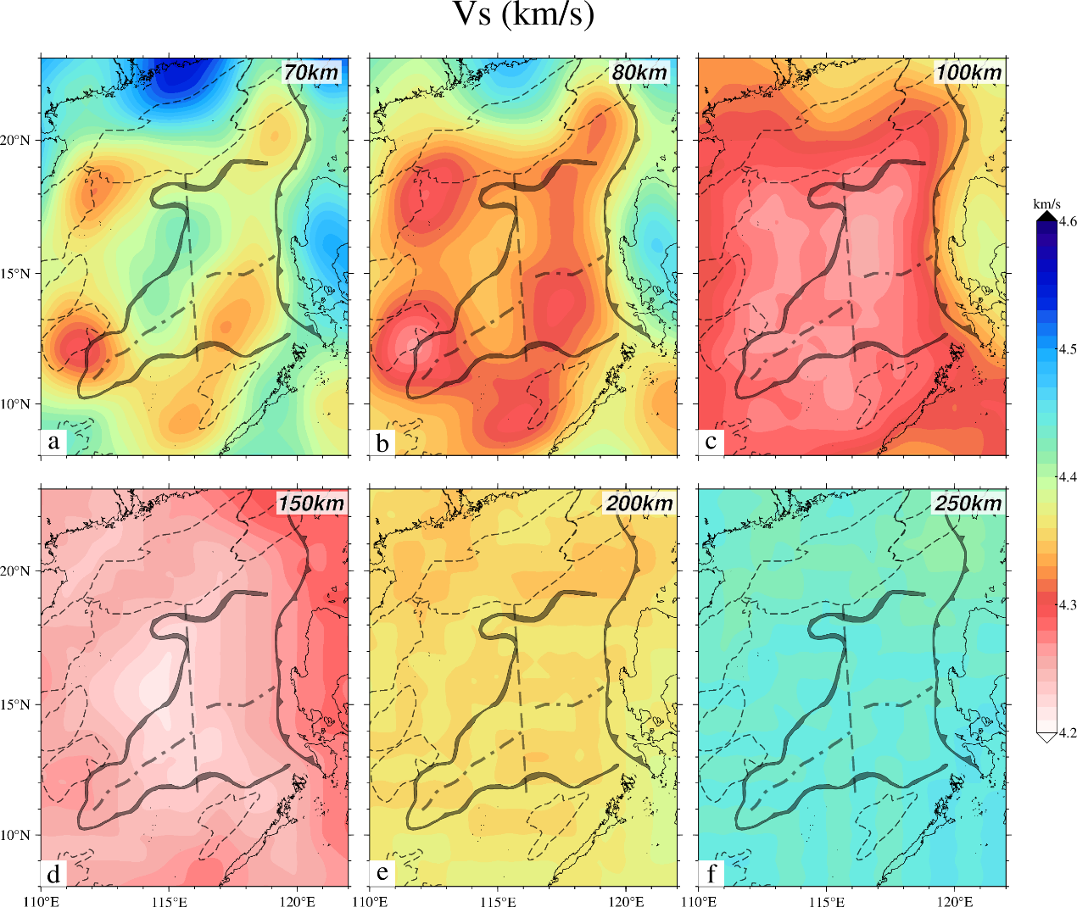
Supplementary Figure 1. Detail mantle S-wave velocity structure¹⁰². Depth slices of the Vs distribution at various depths (a-f).

  - Conversion of shear wave velocity to temperature
Priestley and McKenzie¹⁰³ developed empirical equations and constants to relate shear wave velocity in the oceanic lithosphere to temperature, using an average shear wave velocity model alongside a generic thermal model for the Pacific. Their conversion approach is grounded in the premise that the shear wave velocity structure of the oceanic upper mantle is predominantly influenced by temperature, pressure, and certain activation processes associated with elastic behavior near melting temperatures. Although the presence of retained melt at low concentrations is anticipated to have minimal effects, this nonlinear relationship between shear wave velocity and temperature is considered applicable to various mantle compositions, with the highest accuracy for temperatures above 1100 °C.
  - 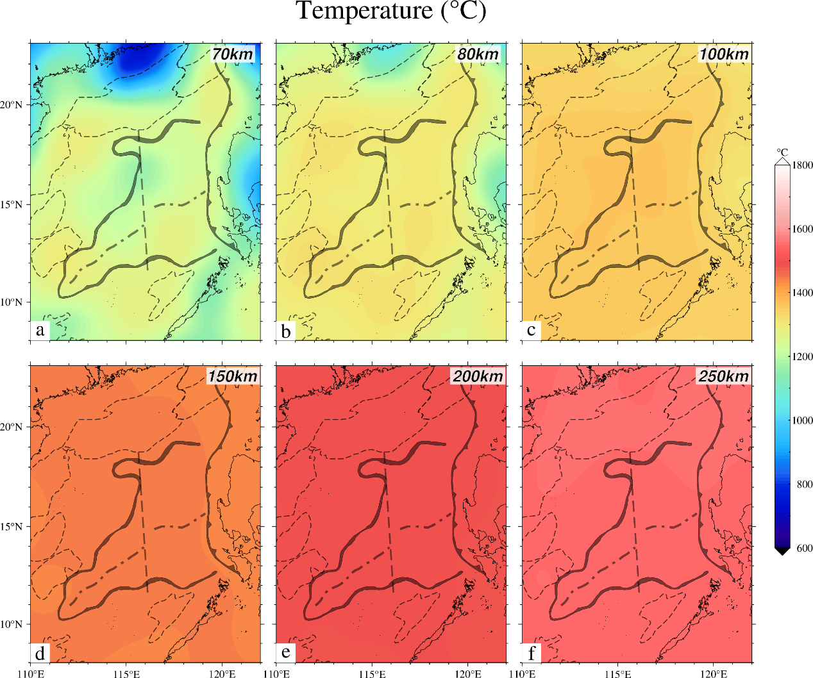
Supplementary Figure 2. Detail mantle temperature structure converted from Vs data. Depth slices of the temperature distribution at various depths (a-f).

1.5 Conversion of temperature to density
Bai et al¹⁰⁴. proposed a set of equations to calculate the density of mantle rock at a given pressure and temperature, taking into account the measurements of thermal expansivity $α_{T}$ and bulk modulus $K_{T}$. Accordingly, the mantle density at temperature $T$ is given by equation (1),
$$\begin{aligned}ρ_{T}=ρ_{0}\left[1-α_{T}\left(T-T_{0}\right)\right]\#\left(1\right)\end{aligned}$$
where $T_{0}$ is 273 $K$, and $ρ_{0}$ is the reference density of the mantle (3300 kg/m³) at $T_{0}$. Bai et al¹⁰⁴. estimated the relationship between $α$ and $T$ using a nonlinear temperature function, as shown in equation (2),
$$\begin{aligned}α_{T}=\left(6{×10}^{-10} T^{3}-2×{10}^{-6} T^{2}+0.0039T+1.727\right)×{10}^{-5}\#\left(2\right)\#\end{aligned}$$
The bulk modulus $K$, indicative of the pressure change needed for a specific volume change, can be determined as a function of temperature¹⁰⁵, as presented in equation (3),
$$\begin{aligned}K_{T}=127.97-0.0232\left(T-300\right)\#\left(3\right)\end{aligned}$$
where the units for $K_{T}$ and $T$ are gigapascal and Kelvin, respectively. Density changes related to in situ pressure ($∆ρ_{P}$) at a specific pressure ($P$) and bulk modulus ($K$) are calculated using the formula in equation (4),
$$\begin{aligned}∆ρ_{P}=\frac{ρ_{0}\left[P-P_{0}\right]}{K_{T}}\#\left(4\right)\end{aligned}$$
where $P_{0}$ denotes standard atmospheric pressure, and the unit for $P$ is gigapascal. Ultimately, the mantle density for a specific temperature and pressure is computed as in equation (5),
$$\begin{aligned}ρ=ρ_{T}+∆ρ_{P}\#\left(5\right)\end{aligned}$$

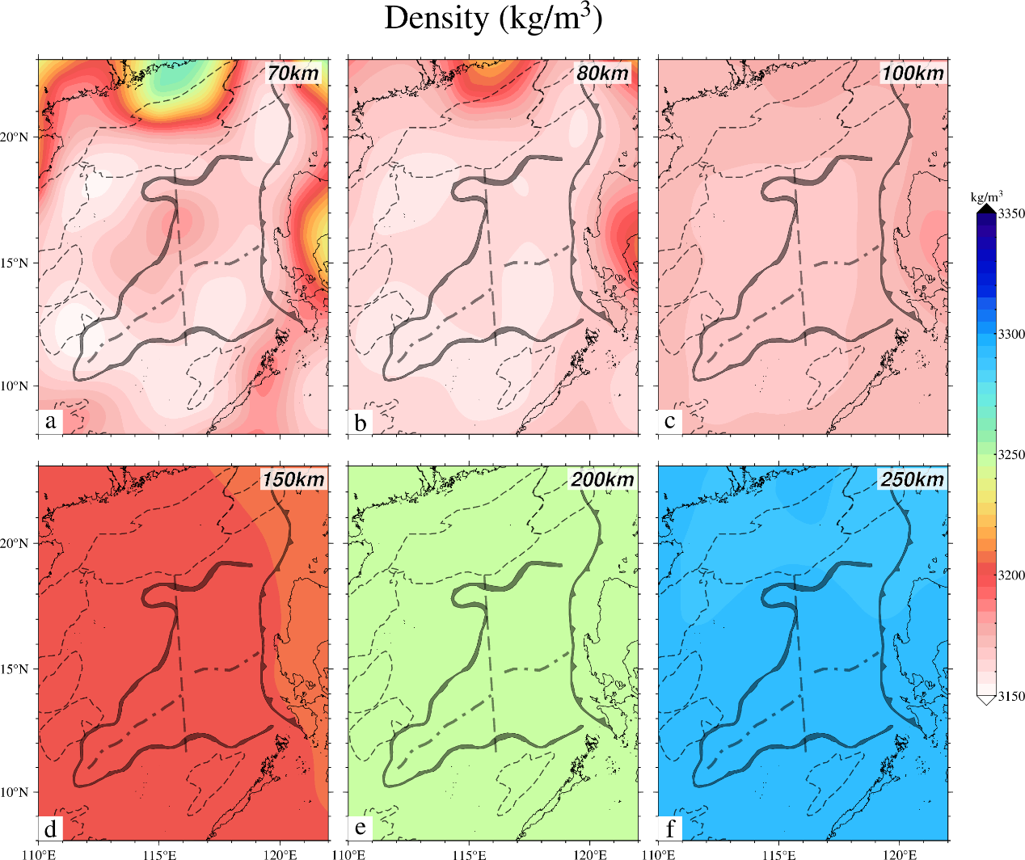
Supplementary Figure 3. Detail mantle density structure converted from temperature. Depth slices of the density distribution at various depths (a-f).

1.6 Sensitivity analysis
We conducted sensitivity tests on the gravity response of our model by interatively varying layer densities and thicknesses, thereby focusing on three distinct domains: N-ESB, S-ESB, and SWSB. Supplementary Table 4 summarizes the tested models by providing information on the performed modifications of specific parameters and the corresponding difference in the calculated gravity response and in the lithospheric mantle density.
Given that the basement depth is relatively well-constrained due to the limited sediment thickness and robust seismic data, we evaluated two scenarios: (i) setting the basement depth equal to the bathymetry, and (ii) shifting it downward by 1.5 km. For the oceanic crust, where seismic data coverage is sparse, the Moho depth uncertainty is estimated at ±2 km. Regarding sediment density, we explored an unrealistic end-member scenario by assuming a largely compacted sediment sequence with a density of 2600 kg/m³. For the crustal units, we tested extreme density values derived from Ocean Bottom Seismometer (OBS) data, as detailed in Supplementary Table 3.
For each modified model scenario, we calculated the gravity response and quantified the differences relative to our preferred model. These differences are summarized as average values in Supplementary Table 4. Despite testing extreme variations in parameters, the range of response differences obtained is significantly smaller than the gravity misfit distribution calculated for a homogeneous mantle (Fig. 3c, in main text). Furthermore, the performed adjustments of input parameters overall result in changes to the inverted lithospheric mantle densities of less than ±10 kg/m³.

Supplementary Table 4. Sensitivity analysis of various parameters of the sedimentary and crustal model on the gravity response and the resulting variation in lithospheric mantle density. Density differences are with respect to the density configuration of the 3D structural model after performing the gravity field inversion.
 | Parameter | Imposed variation | Gravity response differences (mGal) |  |  | Lithospheric mantle density variation (kg/m³)
 | Parameter | Imposed variation | N-ESB | S-ESB | SWSB | N-ESB | S-ESB | SWSB
Z | Basement | Equal to bathymetry | 5 | 3 | 3 | ＜5 | ＜5 | ＜5
 | Basement | +1.0 km | 3 | 2 | 2 | ＜5 | ＜5 | ＜5
 | Moho | ±2 km | $∓$15 | $∓$13 | $∓$12 | ±7 | ＜±5 | ＜±5
$$ρ$$ | Sediment | Assigned 2600 kg/m³ | 3 | 2 | 2 | ＜5 | ＜5 | ＜5
 | Oceanic | ±20 kg/m³ | ±20 | ±15 | ±13 | $∓$12 | ＜$∓$10 | ＜$∓$10

  - Parameters of 2D Thermal Modeling
Supplementary Table 5. Properties of the lithosphere assumed for thermal modeling
Parameter | Value
Compensation depth | 125 km
Temperature at top | 0 °C
Temperature at compensation depth | 1330 °C
Thermal conductivity | 3.1 W m⁻¹ K⁻¹
Thermal diffusivity | 0.7-1.3×10⁻⁶ m² s⁻¹
Internal heat production | 0 W
Volume thermal expansion coefficient | 3.2×10⁻⁵ K⁻¹
Density at 0 °C | 3.33 Mg m⁻³

Supplementary Reference:
1. Gao, J. et al. Crustal structure and extension mode in the northwestern margin of the South China Sea. Geochemistry, Geophysics, Geosystems 17, 2143–2167 (2016).
2. Lei, C. & Ren, J. Hyper-extended rift systems in the Xisha Trough, northwestern South China Sea: Implications for extreme crustal thinning ahead of a propagating ocean. Marine and Petroleum Geology 77, 846–864 (2016).
3. Lei, C., Alves, T. M., Ren, J. & Tong, C. Rift Structure and Sediment Infill of Hyperextended Continental Crust: Insights From 3D Seismic and Well Data (Xisha Trough, South China Sea). Journal of Geophysical Research: Solid Earth 125, e2019JB018610 (2020).
4. Mao, K., Xie, X., Ren, J. & Chen, H. Post-rift tectonic reactivation and its effect on deep-water deposits in the Qiongdongnan Basin, northwestern South China Sea. Marine Geophysical Research 36, 227–242 (2015).
5. Wang, L. et al. Seismic characteristics and mechanism of fluid flow structures in the central depression of Qiongdongnan basin, northern margin of South China Sea. International Geology Review (2020).
6. Zhao, Z., Sun, Z., Sun, L., Wang, Z. & Sun, Z. Cenozoic tectonic subsidence in the Qiongdongnan Basin, northern South China Sea. Basin Research 30, 269–288 (2018).
7. Zhao, Z., Sun, Z., Liu, J., Pérez-Gussinyé, M. & Zhuo, H. The continental extension discrepancy and anomalous subsidence pattern in the western Qiongdongnan Basin, South China Sea. Earth and Planetary Science Letters 501, 180–191 (2018).
8. Qiu, N. et al. Tectonostratigraphic structure and crustal extension of the Qiongdongnan basin, northern South China Sea. Chinese Journal of Geophysics 57, 3189–3207 (2014).
9. Zhang, Q., Wu, S. & Dong, D. Cenozoic magmatism in the northern continental margin of the South China Sea: evidence from seismic profiles. Mar Geophys Res 37, 71–94 (2016).
10. Deng, H. et al. South China Sea documents the transition from wide continental rift to continental break up. Nat Commun 11, 4583 (2020).
11. Ding, W., Li, J., Li, J., Fang, Y. & Tang, Y. Morphotectonics and evolutionary controls on the Pearl River Canyon system, South China Sea. Mar Geophys Res 34, 221–238 (2013).
12. Gao, J. et al. The continent–ocean transition at the mid-northern margin of the South China Sea. Tectonophysics 654, 1–19 (2015).
13. Guo, L. L. et al. Final breakup of continental block and opening of oceanic lithosphere: insights from deep crustal structure and tectonic evolution of the ocean–continent transition zone in the northern South China Sea. Geological Journal 51, 318–330 (2016).
14. Hu, D. et al. Crustal structure and extension from slope to deepsea basin in the northern South China Sea. J. Earth Sci. 20, 27–37 (2009).
15. Lei, C., Ren, J., Pang, X., Chao, P. & Han, X. Continental rifting and sediment infill in the distal part of the northern South China Sea in the Western Pacific region: Challenge on the present-day models for the passive margins. Marine and Petroleum Geology 93, 166–181 (2018).
16. Lei, C. et al. Depositional architecture and structural evolution of a region immediately inboard of the locus of continental breakup (Liwan Sub-basin, South China Sea). GSA Bulletin 131, 1059–1074 (2019).
17. Leyla, B. H., Ren, J., Zhang, J. & Lei, C. En Echelon Faults and Basin Structure in Huizhou Sag, South China Sea: Implications for the Tectonics of the SE Asia. J. Earth Sci. 26, 690–699 (2015).
18. Li, G. et al. Magmatism within the northern margin of the South China Sea during the post-rift stage: An overview, and new insights into the geodynamics. Earth-Science Reviews 225, 103917 (2022).
19. Sun, Z. et al. The mechanism of post-rift fault activities in Baiyun sag, Pearl River Mouth basin. Journal of Asian Earth Sciences 89, 76–87 (2014).
20. Wu, S. et al. Post-rift uplift and focused fluid flow in the passive margin of northern South China Sea. Tectonophysics 615–616, 27–39 (2014).
21. Xie, X., Ren, J., Pang, X., Lei, C. & Chen, H. Stratigraphic architectures and associated unconformities of Pearl River Mouth basin during rifting and lithospheric breakup of the South China Sea. Mar Geophys Res 40, 129–144 (2019).
22. Xie, H. et al. Lithospheric stretching-style variations and anomalous post-rift subsidence in the deep water sub-basins of the Pearl River Mouth Basin, northern South China Sea. Marine and Petroleum Geology 131, 105140 (2021).
23. Zhang, C. et al. Syn-rift magmatic characteristics and evolution at a sediment-rich margin: Insights from high-resolution seismic data from the South China Sea. Gondwana Research 91, 81–96 (2021).
24. Zhao, Y. et al. Extension Discrepancy of the Hyper‐Thinned Continental Crust in the Baiyun Rift, Northern Margin of the South China Sea. Tectonics 40, 1–28 (2020).
25. Zhao, F. et al. Along-strike segmentation of the South China Sea margin imposed by inherited pre-rift basement structures. Earth and Planetary Science Letters 530, 115862 (2020).
26. Zhu, J. et al. Shallow anatomy of a continent–ocean transition zone in the northern South China Sea from multichannel seismic data. Tectonophysics 554–557, 18–29 (2012).
27. Dong, D., Wu, S., Zhang, G. & Yuan, S. Discussion on the rifting process and rifting delay mechanism of the deepwater basin in the northern South China Sea. Chinese Science Bulletin 53, 2342–2351 (2008).
28. Sun X. et al. Texture and tectonic attribute of Cenozoic basin basement in the northern South China Sea. Sci. China Earth Sci. 57, 1199–1211 (2014).
29. Ku, C.-Y. & Hsu, S. Crustal structure and deformation at the northern Manila Trench between Taiwan and Luzon islands. Tectonophysics 466, 229–240 (2009).
30. Li, C.-F., Zhou, Z., Li, J., Hao, H. & Geng, J. Structures of the northeasternmost South China Sea continental margin and ocean basin: geophysical constraints and tectonic implications. Mar Geophys Res 28, 59–79 (2007).
31. Li, C.-F. et al. Late Mesozoic tectonic structure and evolution along the present-day northeastern South China Sea continental margin. Journal of Asian Earth Sciences 31, 546–561 (2008).
32. Wen, Y. et al. The onset of seafloor spreading at the northeastern continent-ocean boundary of the South China Sea. Marine and Petroleum Geology 133, 105255 (2021).
33. Yeh, Y.-C. & Hsu, S.-K. Crustal Structures of the Northernmost South China Sea: Seismic Reflection and Gravity Modeling. Mar Geophys Res 25, 45–61 (2004).
34. Yeh, Y.-C. et al. Crustal features of the northeastern South China Sea: insights from seismic and magnetic interpretations. Mar Geophys Res 33, 307–326 (2012).
35. Gao, J. et al. Extensional structures and Cenozoic magmatism in the northwestern South China Sea. Gondwana Research 120, 219–234 (2023).
36. Ding, W., Franke, D., Li, J. & Steuer, S. Seismic stratigraphy and tectonic structure from a composite multi-channel seismic profile across the entire Dangerous Grounds, South China Sea. Tectonophysics 582, 162–176 (2013).
37. Ding, W., Li, J., Dong, C. & Fang, Y. Oligocene–Miocene carbonates in the Reed Bank area, South China Sea, and their tectono-sedimentary evolution. Mar Geophys Res 36, 149–165 (2015).
38. Franke, D., Barckhausen, U., Heyde, I., Tingay, M. & Ramli, N. Seismic images of a collision zone offshore NW Sabah/Borneo. Marine and Petroleum Geology 25, 606–624 (2008).
39. Franke, D. et al. The continent-ocean transition at the southeastern margin of the South China Sea. Marine and Petroleum Geology 28, 1187–1204 (2011).
40. Hutchison, C. S. The North-West Borneo Trough. Marine Geology 271, 32–43 (2010).
41. Peng, X., Shen, C., Mei, L., Zhao, Z. & Xie, X. Rift–drift transition in the Dangerous Grounds, South China Sea. Mar Geophys Res 40, 163–183 (2019).
42. Peng, X. et al. Anomalous lower crustal structure and origin of magmatism in the southeastern margin of the South China Sea. Marine and Petroleum Geology 122, 104711 (2020).
43. Steuer, S. et al. Oligocene–Miocene carbonates and their role for constraining the rifting and collision history of the Dangerous Grounds, South China Sea. Marine and Petroleum Geology 58, 644–657 (2014).
44. Tong, D., Ren, J., Liao, Y., Yao, Y. & Zhao, Y. Cenozoic tectonic events and their implications for constraining the structure and stratigraphic styles from rifting to collision at the southeastern margin of the South China Sea. Mar Geophys Res 40, 145–161 (2019).
45. Wang, Y., Zhao, Y., Ding, W., Fang, P. & Li, J. Cenozoic Propagated Rifting in the Dangerous Grounds in Response to the Episodic Seafloor Spreading of the South China Sea. J. Earth Sci. 33, 1031–1046 (2022).
46. Xu, J., Ren, J. & Luo, P. The evolution of a gravity-driven system accompanied by diapirism under the control of the prograding West Luconia Deltas in the Kangxi Depression, Southern South China Sea. Mar Geophys Res 40, 199–221 (2019).
47. Zhang, J. et al. Seismic evidence for the crustal deformation and kinematic evolution of the Nansha Block, South China Sea. Journal of Asian Earth Sciences 203, 104536 (2020).
48. Zhang, Y. et al. Extensional tectonics and post-rift magmatism in the southern South China Sea: New constraints from multi-channel seismic data. Marine and Petroleum Geology 117, 104396 (2020).
49. Sun, Z., Zhao, Z., Li, J., Zhou, D. & Wang, Z. Tectonic analysis of the breakup and collision unconformities in the Nansha. Chinese Journal of Geophysics 54, 3196–3209 (2011).
50. Zhao, B. et al. Basement and sedimentary characteristics and controlling factors of the southern east sub-basin, South China Sea. Geotectonica et Metallogenia 46, 884–897 (2021).
51. Chao, P. et al. The tectono-stratigraphic and magmatic evolution of conjugate rifted margins: Insights from the NW South China Sea. Journal of Geodynamics 148, 101877 (2021).
52. Chao, P. et al. A 3D Snapshot of Crustal Breakup Deduced From Seismic Analysis of the Tip of the NW South China Sea. Tectonics 41, e2021TC007127 (2022).
53. Song, T., Li, C.-F., Wu, S., Yao, Y. & Gao, J. Extensional styles of the conjugate rifted margins of the South China Sea. Journal of Asian Earth Sciences 177, 117–128 (2019).
54. Wu, Y. et al. Sedimentary budget of the Northwest Sub-basin, South China Sea: controlling factors and geological implications. International Geology Review 62, 970–987 (2020).
55. Cao, Y., Li, C.-F. & Yao, Y. Thermal subsidence and sedimentary processes in the South China Sea Basin. Marine Geology 394, 30–38 (2017).
56. Chang, S.-P. et al. Crustal architecture and evolution of the southwestern South China Sea: Implications to continental breakup. Marine and Petroleum Geology 136, 105450 (2022).
57. Ding, W., Li, J. & Clift, P. D. Spreading dynamics and sedimentary process of the Southwest Sub-basin, South China Sea: Constraints from multi-channel seismic data and IODP Expedition 349. Journal of Asian Earth Sciences 115, 97–113 (2016).
58. Luo, P. et al. Tectono - Magmatic and stratigraphic evolution of final rifting and breakup: Evidence from the tip of the southwestern propagator in the south China sea. Marine and Petroleum Geology 129, 105079 (2021).
59. Savva, D. et al. Seismic evidence of hyper-stretched crust and mantle exhumation offshore Vietnam. Tectonophysics 608, 72–83 (2013).
60. Wu, Y., Ding, W., Sun, Z., Dong, C. & Fang, Y. Sedimentary budget of the Southwest Sub‐basin, South China Sea: Controlling factors and geological implications. Geological Journal 53, 3082–3092 (2018).
61. Wang, W. et al. Division of passive continental margin structural units and extensional evolution process in the southwest subbasin of the South China Sea.
62. Ding, W., Sun, Z., Dadd, K., Fang, Y. & Li, J. Structures within the oceanic crust of the central South China Sea basin and their implications for oceanic accretionary processes. Earth and Planetary Science Letters 488, 115–125 (2018).
63. Ding, W. et al. Lateral evolution of the rift-to-drift transition in the South China Sea: Evidence from multi-channel seismic data and IODP Expeditions 367&368 drilling results. Earth and Planetary Science Letters 531, 115932 (2020).
64. Li, C.-F., Zhou, Z., Li, J., Chen, B. & Geng, J. Magnetic zoning and seismic structure of the South China Sea ocean basin. Mar Geophys Res 29, 223–238 (2008).
65. Nissen, S. S. et al. Deep penetration seismic soundings across the northern margin of the South China Sea. J. Geophys. Res. 100, 22407–22433 (1995).
66. Qiu, X. et al. Crustal structure across the Xisha Trough, northwestern South China Sea. Tectonophysics 341, 179–193 (2001).
67. Wu Z. et al. Crustal structure of the northwestern sub-basin, South China Sea: Results from a wide-angle seismic experiment. Sci. China Earth Sci. 55, 159–172 (2012).
68. Wang, Q. et al. Crustal velocity structure of the Northwest Sub-basin of the South China Sea based on seismic data reprocessing. Science China Earth Sciences 63, 1791–1806 (2020).
69. Huang, H. et al. Seismic structure of the northwestern margin of the South China Sea: implication for asymmetric continental extension. Geophysical Journal International 218, 1246–1261 (2019).
70. Huang, H., Klingelhoefer, F., Qiu, X., Li, Y. & Wang, P. Seismic Imaging of an Intracrustal Deformation in the Northwestern Margin of the South China Sea: The Role of a Ductile Layer in the Crust. Tectonics 40, e2020TC006260 (2021).
71. Guo X. et al. Crustal structure of Xiasha block and it’s tectonic attributes. Chinese J of Geophysics 59, 288–300 (2016).
72. Li, Y. et al. Crustal structure beneath the Zhongsha Block and the adjacent abyssal basins, South China Sea: New insights into rifting and initiation of seafloor spreading. Gondwana Research 99, 53–76 (2021).
73. Xia, S., Fan, C., Wang, D., Cao, J. & Zhao, F. Hyperextendedcrustal structure of the Qiongdongnan Basin and subsequent magmatic influence from the Hainan mantle plume. Science China Earth Sciences 65, 845–862.
74. Cao, J., Sun, J., Xu, H. & Xia, S. Seismological features of the littoral fault zone in the Pearl River Estuary. Chinese Journal of Geophysics 57, 498–508 (2010).
75. Zhu, J., Xu, H., Qiu, X., Ye, C. & Li, S. Crustal structure and rifting of the northern South China Sea margin: Evidence from shoreline‐crossing seismic investigations. Geological Journal 53, 2065–2083 (2018).
76. Lv, Z. et al. Crustal structure beneath the east side of Pearl River Estuary from onshore-offshore seismic experiment. International Geology Review 62, 1057–1069 (2020).
77. Yan, P., Zhou, D. & Liu, Z. A crustal structure profile across the northern continental margin of the South China Sea. Tectonophysics 338, 1–21 (2001).
78. Wei, X. et al. A wide-angle OBS profile across Dongsha Uplift and Chaoshan Depression in the mid-northern South China Sea.
79. Wang, T. K., Chen, M.-K., Lee, C.-S. & Xia, K. Seismic imaging of the transitional crust across the northeastern margin of the South China Sea. Tectonophysics 412, 237–254 (2006).
80. Lester, R. et al. Rifting and magmatism in the northeastern South China Sea from wide‐angle tomography and seismic reflection imaging. JGR Solid Earth 119, 2305–2323 (2014).
81. McIntosh, K. et al. Crustal structure and inferred rifting processes in the northeast South China Sea. Marine and Petroleum Geology 58, 612–626 (2014).
82. Wan, K., Xia, S., Cao, J., Sun, J. & Xu, H. Deep seismic structure of the northeastern South China Sea: Origin of a high‐velocity layer in the lower crust. JGR Solid Earth 122, 2831–2858 (2017).
83. Fan, C. et al. Lateral crustal variation and post-rift magmatism in the northeastern South China Sea determined by wide-angle seismic data. Marine Geology 410, 70–87 (2019).
84. Li, Y., Yan, P., Wang, Y. & Zhong, G. Deep crustal structure revealed by ocean bottom seismic profile OBS2015-1 in southwestern Dongsha waters. Journal of Tropical Oceanography 36, 83–92 (2017).
85. Wan, X. et al. Seismic Velocity Structure of the Magnetic Quiet Zone and Continent‐Ocean Boundary in the Northeastern South China Sea. JGR Solid Earth 124, 11866–11899 (2019).
86. Liu, Y. et al. Mantle serpentinization beneath a failed rift and post-spreading magmatism in the northeastern South China Sea margin. Geophysical Journal International 225, 811–828 (2021).
87. Lester, R. et al. Crustal accretion in the Manila trench accretionary wedge at the transition from subduction to mountain-building in Taiwan. Earth and Planetary Science Letters 375, 430–440 (2013).
88. Eakin, D. H. et al. Crustal‐scale seismic profiles across the Manila subduction zone: The transition from intraoceanic subduction to incipient collision. JGR Solid Earth 119, 1–17 (2014).
89. McIntosh, K. et al. Inversion of a hyper-extended rifted margin in the southern Central Range of Taiwan. Geology 41, 871–874 (2013).
90. Liu, S. et al. Geophysical constraints on the lithospheric structure in the northeastern South China Sea and its implications for the South China Sea geodynamics. Tectonophysics 742–743, 101–119 (2018).
91. Qiu, X. et al. OBS survey and crustal structure of the Southwest Sub-basin and Nansha Block, South China Sea.
92. Ruan, A. et al. A wide angle Ocean Bottom Seismometer profile across Liyue Bank, the southern margin of South China Sea. Chinese Journal Geophysics 54, 3139–3149 (2011).
93. Pichot, T. et al. Deep crustal structure of the conjugate margins of the SW South China Sea from wide-angle refraction seismic data. Marine and Petroleum Geology 58, 627–643 (2014).
94. Wei, X. et al. Crustal structure and variation in the southwest continental margin of the South China Sea: Evidence from a wide-angle seismic profile. Journal of Asian Earth Sciences 203, 104557 (2020).
95. Zhang, J. et al. Seismic Structure of a Postspreading Seamount Emplaced on the Fossil Spreading Center in the Southwest Subbasin of the South China Sea. JGR Solid Earth 125, e2020JB019827 (2020).
96. Zhao, M. et al. Postseafloor Spreading Volcanism in the Central East South China Sea and Its Formation Through an Extremely Thin Oceanic Crust. Geochem Geophys Geosyst 19, 621–641 (2018).
97. Ruan, A. et al. Crustal structure and fracture zone in the Central Basin of the South China Sea from wide angle seismic experiments using OBS. Tectonophysics 688, 1–10 (2016).
98. Li, C.F. et al. In: Proceedings of the International Ocean Discovery Program. 349. South China Sea Tectonics: College Station, TX (International Ocean Discovery Program) (2015).
99. Sun, Z. et al. In: South China Sea Rifted Margin (Expedition 367/368 Scientists). 367/378. International Ocean Discovery Program (2018).
100. Zhou, D. et al. The Selection of Fitting Curve in Time-Depth Transformation of Deep-Seated Strata and Crust. Earth Science-Journal of China University of Geoscience 33, 531-537 (2008).
101. Huang, L. et al. A refined Moho depth model from a joint analysis of gravity and seismic data of the South China Sea basin and its tectonic implications. Physics of the Earth and Planetary Interiors 334, 106966 (2023).
102. Tang, Q. & Zheng, C. Crust and upper mantle structure and its tectonic implications in the South China Sea and adjacent regions. Journal of Asian Earth Sciences 62, 510–525 (2013).
103. Priestley, K. & McKenzie, D. The thermal structure of the lithosphere from shear wave velocities. Earth and Planetary Science Letters 244, 285–301 (2006).
104. Bai, Y., Williams, S. E., Müller, R. D., Liu, Z. & Hosseinpour, M. Mapping crustal thickness using marine gravity data: Methods and uncertainties. Geophysics 79, G1–G10 (2014).
105. Kroll, H., Kirfel, A., Heinemann, R. & Barbier, B. Volume thermal expansion and related thermophysical parameters in the Mg, Fe olivine solid-solution series. European Journal of Mineralogy 24, 935–956 (2012).

