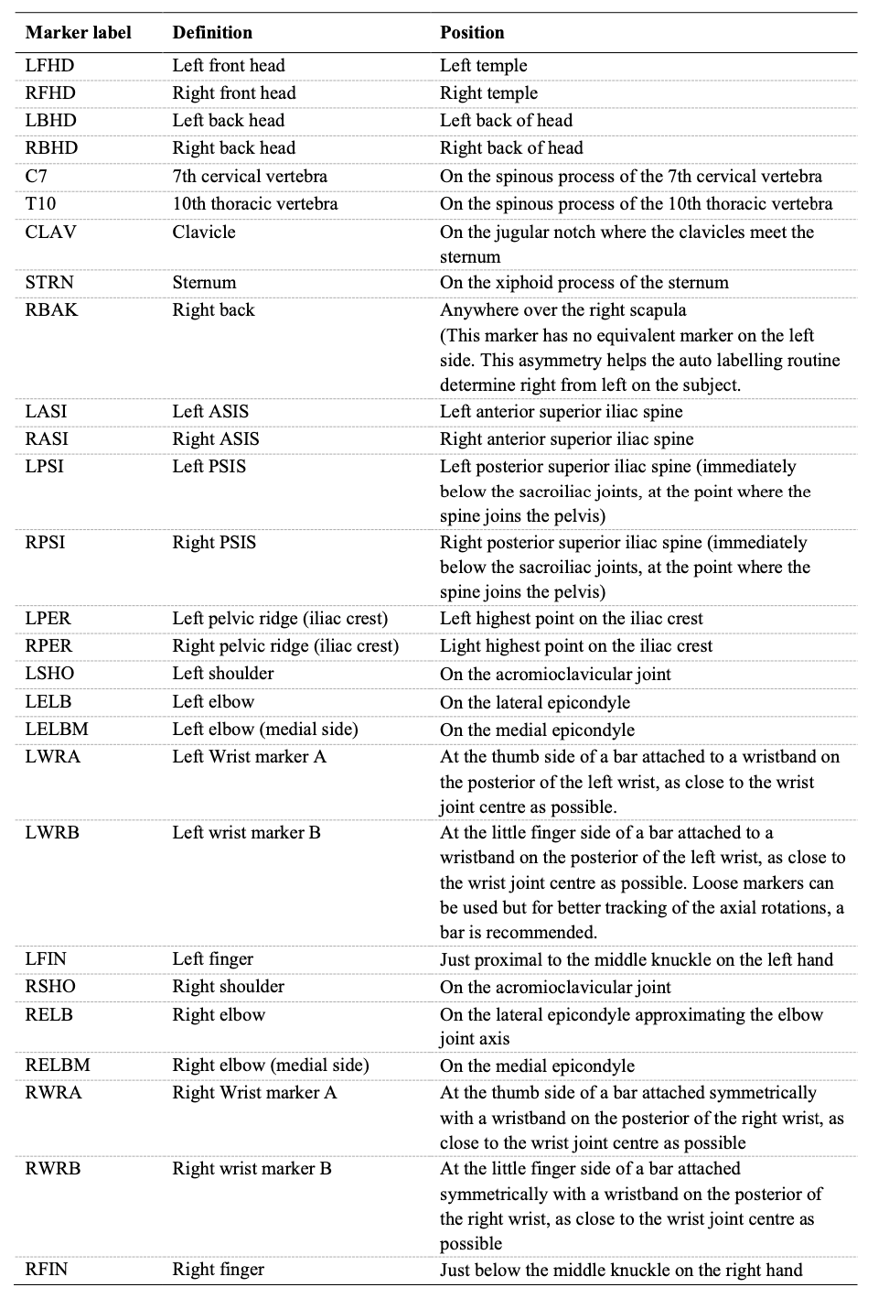
Supplementary Table The details of the full-body marker set.
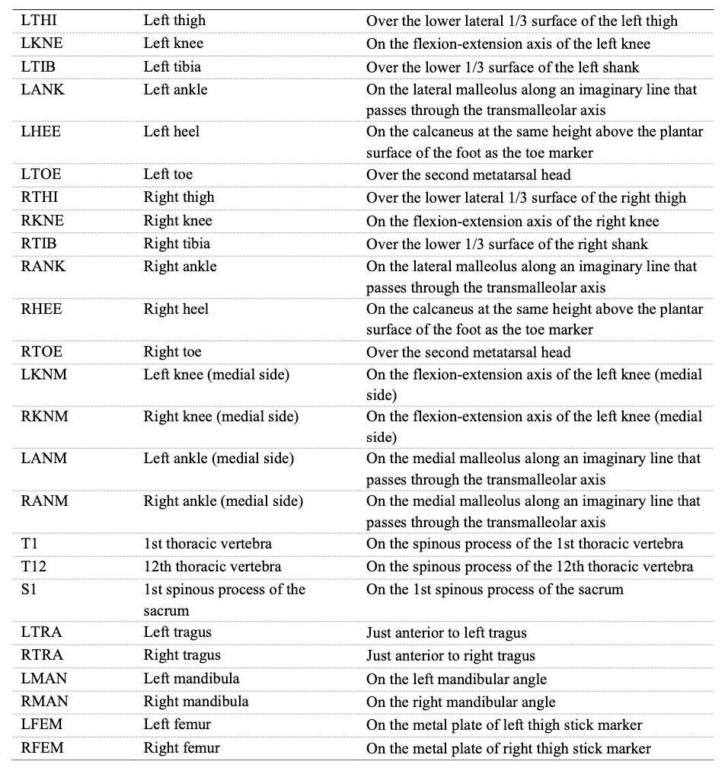
*The full-body marker set referred to the VICON Plug-in Gait reference guide, incorporating the additional markers.

