Supplementary material

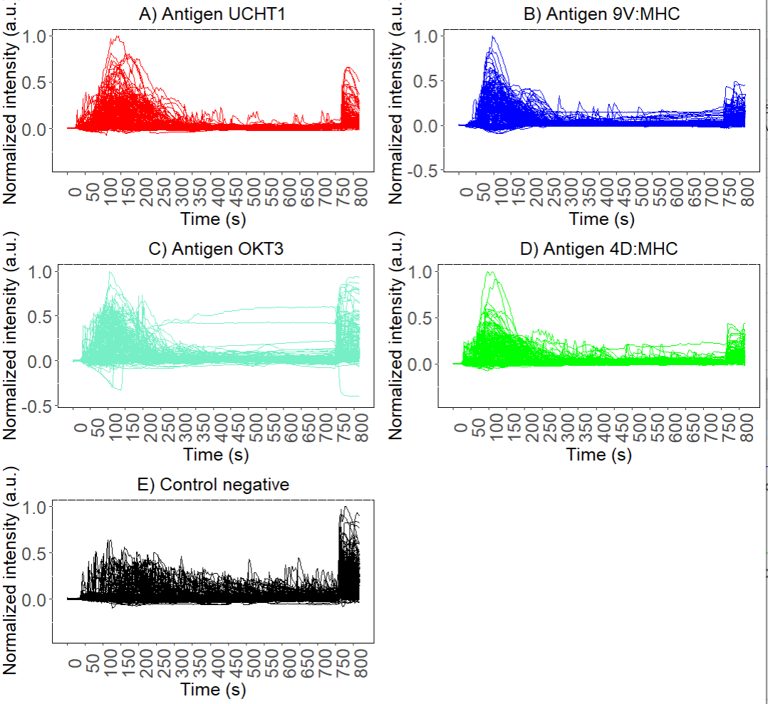
Figure 1: Curves representing the time-normalized fluorescence intensity profile for the whole antigen in time.

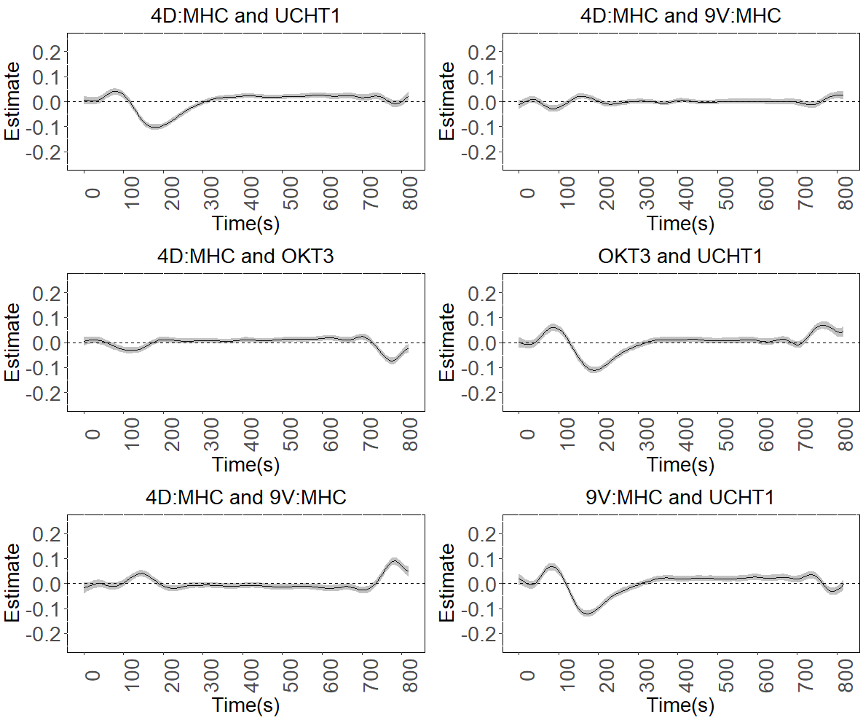
Figure 2: Comparison of the difference in smooth effects curves between the 4D:MHC antigen and the antigens: UCHT1, OKT3, and 9V:MHC (left), and Comparison of the difference in smooth effects curves of antigens 4D:MHC and 9V:MHC, OKT3 and UCHT1, 9V:MHC, and UCHT1 (right) with 95% pointwise confidence interval gray bands.

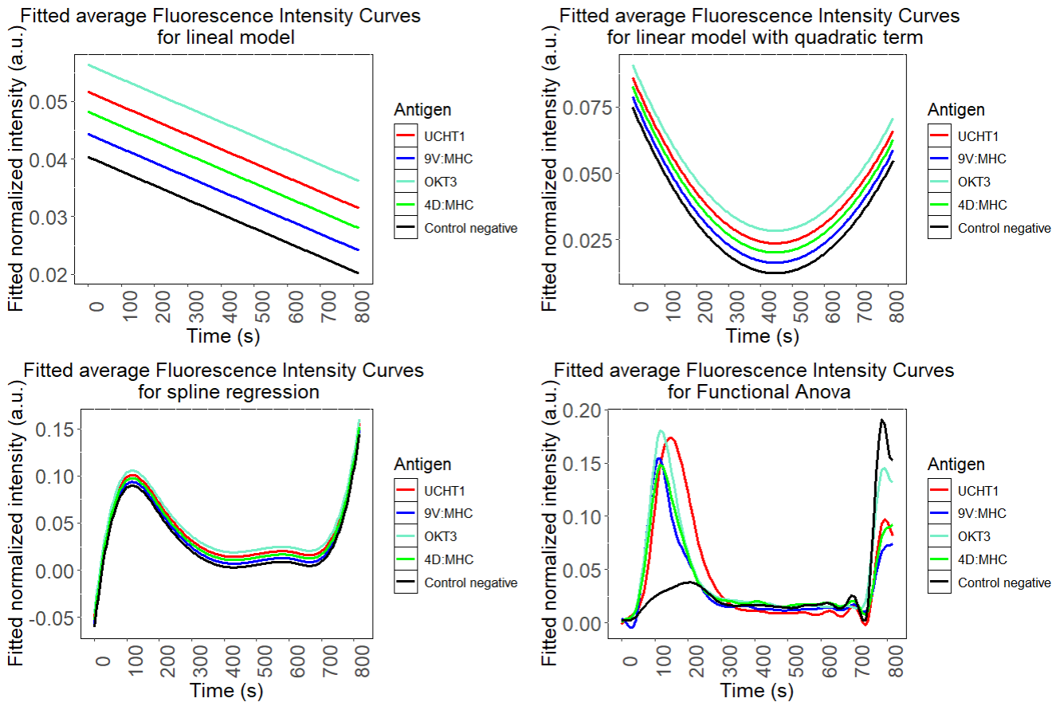
Figure 3 Means estimated by the linear, quadratic, spline and Anova functional models of the fluorescence intensity normalized over time for each antigen and the control

