Suplementary Data
The role of urinary Dickkopf-3/creatinine ratio in diagnosis of acute kidney injury before creatinine elevation in pediatric intensive care unit.
Material and method
The measurement of urine DKK3 and creatinine
The principle is based on the formation of antigen-antibody complexes without competition. DKK3 (unlabeled antigen) found in urine samples binds to antibody coated wells. The biotin-labeled antibody is then added. Following incubation of antibody-antigen-labeled antibody complexes (sandwich) with added enzyme (HRP-Streptavidin) followed by substrate, the intensity of color increases in direct proportion to the concentration of DKK3 present in the sample.
Inter- and intra-assay CV values ​​of the ELISA kit used for DKK-3 are 12% and 10% respectively. Measurements were performed using standard series at concentrations of 2000; 666.7; 222.2; 74.07; 24.69; 8.23 and 2.74 pg/mL, prepared using DKK-3 stock standard (50 ng/mL).
For each kit, the DKK-3 standard graph was drawn with the Curve Expert 1.4 program using the absorbance values corresponding to the standard concentrations. Urine DKK-3 levels calculated with the help of graphics were given as pg/mL (Figure 1). The urine samples were analyzed for creatinine by the Jaffe reaction.
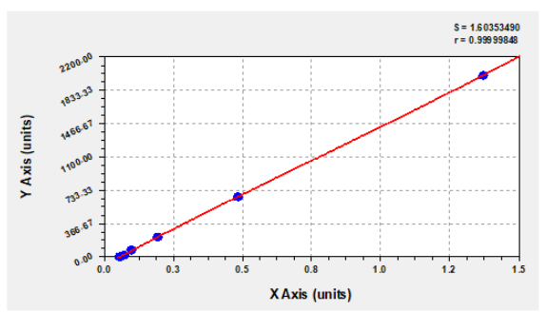
Figure 1 Urine DKK3 standard graph

PRISM (Pediatric Risk of Mortality Score): PRISM score is one of the widely used scoring systems to quantify critical illness in the pediatric age group.
Table 1: Calculation of PRISM
Cardiovascular and neurologic vital signs | Findings | Points
Systolic blood pressure (mmHg) | Neonate and >55  Neonate and 40-55  Neonate and <40  Infant and >65  Infant and 45-65  Infant and <45  Child and >75  Child and 55-75  Child and <55  Adolescent and >85  Adolescent and 65-85  Adolescent and <65 | 0  3  7  0  3  7  0  3  7  0  3  7
Heart rate (beats/min) | Neonate and <215  Neonate and 215-225  Neonate and >225  Infant and <215  Infant and 215-225  Infant and >225  Child and <185  Child and 185-205  Child and >205  Adolescent and <145  Adolescent and 145-155  Adolescent and >155 | 0  3  4  0  3  4  0  3  4  0  3  4
Temperature (°C) | <33  33-40  >40 | 3  0  3
Mental status | Glasgow coma score ≥8  Glasgow coma score <8 | 0  5
Pupillary response | Both reactive  One reactive and (1 fixed and >3 mm)  Both fixed and both >3 mm | 0  7  11

PELOD (Pediatric Logistic Organ Dysfunction): A common scoring method for characterizing multiple organ failure in pediatric patients is the PELOD score. The PELOD score was first created in 1999 and then changed to the PELOD-2 score, which provides a viable way to evaluate the severity of multiple organ dysfunction syndrome.

Table 2: Calculation of PELOD-2
Organ dysfunctions  and variables | Points by severity levels
Organ dysfunctions  and variables | 1 | 2 | 3 | 4 | 5 | 6
Neurologic  GCS  Pupillary reaction | ≥11  Both reactive | 5-10 |  | 3-4 | Both fixed
Cardiovascular  Lactatemia (mmol/L)  MAP (mmHg)  Months  0-<1  1-11  12-23  24-59  60-143  ≥144 | <5.0  ≥46  ≥55  ≥60  ≥62  ≥65  ≥67 | 5.0-10.9 | 31-45  39-54  44-59  46-61  49-64  52-66 | ≥11.0  17-30  25-38  31-43  32-45  36-48  38-51 |  | ≤16  ≤24  ≤30  ≤31  ≤35  ≤37
Renal  Creatinine (µmoL/L)  Months  0-<1  1-11  12-23  24-59  60-143  ≥144 | ≤69  ≤22  ≤34  ≤50  ≤58  ≤92 |  | ≥70  ≥23  ≥35  ≥51  ≥59  ≥93
Respiratoryd  PaO₂ (mm Hg)/FiO  PaCO₂ (mm Hg)  Invasive ventilation | ≥61  ≤58  No | 59-94 | ≤60 | ≥95  Yes
Hematologic  WBC count (×10⁹ /L)  Platelets (×10⁹ /L) | >2  ≥142 | 77-141 | ≤2  ≤76
GCS: Glasgow coma score; MAP: Mean arterial pressure
VIS (Vasoactive-Inotropic Score): VIS is calculated as a weighted sum of all administered inotropes and vasocon-strictors, reflecting pharmacological support of the cardio- vascular system.
- Calculation of VIS:
Dopamine dose (mcg/kg/min) +
Dobutamine dose (mcg/kg/ min) +
100 × Epinephrine dose (mcg/kg/min) +
10 × Milrinone dose (mcg/kg/min) +
10.000 × Vasopressin dose (unit/kg/min) +
100 × Norepinephrine dose (mcg/kg/min)

