SUPPLEMENTARY INFORMATION

Advanced Electrochemical Fabrication of Bimetallic Alloy Anchored Flexible Catalysts for Efficient Hydrogen Evolution Reaction
M. Giray Ersozoglu¹, Hurmus Gursu², A.Sezai Sarac^{3*}, Yucel Sahin^{4*}
¹Composite Technologies Center of Excellence, Sabanci University-Kordsa, Istanbul Technology Development Zone, Sanayi Mah. Teknopark Blvd. No: 1/1B, Pendik, 34906, Istanbul, Türkiye
²Clean Energy Technologies Institute, Yildiz Technical University, Istanbul, Esenler, Türkiye
³Polymer Science and Technology, Istanbul Technical University, Istanbul 34469, Türkiye
⁴Faculty of Arts and Science, Department of Chemistry, Yildiz Technical University, 34220 Istanbul, Türkiye

Table S1. Process bath (solution) compositions
 | Nickel (II) Sulfate (Molarity) | Cobalt (II) Sulfate (Molarity) | Nickel (II) Sulfate weight in 50 ml solution (g) | Cobalt (II) Sulfate weight in 50 ml solution (g)
Ni@GrF | 10⁻¹ | 0 | 1.31 | 0
Ni-Co@GrF1 | 10⁻¹ | 10⁻¹ | 1.31 | 1.41
Ni-Co@GrF2 | 10⁻¹ | 5. 10⁻² | 1.31 | 0.7
Ni-Co@GrF3 | 5.10⁻² | 10⁻¹ | 0.65 | 1.41
Co@GrF | 0 | 10⁻¹ | 0 | 1.41

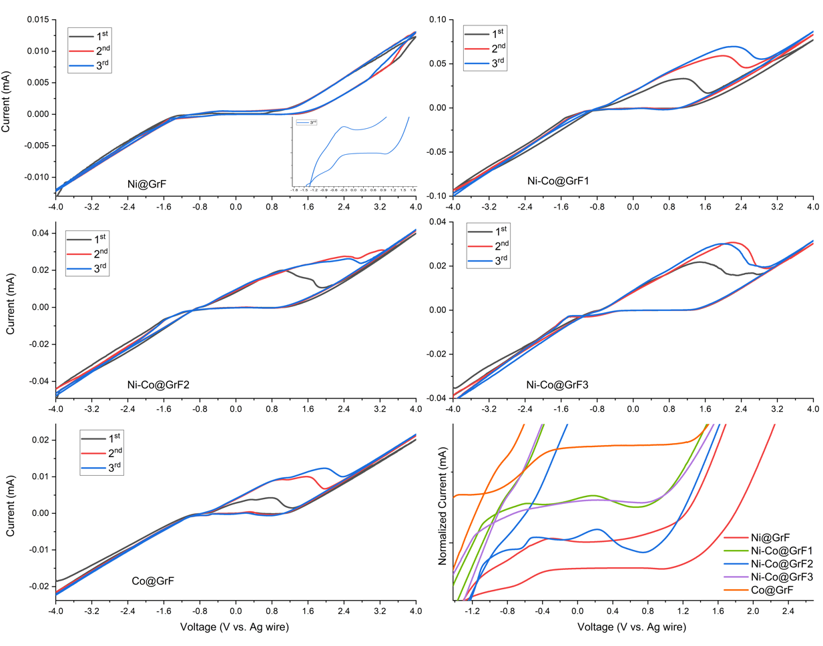
Fig. S1 Cyclic voltammograms of alloy composites

a)
Fig. S2 a) Ni@GrF

b)
Fig. S2 b) Co@GrF

c)
Fig. S2 c) Ni-Co@GrF1

d)
Fig. S2 d) Ni-Co@GrF2

e
Fig. S2 e) Ni-Co@GrF3

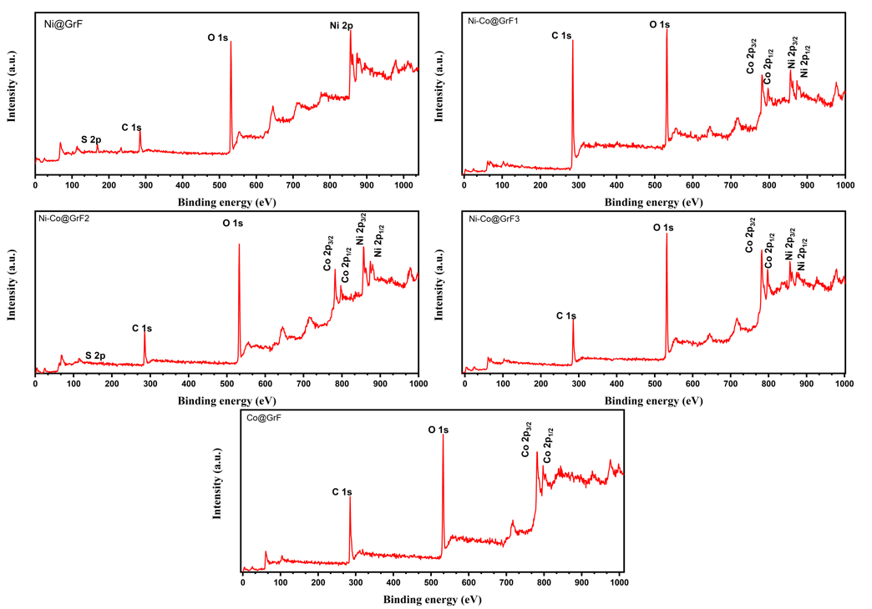
Fig. S3 XPS survey data of alloy composite.

Table S2. Surface atomic composition of alloy composites.

Sample
 | Elemental Surface Composition (XPS)
 | C % | O % | S % | Ni % | Co %
Ni@GrF | 29.1 | 52.96 | 5.2 | 11.2 | -
Ni-Co@GrF1 | 34.7 | 47.25 | 1.25 | 8.19 | 2.27
Ni-Co@GrF2 | 45.6 | 44.4 | 0.59 | 7.13 | 9.45
Ni-Co@GrF3 | 49.55 | 37.1 | 1.12 | 3.24 | 8.3
Co@GrF | 53.1 | 36.95 | 0.65 | - | 9.5

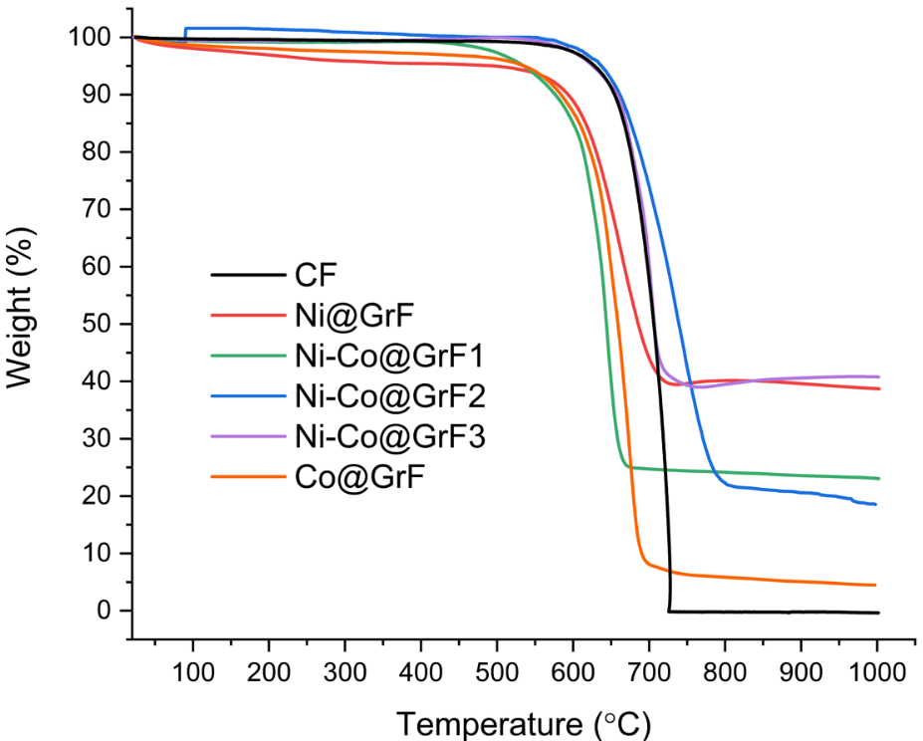
Fig. S4 TGA results of alloy composites.

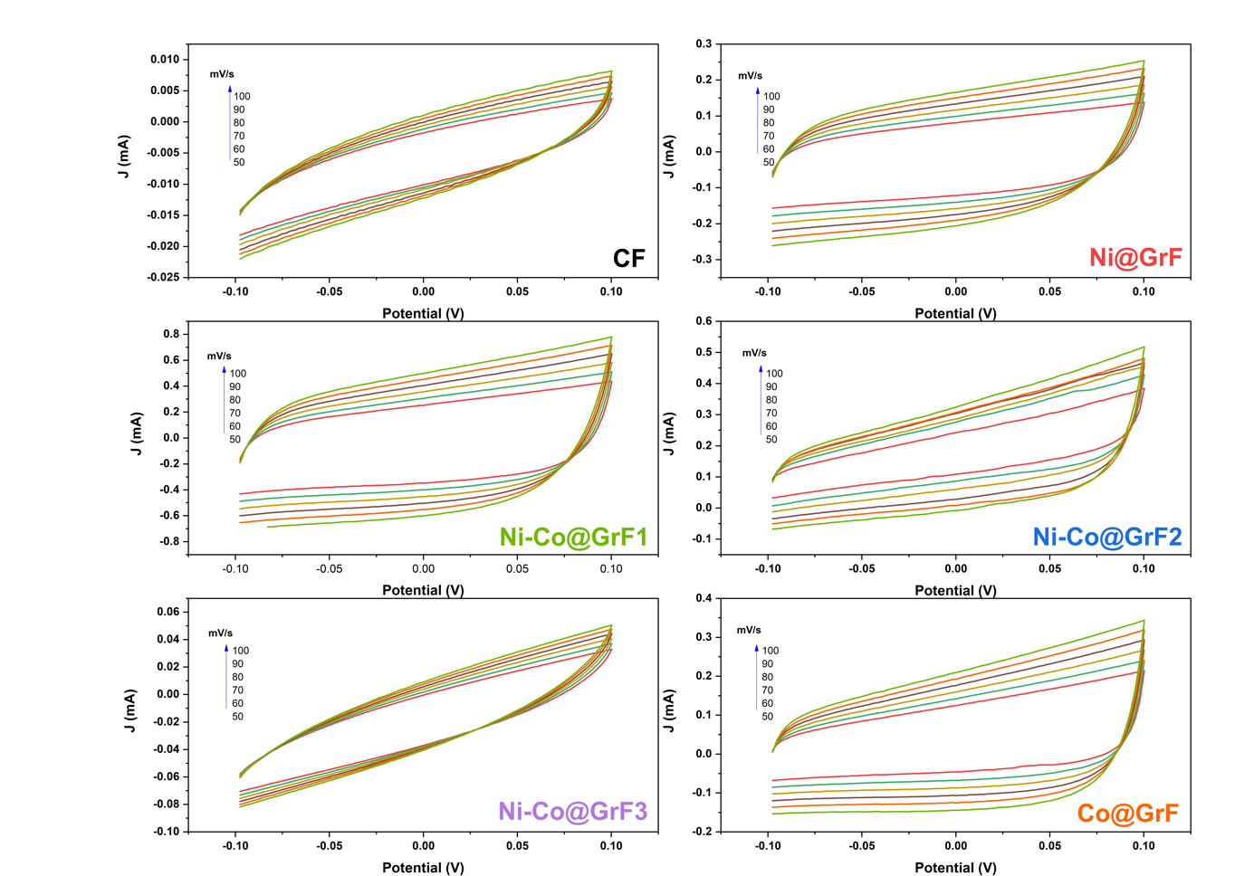
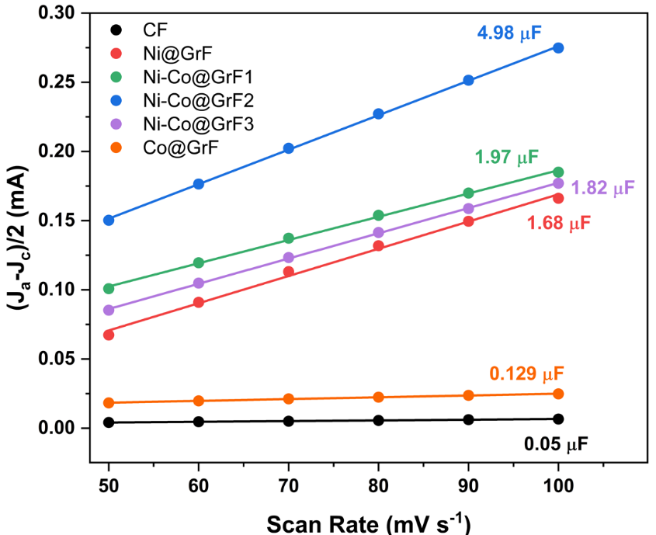
Fig. S5 Cyclic voltammograms scanned in a non-faradaic region (-0.1 to 0.1 V vs. RHE) at a scan rate of 50, 60, 70, 80, 90, and 100 mV s⁻¹ for CF, and alloy composites, and linear fitting between the current densities differences for the half of the potential window of CV versus scan rates.

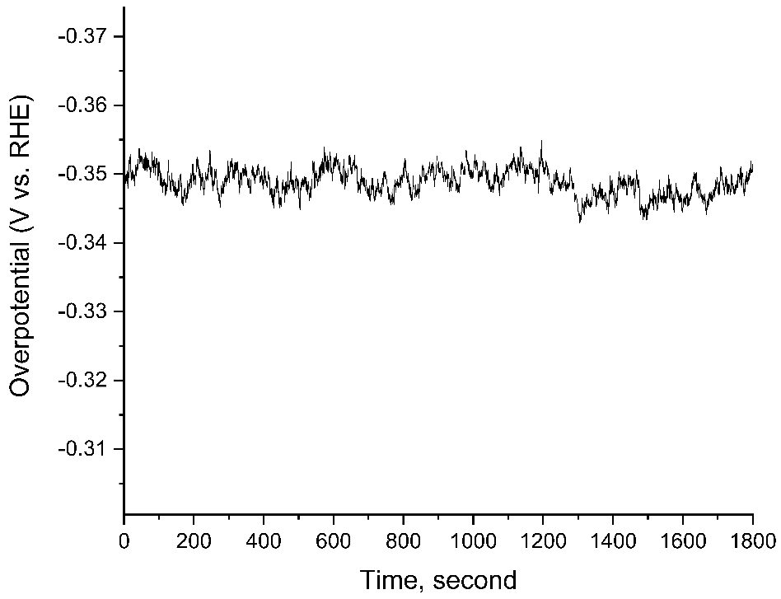
Fig. S6 Stability test of Ni-Co@GrF2 at near overpotential

Table 3. Overpotential at 10 mA cm⁻² and Tafel Slope data from LSV and Tafel Slope plot
Sample | Over Potential at 10 mA cm⁻² (mV) | Tafel Slope (mV dec⁻¹)
CF | 332 | -
Ni@GrF | 123 | -
Ni-Co@GrF1 | 52 | 320
Ni-Co@GrF2 | 42 | 290
Ni-Co@GrF3 | 64 | 400
Co@GrF | 100 | 800
Pt | 37 | 200

