Appendix A. Supplementary data

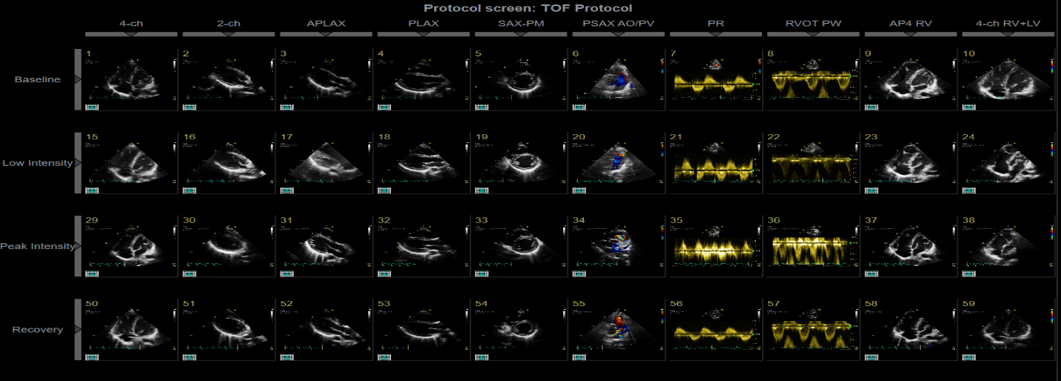

Supplementary Figure 1. TOF stress echocardiography protocol.

