Tritrophic interactions in a changing climate: a seed feeding moth and its larval ectoparasitoids along an elevational gradient

Martin G. M. Randall

Supporting material

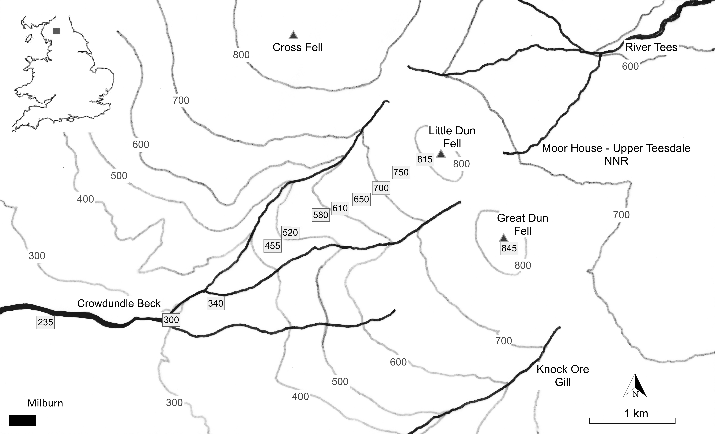

Figure S1: The location of the study area in northern England (inset). The elevational transect, on the western escarpment of Dun Fell, is shown with the position of the 2019 & 2021 sample sites marked in metres. The 1977 & 1978 sites followed the same transect. Contours are at 100m intervals.

Table S1: The elevation of the sample sites on the Dun Fell transect each year in the two study periods and the sample sizes (n) of J. squarrosus inflorescences collected to measure the number of florets, seed capsules and C. alticolella larvae. The sample dates in each year are also shown.

1977 | 1978 | 2019 | 2021

Elevation (m) | n | Elevation (m) | n |  | Elevation (m) | n | Elevation (m) | n |  | Elevation (m) | n |  | Elevation (m) | n

 |  |  |  |  |  | 215 | 30 | 215 | 40
245 | 30 |  | 245 | 30 |  | 245 | 30 | 245 | 30 |  |  | 235 |  | 30 |  |  | 235 |  | 20
 |  |  |  |  |  | 260 | 30 | 260 | 50
 |  |  | 275 | 30 |  | 275 | 30 | 275 | 30
 |  |  |  |  |  | 290 | 30 | 290 | 50
 |  |  | 305 | 30 |  | 305 | 30 | 305 | 30 |  |  | 300 |  | 30 |  |  | 300 |  | 20
335 | 30 |  | 335 | 30 |  | 335 | 30 | 335 | 30 |  |  | 340 |  | 30 |  |  | 340 |  | 20
 |  |  |  |  |  | 350 | 30 | 350 | 50
 |  |  | 365 | 30 |  | 365 | 30 | 365 | 30
395 | 30 |  | 395 | 30 |  | 395 | 30 | 395 | 30
455 | 30 |  | 455 | 30 |  | 455 | 30 | 455 | 30 |  |  | 455 |  | 30 |  |  | 455 |  | 20
520 | 30 |  |  |  |  | 520 | 30 | 520 | 30 |  |  | 520 |  | 30 |  |  | 520 |  | 20
 |  |  |  |  |  |  |  | 550 | 30
 |  |  |  |  |  |  |  | 580 | 30 |  |  | 580 |  | 30
610 | 30 |  |  |  |  | 610 | 30 | 610 | 30 |  |  | 610 |  | 30 |  |  | 610 |  | 20
 |  |  |  |  |  |  |  |  |  |  |  | 650 |  | 30 |  |  | 650 |  | 20
 |  |  |  |  |  | 685 | 20 |  |  |  |  | 700 |  | 30 |  |  | 700 |  | 20
 |  |  |  |  |  | 760 | 20 |  |  |  |  | 750 |  | 30 |  |  | 750 |  | 20
 |  |  |  |  |  | 830 | 20 |  |  |  |  | 815 |  | 30 |  |  | 815 |  | 20
 |  |  |  |  |  |  |  |  |  |  |  | 845 |  | 30 |  |  | 845 |  | 20
10,11 August |  | 6 November |  |  |  | 11 August |  | 7 November |  |  |  |  | 6, 7 October |  |  |  |  | 3, 4 October

The elevation of each sample site was measured using an aneroid barometric altimeter calibrated from Ordnance Survey data in 1977 & 1978. A more accurate GPS altimeter was used in 2019 & 2021. J. squarrosus is no longer present on the transect between 340m and 455m because that area had been enclosed and planted for conservation management of black grouse (Lyrurus tetrix (L)) since the 1970s. Additional samples were also taken at some low elevation sites in November 1977 & 1978 to collect sufficient ectoparasites for analysis of parasitisation rates (see text Table 5).

Table S2: Linear regression analyses of the mean density of J. squarrosus inflorescences produced (number per ¼m²) against elevation (m), and the median values, in each of the four years of the study.
 |  | Estimate | SE | t | p | r² | d.f. | Median values
1977 | Intercept | 16.6 | 14.1 | 1.18 | 0.304 | 0.287 | 4 | 39.7
1977 | Elevation (m) | 0.055 | 0.032 | 1.74 | 0.158
1978 | Intercept | 11.3 | 3.8 | 2.99 | 0.02 | 0.099 | 7 | 15.8
1978 | Elevation (m) | 0.011 | 0.008 | 1.37 | 0.213
2019 | Intercept | 19.4 | 5.4 | 3.61 | <0.01 | -0.111 | 9 | 20.8
2019 | Elevation (m) | 0.0003 | 0.0094 | 0.032 | 0.975
2021 | Intercept | 19.8 | 2.0 | 9.91 | <0.001 | -0.113 | 8 | 18.6
 | Elevation (m) | -0.0010 | 0.0035 | -0.29 | 0.779

Table S3: Linear regression analyses of the mean number of J. squarrosus seeds per seed capsule against elevation (m), and the median values, in each of three years of the study. Few seeds remained in 1978 due to high larval densities.

 |  | Estimate | SE | t | p | r² | d.f. | Median values
1977 | Intercept | 89.6 | 7.2 | 12.45 | <0.001 | 0.073 | 4 | 83.7
1977 | Elevation (m) | -0.019 | 0.016 | -1.182 | 0.303
2019 | Intercept | 61.8 | 5.9 | 10.56 | <0.001 | -0.115 | 7 | 64.6
2019 | Elevation (m) | 0.005 | 0.0011 | 0.421 | 0.686
2021 | Intercept | 73.8 | 4.0 | 18.39 | <0.001 | 0.025 | 9 | 69.0
2021 | Elevation (m) | -0.008 | 0.007 | -1.123 | 0.291

Table S4: The number of parasitised C. alticolella larvae per damaged seed capsule of J. squarrosus in samples from equivalent elevation sites taken in November 1977 & 1978 and October 2019 & 2021 with the recorded parasitisation rates in the first two years and the rates predicted from the proxy relationship between the rate of parasitisation (y) and the number of parasitized larvae per damaged seed capsule (x) (y = 1 – (exp(-2.253x)) for the second two years.

 | 1977 |  |  |  | 1978 |  |  |  |  | 2019 |  |  |  | 2021
Elevation (m) | Parasitised larvae per damaged seed capsule | Proportion parasitised |  |  |  | Parasitised larvae per damaged seed capsule | Proportion parasitised |  |  |  | Parasitised larvae per damaged seed capsule | Proportion parasitised from proxy relationship |  |  | Parasitised larvae per damaged seed capsule | Proportion parasitised from proxy relationship
245/235 | 0.130 | 0.180 |  |  |  | 0.167 | 0.210 |  |  |  | 0.501 | 0.68 |  |  | 0.449 | 0.64
305/300 | 0.033 | 0.018 |  |  |  | 0.017 | 0.020 |  |  |  | 0.256 | 0.44 |  |  | 0.147 | 0.28
335/340 | 0.008 | 0.014 |  |  |  | 0.003 | 0.003 |  |  |  | 0.050 | 0.11 |  |  | 0.194 | 0.35
455 | 0.000 | 0.000 |  |  |  | 0.000 | 0.000 |  |  |  | 0.000 | 0.00 |  |  | 0.056 | 0.12

Table S5: The upper altitudinal limit of C. alticolella larval distribution and J. squarrosus seed production for various years from 1942 to 2019 in northern England. All localities, apart from those used by Pearsall, are on the western escarpment of the Pennines; Knock Ore Gill is about 2km south of the Little Dun Fell transect. The data from Pearsall and Welch are based only on the presence of C. alticolella larval cases. * Indicates years when the reduction in the larval limit was caused by a reduction in the upper limit of seed capsule production. ‡ Elevation with an expected level of 5% of florets developing to seed capsules predicted from the quasibinomial GLM analyses.

Year | Upper limit of C.alticolella larvae (m) | Upper limit of seed capsules (m) | Locality | Source reference
1942/43/45 | 550 | 762-823 | Central Lake District | Pearsall 1950
1947 | 610 | >823 | Blencathra Lake District, Cumbria. | Pearsall 1950
1952 | 564 | 753 | Little Dun Fell | Jordan 1955
1953 | 564 | 753 | Little Dun Fell | Jordan 1955
1954* | 410 | 410 | Little Dun Fell | Jordan 1955
1955 | 427 | >455 | Little Dun Fell | Reay 1959
1956 | 427 - 440 | >455 | Little Dun Fell | Reay 1959
1957 | 455 | >455 | Little Dun Fell | Reay 1959
1963 | 410 | >600 | Knock Ore Gill | Welch 1964
1964 | 427 | >600 | Knock Ore Gill | Welch 1964
1977 | 610 | >750‡ | Little Dun Fell | Randall 1980
1978* | 520 | 553 ‡ | Little Dun Fell | Randall 1980
1991 | 655 |  | Knock Ore Gill | Welch 1992
2019 | 815 | >845 | Little Dun Fell | This study
2021 | 750 | >845 | Little Dun Fell | This study

Updated from Randall, M.G.M. (1980). Aspects of the ecology of Coleophora alticolella Zeller (Lepidoptera) with particular reference to altitude. Ph.D. thesis, University of Durham. Durham E-Theses Online: http://etheses.dur.ac.uk/7424/

