Supplementary materials
Platelet-specific TGFβ1 deficiency aggravates atherosclerosis, vascular inflammation, and hypercholesterolemia in mice

Shuai Tan^{1†}, Yang Sun^{2,3†}, Zi Sheng^{3,4†}, Yanan Min^{1,5}, Anton Gisterå^{1, 6}, Junhao Zhang^{1,7}, Daniel F.J. Ketelhuth^{1, 6, 8}, Wangjun Liao⁷, John Andersson⁹, Hu Hu¹⁰, Miao Wang¹¹, Ming Hou^{3,4}, Mingxiang Zhang^{3,12}, Jun Peng^{3,4}, Chunhong Ma^{2,3}*, Nailin Li^{1,3}*
¹Karolinska Institutet, Department of Medicine-Solna, Cardiovascular Medicine Unit, Stockholm, Sweden; ²Shandong University Cheeloo Medical College, School of Basic Medicine, Department of Immunology, Jinan, China; ³Shandong University-Karolinska Institutet Translational Medicine Collaborative Research Platform, Jinan, China; ⁴Qilu Hospital of Shandong University, Department of Hematology, Jinan, China; ⁵Jining Medical University Affiliated Hospital, Department of Hematology, Jining, China; Karolinska Institutet, ⁶Center for Molecular Medicine, Karolinska University Hospital, Stockholm, Sweden; ⁷Nanfang Hospital, Department of Oncology, Southern Medical University, Guangzhou, China; ⁸Department of Cardiovascular and Renal Research, Institute for Molecular Medicine, University of Southern Denmark; ⁹Department of Environmental Medicine, Integrated Epidemiology Group, Stockholm, Sweden; ¹⁰Zhejiang University School of Medicine, Department of Pathology and Pathophysiology, Hangzhou, China; ¹¹Fuwai Hospital, National Center for Cardiovascular Diseases, Chinese Academy of Medical Sciences and Peking Union Medical College, Beijing, China; ¹²Qilu Hospital of Shandong University, Key Laboratory of Cardiovascular Remodeling and Function Research, Jinan, China

Supplementary Results
Plt-TGFβ^{-/-} alters CD4⁺ effector cell activities in the spleen and lymph nodes
Mononuclear cells were isolated using Ficoll-Paque (Sigma) from the cell mass of the spleen and lymph nodes. Flow cytometric phenotyping of CD4⁺ effector cells were performed using intracellular staining, in which IFNγ⁺, IL-4⁺, IL-17A⁺, and FoxP3⁺-CD25⁺⁺ were used as the markers of Th1, Th2, Th17, and Treg cells among CD4⁺ cells, respectively (Supplementary figure 1A). Briefly, the phenotyping of Th1/Th2/Th17 cells and Treg cells were performed using two separate intracellular staining samples. All CD4⁺ T cells were gated from the mononuclear cells according to their CD4-positive staining and isotypic control staining of individual mouse. The subsets of CD4⁺ T effector cells were subsequently identified by their corresponding intracellular staining markers, and were presented as the percentages of the total CD4⁺ T cells. It was found that plt-TGFβ^{-/-}decreased the percentages of Th2 (Supplementary figure 1B&C) and Th17 (Supplementary figure 1D&E) among the CD4⁺ T cells from both the spleen and the lymph nodes in the 10-week high-fat diet-fed mice. When the duration on high-fat diet was extended to 15 weeks, the suppressed CD4⁺ effector cells were seen in Th2 cells from the lymph nodes (Supplementary figure 1H) and Th17 cells in the spleen (Supplementary figure 1I).
Plt-TGFβ^{-/-} elicits a pro-inflammatory profile in the aortic vessel wall
Further efforts were made to reveal the impact of plt-TGFβ^{-/-} on vascular inflammation in the aorta. Using RNA sequencing data from aortas of mice fed with a 15-week high-fat diet, gene ontology (GO) enrichment analyses showed that plt-TGFβ^{-/-} enhanced lymphocyte and monocyte chemotaxis/infiltration and inflammatory responses (Supplementary figure 2A).
With proteomic data of the aorta from 15-week high-fat diet-fed mice, GO enrichment analyses demonstrated that plt-TGFβ^{-/-} increased the expression of the major histocompatibility complex class II (MHC-II) protein complex (Supplementary figure 2B), indicating that the vascular inflammation was promoting local antigen presentation.
Supplementary Figures and Legends
Supplementary Figure 1
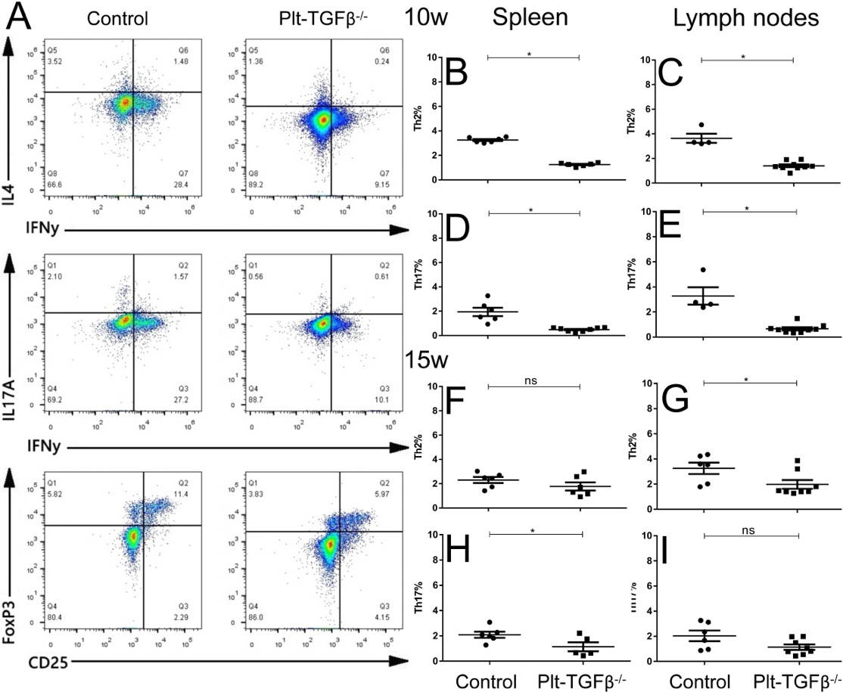
Supplementary Figure 1. Platelet-specific TGFβ deficiency alters CD4⁺ effector cell populations in the spleen and lymph nodes. Plt-TGFβ^{−/−} mice and their littermate control were fed with a high-fat chow for 10 and 15 weeks. The spleen and lymph nodes were harvested for the preparation of single cell suspensions at both time points. Panel A: Flow cytometric phenotyping of CD4⁺ T effector cells, which were first stimulated using PMA (50 ng/ml) and ionomycin (5 µg/ml) for 2 hours, and followed by adding brefeldin A (5 µM) for further incubation for 4 hours. Representative pseudocolor plots. Panels B-C (10 W) and F-H (15 W): Th2 cells, CD4⁺-IL-4⁺. Panels D-E (10 W) and I-J (15 W): Th17 cells, CD4⁺-IL-17A⁺. *p<0.05 as compared to controls by Student’s t-test, n=4-9.

Supplementary Figure 2
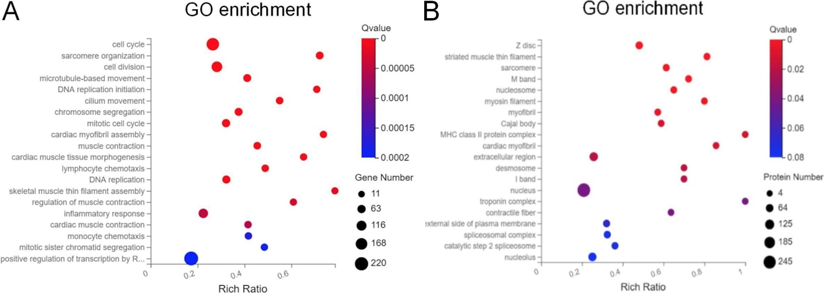
Supplementary Figure 2. Altered transcriptomic and proteomic landscape in aortas from mice with platelet-specific TGFβ deficiency. Plt-TGFβ^{−/−} mice and littermate controls were fed a high-fat diet for 15 weeks. The whole aorta was harvested, snap-frozen, and stored at -80°C for subsequent total RNA and protein isolation using Qiazol reagent and isopropanol precipitation. RNA sequencing was performed using the DNBSEQ™ Technology Platform, and mass spectrometric analyses and proteome profiling were carried out at BGI (Shenzheng, China). Data were analysed using the Dr. Tom program. Panel A: GO enrichment analysis of RNA sequencing. Panel B: GO enrichment analysis of aorta proteomic data. n=3-5.

