SUPPLEMENTAL MATERIAL

Supplemental Figure Legends
Figure S1. Schematic of Experimental Workflow for Preventive and Therapeutic γδTreg Studies in AA Using Humanized Mouse Models and Ex Vivo Hair Follicle CulturesThe workflow outlines the experimental steps taken to evaluate both the preventive and therapeutic effects of γδTregs in an in vivo humanized mouse model and ex vivo human hair follicle cultures. Human PBMCs are isolated from healthy volunteers and stimulated with zoledronate, IL-2, IL-15, and TGF-β1 to expand γδTreg cells. These γδTreg cells are subsequently sorted and used in two parallel experimental setups:
In Vivo Humanized Mouse Model: Human scalp skin xenografts are transplanted onto SCID/beige mice. CD8+/NKG2D+ cells, either alone or co-administered with γδTregs, are injected into the xenografts to evaluate: Preventive Effect: γδTregs are co-administered with CD8+/NKG2D+ cells to assess their ability to prevent the onset of AA. Therapeutic Effect: γδTregs are injected after AA lesions develop, to assess their ability to reverse established hair loss and promote hair regrowth.
Hair regrowth and immune responses are monitored to evaluate the impact of γδTregs in both preventive and therapeutic settings.
Ex Vivo Hair Follicle Model: Human scalp hair follicles are cultured in an organ culture system with the following conditions: HFs co-cultured with CD8+/NKG2D+ cells alone. HFs co-cultured with CD8+/NKG2D+ cells and γδTregs. HFs co-cultured with γδTc cells. HFs co-cultured with γδTregs cells. Control HFs co-cultured with PBMCs/PHA. Control HFs with no added immune cells. These conditions are used to observe the effects of different immune cell populations on hair follicle immune privilege, HF integrity, and hair growth. The structure of the hair follicles and the immune environment are analyzed to assess the protective and immunoregulatory role of γδTregs compared to other cell types.
The combined results from these models demonstrate the potential of γδTregs to both prevent immune-mediated damage and promote hair regrowth in AA.

Fig. S2. Schema Demonstrating the Induction and Analysis of γδT Regulatory Cells from Healthy Donors: Cultivation, Sorting, and FACS Profiling.
PBMCs from healthy volunteers were cultured with zoledronate to induce a notable expansion of γδT cells. The expanded γδT cells were then cultured for 12 days in a specialized medium supplemented with IL-2, IL-15, and TGF-β1, fostering the development of γδ regulatory T cells, albeit with varying purity. After cultivation, FACSAria sorting was deployed to isolate and purify the cells, followed by subsequent FACS analysis. The protocol also includes the isolation and purification of peripheral γδT cells and CD8+/NKG2D+ cells, as well as the cultivation of non-specifically activated T-cells achieved by incubating autologous PBMCs with PHA.

Fig.S3. Analysis of γδTregs Distribution in Humanized AA Mouse Model. Immunofluorescence microscopy analysis of the distribution and prevalence of γδTregs in various treatment groups.(A) A significant increase in the number of γδTregs, predominantly TRVδ2+ (red) /Foxp3 (green) (double staining is highlighted in yellow), surrounding the bulb area in AA reversed xenotransplants treated with CD8+/NKG2D+ and γδTregs. This increase is compared to xenotransplants treated with CD8+/NKG2D+ alone and control treated with PBMCs/PHA. (B) TRVδ1+ (red)/Foxp3 (green) scattered within and around the bulb area of hair follicles in both control xenotransplants treated with PBMCs/PHA and in the AA humanized mouse model. (C) A comparison with TCRVδ1+/Foxp3 cells, highlighting the dominance of TCRVδ2+/Foxp3 in the treated groups. Analysis was conducted on 9 xenotransplants per group, sourced from 2 distinct donors. (between 5-9 HFs per donor). Following the Shapiro-Wilk test, one-way ANOVA was used with p<0.05 values considered statistically significant. This comprehensive analysis underscores the pivotal role of γδTregs in mitigating AA, offering invaluable insights for future research and therapeutic approaches.Red arrow - TCRVδ2+/Foxp3-, White arrow - TCRVδ2+/Foxp3+. Scale bars: 50 µm.

Fig. S1.
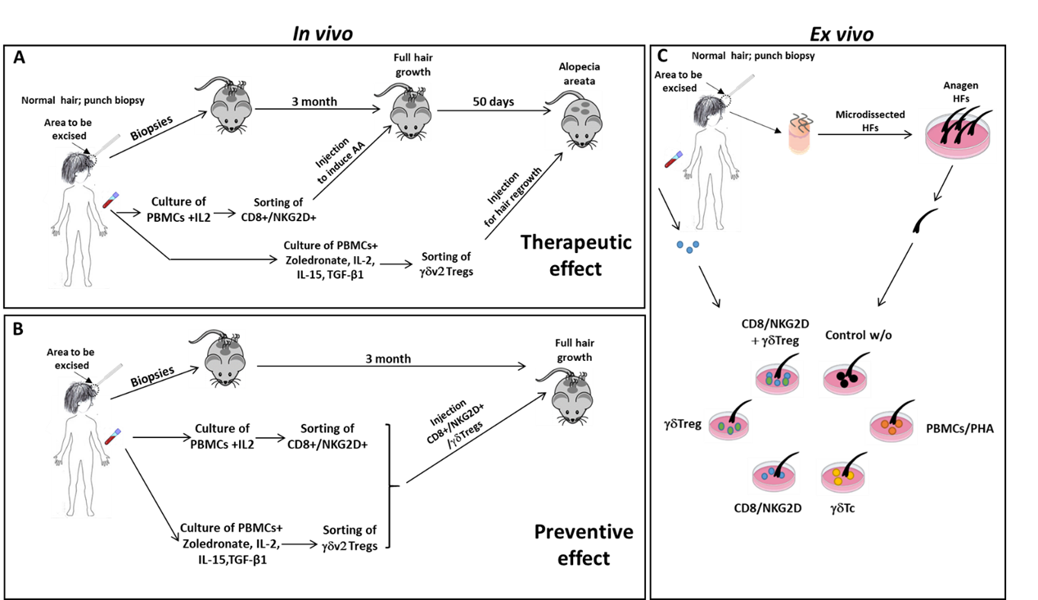

Fig. S2.

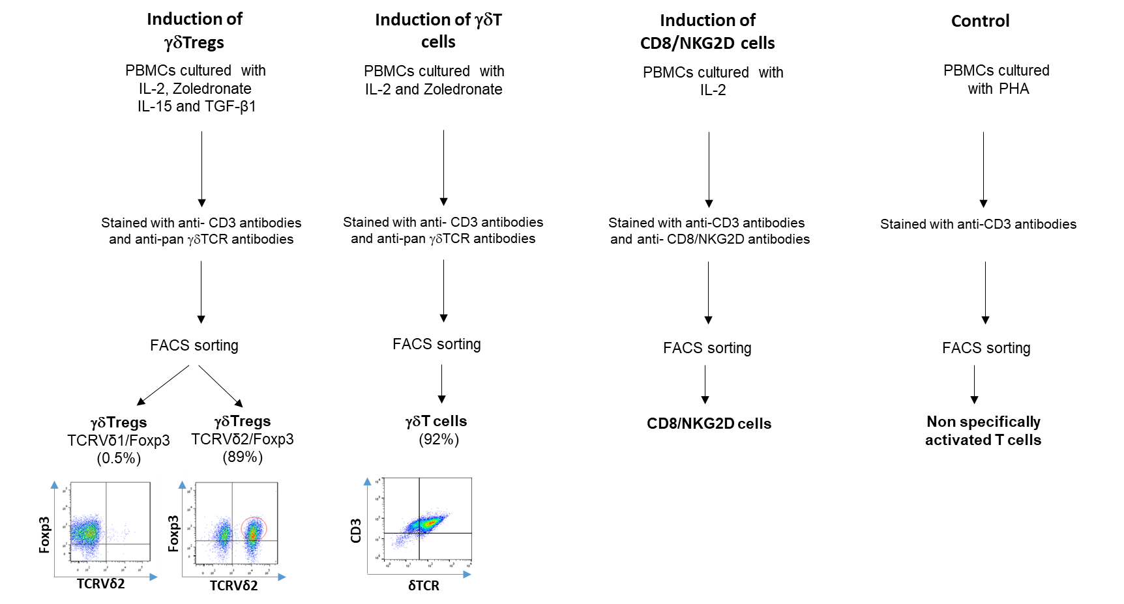

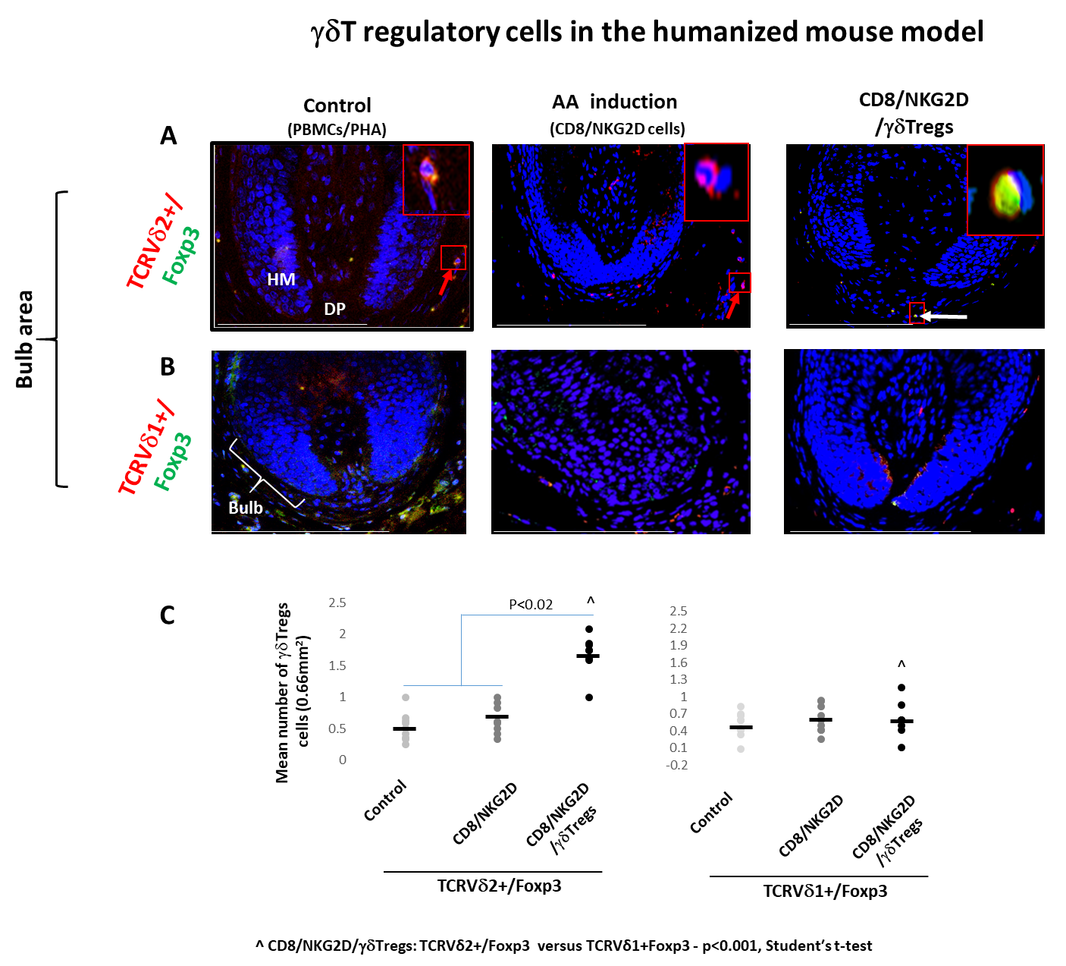
Fig.S3.

Table S1: Agents used for cell culture expansion and enrichment

Enriched cell type | Agents | References
CD8+NKG2D+ | IL-2 (100 U/ml) | [24-26]
γδTreg | IL-2 (25 U/ml), Zoledronate (2µM), IL-15 (50ng/ml), TGF-β1 (8.5 ng/ml) | [89,90]
γδT cells | IL-2 (100 U/ml), Zoledronate (2µM) | [88,S1]
PHA | PHA (10µg/ml) | [25]

Table S2: FACSAria antibodies

Cell type | Antibodies for sorting
CD8+NKG2D+ cells | anti-CD3(APC/FITC), CD8(Pe/cy7, 300913), anti-NKG2D (VioBright FITC, 130-104-888)
γδTreg cells | anti-CD3(APC/FITC), anti-γδTCR(PE/APC), anti-Foxp3 (VioBright FITC)
γδT cells | anti-CD3(APC/FITC), anti-γδTCR(PE/APC)
PHA cultured cells | anti-CD3(APC/FITC)

Table S3: FACS Antibodies

Antigen | Antibodies
Extracellular | anti-CD3(APC/FITC)  anti- CD8 (Pe/cy7, biolegend, cat 300913),  NKG2D-VioBright FITC (Miltenyi Biotec, cat 130-104-888)  anti-γδTCR(PE/APC. Biolegend, cat 331210 and biolegend , cat 331212, respectively)  Anti-TCR-Vδ2-VioBlue (Miltenyi Biotec, cat 130-101-157) (PB)  Anti-TCR-Vδ1-PerCP-Vio700 (Miltenyi Biotec, cat 130-100-537)
Intracellular | Anti-Foxp3-APC(Miltenyi Biotec, 130-093-013)  IL-10 (PE, biolegend, cat 365321)

Table S4: IHC and Immunofluorescence Antibodies

Primary  antibody | Origin | Clone | Vendor | Dilution | Sections | Antigen retrieval | Species Reactivity | Secondary  antibody
Ki-67 | Mouse | 7B11 | Invitrogen | 1:100 | Paraffin | EDTA | Human | Biotinylated Horse Anti-Mouse, Vector
CD4 | Mouse | 4B12 | Dako | 1:80 | Paraffin | EDTA | Mouse,Human | Biotinylated Horse Anti-Mouse, Vector
CD8 | Mouse | C8/144B | Cell Marque | 1:80 | Paraffin | EDTA | Mouse, Human | Biotinylated Horse Anti-Mouse, Vector
IFNγ | Rabbit | --- | Abcam | 1:80 | Paraffin | S. citrate | Human | Biotinylated Goat Anti-Rabbit,Vector
HLA A,B,C | Mouse | EMR8-5 | Abcam | 1:100 | Paraffin | S.citrate | Human | Biotinylated Horse Anti-Mouse, Vector
HLA DR | Rabbit | EPR3692 | Abcam | 1:1000 | Paraffin | EDTA | Mouse, Human | Biotinylated Goat Anti-Rabbit,Vector
CD1d | Mouse | NOR3.2 | Abcam | 1:100 | Paraffin | S.citrate | Human | Biotinylated Horse Anti-Mouse, Vector
MICA/B | Rabbit | EPR22031 | Abcam | 1:200 | Paraffin | EDTA | Human | Biotinylated Goat Anti-Rabbit,Vector
αMSH | Mouse | --- | LSBio | 1:100 | Paraffin | S.citrate | Human | Biotinylated Horse Anti-Mouse,Vector
TGF-β1 | Mouse | TB21 | Abcam | 1:200 | Paraffin | S.citrate | Human | Biotinylated Horse Anti-Mouse, Vector
TCRVγδ | Mouse | TS8.2 | Invitrogen | 1:100 | Paraffin | S.citrate | Human | Alexa Fluor, Jacksonimmuno
TCRVγδ | Rabbit | 15D | Novus bio | 1:125 | Paraffin | EDTA | Mouse, Human | Alexa Fluor, Jacksonimmuno
FOXP3 | Rabbit | --- | Abcam | 1:200 | Paraffin | S.citrate | Mouse, Human | Alexa Fluor, Jacksonimmuno

