SUPPLEMENTARY INFORMATION
Space oddity: Absence of prezygotic-premating barriers in Eurydema lundbladi and Eurydema ornata

Journal of Insect Conservation

Mario Alamo^{1, 2, *}, Diego Gil-Tapetado^{1,3}
¹ Universidad Internacional Menéndez Pelayo, C. de Isaac Peral, 23, Moncloa - Aravaca, 28040 Madrid, Spain
² Museo Nacional de Ciencias Naturales, José Gutiérrez Abascal 2, 28006, Madrid, Spain
³ Universidad Complutense de Madrid, Facultad de Ciencias Biológicas. Departamento de Biodiversidad, Ecología y Evolución, José Antonio Nováis 12, 28040, Madrid, Spain
*corresponding author mario.alamodelolmo@hotmail.com

Fig. S1 Interspecific copulation recorded at Pico de la Nieve, La Palma, Canary Islands in 2023. Eurydema lundbladi ♂ and Eurydema ornata ♀. Photographs by A.M.

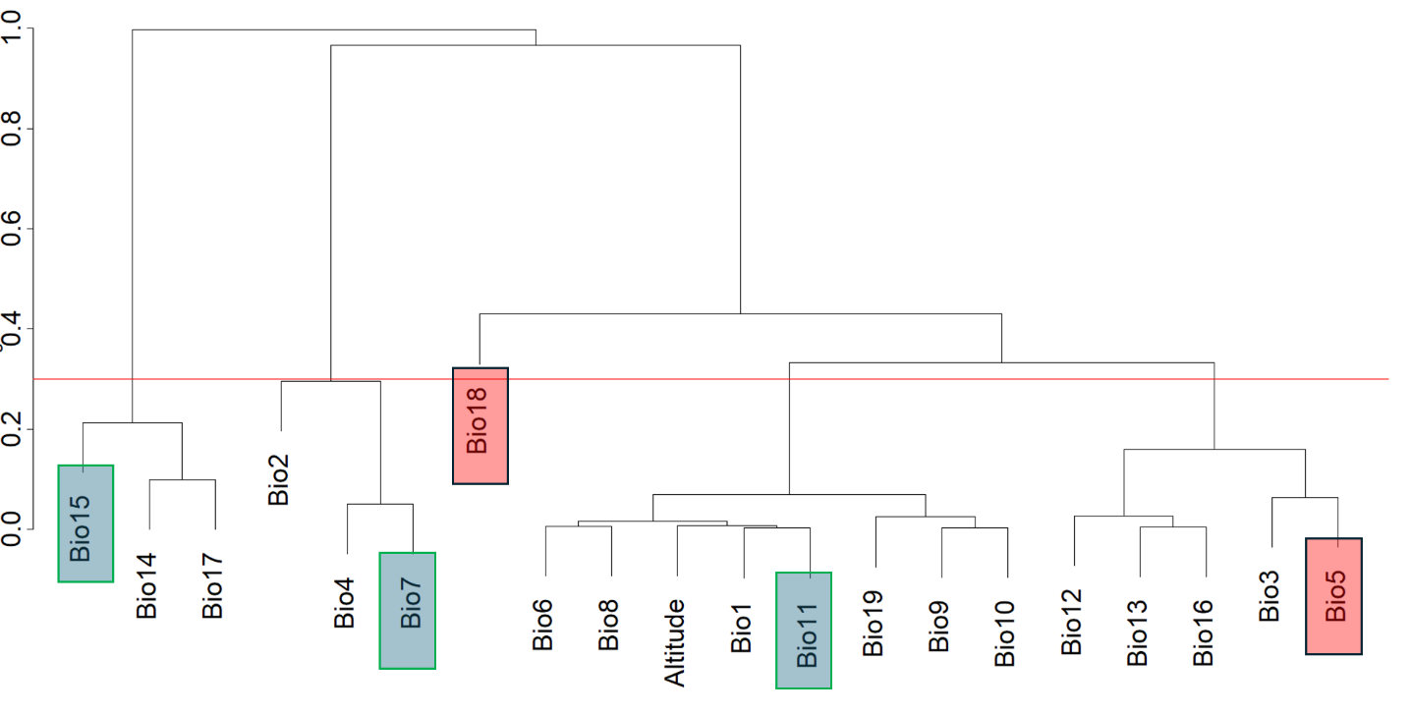
Fig. S2 Dendrogram obtained from the cluster analysis used to select the relevant WorldClim variables (in blue boxes; red boxes represent variables discarded by the VIF analysis); the red horizontal line indicates the chosen distance-threshold to form the clusters (i.e., 0.3 or less than 70% correlation).

