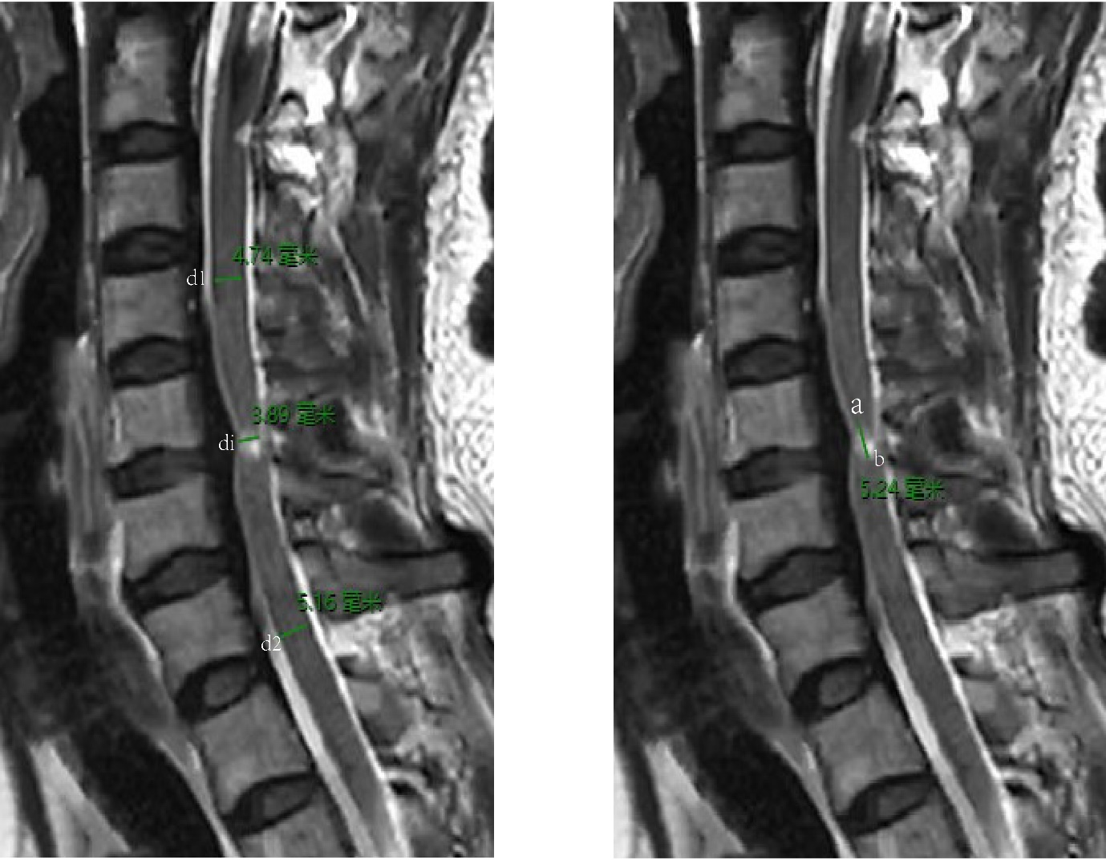
Fig. S1 Conventional magnetic resonance imaging (MRI) scans display measurements of spinal cord compression ratio and lesion length.
The spinal cord compression ratio is 2×di/(d1+d2), where di is the diameter of the spinal cord at the compression level, dl is the normal spinal cord diameter above the compression level, and d2 is the normal spinal cord diameter below the compression level. The length of the lesion is measured as the distance from a to b on the sagittal image
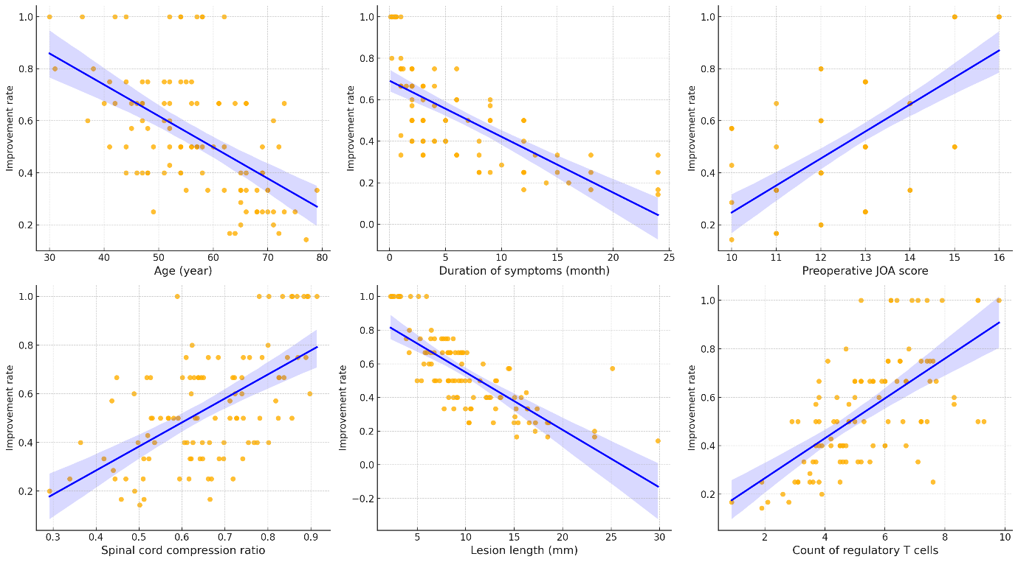

Fig. S2 Single factor regression analysis chart.
We plotted regression lines for factors with p-values less than 0.05 in the univariate regression analysis, where the shaded areas represent the confidence intervals.

