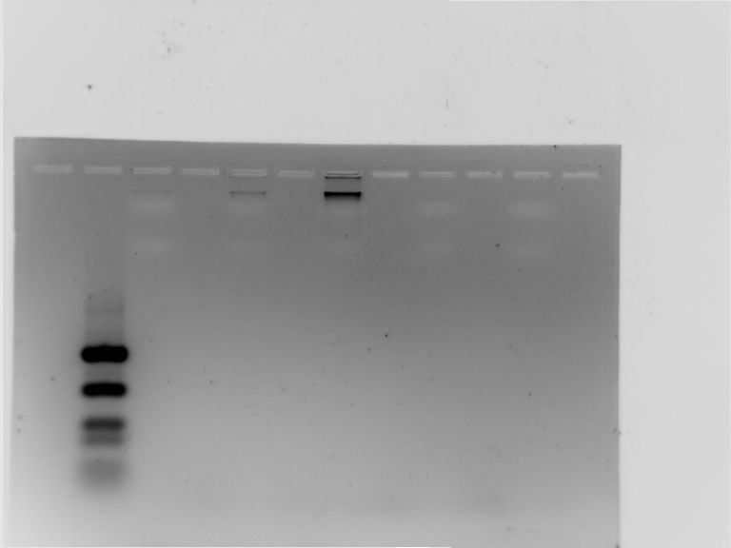

Agarose gel image of Genomic DNA

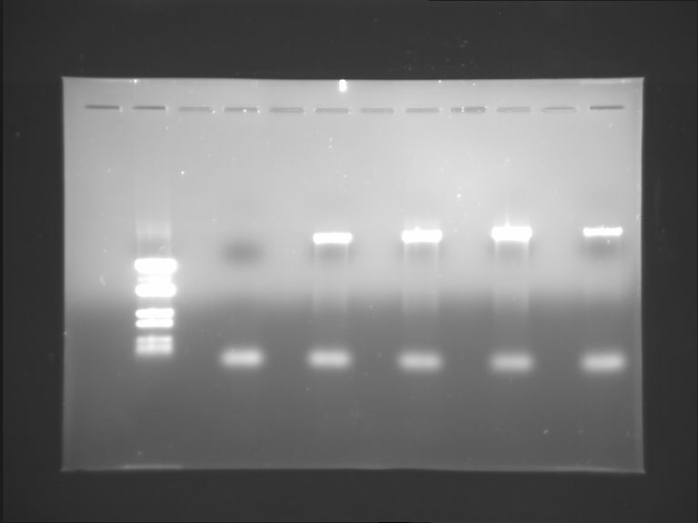

Agarose gel image of PCR products

