Appendix A: Comparative Readability Analysis Using Various Measurements
The use of file size as a proxy for text readability has been suggested in prior research. However, as Bonsall et al. (2017, p. 329) highlight, the variation in Form 10-K file size over time is often influenced by non-textual content (e.g., varying file formats HTML, XML, PDFs and content, that might include tables and figures). Given the limitations of this approach for our focused analysis of Item 7, we instead examine the length of individual Items in the 10-K report as a potential alternative indicator.
In Figure A1, we show the yearly average word count for Item 1, Item 7, and the entire 10-K report. Notably, Item 1’s word count has seen a significant increase, growing from approximately 4,600 words in 1996 (14,669 words in the full report) to nearly 21,000 words in 2022 (48,000 words in the full report). In contrast, Item 7’s word count has remained relatively stable since 2008, with 7,038 words in 2008 and 6,938 words in 2022. These trends in word counts support our hypothesis that the readability of Item 7 is diverging from that of Item 1, particularly in the broader context of the complete report.

Figure A1. Temporal Dynamics of Word Counts in Different Segments (10-K Report, Item 7, and Item 1).
The figure illustrates the temporal trajectory of word counts across distinct segments, namely the 10-K report, Item 7, and Item 1. Each data point on the graphs corresponds to the computed annual average within the respective corpora. These yearly averages are supplemented by 95% confidence intervals, determined via the analysis of 10,000 bootstrap samples.
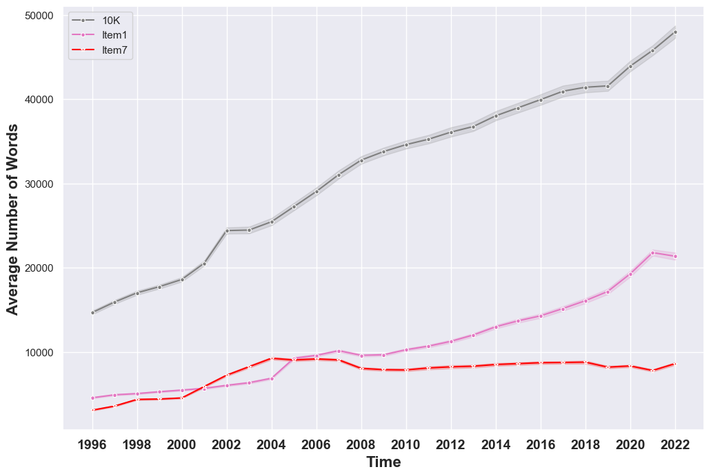
Figure A1 reveals that the length of Item 7 in 10-K reports has been relatively stable from 2008 to the present. This observation, however, contradicts the implications of readability calculations. Figure A2 presents the average Fog Index values for Item 7, Item 1, and the complete 10-K report over our study period. Despite the consistent length of Item 7 since 2008, its Fog score has steadily increased, indicating an increase in complexity that goes beyond word count alone.
A comparison of the Fog Index scores for both items reveals a distinct divergence over time. Between 1996 and 2004, the scores for Item 1 and Item 7 were relatively close, with Item 1 averaging 18.3 and Item 7 at 17.6. However, by 2022, these scores diverged significantly, with Item 1 reaching 21.7 and Item 7 at 20.19. The divergence is further highlighted by the differing slopes of their regression lines, 1.51 for Item 1 and 1.21 for Item 7, illustrating the unique trajectory of each item’s readability.
These trends not only underscore the distinct nature of Item 7 compared to the rest of the report but also challenge the notion of using length as a sole indicator of readability. Additionally, starting from 2010, it’s important to note the converging trends observed between Item 7 and the overall 10-K report.

Figure A2. Temporal Dynamics of Gunning-Fog Index in Different Segments (10-K Report, Item 7, and Item 1).
The figure portrays the temporal evolution of the Gunning-Fog Index across discrete segments, specifically the 10-K report, Item 7, and Item 1. Each data point on the graphs corresponds to the calculated yearly average within the respective corpora. These yearly averages are accompanied by 95% confidence intervals, derived from the analysis of 10,000 bootstrap samples.
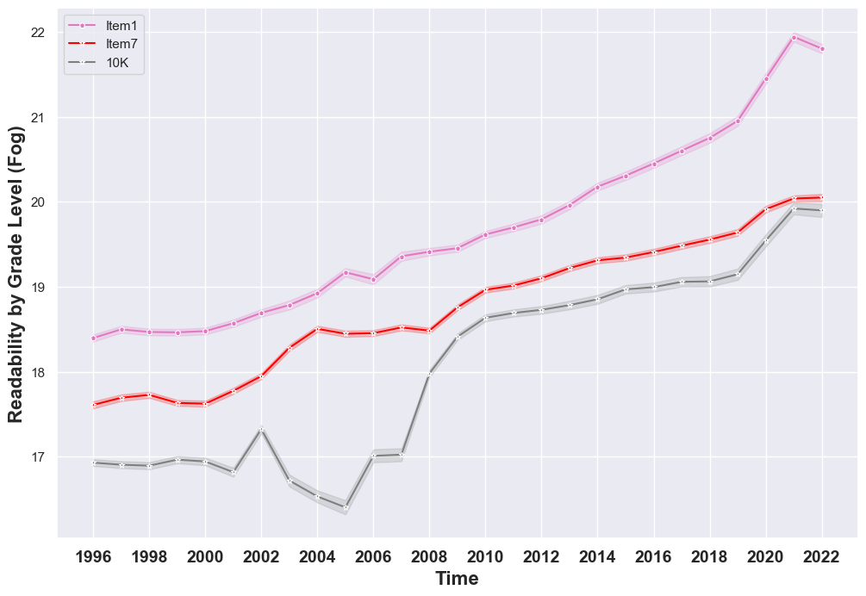

In this article, we focus exclusively on analyzing the readability of Item 7 from 10-K reports, utilizing the Gunning Fog Index as our primary measure. To the best of our knowledge, this is the first study that concentrates solely on Item 7, rather than assessing the readability of the entire 10-K document. However, it is valuable to compare our findings with those derived from different formulas or methods. To this end, we also calculate the Fog Index for the entire 10-K reports and compare these results with the only available alternative measure, the BOG Index.3
Below is a table that provides a comparison of the applied methods, including their descriptions, main findings, and critiques.
Researcher | Method | Description | Results | Critics
Li (2008) | Fog index of the whole report. | To calculate the fog index, Li uses a Perl package (Lingua::EN::Fathom) for sentence segmentation . | There is no trend observed. | Bushee, Gow, and Taylor (2018) demonstrate that this package has inaccuracies in identifying sentence boundaries, leading to less precise Fog Index scores. These inaccuracies may account for the observed lack of a clear trend in the results.
Loughran and McDonald (2014, 2016) | Natural log of the gross file size of the whole report. | Calculate for each report available in the SEC EDGAR database the natural log size. | There is a high correlation between file size and document readability. | Analyzing only a portion of the report can lead to issues with reproducibility. Bonsall IV et al. (2017) demonstrate that variations in file size are often driven by non-text elements, such as HTML tags and other formatting characters, rather than the actual content.
Bonsall IV et al. (2017) | Bog index of the whole report. | $Bog Index= sentence bog+word bog-Pep$,  $$sentence bog=\frac{1}{35}{\left[\frac{Words}{Sentences}\right]}^{2}$$  The first component of the BOG Index is the average sentence length, calculated across the entire document, squared and then scaled by a standard long sentence limit of 35 words. The second component, word bog, consists of two elements: (1) the total count of plain English stylistic infelicities—such as legal jargon, passive voice, etc.—identified in the SEC’s handbook and present in the text; and (2) word difficulty, determined by a custom dictionary that assigns a familiarity-related score from 0 to 4 to over 200,000 unique words. The final component, Pep, "accounts for good writing by summing the usage of items such as names and interesting words, which tend to make writing more engaging" (Bonsall IV et al., 2017, p. 334). As with other text complexity indices, a higher BOG Index score is associated with less readable text. | The authors did not deliberately search for trend, but they did publish their scores for each report, so we use it to compare our results with theirs. | The BOG Index was calculated using the entire 10-K report rather than just Item 7. Unfortunately, the BOG Index is not fully reproducible because some of its components are generated by StyleWriter—the Plain English Editor, a proprietary software with non-transparent processes. Additionally, the authors do not disclose critical details such as their sentence-segmentation algorithm, the composition of the 200,000-word glossary, or the specifics of the Pep calculation.

To compare the Fog Index with the BOG Index, we merged the different methodologies using the unique combination of Central Index Key (CIK) and year for precise identification. This process yielded a corpus of 145,219 10-K reports, each containing both the BOG Index and Fog Index data, spanning the years 1996 to 2020.
Figure A3 illustrates a similar trend for both indexes, despite differences in scale. Both the Fog Index and BOG Index indicate an increasing complexity in the reports over time.

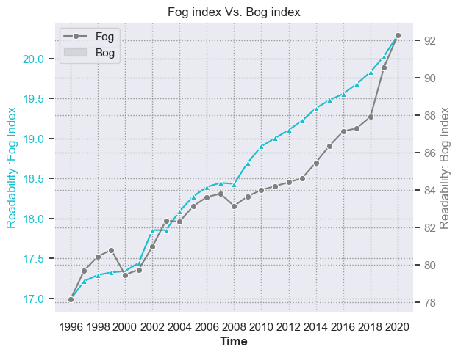 Figure A3. Comparison of the Fog and BOG Indexes. The x-axis represents time, while the y-axis displays the Fog Index (left, in cyan) and the BOG Index (right, in gray).

Appendix B: Readability in Terms of Cognitive Load
The concept of cognitive load is pivotal in understanding readability, particularly in relation to Working Memory (WM). According to Miller (1956) and Cowan (2001), WM has a limited capacity for processing information simultaneously. WM is defined as the system actively maintaining and manipulating information for further processing, including verbal tasks involved in reasoning and comprehension (Saussereau, Guerbert, Anger, and Goulle, 2014, p. 121). This limitation implies that human memory has a cap on the number of 'chunks' of information it can effectively store or process at any given time.
In this context, we explore whether sentence length, a component of the Fog index, contributes to cognitive load and impacts comprehension. Intuitively, longer sentences can be more challenging to understand, requiring greater focus for comprehension. They are often used to express complex ideas, which could increase cognitive load. Supporting this, Gilchrist, Cowan, and Naveh-Benjamin (2008) found that longer sentences could hinder correct processing. This is partly because longer sentences are typically multiclausal, containing multiple semantic propositions (propositional density). This increases language processing demands and could potentially lead to WM depletion (Martin-Aragonese, Mejuto, Del Rio, Fernandes, Rodrigues, and Lopez-Higes, 2023).
Figure B1 illustrates the changing trends in sentence length over time across different corpora. Each point on the graph reflects the annual average sentence length for each corpus. Distinctively, Item 7 stands out in its trend of increasing sentence length, diverging from other corpora which show a consistent movement toward shorter sentences.

Figure B1. Temporal Trends in Sentence Length
The figure illustrates the temporal trajectory of sentence length across distinct corpora. Each data point on the graphs corresponds to the computed annual average within the respective corpora.
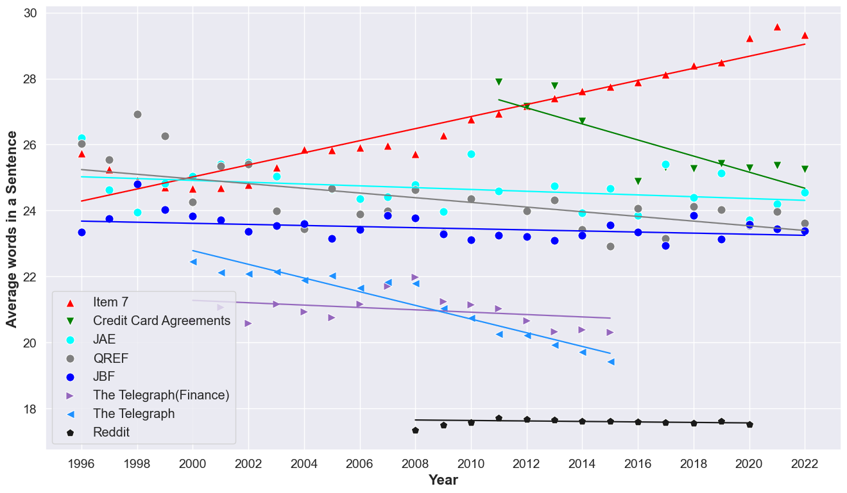
Appendix C: Flesch Reading Ease and Flesch-Kincaid Grade Level Analysis
In conjunction with the Fog index, we have incorporated two additional readability metrics: the Flesch Reading Ease and the Flesch-Kincaid Grade Level (FKGL). These measures provide a broader perspective on the readability of the texts analyzed.

Flesch Reading Ease
Developed by Rudolf Flesch, this metric quantifies how easily a piece of writing can be understood. It assigns a score based on the average sentence length and the average number of syllables per word, where a higher score signifies easier readability. The formula used is:
206.835 - (1.015 × Average sentence length) - (84.6 × Average number of syllables per word).

Flesch-Kincaid Grade Level
This measure, in contrast, is designed to reflect the U.S. school grade level necessary for understanding a text. Factors like sentence length and syllable count per word are integral to this calculation. For example, a FKGL score of 8.0 suggests the text should be easily comprehensible to an eighth-grade student. The FKGL is calculated as:
(0.39 × Average number of words per sentence) + (11.8 × Average number of syllables per word) - 15.59.

Figure C1. Temporal Trends Flesch Reading Ease and Flesch-Kincaid Grade

The figure shows the evolution over time of the Flesch Reading Ease and Flesch-Kincaid Grade Levels, displaying annual averages alongside 95% confidence intervals calculated using the Bootstrap method. Panel A focuses on the Flesch Reading Ease scores. Panel B details the Flesch-Kincaid Grade Level scores.

Panel A: Flesch Reading Ease
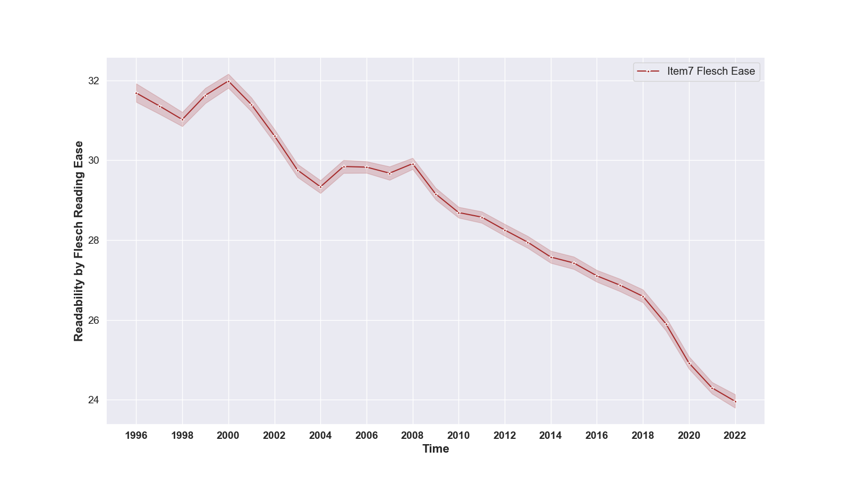
Panel B: Flesch-Kincaid Grade Level
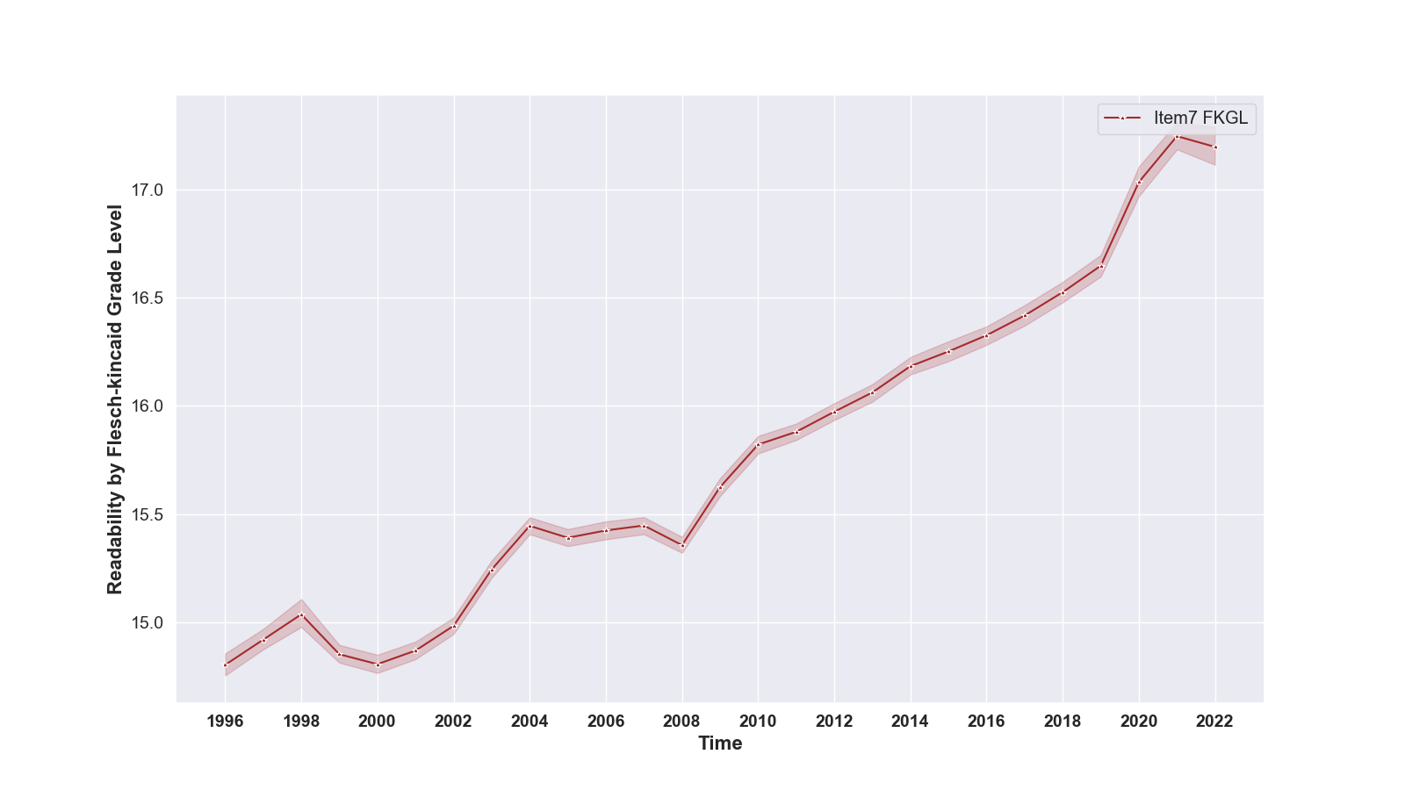

Figure C1 visualizes the evolution over time of the Flesch Reading Ease and Flesch-Kincaid Grade Levels, displaying annual averages alongside 95% confidence intervals. Our analysis reveals a discernible trend of decreasing readability across the years, similar to the patterns observed with the Gunning—Fog index. Specifically, the data shows a progression from a FKGL score of 14.7 in 1996 to nearly 18 in 2022, indicating an increasing complexity in the text.
Appendix D: Gunning-Fog Index Evolution with Bootstrapping
To validate our findings, we have employed the bootstrapping technique to establish confidence intervals and assess standard errors. Figure D1 presents our key results, incorporating bootstrapped samples with calculated 95% confidence intervals. We used a standard sample size of 10,000 for most datasets. However, for the academic journals’ dataset—specifically JAE and JBF—we reduced the sample size to 1,000 articles, and to 250 articles for QREF. This reduction reflects the narrower scope and availability of articles in these journals.
The wider error bands observed in the JAE, JBF, and QREF corpora signify higher standard errors, primarily due to the smaller number of available observations in these datasets.
Figure D1. Temporal Trends in Gunning-Fog Index Across Diverse Corpora – A Bootstrap Confidence Interval Analysis.
This figure presents a year-over-year evolution comparison of the Gunning-Fog Index across various corpora. Each point in the graph represents the yearly average Gunning-Fog Index for each corpus. Additionally, 95% confidence intervals, determined using the Bootstrap method, are included to provide statistical context.
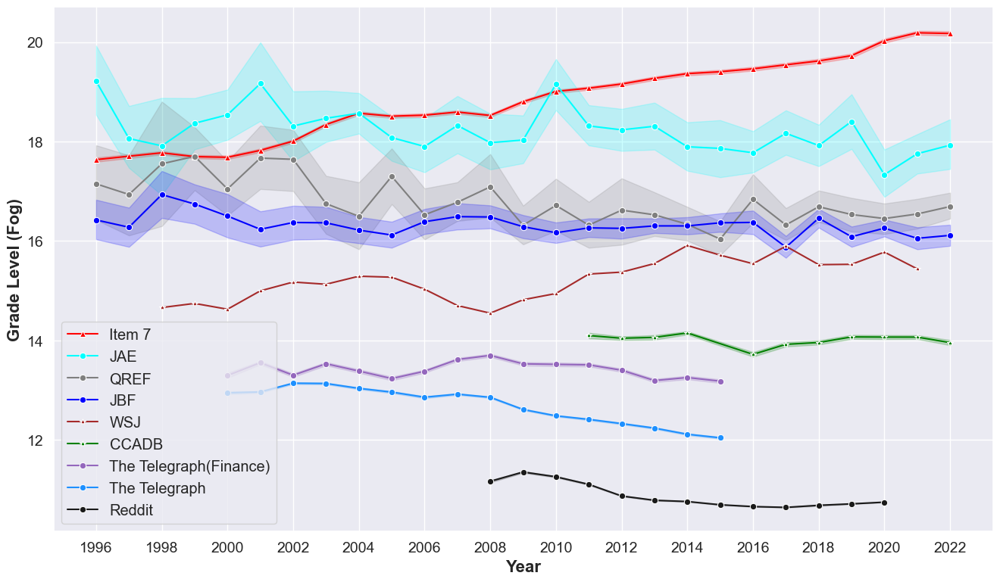

Appendix E: Regression Analysis of Readability Trends Over Time

This appendix supplements Figure 2 by presenting the estimated yearly coefficients derived from regression model (2).
Table E1. Yearly Changes in Gunning-Fog Index for Item 7.
This table shows the coefficients for each year as determined by regression equation (2). The analysis focuses on the Gunning-Fog Index for Item 7 as the dependent variable and includes industry fixed effects based on the Fama-French 12 industry classification. The numbers in parentheses represent robust standard errors, clustered at the firm level. The symbols *, **, and *** indicate significance levels at 10%, 5%, and 1%, respectively.

 | (1)
 | fog_score_item7
year== 1997 | 0.0714*
 | (0.0354)
year== 1998 | 0.137***
 | (0.0348)
year== 1999 | 0.0643
 | (0.0467)
year== 2000 | 0.0467
 | (0.0627)
year== 2001 | 0.167**
 | (0.0735)
year== 2002 | 0.357***
 | (0.0816)
year== 2003 | 0.688***
 | (0.0774)
year== 2004 | 0.913***
 | (0.0593)
year== 2005 | 0.860***
 | (0.0708)
year== 2006 | 0.876***
 | (0.0725)
year== 2007 | 0.935***
 | (0.0966)
year== 2008 | 0.877***
 | (0.144)
year== 2009 | 1.164***
 | (0.145)
year== 2010 | 1.368***
 | (0.128)
year== 2011 | 1.431***
 | (0.130)
year== 2012 | 1.510***
 | (0.124)
year== 2013 | 1.620***
 | (0.123)
year== 2014 | 1.696***
 | (0.105)
year== 2015 | 1.726***
 | (0.107)
year== 2016 | 1.781***
 | (0.108)
year== 2017 | 1.853***
 | (0.104)
year== 2018 | 1.914***
 | (0.105)
year== 2019 | 2.012***
 | (0.111)
year== 2020 | 2.294***
 | (0.124)
year== 2021 | 2.451***
 | (0.137)
year== 2022 | 2.444***
 | (0.0901)
Industry FE | YES
Observations | 174,950
Adjusted R² | 0.228

13 https://sites.google.com/iu.edu/professorbrianpmiller/bog-data [Acc. 07/29/24]

