Fabrication of Low-Tortuosity Thick Electrodes with Minimal Material Loss by Temporally Shaped Ultraviolet Femtosecond Laser
Junrui Wu¹, Ruoxi Wang¹, Lan Jiang^{1,2}, Xin Li^{1,2, *}, Jiang Zhang¹, Richen Jia¹, Mengyao Tian¹, Yu Liu¹, Huixin Guo³, Simon Wang⁴, Ran Zhao⁵, Xiangbiao Liao³, and Qian Cheng ^{1,*}
¹Laser Micro/Nano-Fabrication Laboratory, School of Mechanical Engineering, Beijing Institute of Technology, Beijing 100081, P. R. China
²Complex microstructure processing technology (National) Innovation Center, Beijing 100081, P. R. China
³Advance Research Institute of Multidisciplinary Sciences, Beijing Institute of Technology, Beijing 100081, China
⁴Shenzhen Thinkpart materials technology co., Ltd
⁵Beijing Key Laboratory of Environmental Science and Engineering, Beijing 100081, P. R. China
*Corresponding authors. E-mail address: qiancheng@bit.edu.cn (Q. Cheng), lixin02@bit.edu.cn (X. Li)

Table S1. Comparisons of loss ratio and performance on different electrode materials with various methods.
Materials | Methods | Electrochemical performance | Structure | Processing equipment | Active mass loading /Thickness | Intrinsic porosity of materials | Loss ratio | Hole spacing | Equivalent space utilization ratio | Reference
LiCoO₂ | Emulsion-based, magnetic-alignment  method | The low-tortuosity LCO electrode delivered a total discharge capacity of 111.4 mAh g⁻¹, approximately 80% of the theoretical  capacity of LCO | Highly oriented pore channels | Sonicated using a bath sonicator  for 20 min before 30 µL of oil-based ferrofluid | >400 µm | 41.3% | - | - | 58.7% | 1
LiFePO₄ | Templated phase inversion  method | The ultrathick bilayer LiFePO₄ electrodes (up to 1.2 mm) demonstrate marked improvements in rate performance and cycling stability under high areal loadings (up  to 100 mg cm⁻²) | Microchannels with interconnected porous walls | The homogeneous slurry was cast on a  glass plate, and a stainless-steel mesh was placed just under the slurry  surface. | 100 mg cm⁻² /1.2 mm | 71% | - | - | 29% | 2
LiN_{i0.8}Co_{0.15}Al_{0.05}O₂ (NCA) cathodes | Freeze-casting | >90% of the low-rate electrode capacity could be obtained at C/5 rate, reaching a practical area capacity of ∼13 mAh cm⁻² | Pore topologies | Freeze-cast and sintered NCA electrodes | 330 μm | 45.4 % | - | - | 54.6% | 3
Graphite electrodes | Freeze-drying | Higher capacity retention (over 8% higher after 90 cycles at C/5) and better  rate capability (60% higher capacity at 1C) | Low-tortuous structure | Directional freeze-drying of  slurries cast on a copper foil | 7.41mg cm⁻²/85μm | 50 % | - | - | 50 % | 4
LiNi_{1/3}Mn_{1/3}Co_{1/3}O₂ (NCM111) | Modified ice-templating method | Diminished capability under a C-rate  larger than 1.5 C, those with thinner walls could maintain ∼70% capacity  under 2.5 C. | Channel | With ice-templating method using different  mixed solvents | 20−25 mg cm⁻² | 40% | - | - | 60% | 5
Graphite anode | Laser-patterning process | > 97% and >93% capacity retention after 100 cycles of 4C and 6C fast-charge cycling | Vertical pore  Channels (42.7 μm top, 12.4 μm bottom) | A high-precision  laser patterning platform | 8.51  mg cm⁻² | 32% | 10.2 % | 85 μm | 61.06% | 6
Graphite | High repetition ultrafast laser ablation | Unstructured electrodes reach  189 ± 26 Wh kg⁻¹, the structured electrodes achieve  241 ± 24 Wh kg⁻¹ | Line patterning (85 μm) | High-power, high repetition  rate laser source | 115.3 μm | 40% | 15% | 387 μm | 51.00% | 7
LiNi_{0.5}Mn_{0.3}  Co_{0.2}O₂ | Micro-grooves by femtosecond laser | (thickness = 175 μm, porosity = 26%) at 0.5C is about twice higher than unstructured electrode (thickness = 100 μm, porosity = 50%)，unstructured electrode (thickness = 100 μm, porosity = 50%) | Micro-grooves (30-50 μm line) | Ultrashort pulse laser, galvanometer scanner (SCANLAB) with a  focusing lens (focal length = 167 μm) | 24.1 mg cm⁻²/100 μm | 26% | 20.3% | 200 μm | 58.98% | 8
lithium iron phosphate (LFP) | Microchannel structure by laser drilling technology | Improved cycling stability at 0.5C than the undrilled  samples. | Microchannel (171 μm hole) | A laser drilling  technique (SL-G10, Suzhou Shoulei Co., Ltd.) | 40 mg cm⁻ ²/100 μm | 30% | 18.84% | 349 μm | 56.81% | 9
LCO，graphite | Laser structuring of ultra-thick electrodes for high-energy batterys | Rate capability and areal discharge capacity of laser-structured cells increase by 5 times than  that of unstructured one at 0.1C. | Straight grooves（50 μm line） | Ultra-short pulsed laser system, a galvanometer scanner (SCANLAB) with a focusing lens (focal length = 167  μm) | 172 ± 5 mg cm⁻ ²/700 μm, 71 ± 2 mg  cm⁻ ²/500 μm | 50% | 16.7% | 300 μm | 41.65% | 10
Lithium iron phosphate (LFP) | Frequency/time domain shaping laser percussion drilling | With a mass loading of 60 mg cm⁻², laser-structured thick cathode can operate at 1 C with a capacity of 125.63 mAh g⁻¹, outperforming unstructured electrodes (23.63mAh g⁻¹). | Through holes（6 μm） | Femtosecond pulsed laser system | 260 μm | 30% | 1% | 60 μm | 69.3% | This work

Table S2. Focal spot diameter and focal depth length corresponding to objective lens with different numerical aperture.
Objective magnification | Focal spot diameter (μm) | Focal depth (μm)
0.15 | 10.67 | 223.29
0.3 | 5.33 | 55.82
0.4 | 4.00 | 31.40
0.45 | 3.56 | 24.81
0.5 | 3.20 | 20.10
0.8 | 2.00 | 7.85

Table S3. The current status of fabricating through-holes using femtosecond lasers.
Materials | Method | Upper surface aperture | Hole depth | Depth-diameter ratio | Reference
TiO₂-coated graphene hybrids and under-layer graphene | Femtosecond laser drilling method | 10 μm | 100 μm | 10 | 11
Inconel 718 superalloy plates | Femtosecond laser drilling | 127 μm | 2000 μm | 15.7 | 12
Inconel 718 plates | Laser polarization trepanning and laser spinning methods | 114 μm | 2300 μm | 20 | 10
304 stainless steel | Femtosecond-laser spiral trepanning  method | 490 μm | 2000 μm | 4.08 | 13
Al foil | Multiple femtosecond laser scans | 5.6 μm | 33.5 μm | 5.98 | 14
Thermal barrier coated alloys | Millijoule femtosecond laser spiral drilling | 200 μm | 2400 mm | 12 | 15
ZnO | Femtosecond laser microhole array | 2μm | 25nm | 0.0125 | 16
Ti–6Al–4V sheet | Concentric circle scanning path | 100μm | 0.5mm | 5 | 17
Ti foil | Laser percussion drilling | 28 μm | 30 μm | 1.07 | 18
Silicon | Laser percussion drilling | 18.1 μm | 280 μm | 15.5 | 19
RuO₂-graphene/graphene | Laser percussion drilling | 7 μm | 143 μm | 20.42 | 20
aluminum foil | Water-assisted femtosecond  laser perforating | 12.9 μm | 25 μm | 2 | 21
Inconel 718 superalloys | Femtosecond laser trepanning with an axial feed | 200 μm | 2000 μm | 10 | 22
Cemented tungsten | Trepanning drilling | 300 μm | 1000 μm | 3.3 | 23
Thermal barrier coated titanium alloy | Zig-zag scanning modes | 60 μm | 500 μm | 8.3 | 24
Carbon  Fiber-Reinforced Polymer | Spiral drilling | 700 μm | 2100 μm | 3 | 25
Stainless steel | Magnetic field-assisted femtosecond laser through-hole drilling | 200 μm | 2000 μm | 10 | 26
IN792 superalloy | Femtosecond laser trepan drilling | 400 μm | 680 μm | 1.7 | 27
DD6  Single Crystal Alloy | Annular drilling | 400 μm | 2000 μm | 5 | 28
Nickel-based alloy | Helical drilling | 162 μm | 2000 μm | 15 | 29
Lithium iron phosphate (LFP) | Frequency/time domain shaping laser percussion drilling | 6 μm | 280 μm | 47 | This work

Areal mass loading (mg cm⁻²) | Thickness (μm) | Unstructured LFP (0.2C) | Laser structured LFP  (0.2C) | Unstructured LFP (0.5C) | Laser structured LFP  (0.5C)
14 | 80 | 96.04% | 96.11% | 93.04% | 93.82%
30 | 150 | 88.97% | 95.03% | 84.70% | 91.17%
40 | 190 | 92.59% | 96.10% | 76.90% | 92.20%
60 | 280 | 83.83% | 93.57% | 76.03% | 92.28%
Table S4. The energy efficiency of electrodes with different thickness.

Table S5 Comparison of tortuosity of different electrodes.
Areal mass loading (mg cm⁻²) | Thickness (μm) | EIS of Laser structured LFP before cycling (Ω) | EIS of unstructured LFP before cycling (Ω) | EIS of Laser structured LFP after cycling (Ω) | EIS of unstructured LFP after cycling (Ω) | Tortuosity of structured LFP before cycling | Tortuosity of unstructured LFP before cycling
30 | 150 | 90 | 170 | 162 | 2912 | 1.56 | 2.94
40 | 190 | 114 | 189 | 278 | 2493 | 1.51 | 2.50
60 | 280 | 164 | 1011 | 357 | 2436 | 1.42 | 8.75

Fig. S1 a. The relationship between the thickness of LFP cathode and the ratio of active materials in LFP//Li batteries. b. The relationship between volume energy density and the thickness of electrode in LFP//Li batteries.

Fig. S2 Upper and lower surface morphologies of 190 μm thick LFP electrodes (40 mg cm⁻²) percussion drilled by 800 nm femtosecond laser with different NA objective lenses.
Fig. S3 SEM morphologies of 190 μm thick LFP electrodes (40 mg cm⁻²) percussion drilled by 800 nm femtosecond laser with different NA objective lenses.

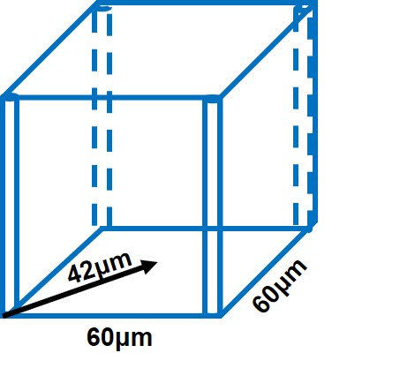
Fig. S4 The longest diffusion length in 6 -60 μm thick LFP electrodes.

Fig. S5 Upper and lower surface morphologies of through holes with 6 - 60 μm configuration on LFP electrode. a. 14mg cm⁻²; b. 30 mg cm⁻²; c. 40 mg cm⁻²; d. 60 mg cm⁻².

Fig. S6 Upper and lower surface morphologies of 280 μm thick LFP electrodes (60 mg cm⁻²) percussion drilled by 400 nm temporally shaped femtosecond laser with different pulse delays.

Fig. S7 Upper and lower surface morphologies of 190 μm thick LFP electrodes (40 mg cm⁻²) percussion drilled by 400 nm temporally shaped femtosecond laser with different pulse delays.
Fig. S8 The relationship between pore size and pulse delay, and whether a through-hole is formed in the 60 mg cm⁻² LFP electrode.

Fig. S9 The mechanism of high aspect ratio through-holes drilled by temporally shaped ultraviolet femtosecond laser.
Fig. S10 The light field distribution of a. unshaped and b. temporally shaped ultraviolet laser with 0.45 ps before objective focusing.

Fig. S11. Comparison of surface morphologies of a. unstructured LFP electrode and b. the vicinity of laser-drilled holes on laser-structured LFP electrode.

Fig. S12. EDS elemental mapping images of a. unstructured LFP electrode and b. laser-structured LFP electrode.
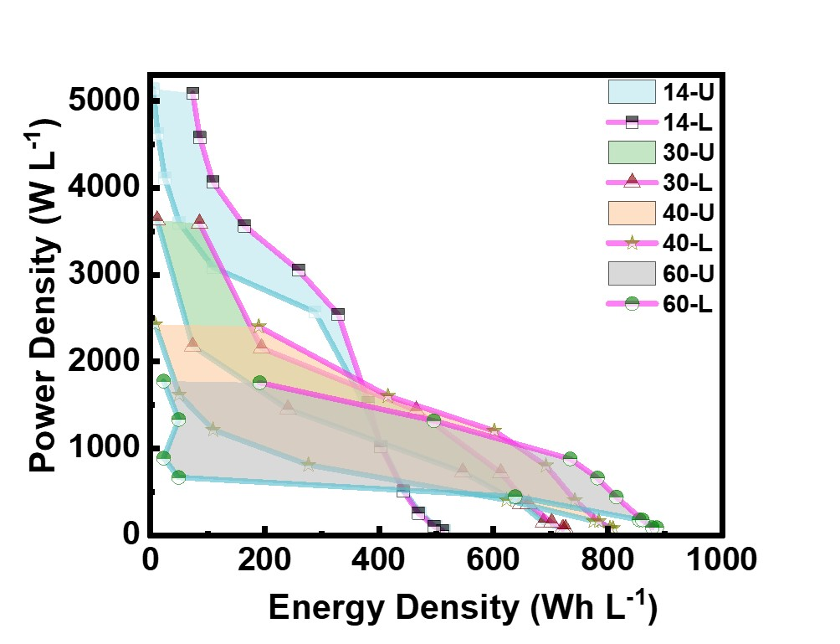
Fig. S13 Volume energy density and power density of different electrode thicknesses.

Fig. S14 CV curves of the unstructured LFP electrode and laser-structured electrode with different thicknesses at a scan rate of 0.05 mV s⁻¹.
Fig. S15 The comparison of cycling performance for electrodes with different thicknesses at 0.5C.
Fig. S16. Upper and lower surface of through holes with 6 - 60 μm configuration on NMC electrode. a. 14mg cm⁻²; b. 50 mg cm⁻².
Fig. S17 SEM morphologies of unstructured thick NMC electrodes (14 mg cm⁻²).

Calculations:
Regarding the formula calculation in the article, the specific parameters are as follows:
Suppose it is 1 cm². For aluminum foil with a thickness of 10 μm and a density of 2.7 g cm⁻³, its mass M_{aluminum} is 2.7 g cm⁻³×10 μm×10⁻⁴ ×10³= 2.7 mg. For copper foil with a thickness of 5 μm and a density of 8.92 g cm⁻³, its mass M_{copper} is 8.92 g cm⁻³×5 μm×10⁻⁴×10³ = 4.46 mg. For lithium foil with a thickness of 40 μm and a density of 0.534 g cm⁻³, its mass M_{lithium} is 0.534 g cm⁻³×40 μm×10⁻⁴×10³ = 2.136 mg. The thickness of the separator is 20 μm and its mass can be ignored.
Suppose the pore loss introduced by punching is L%. The porosity of the electrode itself is 30%. Then the equivalent space utilization rate is: 1 - 70% × (1 - L%).
The density of the electrolyte is 1.242 g cm⁻³. Then its mass is divided into the mass of the electrolyte in the pores and the mass of the electrolyte at the separator. M_{electrolyte} =1.242 g cm⁻³× 1000 × (1 - 70% (1 - L%)) × t μm× 10⁻⁴ + 2.484 mg = 0.1242 × (1 - 70% (1 - L%)) × t + 2.484 mg.
Suppose the thickness is t. Then the mass of the M_{LFP} active material is: 60t/260 mg.
The thickness of the active material corresponding to different areal densities of 14, 30, 40, and 60 mg cm⁻²: 60, 130, 170, and 260 μm respectively.
The theoretical areal capacities are:
150 mAh g⁻¹ × 14mg cm⁻² = 2.1 mAh cm⁻²
150 mAh g⁻¹ × 30mg cm⁻² = 4.5 mAh cm⁻²
150 mAh g⁻¹ × 40mg cm⁻² = 6 mAh cm⁻²
150 mAh g⁻¹ × 60mg cm⁻² = 9 mAh cm⁻²
- Then the mass percentage of the active material of unpunched LFP (Fig.S1a) is:
$$∅=\frac{\frac{60 t}{260} mg}{\frac{60t}{260×0.95} mg+2.7 mg+4.46 mg+2.136 mg+2.484 mg+0.1242×30\%×t mg}$$
When the pore loss introduced by punching is 20%, the proportion of loss is:
$$∅=\frac{\frac{60t}{260}×0.8 mg }{\frac{60t}{260×0.95}×0.8 mg+2.7 mg+4.46 mg+2.136 mg+2.484 mg+0.1242×\left(1-70\%（1- 20\%）\right)×t mg}$$
When the pore loss introduced by punching is 1%, the proportion of loss is:
$$∅=\frac{\frac{60t}{260}×0.99 mg}{\frac{60t×0.99}{260×0.95} mg +2.7 mg+4.46 mg+2.136 mg+2.484 mg+0.1242×\left(1-70\%（1- 1\%）\right)×t mg}$$
(2) Then the gravimetric energy density proportion of the active material (Fig.1d) of LFP is:
$$E_{gravi}=\frac{\frac{t}{260}×9×3.3×1000 mWh }{\frac{60t}{260×0.95} mg+2.7 mg+4.46 mg+2.136 mg+2.484 mg+0.03726×t mg }$$
When the pore loss introduced by punching is 20%, the proportion of loss is:
$$E_{gravi}=\frac{\frac{t}{260}×9×3.3×1000×0.8 mWh }{\frac{60t×0.8}{260×0.95} mg+2.7 mg+4.46 mg+2.136 mg+2.484 mg+0.05648×t mg}$$
When the pore loss introduced by punching is 1%, the proportion of loss is:
$$E_{gravi}=\frac{\frac{t}{260}×9×3.3×1000×0.99 mWh }{\frac{60t×0.99}{260×0.95} mg+2.7 mg+4.46 mg+2.136 mg+2.484 mg+0.03813×t mg}$$
(3) Then the volume energy density proportion of the active material (Fig.S1b) of LFP is:
$$∅_{volume}=\frac{\frac{t}{260}×9×3.3×10000×1 mWh }{\left(t+75\right)*1{ cm}^{-3}}$$
When the pore loss introduced by punching is 20%, the proportion of loss is:
$$∅_{volume}=\frac{\frac{t}{260}×9×3.3×10000×1×\left(1-L\%\right) mWh }{(t+75)×1{ cm}^{-3}}$$
When the pore loss introduced by punching is 1%, the proportion of loss is:
$$∅_{volume}=\frac{\frac{t}{260}×9×3.3×10000×1×\left(1-L\%\right) mWh }{(t+75)×1{ cm}^{-3}}$$
(4) Areal capacity calculation (Fig. 4h):
The areal capacity at different rates (mAh cm⁻²) = areal density (mg cm⁻²) × specific capacity at different rates (mAh g⁻¹).
(5) Calculation of volume energy density and gravimetric power density (Fig. S13e):
Volume energy density:
$E_{vol}=\frac{(10000 × 1 × areal density × specific capacity at different rates × medium discharge voltage) mWh}{((t + 75) × 1 {cm}^{3}}$(unpunched);
$E_{vol}=\frac{(0.99 × 10000 × 1 × areal density × specific capacity at different rates × medium discharge voltage) mWh}{((t + 75) × 1 {cm}^{3}}$(punched).
Volume power density:
$P_{vol}=\frac{(10000 × 1 × rate × areal density × theoretical specific capacity × medium discharge voltage) mW}{((t + 75) × 1 {cm}^{3}}$(unpunched);
$P_{vol}=\frac{(0.99 × 10000 × 1 × rate × areal density × theoretical specific capacity × medium discharge voltage) mW}{((t + 75) × 1 {cm}^{3}}$(punched).
Calculation of gravimetric energy density and gravimetric power density (Fig. 1e):
(6) Gravimetric energy density:
$E_{vol}=\frac{(10000 × 1 × areal density × specific capacity at different rates × medium discharge voltage) mWh}{\frac{60t}{260×0.95} mg+2.7 mg+4.46 mg+2.136 mg+2.484 mg+0.1242×30\%×t mg}$(unpunched);
$E_{vol}=\frac{(0.99 × 10000 × 1 × areal density × specific capacity at different rates × medium discharge voltage) mWh}{\frac{60t}{260×0.95} mg+2.7 mg+4.46 mg+2.136 mg+2.484 mg+0.1242×30\%×t mg}$(punched).
Gravimetric power density:
$P_{vol}=\frac{(10000 × 1 × rate × areal density × theoretical specific capacity × medium discharge voltage) mW}{\frac{60t}{260×0.95} mg+2.7 mg+4.46 mg+2.136 mg+2.484 mg+0.1242×30\%×t mg}$(unpunched);
$P_{vol}=\frac{(0.99 × 10000 × 1 × rate × areal density × theoretical specific capacity × medium discharge voltage) mW}{\frac{60t}{260×0.95} mg+2.7 mg+4.46 mg+2.136 mg+2.484 mg+0.1242×30\%×t mg}$(punched).

References
1. Li L, Erb RM, Wang J, Wang J, Chiang YM. Fabrication of Low‐Tortuosity Ultrahigh‐Area‐Capacity Battery Electrodes through Magnetic Alignment of Emulsion‐Based Slurries. Adv. Energy Mater. 9, 1802472 (2018).
2. Wu J, et al. Ultrahigh-Capacity and Scalable Architected Battery Electrodes via Tortuosity Modulation. ACS Nano 15, 19109-19118 (2021).
3. Delattre B, Amin R, Sander J, De Coninck J, Tomsia AP, Chiang Y-M. Impact of Pore Tortuosity on Electrode Kinetics in Lithium Battery Electrodes: Study in Directionally Freeze-Cast LiNi0.8Co0.15Al0.05O2(NCA). J. Electrochem.l Soc. 165, A388-A395 (2018).
4. Dang D, Wang Y, Gao S, Cheng Y-T. Freeze-dried low-tortuous graphite electrodes with enhanced capacity utilization and rate capability. Carbon 159, 133-139 (2020).
5. Zhang X, et al. Tunable Porous Electrode Architectures for Enhanced Li-Ion Storage Kinetics in Thick Electrodes. Nano Lett. 21, 5896-5904 (2021).
6. Chen K-H, et al. Efficient fast-charging of lithium-ion batteries enabled by laser-patterned three-dimensional graphite anode architectures. J. Power Sources 471, 228475 (2020).
7. Meyer A, Sterzl Y, Pfleging W. High repetition ultrafast laser ablation of graphite and silicon/graphite composite electrodes for lithium-ion batteries. J. Laser Appl. 35, 4 (2023).
8. Park J, Hyeon S, Jeong S, Kim H-J. Performance enhancement of Li-ion battery by laser structuring of thick electrode with low porosity. J. Ind. Eng. Chem. 70, 178-185 (2019).
9. Wu S, et al. High-capacity, low-tortuosity LiFePO4-Based composite cathode enabled by self-supporting structure combined with laser drilling technology. Chem. Eng. J. 430, 132810 (2022).
10. Park J, Jeon C, Kim W, Bong S-J, Jeong S, Kim H-J. Challenges, laser processing and electrochemical characteristics on application of ultra-thick electrode for high-energy lithium-ion battery. J. Power Sources 482, 228948 (2021).
11. Xu C, Li Q, Wang Q, Kou X, Fang H-T, Yang L. Femtosecond laser drilled micro-hole arrays in thick and dense 2D nanomaterial electrodes toward high volumetric capacity and rate performance. J. Power Sources 492, 229638 (2021).
12. Wang R, et al. A comparative study on high pulse energy femtosecond laser drilling of high-aspect-ratio holes under different pressure conditions. J. Manuf. Processes 85, 492-502 (2023).
13. Li F, Feng G, Yang X, Li X, Ma G, Lu C. Research on Microhole Processing Technology Based on the Femtosecond-Laser Spiral Trepanning Method. Applied Sciences 10, 7508 (2020).
14. Liu H, Lin W, Lin Z, Ji L, Hong M. Self‐Organized Periodic Microholes Array Formation on Aluminum Surface via Femtosecond Laser Ablation Induced Incubation Effect. Adv. Funct. Mater. 29, 1903576 (2019).
15. Wang R, Dong X, Wang K, Sun X, Fan Z, Duan W. Investigation on millijoule femtosecond laser spiral drilling of micro-deep holes in thermal barrier coated alloys. Int. J. Adv. Manuf. Tech. 114, 857-869 (2021).
16. Zang Z, Zeng X, Du J, Wang M, Tang X. Femtosecond laser direct writing of microholes on roughened ZnO for output power enhancement of InGaN light-emitting diodes. Opt. Lett. 41, 1903576 (2016).
17. Deepu P, Jagadesh T, Duraiselvam M. Investigations into morphology and surface integrity of micro-hole during femtosecond laser drilling of titanium alloy. J. Braz. Soc. Mech. Sci. 45, 516 (2023).
18. Wang C, Liu B, Luo Z, Ding K, Duan Ja. Fabrication of microholes array on titanium foil by a femtosecond laser and a surface’s wettability switching. Chin. Opt. Lett. 19, 082201 (2021).
19. Gao B, Chen T, Chen Y, Si J-H, Hou X. Fabrication of Through Micro-hole Arrays in Silicon Using Femtosecond Laser Irradiation and Selective Chemical Etching. Chinese Phys. Lett. 32, 107901 (2015).
20. Wang Q, Zhang J. Fabrication of RuO2-graphene/graphene thick-and-dense micro-hole array material by femtosecond laser for high volumetric rate performance. Electrochim. Acta 504, 144919 (2024).
21. Li G, et al. High-quality microhole arrays by water-assisted femtosecond laser perforating for improved particle sorting. Opt. Eng. 57, 056114 (2018).
22. Wang R, Dong X, Wang K, Sun X, Fan Z, Duan W. Two-step approach to improving the quality of laser micro-hole drilling on thermal barrier coated nickel base alloys. Opt. Lasers Eng. 121, 406-415 (2019).
23. Xuan Pham K, Tanabe R, Ito Y. Trepanning drilling of microholes on cemented tungsten carbide using femtosecond laser pulses. J. Laser Appl. 24, 3 (2012).
24. Deepu P, Jagadesh T. Femtosecond Laser Micro Drilling of Cooling Holes on Thermal Barrier Coated Titanium Alloy for Aeroengine Application. J. Mater. Eng. Perform., 1, 1-22 (2023).
25. Jiang H, Ma C, Li M, Cao Z. Femtosecond Laser Drilling of Cylindrical Holes for Carbon Fiber-Reinforced Polymer (CFRP) Composites. Molecules 26, 2953 (2021).
26. Xia K, et al. Experimental investigation of femtosecond laser through-hole drilling of stainless steel with and without transverse magnetic assistance. Appl. Optics 60, 1399-1410 (2021).
27. Zhang F, et al. Optimization of the femtosecond laser trepan drilling strategy on IN792 for improving hole geometrical characteristics and machining efficiency. Int. J. Adv. Manuf. Tech. 127, 93-106 (2023).
28. Du T, et al. Optimization of Femtosecond Laser Drilling Process for DD6 Single Crystal Alloy. Metals 13, 333 (2023).
29. Zhai Z, Wang W, Mei X, Li M, Li X. Percussion drilling on nickel-based alloy with thermal barrier coatings using femtosecond laser. Optik 194, 163066 (2019).

