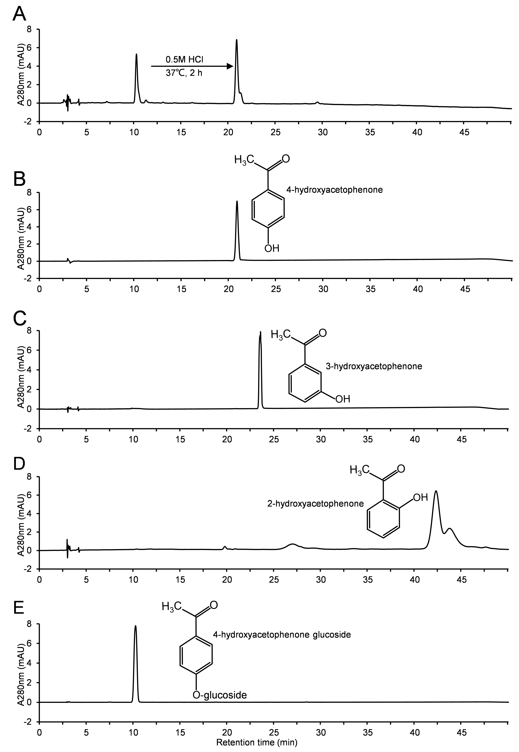
Fig.S1. HPLC chromatogram of partial hydrolysis products of 4HAP-G(A), standard 4-hydroxyacetophenone (pHAP) (B), standard 3-hydroxyacetophenone (C), standard 2-hydroxyacetophenone (D) and standard 4HAP-G (E).

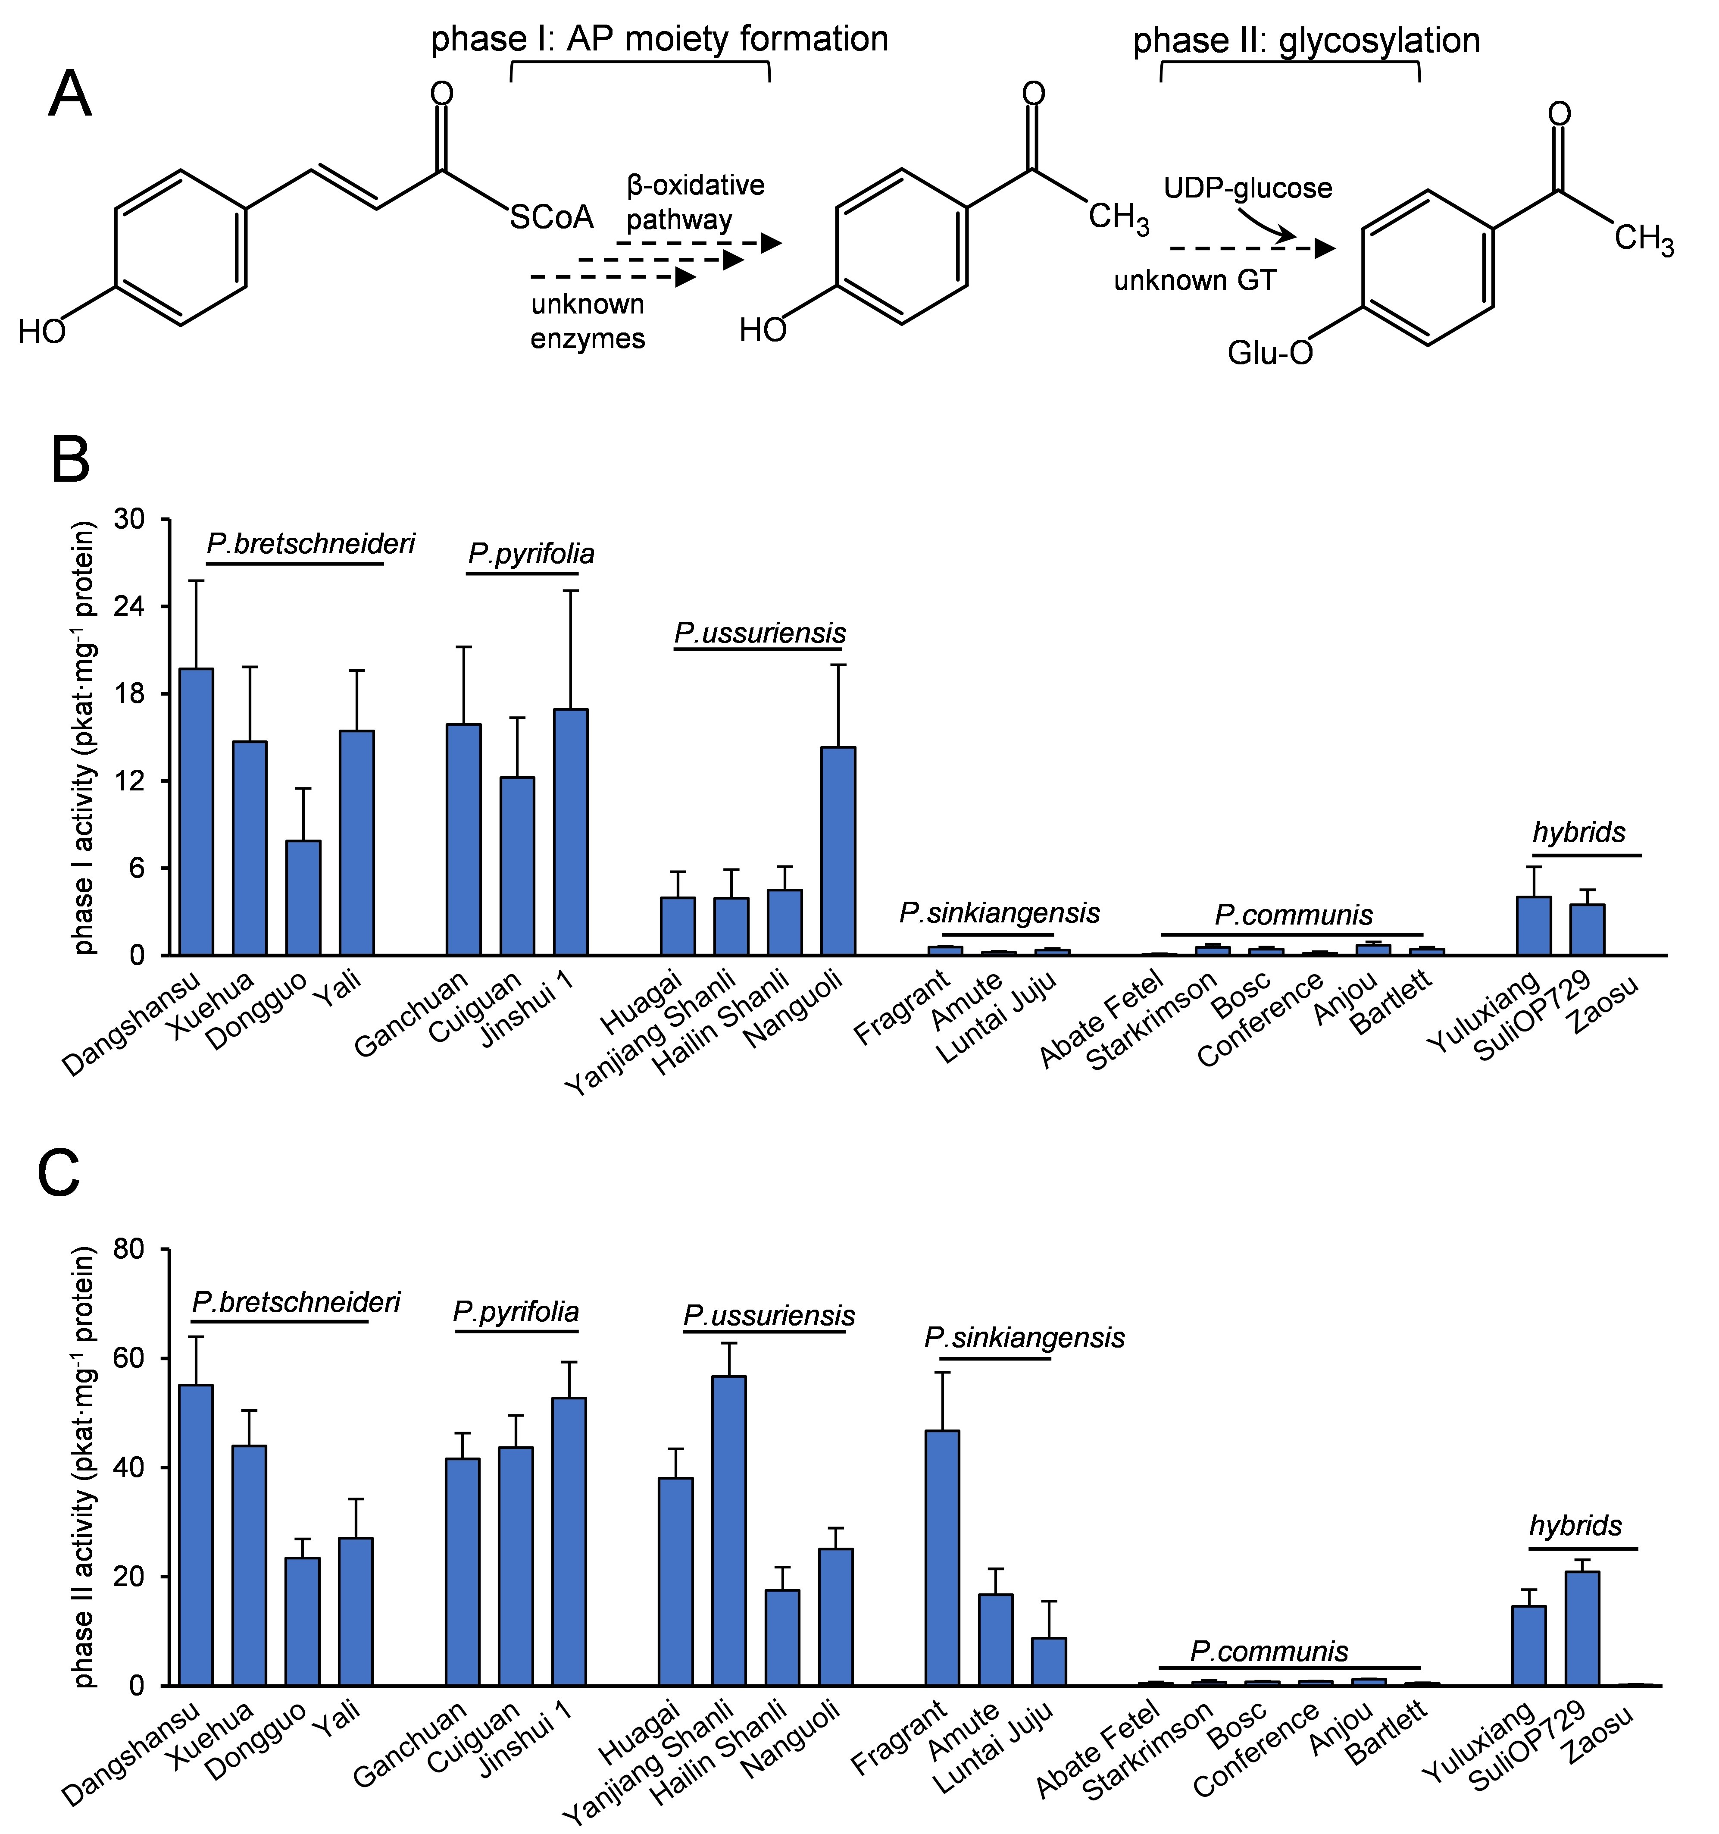
Fig.S2. Enzyme activities involved in the 4HAP-G formation in different pear cultivars. (A) Proposed biosynthetic pathway of 4HAP-G from 4-Coumaryl-CoA (4CA-CoA) in pear leaves. Enzymatic activity of phase I (B) and phase II (C) in different pear cultivars. Data are means ± SEM, n=3.

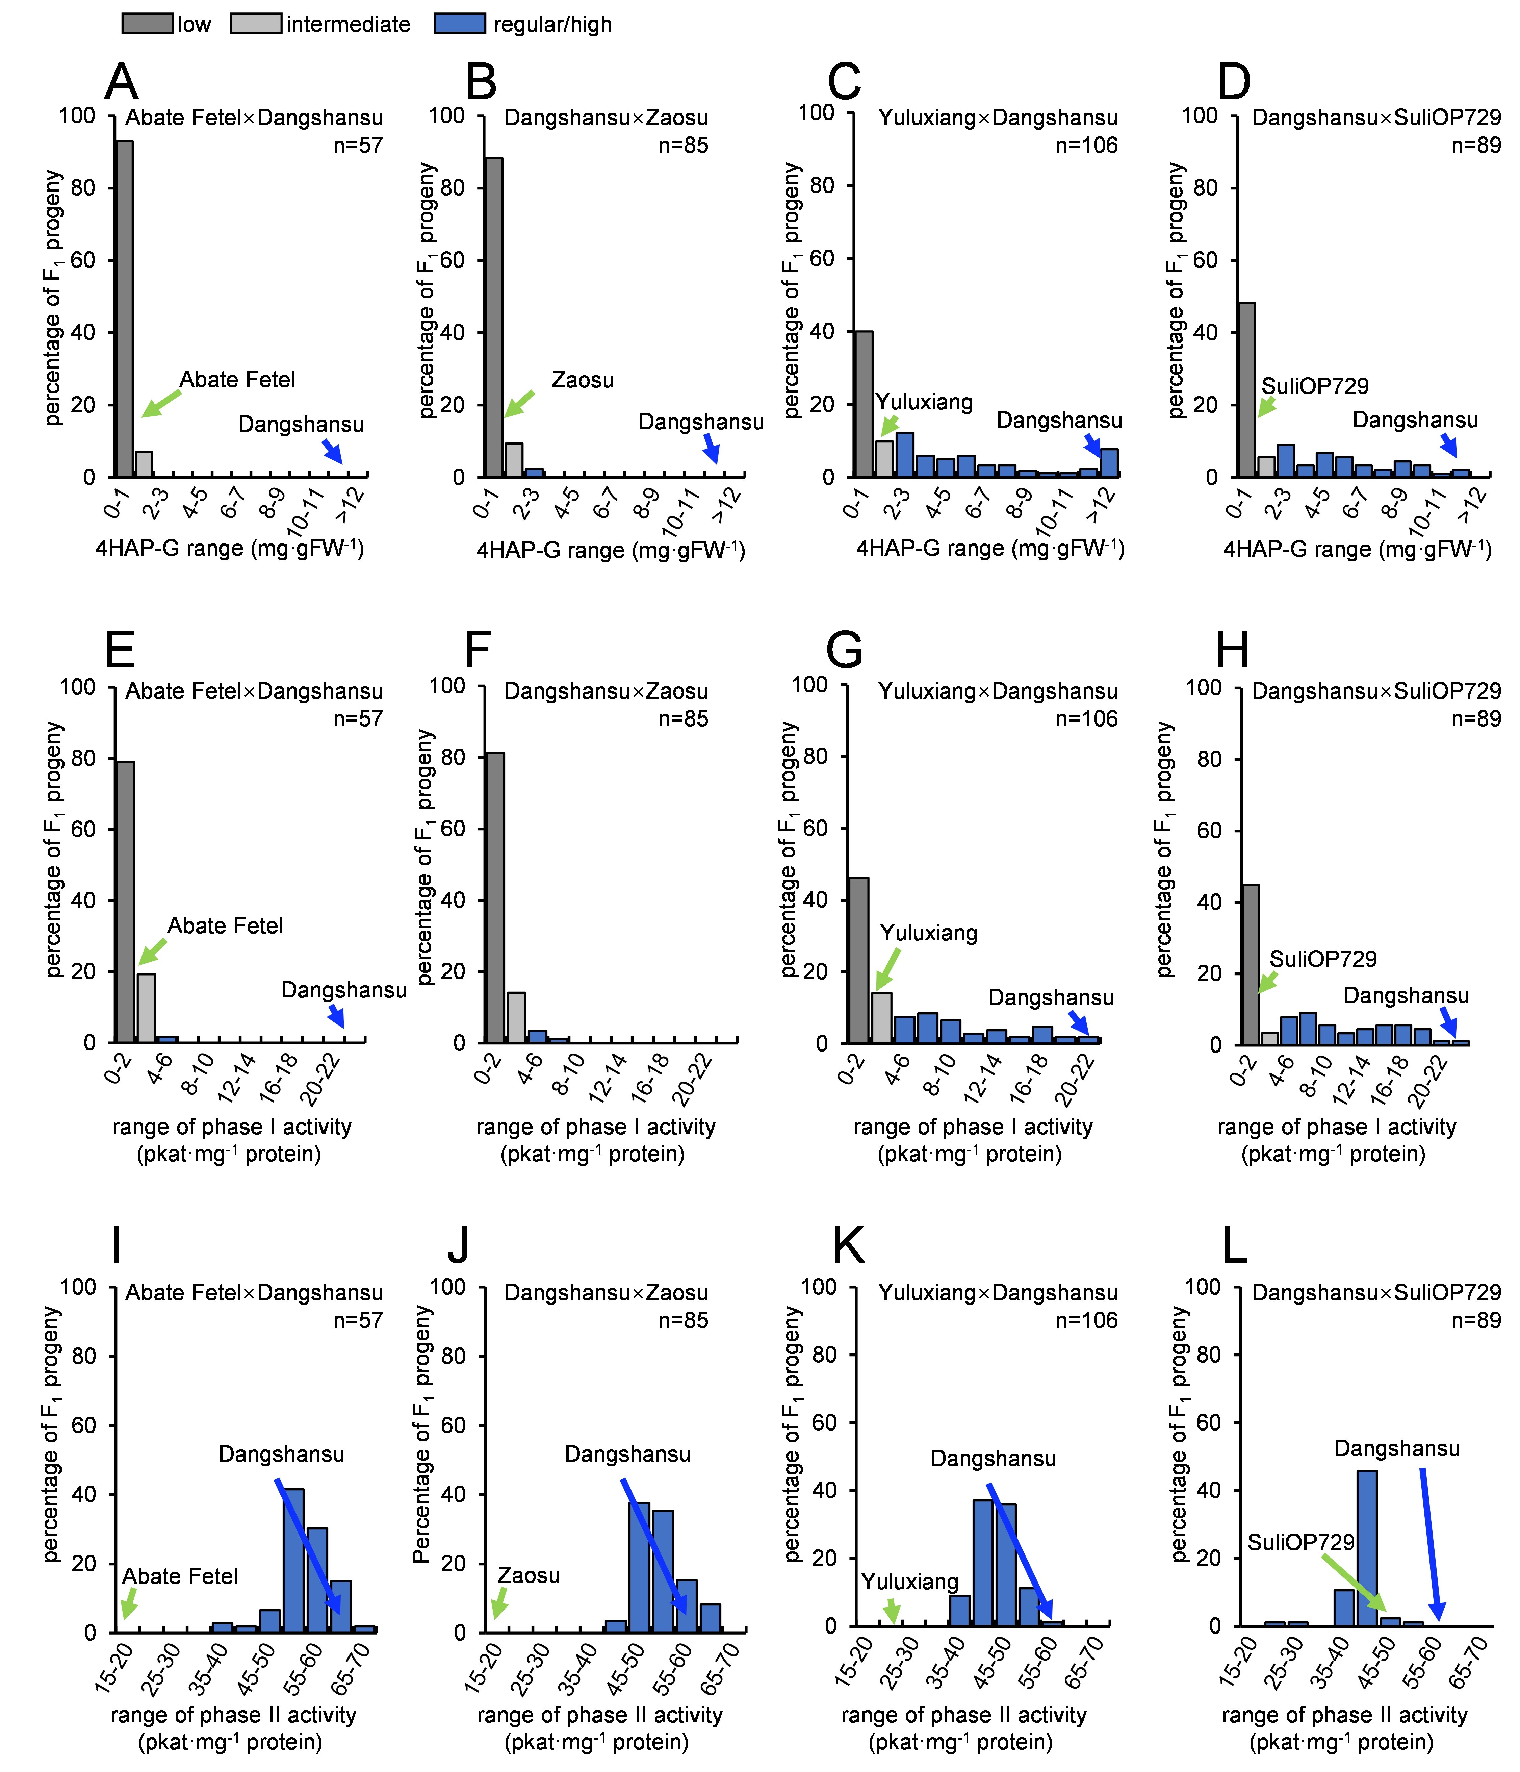
Fig.S3. Distribution of 4HAP-G and related enzymatic activities in four F₁ populations. The concentration range of 4HAP-G in the F₁ plants were obtained from interspecific crosses including ‘Abate Fetel’ × ‘Dangshansu’(A), ‘Dangshansu’ × ‘Zaosu’(B), ‘Yuluxiang’ × ‘Dangshansu’(C), and ‘Dangshansu’ × ‘SuliOP729’(D). The 4HAP moiety formation ability (phase I) in F₁ plants were obtained from interspecific crosses including ‘Abate Fetel’ × ‘Dangshansu’(E), ‘Dangshansu’ × ‘Zaosu’(F), ‘Yuluxiang’ × ‘Dangshansu’(G), and ‘Dangshansu’ × ‘SuliOP729’(H). Catalyzing activity of phase II in the F₁ plants were obtained from interspecific crosses including ‘Abate Fetel’ × ‘Dangshansu’(I), ‘Dangshansu’ × ‘Zaosu’(J), ‘Yuluxiang’ × ‘Dangshansu’(K), and ‘Dangshansu’ × ‘SuliOP729’(L).

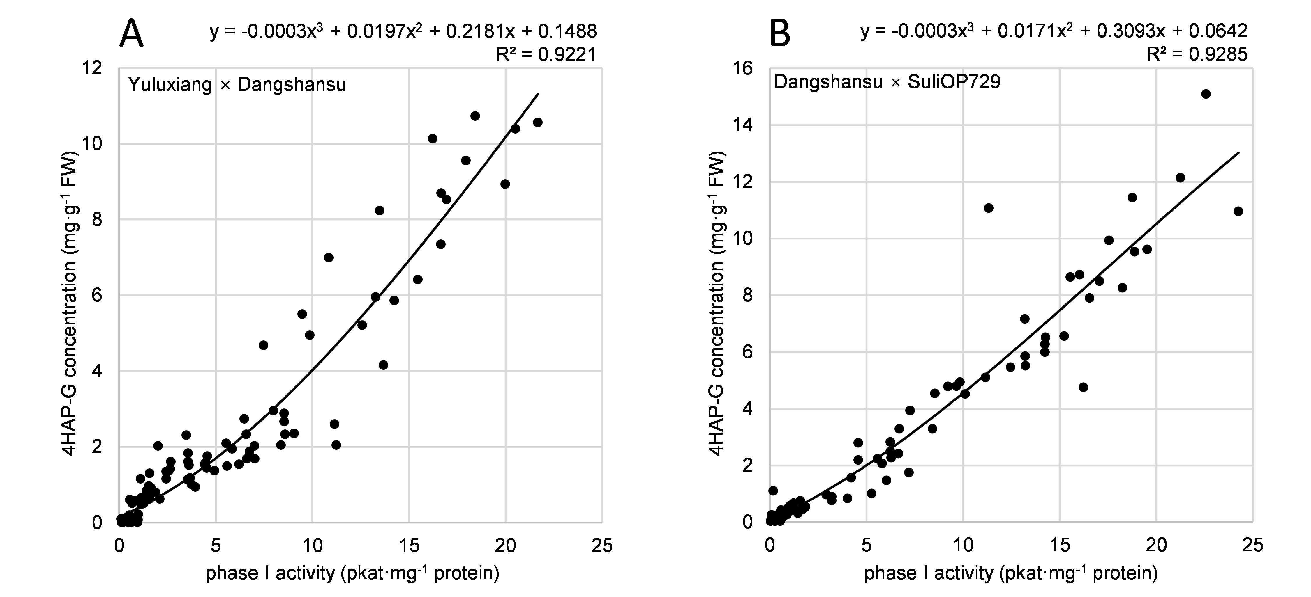
Fig.S4. Correlation analysis between the concentration of 4HAP-G and phase I activity in F₁ plants obtained from interspecific cross between ‘Yuluxiang’ and ‘Dangshansu’ (A), and from interspecific cross between ‘Dangshansu’ and ‘SuliOP729’ (B).
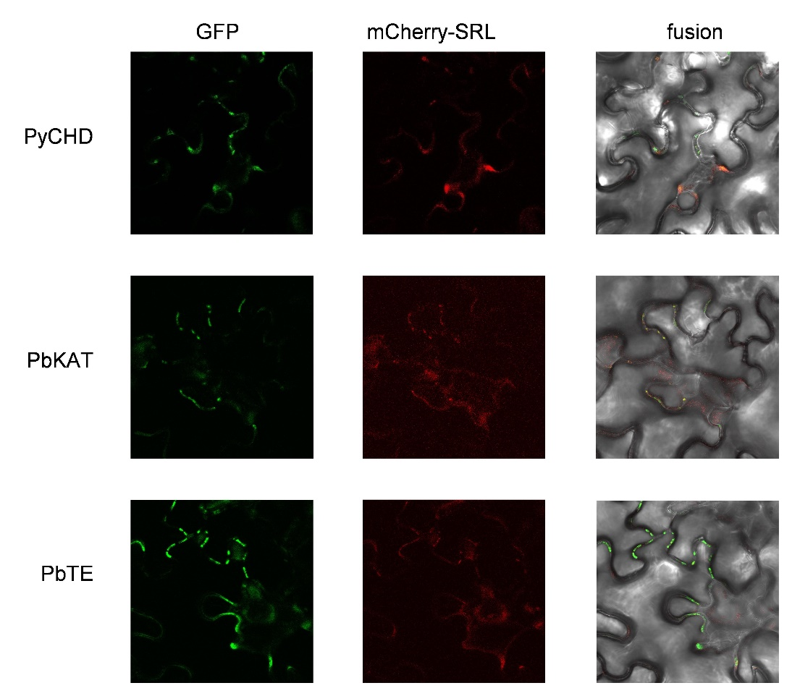
Fig.S5. Subcellular location of PyCHD, PbKAT and PbTE. N-terminal GFP is fused with PyCHD, PbKAT and PbTE, respectively. The fused genes are co-expressed with N-terminal mCherry labelled peroxisomal SRL marker in leaves of N. benthamiana. GFP fluorescence and mCherry fluorescence were shown in the leaf and middle panel, respectively. The merge panel in the right panel show the overlay of GFP and mCherry fluorescence.

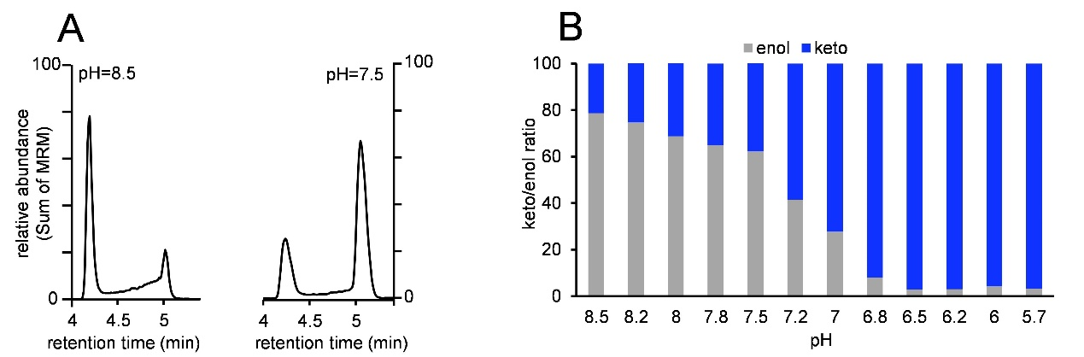
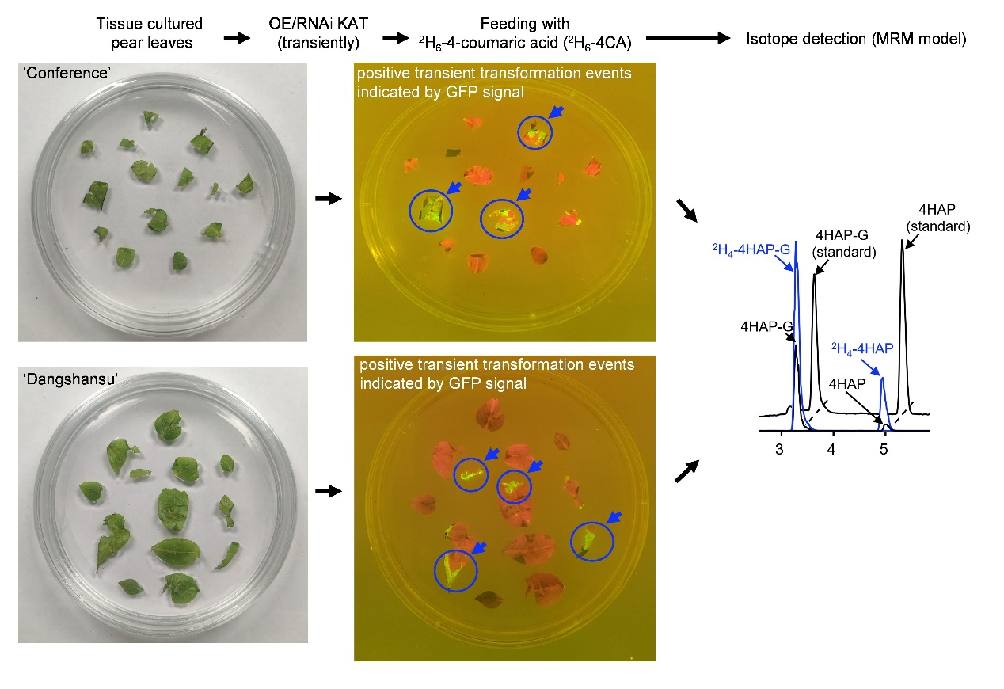
Fig.S6. Schematic representation for transient expression of KAT genes combined with isotope feeding in tissue-cultured pear leaves.
Fig.S7. pH sensitive keto-enol tautomerization of 4HAP. (A) The enol/keto ratio of 4HAP presented as LC-MS/MS chromatogram produced in reaction buffer with different pH environments. (B) The enol/keto ratio of 4HAP (produced in buffer with pH=8.5) incubated in the buffers with different pH for 2h in room temperature.

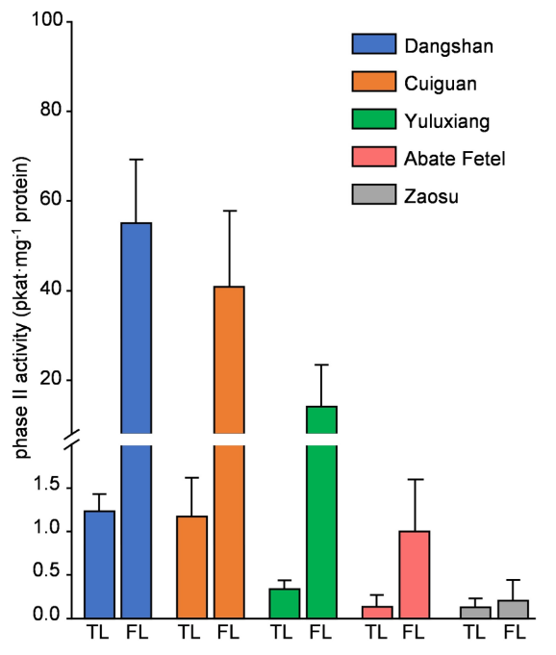
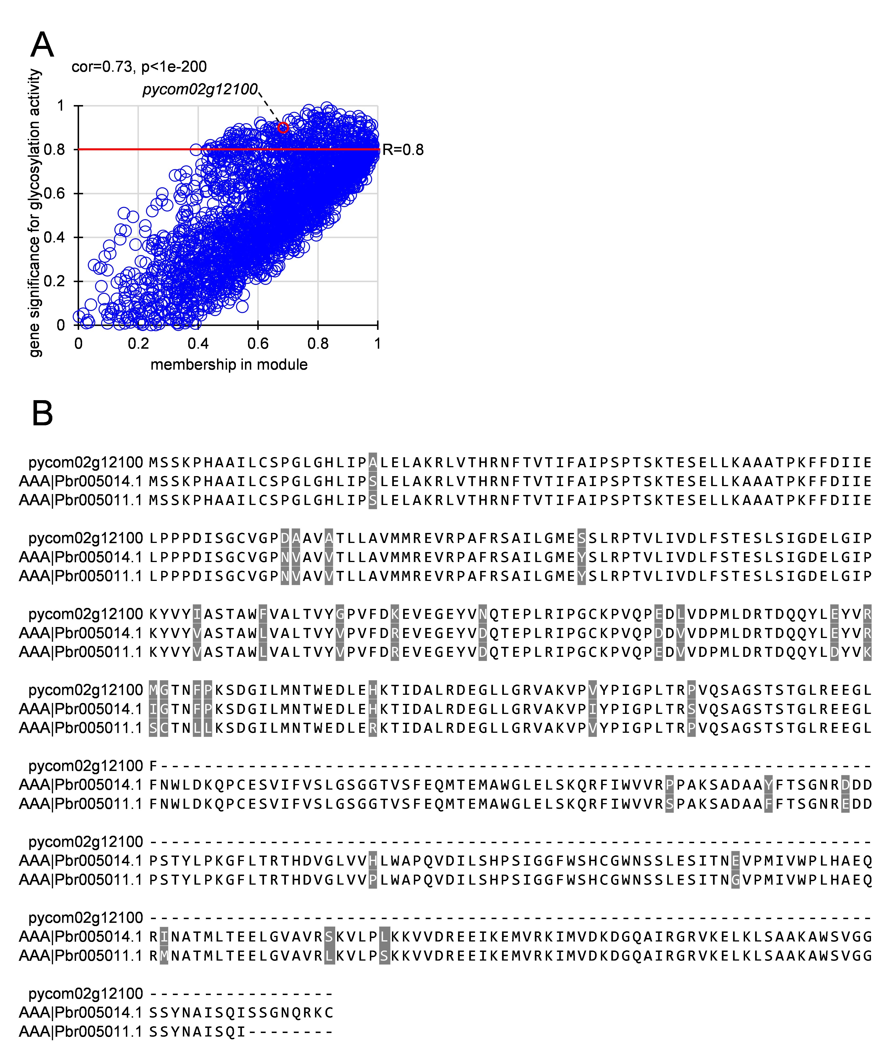
Fig.S9. 4HAPGT in the BaDH genome is incomplete. (A) WGCNA analysis (from the BaDH genome) for identifying candidate GTs from the gene-module which correlated with the glycosylation activity for 4HAPGT in pear leaves of different pear cultivars. The correlation between genes and the glycosylation activity for 4HAPGT were quantified as gene significance by WGCNA analysis using RNA-seq data. The relationship between genes and their own gene-modules were quantified as module membership by WGCNA analysis using RNA-seq data. The significance and membership data were further presented in the scatter plot (A). Only one candidate GT with high gene significance value (over 0.8) was identified in the gene-module and labelled in red. (B) Sequence alignment of the candidate 4HAPGTs from the BaDH genome and the haplotype Asian pear genome.
Fig.S8. Glycosylation ability for 4HAP (phase II) in TL and FL leaves of different pear cultivars.

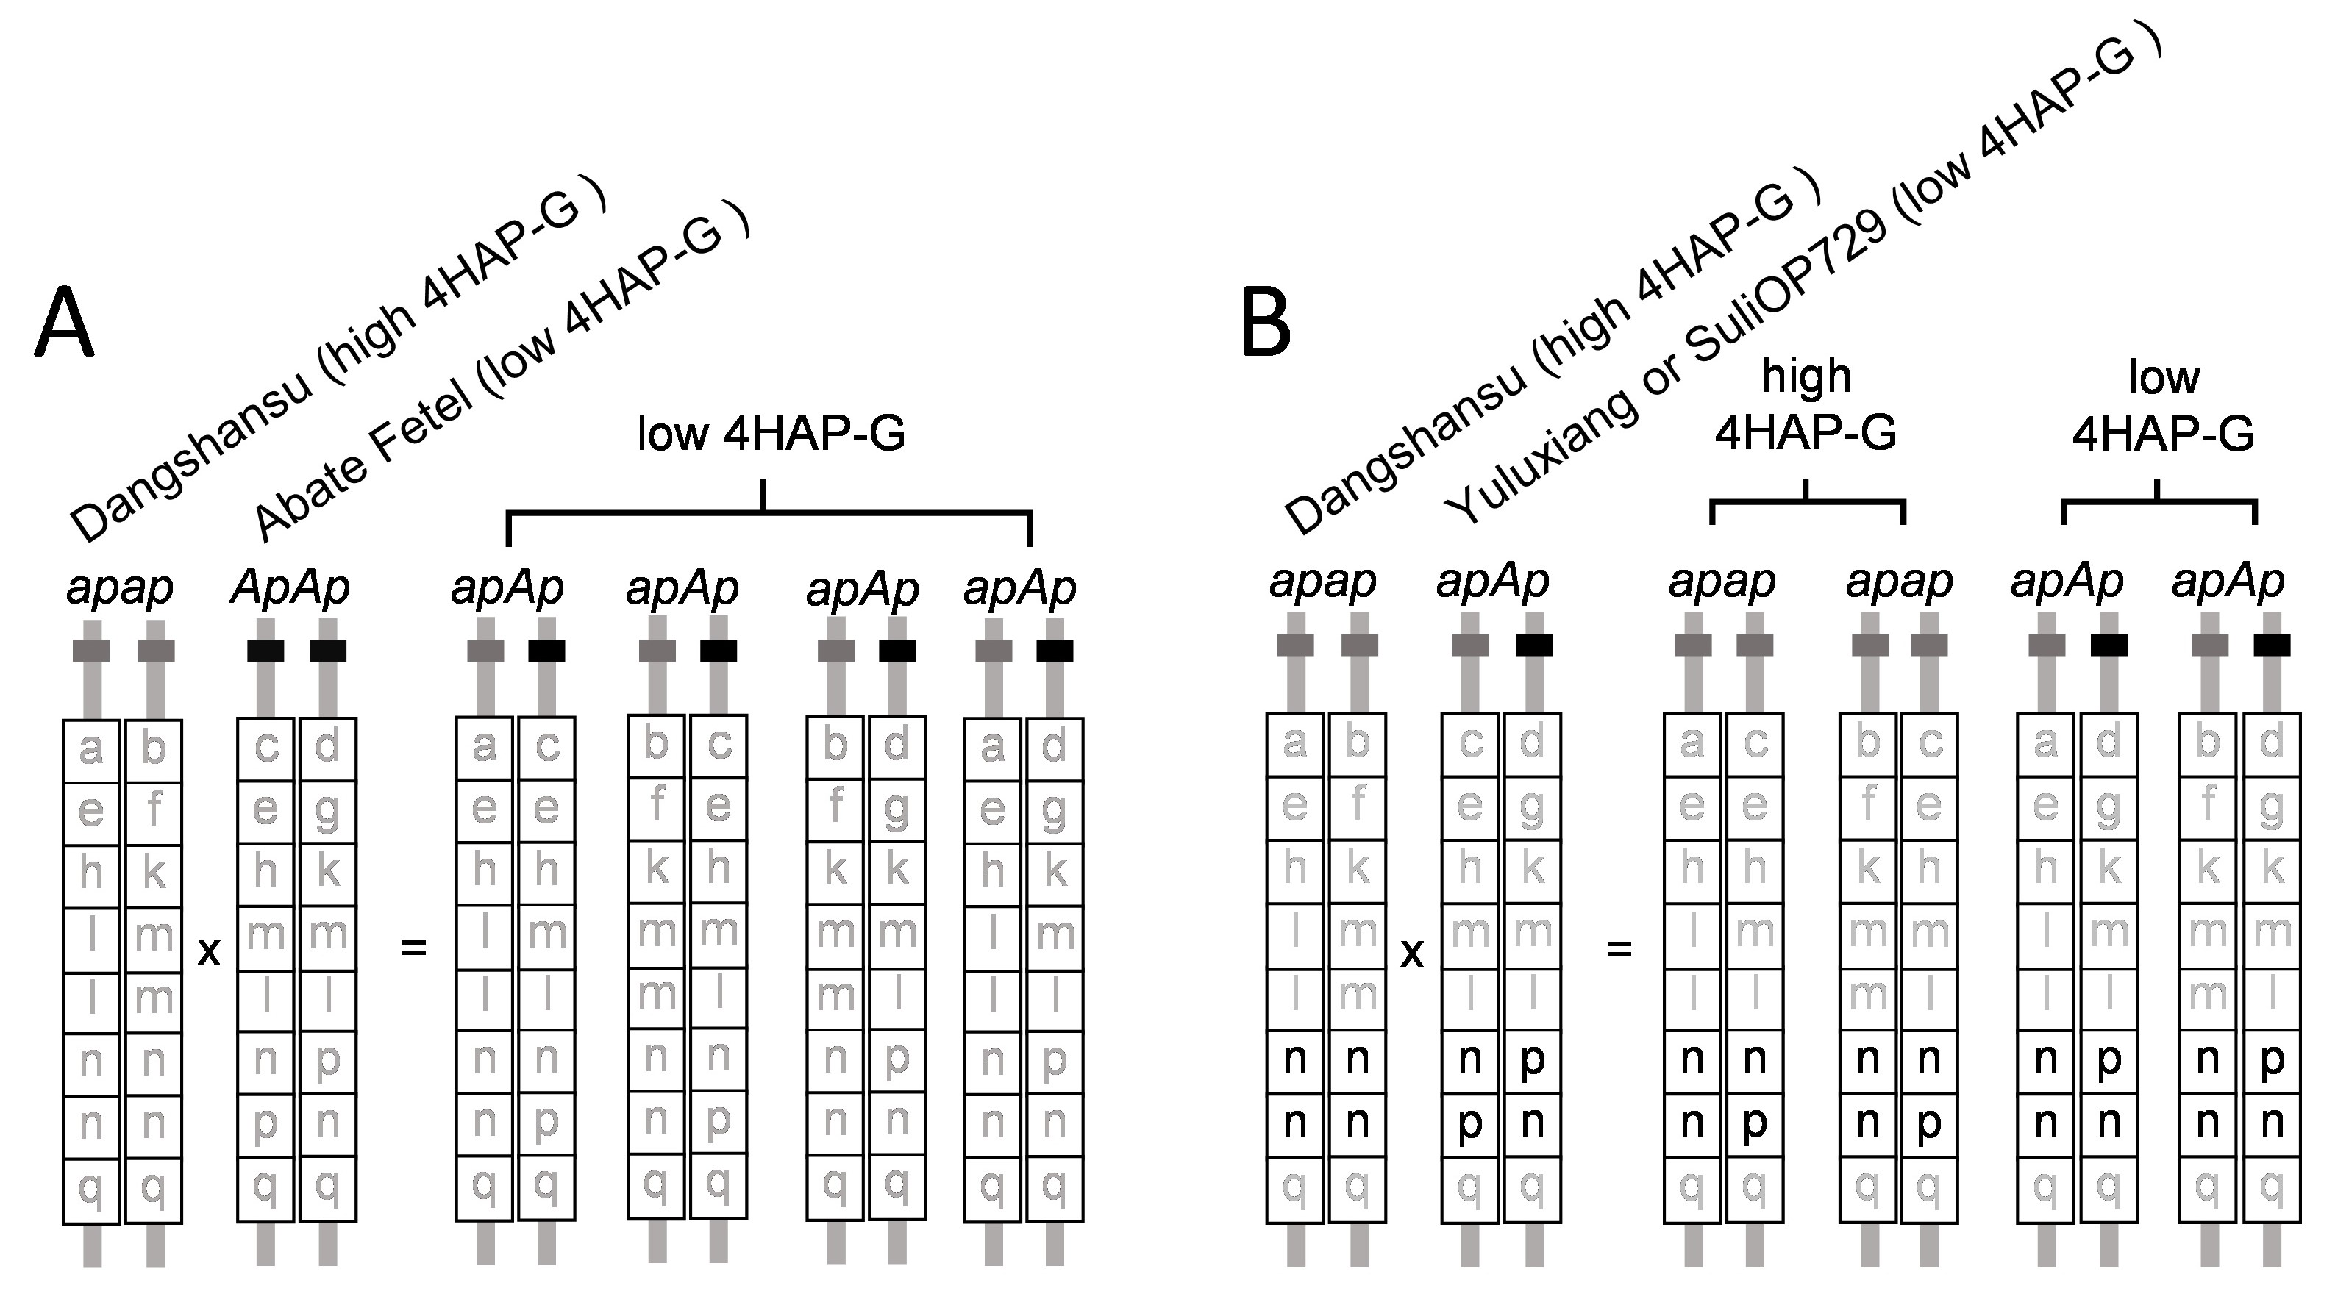
Fig.S10. Schematic representations of the segregation of single-nucleotide variants (SNVs) linked to the 4HAP-G accumulation trait in F₁ plants from interspecific cross between ‘Dangshansu’ and ‘Abate Fetel’ (A), and from interspecific cross between ‘Dangshansu’ and ‘Yuluxiang’ / ‘SuliOP729’ (B). The SNVs <nn × np> and <nn> × <pn> are highlighted in black, which are informative for mapping the recessive 4HAP-G accumulation trait.
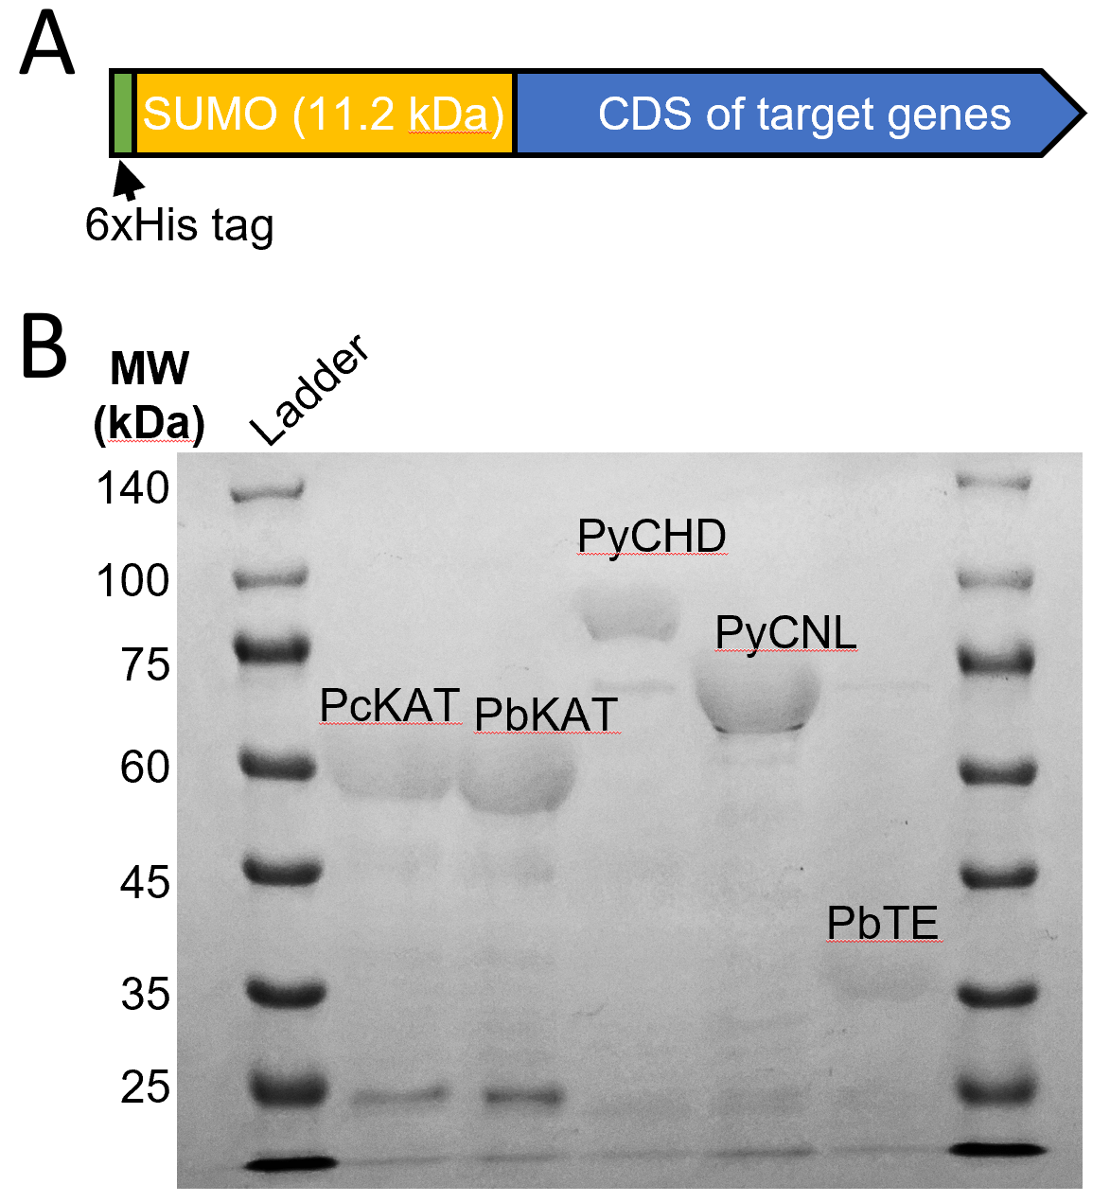
Fig.S11. The constructs used for the purification of 6xHis-SUMO tagged target genes including KATs, PyCHD, PbTE and PyCNL(for producing 4CA-CoA) and the purification results indicated by SDS-gels (B)
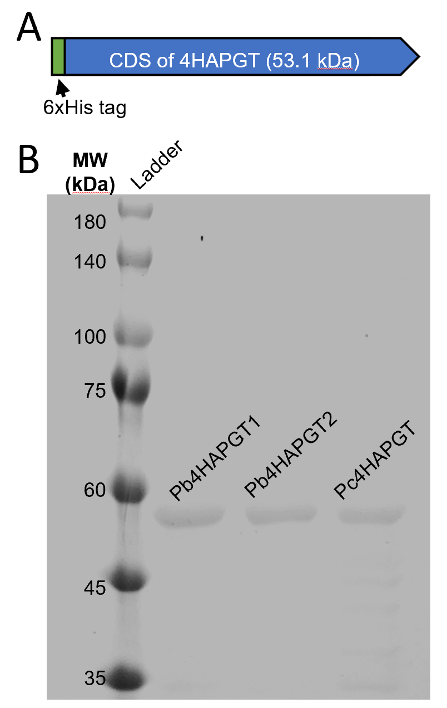
Fig.S12. The constructs used for purification of 6xHis tagged 4HAPGT(A) and the purification results indicated by SDS-gel (B)

Table S1. Subcellular location prediction of KAT, CHD and TE
 | C-signal  sequence | Deep-loc 2.1 |  |  |  | Plant-mPLoc
PcKAT | RAV | Peroxisomal targeting signal (0.8034) |  |  |  |  | Peroxisome
PbKAT | RAV | Peroxisomal targeting signal (0.8406) |  |  |  |  | Peroxisome
PyCHD | SRM | Peroxisomal targeting signal (0.9896) |  |  |  |  | Peroxisome
PbTE | AKL | Peroxisomal targeting signal (0.997) |  |  |  | Chloroplast
PcTE | AKL | Peroxisomal targeting signal (0.997) |  |  |  | Chloroplast

Table S2 the expression patterns and functional annotation of candidate CHDs and TEs in pears
Gene_id |  | Transcription abundance (FPKM) |  |  |  |  |  |  |  |  |  |  |  |  |  | Blastp result (swissprot ) | DeepLoc2.1
 |  | Dangshansu |  |  | Cuiguan |  |  | Yuluxiang |  |  | Abate Fetel |  |  | Zaosu
CHD |  | TL | FL |  | TL | FL |  | TL | FL |  | TL | FL |  | TL | FL
pycom02g03600 | Chr2 | 11.3 | 11.2 |  | 10 | 8.8 |  | 13 | 6.2 |  | 11 | 4 |  | 9.6 | 7 | Q9ZPI6.1 Full=Peroxisomal fatty acid beta-oxidation multifunctional protein AIM1 | peroxisomal
pycom15g16410 | Chr15 | 301 | 500 |  | 286 | 190 |  | 175 | 289 |  | 252 | 233 |  | 205 | 225 | Q9ZPI6.1 Full=Peroxisomal fatty acid beta-oxidation multifunctional protein AIM1 | peroxisomal
pycom13g14220 | Chr13 | 13.3 | 9.9 |  | 6.8 | 13 |  | 8.5 | 15 |  | 11 | 30 |  | 14.1 | 19 | Q9ZPI5.1 Full=Peroxisomal fatty acid beta-oxidation multifunctional protein MFP2 | peroxisomal
TE
pycom13g11980 | Chr13 | 7.2 | 16.8 |  | 9.3 | 2.6 |  | 15 | 23 |  | 14 | 9 |  | 11.3 | 15 | Q9SX65.1 Full=1,4-dihydroxy-2-naphthoyl-CoA thioesterase 1 | peroxisomal
pycom13g11990 | Chr13 | 17.6 | 292 |  | 26 | 41 |  | 44 | 95 |  | 25 | 16 |  | 15.6 | 19 | Q9SX65.1 Full=1,4-dihydroxy-2-naphthoyl-CoA thioesterase 1,Peroxisomal | peroxisomal
pycom07g12050 | Chr7 | 21.6 | 18.6 |  | 19 | 18 |  | 25 | 31 |  | 31 | 35 |  | 20.8 | 20 | PF03061:Thioesterase superfamily,Peroxisomal | peroxisomal
pycom16g03560 | Chr16 | 4.7 | 4.3 |  | 8.3 | 4.5 |  | 4.8 | 2.7 |  | 5.8 | 4 |  | 4.9 | 2 | Q8W583.1 Full=Acyl-acyl carrier protein thioesterase ATL3 | chloroplastic
pycom05g14700 | Chr5 | 11.8 | 31.7 |  | 25 | 23 |  | 14 | 50 |  | 32 | 41 |  | 21.2 | 26 | Q9R0X4.1 Full=Acyl-coenzyme A thioesterase 9 | mitochondrial
pycom11g06960 | Chr11 | 28.3 | 21.2 |  | 19 | 12 |  | 18 | 19 |  | 23 | 20 |  | 14.2 | 18 | Q9NPJ3.1 Full=Acyl-coenzyme A thioesterase 13.Peroxisomal | peroxisomal

Table S3 Primers list
Names | Sequence (5' to 3') | Usage
4HAPGT-Pbr005014.1F | TTTGATAGAGAAGTGGAAGGAGAGTA | RT-qPCR
4HAPGT-Pbr005014.1R | TCACTCTTCGGGAAATTAGTACCTA | RT-qPCR
4HAPGT-Pbr005011.1F | TTTGATAGAGAAGTGGAAGGAGAGTA | RT-qPCR
4HAPGT-Pbr005011.1R | TCACTCTTCAGCAAATTAGTACAAC | RT-qPCR
CHDF | TCATTGAGAGTGTTCCTCTCAAACAGAA | RT-qPCR
CHDR | TATTTCAAGAAGAGGCATCACATGAGC | RT-qPCR
KATF | TTCTTGGTGTTTTCAGGAGTTTTGCT | RT-qPCR
KATR | TTGACTTTCTCAGGATCAAGCTCCAA | RT-qPCR
TEF | GCCTCCATGTCACCGAAAACTG | RT-qPCR
TER | TCAGCAAAGATATGGTCGTCGAG | RT-qPCR
Pb4HAPGTa-28a-F | GGTGCCGCGCGGCAGCCATATG ATGAGCTCAAAGCCACATG | cloning into pET28a
Pb4HAPGTa-28a-R | GTGGTGGTGGTGGTGCTCGAG GCATTTTCTTTGATTGCCACTTG | cloning into pET28a
Pb4HAPGTb-28a-F | GGTGCCGCGCGGCAGCCATATG ATGAGCTCAAAGCCACATG | cloning into pET28a
Pb4HAPGTb-28a-R | GTGGTGGTGGTGGTGCTCGAG TATTTGAGAAATTGCATTATACGAT | cloning into pET28a
Pc4HAPGT-28a-F | GGTGCCGCGCGGCAGCCATATG ATGAGCTCAAAGCCACATG | cloning into pET28a
Pc4HAPGT-28a-R | GTGGTGGTGGTGGTGCTCGAG GCATTTTCTTTGATTGCCACT | cloning into pET28a
PyCNL-SUMO-F | ACAGATTGGTGGATCC ATGGCCTTTGAATCAATGAATATGCTTCC | cloning into pRSFDuet-1
PyCNL-SUMO-R | ATGCGGCCGCAAGCTT TCAAAGACGAGACAAAGCAAGAATCTG | cloning into pRSFDuet-1
Pb/PcCHD-SUMO-F | ACAGATTGGTGGATCC ATGGCGAGGGGGACTCTG | cloning into pRSFDuet-1
Pb/PcCHD-SUMO-R | ATGCGGCCGCAAGCTT TTACATGCGTGACCTTGAAG | cloning into pRSFDuet-1
Pb/PcKAT-SUMO-F | ACAGATTGGTGGATCC ATGGATAAAGCACTTAACAGACAGAAGGT | cloning into pRSFDuet-1
Pb/PcKAT-SUMO-R | ATGCGGCCGCAAGCTT CTAGACAGCTCTAGCATTGCTTAACTCA | cloning into pRSFDuet-1
PbTE-SUMO-F | ACAGATTGGTGGATCC ATGTTTGGTACAGATATGGCTTCACAG | cloning into pRSFDuet-1
PbTE-SUMO-R | ATGCGGCCGCAAGCTT TTATAATTTGGCATACTTCTTGAGCGTTTCACC | cloning into pRSFDuet-1
Pb/PcCHD-OE-F | TACATTTACAATTACGTCGACA TGGCGAGGGGGACTCTG | cloning into pK2gw7
Pb/PcCHD-OE-R | CTCATTAAAGCAGAGGTCGAC TTACATGCGTGACCTTGAAGATG | cloning into pK2gw7
Pb/PcKAT-OE-F | TACATTTACAATTACGTCGAC ATGGATAAAGCACTTAACAG | cloning into pK2gw7
Pb/PcKAT-OE-R | CTCATTAAAGCAGAGGTCGAC CTAGACAGCTCTAGCATTGCTTAAC | cloning into pK2gw7
Pb/PcCHD-LOC-F | CATGGATGAACTATACAGA ATGGCGAGGGGGACTCTG | cloning into Pcambia2300-N-GFP
Pb/PcCHD-LOC-R | GATTTTTGCGGACTCTAG TTACATGCGTGACCTTGAAGATG | cloning into Pcambia2300-N-GFP
Pb/PcKAT-LOC-F | CATGGATGAACTATACAGA ATGGATAAAGCACTTAACAG | cloning into Pcambia2300-N-GFP
Pb/PcKAT-LOC-R | GATTTTTGCGGACTCTAG CTAGACAGCTCTAGCATTGCTTAAC | cloning into Pcambia2300-N-GFP
Pb/PcKAT-LOC-F | CATGGATGAACTATACAGA ATGGATAAAGCACTTAACAGACAG | cloning into Pcambia2300-N-GFP
Pb/PcKAT-LOC-R | GATTTTTGCGGACTCTAG CTAGACAGCTCTAGCATTGCTTAACTCA | cloning into Pcambia2300-N-GFP
GypsyF | CCACGTACTCTCTGTGAACACGA | retrotransposon verification
GypsyR | TAAAGAAGTGGAAGGAGAGTGTAGACA | retrotransposon verification

Materials and Methods
Plant material and growth conditions
Stem, flower bud, seed, fruitlet, mature fruit, petal, ovary, stamen, pistil, tender leaf, fully expanded young leaf and senescent leaf of ‘Dangshansu’ pear were harvested from twenty-year-old pear trees. Fully expanded young leaf of other pear cultivars were harvested from eighteen to twenty-year-old pear trees. These pear trees were all cultivated in the Horticultural Research Base of Northwest A&F University in Yangling Distinct, Shaanxi Province, China. Four-year-old seedlings from F₁ population of four interspecific crosses and one-year-old ‘Dangshansu’ self-rooting plants were cultivated in Puchengsuli Experimental Station in Shaanxi Province, China. Root, tender leaf, fully expanded young leaf and senescent leaf of one-year-old ‘Dangshansu’ were harvested from self-rooting plants. Harvested pear tissues for later use were immediately frozen in liquid nitrogen. The frozen tissues were ground to a fine powder in liquid nitrogen and then stored at -80 ℃ until used. Tissue-cultured ‘Conference’ and ‘Dangshansu’ shoots were monthly propagated in vitro on QL and NN69 medium at 24 ℃, respectively. N. benthamiana plants were grown in a growth chamber with 16 h light, 23±1 ℃, and 60% relative humidity.
Chemicals
4CA-CoA was synthesized enzymatically and purified according to Beuerle and Pichersky (2002)¹, with a modification that we used a pear peroxisomal cinnamate-CoA ligase (CNL; accession number in BaDH genome: pycom09g18850) instead of 4CL for producing 4CA-CoA. ²H₆-4-coumaric acid (²H₆-4CA) was purchased from MedChemExpress. Other chemicals and reagents were purchased from Sigma-Aldrich.
Extraction of acetophenones
About 0.5g frozen powder of plant tissues was extracted with 1.8 mL 50% methanol. The mixture was vortexed for 1 min, sonicated for 10 min, and centrifuged at 10000 g for 15 min at 4°C. 20 μL filtered supernatant by a 0.22 μm syringe filter was used for HPLC or LC-MS/MS analysis.
4HAP-G identification
The methanol extracts were analyzed at 280 nm by a Liquid Chromatograph with a Diode Array Detector (Shimadzu LC-20A), as described in Wang et al (2020)². Chromatographic fraction containing the unknown compound with the highest absorption peak in ‘Dangshansu’ FL leaf extracts was collected and dried by evaporation with nitrogen gas at 24 ℃. The dried fraction was re-dissolved in 200 μL methanol. 100 μL fraction was analyzed using electrospray ionization source tandem mass spectrometry (ESI-MS/MS) system (Applied Biosystems 5500 Q TRAP). Negative ion mass spectra were recorded from 50-800 m/z under the collision energy at -10 V and -37V. The instrument was operated with a capillary voltage of 3500 V; drying gas stream of 5L/min; drying gas of 30 psi; heater gas temperature of 350 ℃. All of the gases used were nitrogen. Another 100 μL fraction was dissolved in 2 mL 0.5M HCl solution and boiled for 2 h to hydrolyze. The unknown compound and its hydrolysate were respectively identified as 4HAP-G and 4HAP by authentic standards including 4HAP, 3HAP, 2HAP and 4HAP-G using HPLC analysis.
LC-MS/MS analysis
A liquid chromatograph (Shim-pack UFLC SHIMADZU CBM20A system) coupled to an electrospray ionization source tandem mass spectrometry (Applied Biosystems 5500 Q TRAP) was used for mass analysis and detection. According to the methodology described by Wang et al (2024) with slight modifications³, an AQ-C18 column (150 mm × 4.6 mm, 5 μm, Shimadzu, Kyoto, Japan) was used for the analysis. Mobile phase A consisted of 0.1% formic acid dissolved in water, and mobile phase B was acetonitrile. The gradient consisted of 25% B (1.0 min), 35-95% B (1.0-6.0 min), 95% B (6.0-8.9 min) and 95%-25% B (8.9-9.0 min), sequentially. The post-run time was 1 min. The flow rate was 0.7 mL/min at 40 °C, the injection volume was 5 μL. Negative ion mass spectra were recorded from 100-1000 m/z under full-scan model. Detection of targeted metabolites was achieved in negative mode using multi reaction monitoring (MRM) mode, as described by Lackus et al (2021)⁴. The instrument was operated with a capillary voltage of 3500 V; drying gas stream of 5L/min; drying gas of 30 psi; heater gas temperature of 350 ℃.
Crude enzyme extraction from pear leaves
All work was done at 4 ℃. About 0.2 g frozen tender leaves or young fully expanded leaves of different pear cultivars and hybrid seedlings were homogenized in 2 mL 50 mM K₂PH₄ buffer pH 7.5 containing 15 % polyvinylpolypyrrolidone, 10 % glycerol, 10 mM β-mercaptoehtanol and 1 mM PMSF. Following one hour ice-incubation and subsequent sonication, the extract was then centrifuged at 13,000 rpm for 30 min. 2 mL supernatant was desalted and recovered through a PD10 column (GE healthcare) equilibrated with 50 mM K₂PH₄ buffer pH 7.5 containing 10% glycerol.
AFDDD analysis
Tender leaves of ‘Dangshansu’, ‘Yuluxiang’, ‘SuliOP729’, and hybrids seedlings were used for DNA isolation. Genomic DNA of ‘Dangshansu’, ‘Yuluxiang’ and ‘SuliOP729’ was sequenced over 20× genome size using a paried-ends 150 strategy (Illumina NovaSeq 6000, Illumia). Of the ‘Yuluxiang’ × ‘Dangshansu’ F₁ hybrids, 22 individuals containing extremely low level of 4HAP-G and 18 individuals containing extremely high level of 4HAP-G were chosen for allele frequency directional difference and density (AFDDD) analysis. Genomic DNA of each F₁ individuals containing extremely level of 4HAP-G was pooled to construct segregant bulks. Genomic DNA pools were sequenced over 20× genome size using a paried-ends 150 strategy (Illumina NovaSeq 6000, Illumia). Of ‘Dangshansu’ × ‘SuliOP729’ F₁ hybrids, 28 individuals containing extremely low level of 4HAP-G and 24 individuals containing extremely high level of 4HAP-G were chosen for AFDDD analysis. To fine map the ap locus, genotype of each chosen individual in this F₁ population was obtained by re-sequencing their genomic DNA over 10× genome size using a paried-ends 150 strategy (Illumina NovaSeq 6000, Illumia). These sequencing reads were then pooled to construct segregant bulks.
The clean sequencing reads were mapped to the BaDH genome using Burrows–Wheeler alignment (BWA) software⁵. Single nucleotide variants (SNVs) of segregation types <nn x np> and <nn x pn> were selected as the informative SNVs for allele frequency directional difference and density (AFDDD) mapping approach (Fig. S10)^{6, 7}. The expected AFDD value was in the range from 0.49 to 0.51. These SNVs were further plotted against the BaDH genome. To identify the recombinant events in the progenies of ‘Dangshansu’ × ‘SuliOP729’, the InDel variants in F₁ Individuals was analyzed using their genome resequencing data.
RNA-sequencing, WGCNA analysis and RT-qPCR analysis
RNA-sequencing. Tender leaves and young fully expanded leaves of different pear cultivars were collected for RNA-extraction, purified total RNA was submitted to Novogene (https://en.novogene.com) for library construction and RNA sequencing with an Illumina NovaSeq 6000 (Illumina). The clean data for each sample were mapped to the BaDH genome and the haplotype ‘P. bretschneideri’ genome with Hisat2.
WGCNA analysis. The corresponding read counts data were used to infer co-expressed genes with 4HAP-G contents, the 4HAP moiety formation ability and the glycosylation ability for 4HAP using weighted gene co-expression network analysis (WGCNA)⁸. WGCNA network construction and module detection was conducted using an unsigned type of topological overlap matrix (TOM), a power β of 9, a minimal module size of 28, and a branch merge cut height of 0.25.
RT-qPCR analysis. Reverse transcription was performed with the Evo M-MLV RT Kit (Accurate Biology), according to the manufacturer's instructions. RT-qPCR was performed using a StepOne™ Real-Time PCR System (Applied Biosystems) with the SYBR Green Premix Pro TaqHS qPCR kit (Accurate Biology). ACTIN (accession number in BaDH genome: pycom15g30330) was used as the reference gene. Gene-specific primers are listed in Table S3.
Generation of vector constructs
To generate constructs for heterologous expression in E. coli, full-length coding sequences of target genes were amplified using primers in Table S3 and fused with the N terminal His₆-tag of the pET28a (Novagen) for 4HAPGTs and the N terminal His₆-SUMO-tag of the modified pRSFDuet-1 (Novagen) vector for CNL, CHD, TE, wild type KATs and mutated KATs.
To generate plant overexpression constructs of target genes, full-length coding sequences of CHD, TE, wild type KATs and mutated KATs were inserted into a modified plant expression vector pK2GW7⁹, containing an independent overexpression cassette of GFP.
To generate the RNAi construct of CHD, complementary DNA fragments corresponding to nucleotide 314-868 and 662-868 (in the antisense orientation) were selected for designing a harpin structure, which was then synthesized by Sangon Biotech Co (https://www.sangon.com). To generate the RNAi construct of KAT, complementary DNA fragments corresponding to nucleotide 231-737 and 534-737 (in the antisense orientation) were selected for designing a harpin structure, which was then synthesized by Sangon Biotech Co. These two synthesized hairpin structures were inserted into the modified pK2GW7 vector described above, respectively.
To generate constructs for subcellular location, N-terminal GFP was fused with full-length coding sequences of PyCHD, PbKAT and PbTE, mCherry with modified 3’ ends to add C-terminal SRL was used as peroxisomal marker. These fragments were then inserted into a plant expression vector pCAMBIA2300.
To generate constructs for evaluating the translation inhibition effects of 5’UTR PRG4 structure of KATs by luciferase reporter assay, the 1505-bp upstream region from the PbKAT and PcKAT start codon was respectively amplified. 5’UTR deletion, 5’UTR replacement, PRG4 deletion, and PRG4 replacement mutants of the upstream region of KATs were generated by overlap PCR. The wild type and mutant upstream region of KATs were then cloned into the vector pGreen 0800-LUC¹⁰, containing the luciferase reporter. To evaluate the translation inhibition effects of 5’UTR PRG4 structure on KATs, full-length coding sequences of PbKAT and PcKAT driven by wild type or the described mutant upstream regions were also generated by overlap PCR and cloned into pK2GW7, respectively.
All fragment-vector ligation were using the One Step Cloning Kit (Vazyme) in this study.
Transient in pear leaves and iso-tope feeding
Top three expanded young leaves of 30-day-old tissue-cultured plantlets of ‘Dangshansu’ and ‘Conference’ were selected for transient experiments. These leaves were harvested and precultured in dark for one day on MS solid medium with 1.2 g/L sorbitol before infiltration. Recombinant vectors for gene overexpression or knocked-down by RNA interference (RNAi) were transformed into Agrobacterium rhizogenes strain K599. The precultured pear leaves were infiltrated with A. rhizogenes under a vacuum of 90 kPa for 30 min. After five days dark-culture, the positive transient transformation events were visually screened by the GFP fluorescent signal, which was expressed from an independent overexpression cassette within the recombinant vectors.
Isotop-feeding. For KATs and CHD, leaves with visible GFP signal were selected and feeding with 10μM ²H₆-4CA under a vacuum of 90 kPa for 5 min, after 16 h dark incubation, ²H₄-4HAP and ²H₄-4HAP-G were scanned by MS/MS under MRM mode.
4HAP-feeding. For 4HAPGT, leaves with visible GFP signal were selected and feeding with 10μM 4HAP under a vacuum of 90 kPa for 5 min, after 16 h dark incubation, ²H₄-4HAP and ²H₄-4HAP-G were scanned by MS/MS under MRM mode.
Transient assays in N. benthamiana
Subcellular location. Recombinant and peroxisomal marker vectors were introduced into tobacco (Nicotiana benthamiana) leaves through Agrobacterium (EHA105 strain)-mediated transient transformation. After 3 d of infection, GFP and mCherry fluorescence were observed using a confocal laser scanning microscope (FV3000; Olympus) at excitation wavelengths of 488 and 633 nm, respectively.
Transient expression. Recombinant and empty vectors were introduced into tobacco (N. benthamiana) leaves through Agrobacterium (EHA105 strain)-mediated transient transformation. 5 d after inoculation, leaves were infiltrated with 1 mL 50 μM 4-CA. After 12 h the leaves were detached and frozen at −80°C for later use. Acetophenones were extracted using 50% methanol for LC-MS/MS analysis under MRM mode. Total RNA and crude proteins were extracted as described above for RT-PCR and immunoblot analysis, respectively.
Luciferase assay. 5’UTR activity was evaluated by luciferase reporter assay using N. benthamiana leaves. The transient transformation protocol was the same as described above for the subcellular localization assays. After 3 d, the infected leaves were used to determine the 5’UTR activities with the Dual Luciferase Reporter Gene Assay Kit (Yeasen) and GloMax® 96 Microplate Luminometer (Promega).
Enzyme assay
Enzymatic activities for the 4HAP moiety formation. Reaction buffer was prepared as previously described¹¹ with slight modifications. 150 μL reaction buffer containing 0.1 M Tris–HCl buffer pH 8.0, 2 mM MgCl₂, 1 mM pyruvic acid, 400 μM acyl-CoA, 1 mM NAD⁺, 2 mM CoA, 2 U lactate dehydrogenase. Three reactions were sequentially verified as follows: for reaction I, 100 ng purified CHD protein and 0.1 mM substrate 4CA-CoA were added to the reaction buffer and incubated for 90 min at 24 ℃; for reaction II, 500 ng purified KAT proteins including PcKAT, PbKAT and mutant PbKATs was respectively added to the reaction I enzyme assays and incubated for 30 min at 24 ℃; for reaction III, 100 ng purified TE protein was added to the reaction II enzyme assays and incubated for another 60 min at 24 ℃. Enzymatic activities for the 4HAP formation in crude enzymes from pear leaves was determined in the same reaction buffer and 0.1 mM substrate 4CA-CoA with 10 μg crude pear enzyme extract using 60 min assays. These reactions were stopped by the addition of equal volumes of methanol. 10 μL reaction product was then analyzed by LC-MS/MS under MRM mode.
Glycosylation activity for 4HAP. in crude enzymes from pear leaves. GT activity assays were performed in triplicate in 150 µL reactions containing 0.1 M Tris–HCl buffer pH 8.0, 0.5 mm of 4HAP, 0.5 mm of UDP-Glucose, and 40 ng purified 4HAPGTs (or 10 μg crude pear enzyme extract). Reaction mixtures were incubated for 30 min at 24 °C and reactions stopped by the addition of equal volumes of methanol. 10 μL reaction product was then analyzed by LC-MS/MS under MRM mode.
Thiolase Activity of KAT. Purified KAT proteins were preincubated with 0.1 M Tris–HCl buffer containing, 10 mM cysteamine (CSH), 10 mM cystamine (CSSC) and 0-100 μM H₂O₂ for 30 min at 24 °C. The thiolase activity of pear KATs was determined by monitoring the absorbance increase at 232 nm due to the formation of new acyl-CoA ester bonds according to Pye et al (2010)¹².
Heterologous expression and purification of recombinant proteins
Fragments with site-directed mutations of KATs were synthesized by Sangon Biotech Co. (Shanghai, China). Recombinant proteins were expressed in E. coli Rosetta (DE3) cells with 0.5 mM of IPTG (isopropyl β-d-thiogalactoside) at 16 ℃ for 48 h with agitation at 120 rpm. Purification of recombinant proteins was performed using Ni-NTA agarose (EMD Millipore). The gel-verified recombinant proteins were presented in Fig.S11 and 12.
GR retrotransposon detection
Total DNA was extracted from young fully expanded leaves of different pear cultivars using the Super Plant Genomic DNA Kit (TIANGEN). Primers used to detect the presence or absence of the GR retrotransposon in 4HAPGT are shown in Table S3.
Phylogenetic analysis
For phylogenetic analysis amino acid sequences were initially aligned using MUSCLE. Based on alignments, trees were inferred using the maximum likelihood method based on the JTT matrix-based model sites. Bootstrap resampling analysis with 1000 replicates were performed to evaluate the topology of the generated trees.

References
- Beuerle T, Pichersky E. Enzymatic synthesis and purification of aromatic coenzyme a esters. Anal Biochem. 2002;302(2):305-312. doi:10.1006/abio.2001.5574
- Wang Y, Yauk YK, Zhao Q, et al. Biosynthesis of the Dihydrochalcone Sweetener Trilobatin Requires Phloretin Glycosyltransferase2. Plant Physiol. 2020;184(2):738-752. doi:10.1104/pp.20.00807
- Wang M, Rao T, Gao Y, et al. Determination of bioactive substances in 27 edible flowers based on LC-MS/MS. Sci Hortic. 337: 113517. doi: 10.1016/j.scienta.2024.113517.
- Lackus ND, Schmidt A, Gershenzon J, Köllner TG. A peroxisomal β-oxidative pathway contributes to the formation of C6-C1 aromatic volatiles in poplar. Plant Physiol. 2021;186(2):891-909. doi:10.1093/plphys/kiab111
- Li H, Durbin R. Fast and accurate short read alignment with Burrows-Wheeler transform. Bioinformatics. 2009;25(14):1754-1760. doi:10.1093/bioinformatics/btp324
- Dougherty L, Singh R, Brown S, Dardick C, Xu K. Exploring DNA variant segregation types in pooled genome sequencing enables effective mapping of weeping trait in Malus. J Exp Bot. 2018;69(7):1499-1516. doi:10.1093/jxb/erx490
- Identification of two QTLs associated with high fruit acidity in apple using pooled genome sequencing analysis. Hortic Res. 2020;7:171. doi:10.1038/s41438-020-00393-y
- Langfelder P, Horvath S. WGCNA: an R package for weighted correlation network analysis. BMC Bioinformatics. 2008;9:559. doi:10.1186/1471-2105-9-559
- Karimi M, Inzé D, Depicker A. GATEWAY vectors for Agrobacterium-mediated plant transformation. Trends Plant Sci. 2002;7(5):193-195. doi:10.1016/s1360-1385(02)02251-3
- Hellens RP, Allan AC, Friel EN, et al. Transient expression vectors for functional genomics, quantification of promoter activity and RNA silencing in plants. Plant Methods. 2005;1:13. doi:10.1186/1746-4811-1-13
- Qualley AV, Widhalm JR, Adebesin F, Kish CM, Dudareva N. Completion of the core β-oxidative pathway of benzoic acid biosynthesis in plants. Proc Natl Acad Sci U S A. 2012;109(40):16383-16388. doi:10.1073/pnas.1211001109
- Pye VE, Christensen CE, Dyer JH, Arent S, Henriksen A. Peroxisomal plant 3-ketoacyl-CoA thiolase structure and activity are regulated by a sensitive redox switch. J Biol Chem. 2010;285(31):24078-24088. doi:10.1074/jbc.M110.106013

