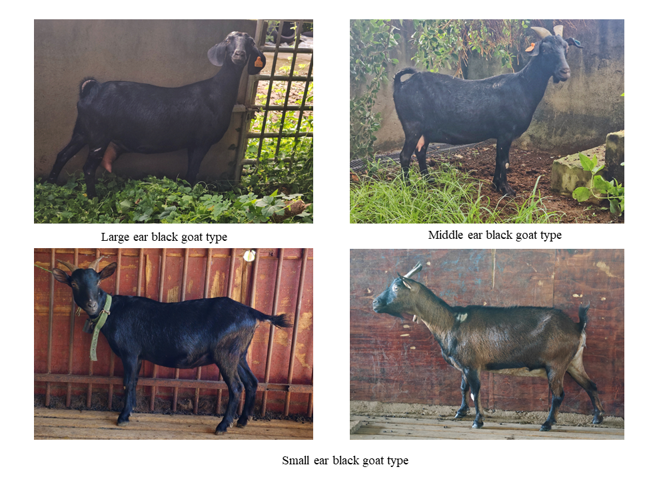
Figure S1: Different types of black goats in Hainan

Figure S2: GO function annotation diagram for θπ analysis of candidate genes.
(A)Big ear black goat vs Black goat in Guangxi; (B)Big ear black goat vs Middle ear black goat; (C)Big ear black goat vs Small ear black goat.

Figure S3: GO functional annotation of candidate genes for Fst analysis.
(A)Big ear black goat vs Black goat in Guangxi; (B)Big ear black goat vs Middle ear black goat; (C)Big ear black goat vs Small ear black goat.
Figure S4: Visual line map of methylation levels in the gene ontology region.
(A) ENSCHIG00000000074; (B)ENSCHIG00000000505;(C) ENSCHIG00000000516;(D) ENSCHIG00000000644;(E)ENSCHIG00000000940;(F)ENSCHIG00000002357;(G) ENSCHIG00000002361;(H)ENSCHIG00000002371;(I) ENSCHIG00000007633;(J) ENSCHIG00000024242. The red line is Big ear black goat, the blue line is Small ear black goat.

Figure S5: Inter-group differences in methylation levels in gene ontology regions.
(A)ENSCHIG00000000074;(B)ENSCHIG00000000505;(C)ENSCHIG00000000516;(D)ENSCHIG00000000644;(E)ENSCHIG00000000940;(F)ENSCHIG00000002357;(G)ENSCHIG00000002361;(H)ENSCHIG00000002371;(I)ENSCHIG00000007633;(J)ENSCHIG00000024242.The red line is Big ear black goat(N=30), the blue line is Small ear black goat(N=20).

Figure S6: Visual line map of methylation levels in gene promoter region.
(A) ENSCHIG00000000074; (B) ENSCHIG00000000516;(C) ENSCHIG00000000644;(D)ENSCHIG00000000940;(E)ENSCHIG00000002357;(F) ENSCHIG00000002361;(G)ENSCHIG00000002371;(H) ENSCHIG00000007633;(I) ENSCHIG00000024242. The red line is Big ear black goat, the blue line is Small ear black goat.

Figure S7: Intergroup differences in methylation levels of gene promoter region.
(A) ENSCHIG00000000074; (B) ENSCHIG00000000516;(C) ENSCHIG00000000644;(D)ENSCHIG00000000940;(E)ENSCHIG00000002357;(F) ENSCHIG00000002361;(G)ENSCHIG00000002371;(H) ENSCHIG00000007633;(I) ENSCHIG00000024242.The red line is Big ear black goat(N=30), the blue line is Small ear black goat(N=20).

Attached Table S1: Body size data of Black goats in Hainan
Number | Weight | body length | body height | Goat bust | Goat girth | Ear length
Large ear | 61.46±5.45ª | 68.34±4.52 ª | 67.12±3.86 ª | 88.45±4.89 ª | 12.32±0.86 ª |  | 17.50±1.82 ª
Middle ear | 59.32±4.89 ª | 66.15±4.32 ^{ab} | 65.45±3.55 ª | 85.35±4.23 ª | 10.40±0.84 ^{ab} |  | 14.68±1.46 ^{ab}
Small ear | 31.12±3.74 ^{b} | 62.23±3.12^{b} | 59.46±2.24^{b} | 78.54±3.20^{b} | 9.42±0.45 ^{b} |  | 12.42±1.12 ^{b}
Note: Large ear type black goat n=30, Middle ear type black goat n=30, Small ear type black goat n=30.

