Supplementary Materials

Supplementary Figures
Supplementary Fig.S1. Complete genome of lytic phage Kp11 against Klebsiella Pneumoniae (GenBank: ON148528.1).
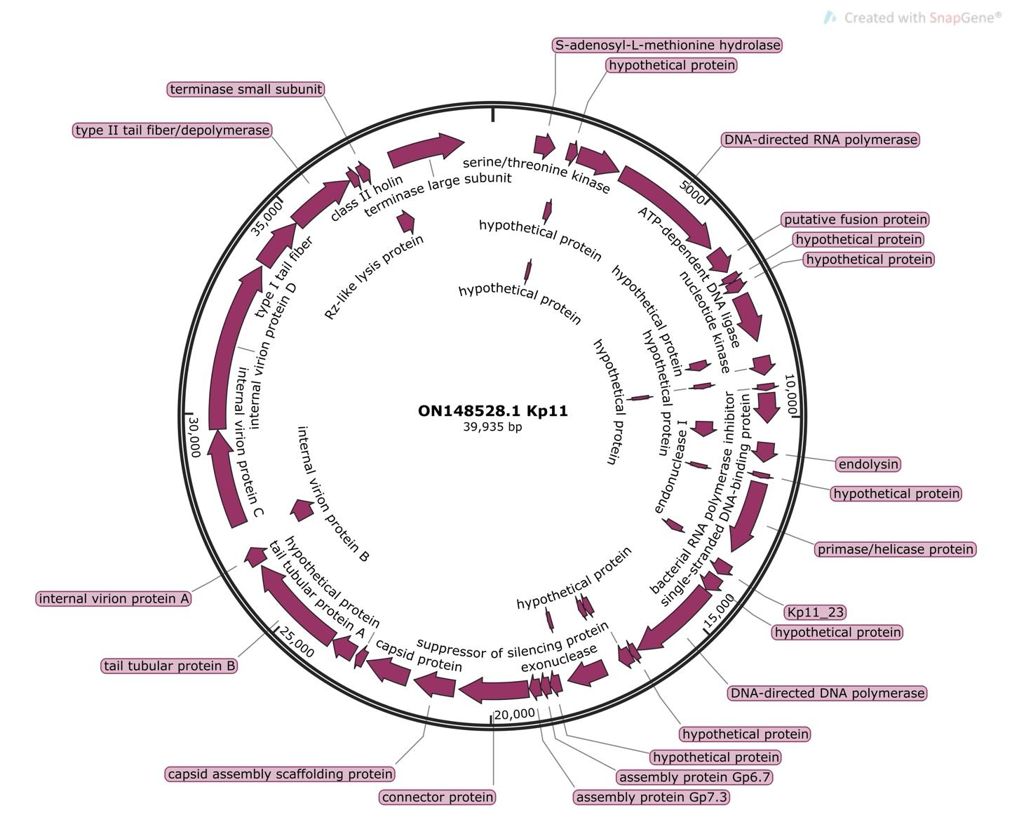

Supplementary Fig.S2. Susceptibility to phage T4 is similar for KLY and longer lag-time strain metG*.
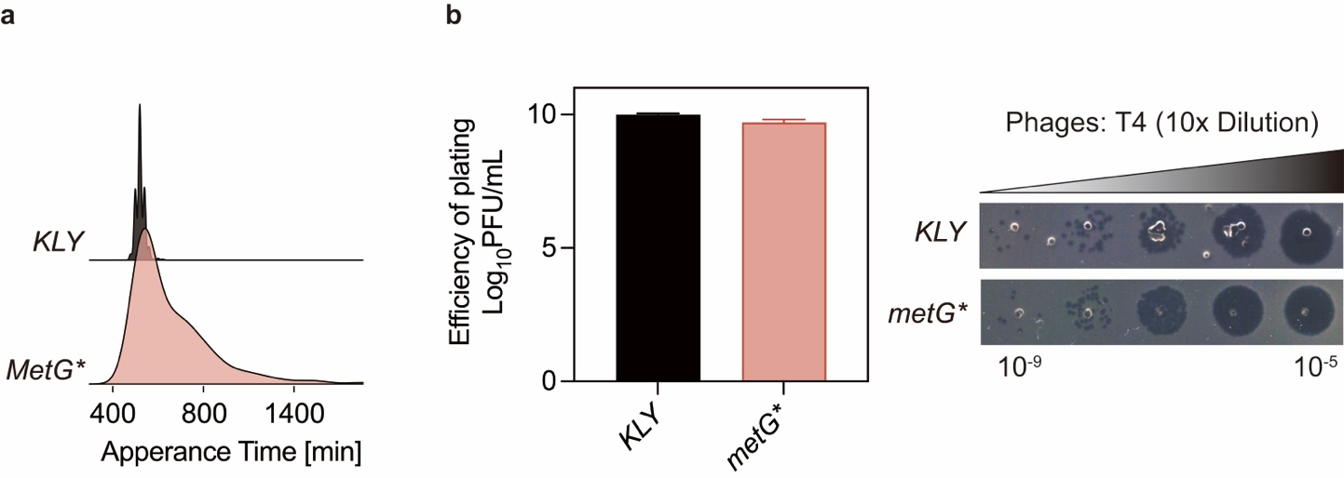
a. The distribution of appearance times of colonies for E. coli strain KLY and metG* was measured using ScanLag (refer to Materials and Methods). The y-axis represents the normalized proportion of colony-forming units (CFUs) detected at each time points.
b. The relative minimum phage titer of KLY and metG* for T4 test and small drop assay phenotypes. Data are presented as the mean ± s.d. from three independent biological replicates. This data corresponds to the results discussed in Fig.1 of the main text, showing increased lag time does not confer protection against phage infection.

Supplementary Fig.S3. Heat induced phage tolerance was impacted by treatment time and temperature.
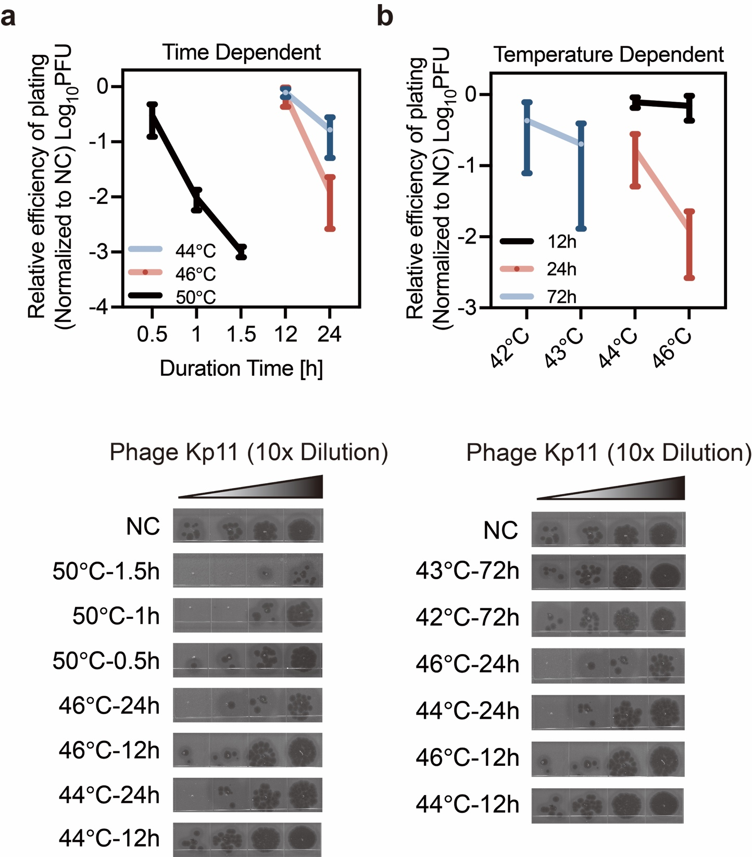
Phage tolerance in K. pneumoniae induced by heat stress as a function of treatment duration (a) and treatment temperature (b). Data are presented as mean ± s.d. from three independent biological replicates. This data corresponds to the results discussed in Fig.2 of the main text, showing effects of heat-treated phage tolerance being both time- and temperature-dependent.

Supplementary Fig.S4. Phage tolerance induced by heat stress is a consistent response observed across various bacterial strains.
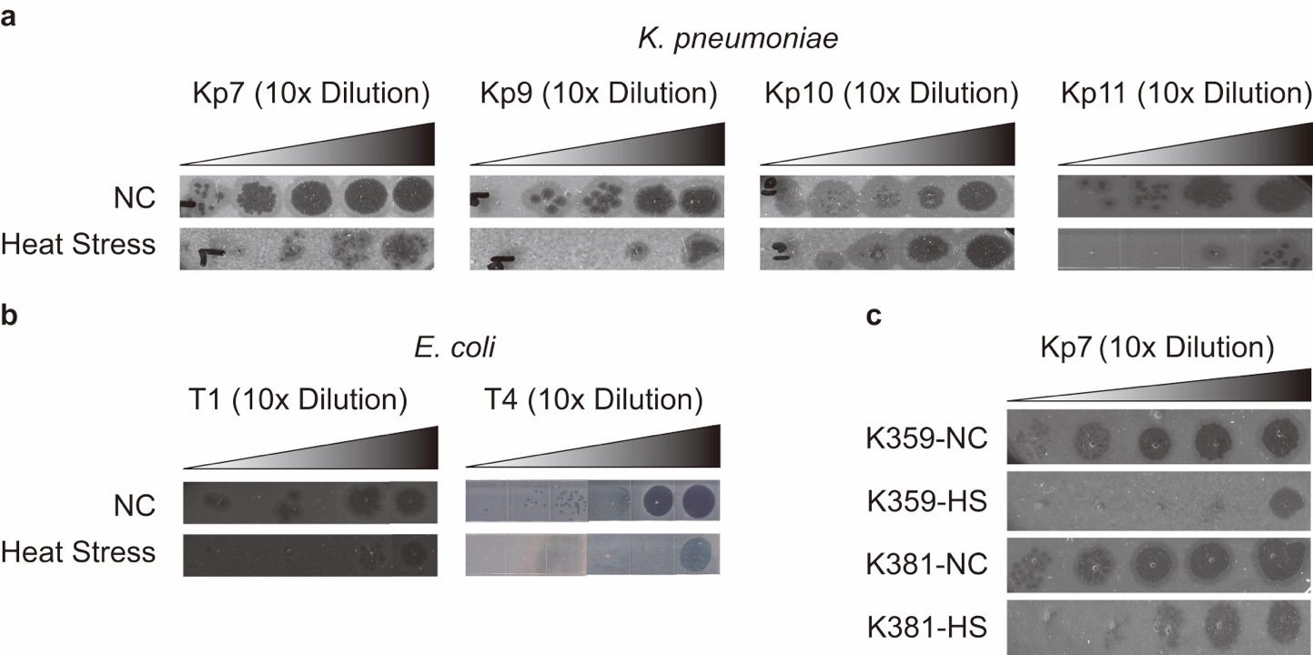
Morphological comparison of K. pneumoniae ATCC 43816 infected with phages Kp7, Kp9, Kp10, and Kp11 (a), E. coli KLY infected with phages T1 and T4 (b), and clinical K. pneumoniae strains K359 and K381 infected with phage Kp7 (c), before and after heat treatment. This data corresponds to the results discussed in Fig.3 of the main text.
Supplementary Fig.S5.
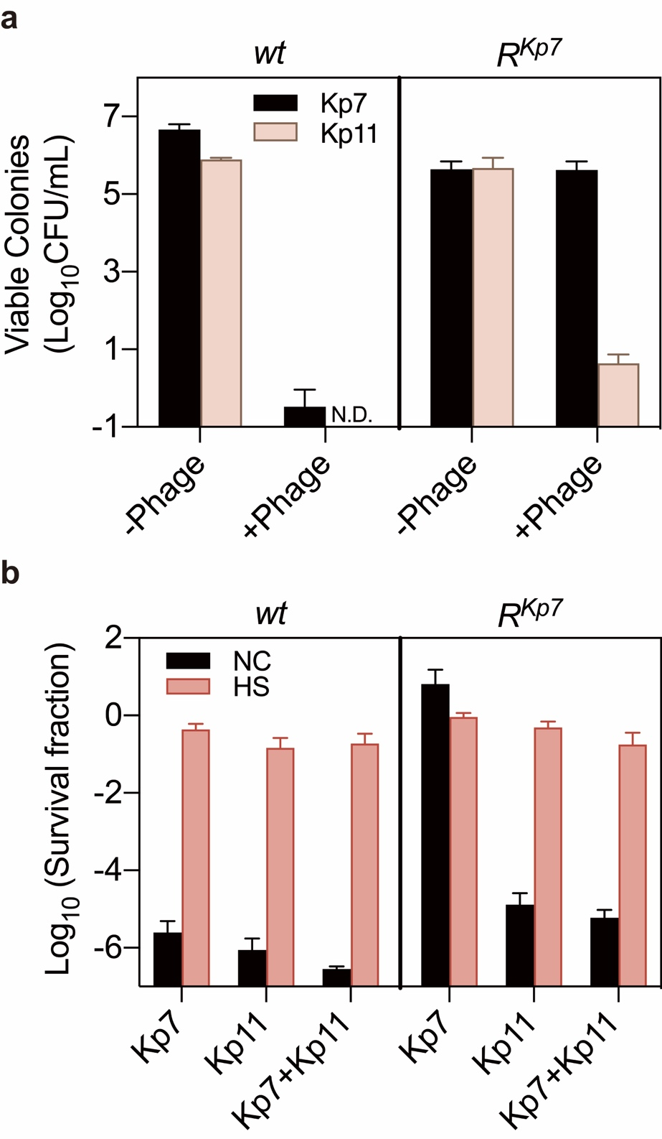
a. The Kp7-resistant strain (R^{Kp7}) remained sensitive to phage Kp11. Colonies of R^{Kp7}were detectable only on the Kp7 phage plates but not on the Kp11 phage plates, while the wild-type (wt) strain was sensitive to both phages, showing no viable colonies on either plate. Data are presented as the mean ± s.d. independent biological replicates.
b. Killing assay of wt and R^{Kp7}strains with phage Kp7, Kp11, and their combination, before and after heat treatment. Heat stress increased bacterial survival under all conditions, including exposure to Kp7 alone, Kp11 alone, and the combination of Kp7 and Kp11. Data are presented as the mean ± s.d. from three independent biological replicates. This data corresponds to the results discussed in Fig.3 of the main text.
Supplementary Fig.S6. Production and structure of the bacterial capsule in heat-treated and untreated bacteria.
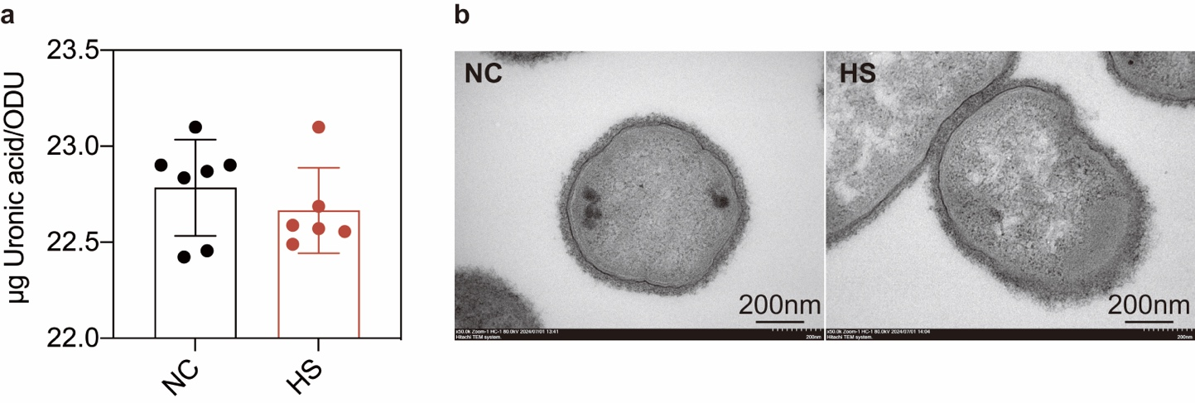
a. Quantification of capsular production of untreated bacteria and heat-treated bacteria. Capsular production was measured using the uronic acid method and expressed as the amount of uronic acid per OD600. Data are presented as the mean ± s.d. from six independent biological replicates.
b. Detection of bacterial capsular structure by transmission electronic microscopy (TEM) before and after heat treatment. This data corresponds to the results discussed in Fig.4 of the main text, showing the production and structure of the bacterial capsule remained unchanged.
Supplementary Fig.S7. Impact of pspA mutations on bacterial survival and phage resistance.
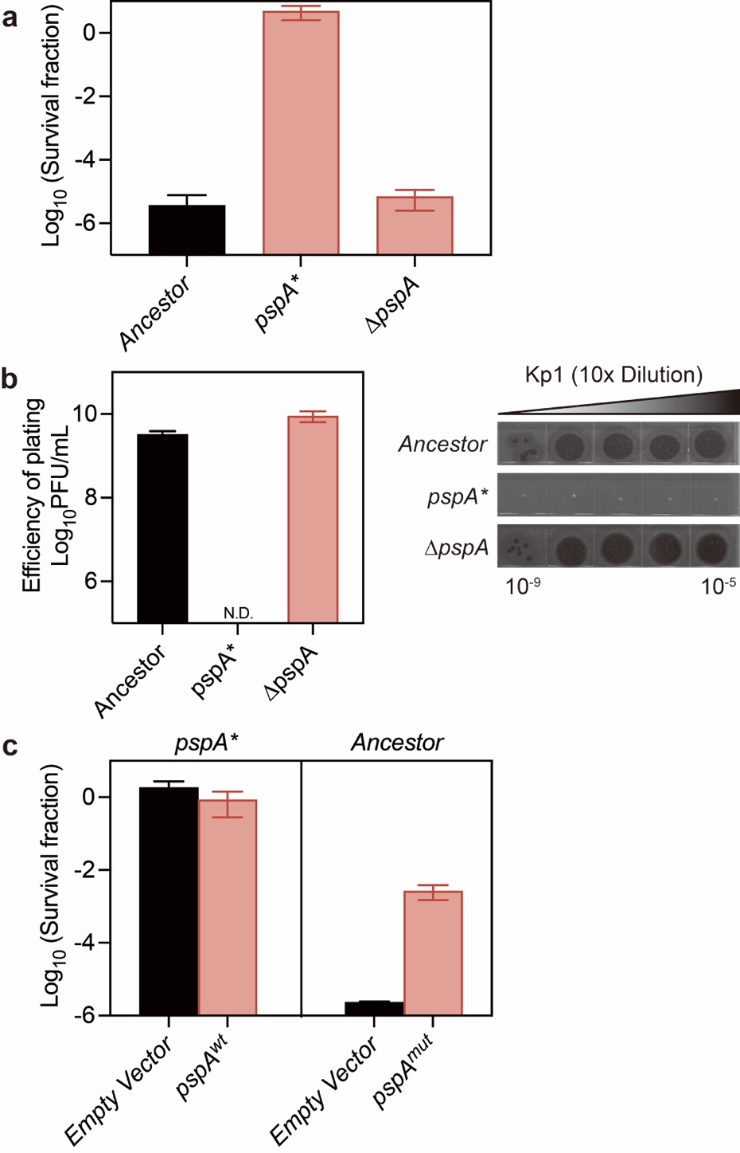
a.b. The pspA knockout strain did not display the phenotype associated with the pspA mutation in survival (a) and efficiency of plating (b) when exposed to phage Kp11.
c. Reintroduction of wild-type PspA into the mutant strain did not restore the original phenotype; However, overexpression of the mutant PspA enhanced survival during phage infection. Data are presented as the mean ± s.d. from three biological replicates. This data corresponds to the results discussed in Fig.5 of the main text, showing the mutant in gene pspA was a gain-of-function mutation.
Supplementary Fig.S8. Superior protection of un-treated ancestral strain ATCC 43816 against immune clearance of septic infection.
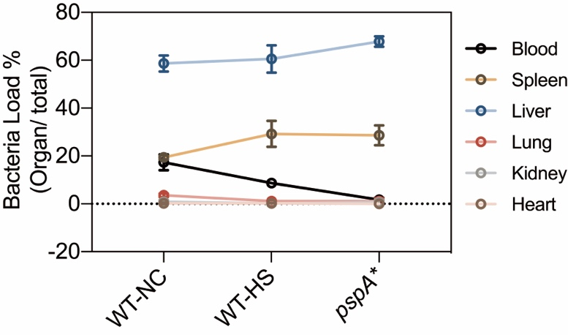
Female ICR mice were intravenously (i.v.) infected with approximately 10⁶ CFU of the ancestral strain ATCC 43816, with and without heat treatment, and the pspA* mutant. CFU counts in the blood and major organs were determined at 30 minutes post-infection. Data are presented as the mean ± s.d. from three independent biological replicates. This data corresponds to the results discussed in Fig.6 of the main text, showing a significant reduction in immune evasion capacity both in pspA* and heat-treated ancestral strain.
Supplementary Tables.

Table S1. List of bacterial strains and phages used in this study.
Strain Name | Description | Reference
K. pneumoniae
ATCC 43816
K381  K357 | Isolated from Hospital  Isolated from Hospital | This Study  This Study
pspA* | Evolution BC2G11C1 | This Study
rpoH* | Evolution BC3G11C2 | This Study
Δcps | ATCC 43816 Δcps | (Huang et al., 2022)
ΔpspA | ATCC 43816 ΔpspA | This Study
E. coli
KLY | KL16-YFP Cam | (Fridman et al., 2014)
metG* | KLY metG^{T} | (Levin-Reisman et al., 2017)
Phages
Kp11 | K. pneumoniae phage (GenBank: ON148528.1) | Provided by Xiang Lab.(Huang et al., 2024)
Kp7 | K. pneumoniae phage (GenBank: ON148527.1) | Provided by Xiang Lab.(Huang et al., 2024)
Kp9 | K. pneumoniae phage (GenBank: ON148529.1) | Provided by Xiang Lab.(Huang et al., 2024)
Kp10 | K. pneumoniae phage | Provided by Xiang Lab.(Huang et al., 2024)
T1/T4 | MG 1655 E. coli phage | Provided by Liang Lab.
Table S2. List of plasmids and primers used in this Study.
Primer name | Description | Reference
pCasKP-apr | Thermosensitive plasmid carrying Cas9 gene and lambda red system; Apr^{R} | (Wang et al., 2022)Provided By Ji Lab.
pSGKP-spe | Expressing sgRNA and carrying sacB; Spe^{R} | (Wang et al., 2022)Provided By Ji Lab.
Primers
ZF-pspA1 | tagtGCAGTTTGCCGAACTGAAAGCGG | This Study  For pspA deletion
ZF-pspA2 | aaacCCGCTTTCAGTTCGGCAAACTGC | This Study  For pspA deletion
ZF-pspA3 | TGTCGCCAGCTCATCGAGAAACAGCGTC | This Study  For pspA deletion
ZF-pspA4 | TTTCTCGATGAGCTGGCGACA | This Study  For pspA deletion
ZF-pspA5 | TGAAACCAGAACTATGAGGATTGAAATTGTATGATTGCGCGGCGCGGCGTTGCG | This Study  For pspA deletion
ZF-pspA6 | ATGAGCTCCACCGCGGTGGCGGCCGCTCTAGCCGTACAGCTCGCTGTCCGGTAT | This Study  For pspA deletion
ZFqP1-F | GACGATCCCTAGCTGGTCTG | This Study  For qPCR
ZFqP1-R | GTGCAATATTCCCCACTGCT | This Study  For qPCR
ZFqP2-F | GACATCCCGTTCGACTACCT | This Study  For qPCR
ZFqP2-R | GCAGCTGTGAGACGTTAAGG | This Study  For qPCR
Table S3. Mutation rate of K. pneumoniae to phage.
 | replicates | Nt  (x10⁷) | No mutation cultures | P₀ | Mutation rate
NC | 1 | 23 | 14/14 | 1 | 1.23x10⁻⁹
NC | 2 | 3.7 | 12/14 | 0.875 | 1.23x10⁻⁹
NC | 3 | 11 | 13/14 | 0.929 | 1.23x10⁻⁹
NC | 4 | 5.6 | 13/14 | 0.929 | 1.23x10⁻⁹
NC | 5 | 1.8 | 14/14 | 1 | 1.23x10⁻⁹
HS | 1 | 1.9 | 12/14 | 0.875 | 3.61x10⁻¹⁰
HS | 2 | 2.3 | 14/14 | 1 | 3.61x10⁻¹⁰
HS | 3 | 2.8 | 11/14 | 0.786 | 3.61x10⁻¹⁰
HS | 4 | 1.8 | 12/14 | 0.875 | 3.61x10⁻¹⁰
HS | 5 | 1.1 | 14/14 | 1 | 3.61x10⁻¹⁰

Supplementary Videos

Supplementary Video 1. Untreated bacteria were lysed by phages before cell division could occur.
Shown is the rapid lysis of untreated K. pneumoniae ATCC43816 infected with phage Kp11 at an MOI of 100. The bacteria are lysed before they can undergo cell division, demonstrating the efficiency of phage-induced lysis at this infection level. Watch as bacteria are quickly disrupted following phage exposure.

Supplementary Video 2. heat-treated bacteria were able to undergo cell division despite exposure to the lytic phage.
Shown is the infection of heat-treated K. pneumoniae ATCC43816 by phage Kp11 at an MOI of 100. Unlike the untreated bacteria, these bacterial cells can be observed undergoing division before lysis occurs. The delayed lysis highlights the increased tolerance of heat-treated bacteria to phage infection under similar conditions. This increased frequency for bacterial division facilitates the evolution of phage resistance, highlighting the impact of heat treatment on bacterial survival under phage infection.

