Heat Stress Induced Bacterial Tolerance against Phage Facilitates the Evolution of Resistance
Authors: Fan Zhang ¹, Haoze Chen ¹, Bo Zheng ¹, Liang Huang ¹, Ye Xiang ^{1,2,3,4}, Jing-Ren Zhang ^{1,2}, Jiafeng Liu ^{1,2}*.
Affiliations:
¹Center for Infection Biology, School of Basic Medical Sciences, Tsinghua University, Beijing 100084, China.
²Tsinghua-Peking Center for Life Sciences, Beijing 100084, China.
³SXMU-Tsinghua Collaborative Innovation Center for Frontier Medicine, Shanxi Medical University, Taiyuan, Shanxi Province 030001, China.
⁴Beijing Frontier Research Center for Biological Structure, Tsinghua University, Beijing 100084, China.

*Corresponding author: Email: jfliu@mail.tsinghua.edu.cn

Extended Data Figures for Heat Stress Induced Bacterial Tolerance against Phage Facilitates the Evolution of Resistance

This file includes:
Extended Data Figures. Extended Data Fig.1 - 7
Extended Data Fig.1. Susceptibility to phage T4 is similar for KLY and longer lag-time strain metG*.
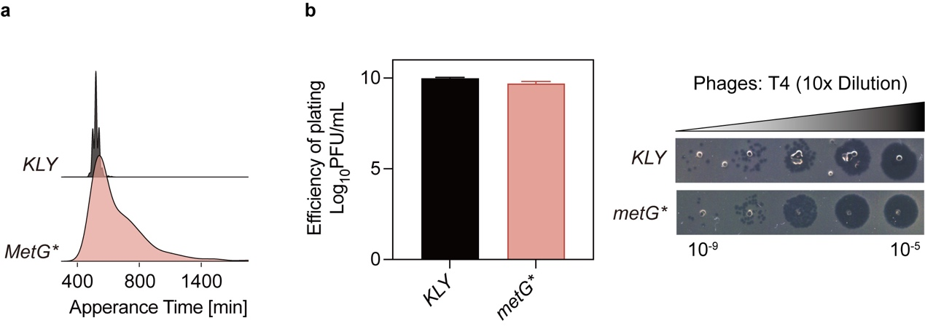
a, The distribution of appearance times of colonies for E. coli strain KLY and metG* was measured using ScanLag (refer to Materials and Methods). The y-axis represents the normalized proportion of colony-forming units (CFUs) detected at each time points. b, The relative minimum phage titer of KLY and metG* for T4 test and small drop assay phenotypes. Data are presented as the mean ± s.d. from three independent biological replicates. This data corresponds to the results discussed in Fig.1 of the main text, showing increased lag time does not confer protection against phage infection.
Extended Data Fig.2. Heat induced phage tolerance was impacted by treatment time and temperature.
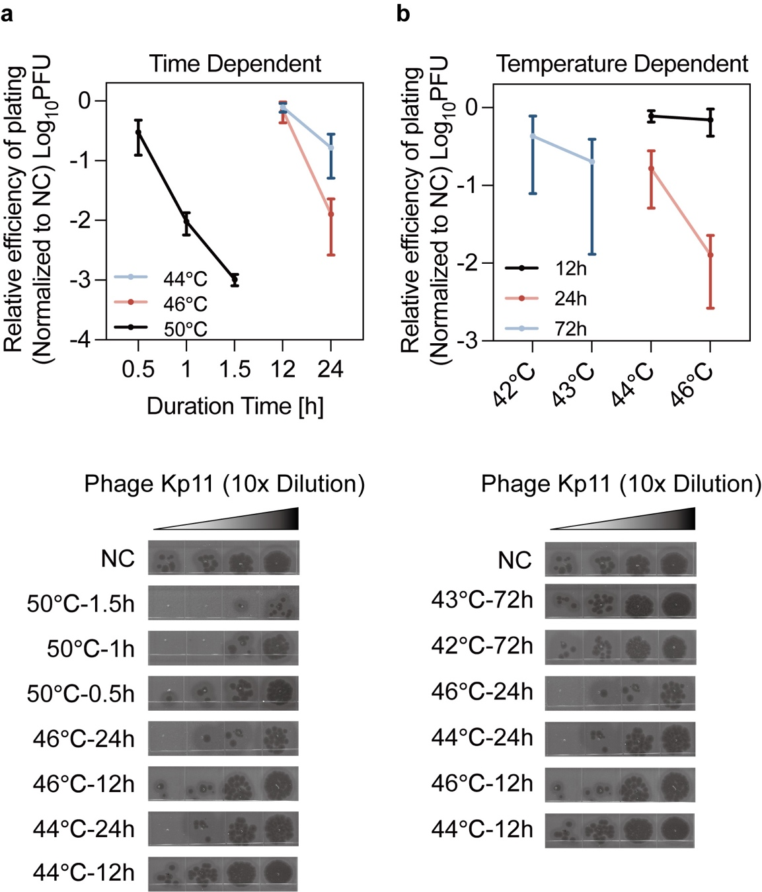
Phage tolerance in K. pneumoniae induced by heat stress as a function of treatment duration (a) and treatment temperature (b). Data are presented as mean ± s.d. from three independent biological replicates. This data corresponds to the results discussed in Fig.2 of the main text, showing effects of heat-treated phage tolerance being both time- and temperature-dependent.
Extended Data Fig.3. Phage tolerance induced by heat stress is a consistent response observed across various bacterial strains.
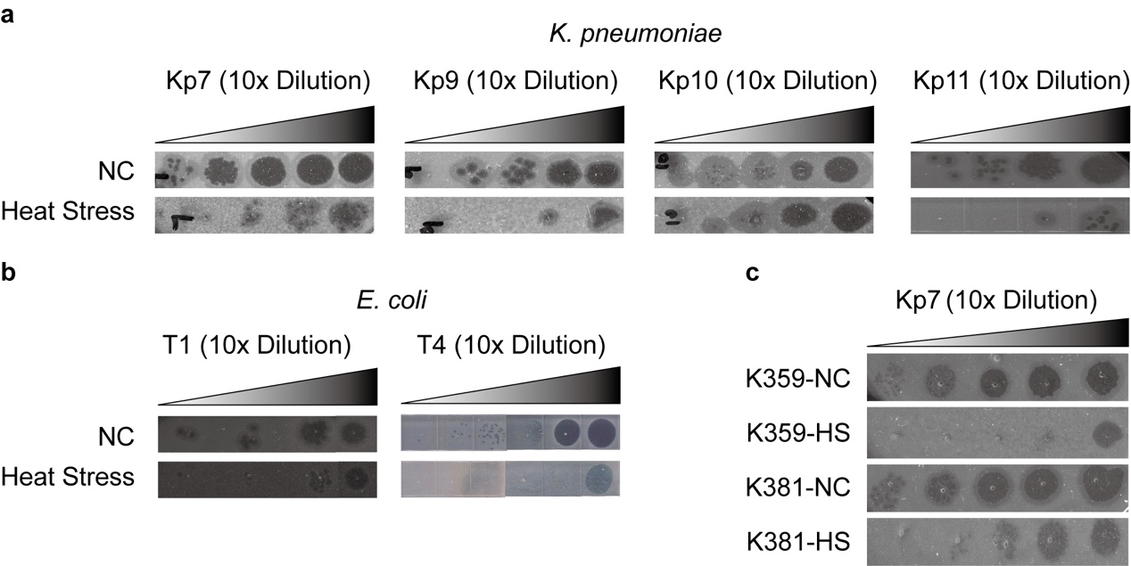
Morphological comparison of K. pneumoniae ATCC 43816 infected with phages Kp7, Kp9, Kp10, and Kp11 (a), E. coli KLY infected with phages T1 and T4 (b), and clinical K. pneumoniae strains K359 and K381 infected with phage Kp7 (c), before and after heat treatment. This data corresponds to the results discussed in Fig.3 of the main text.
Extended Data Fig.4.
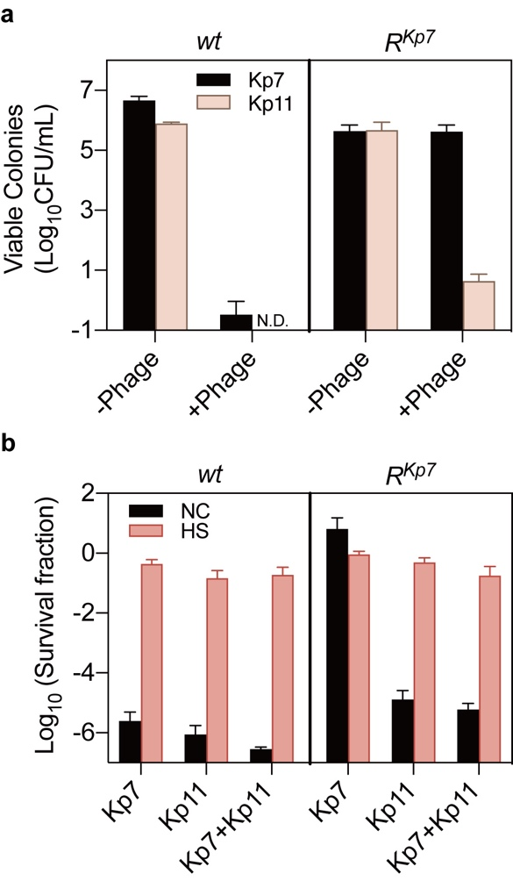
a, The Kp7-resistant strain (R^{Kp7}) remained sensitive to phage Kp11. Colonies of R^{Kp7} were detectable only on the Kp7 phage plates but not on the Kp11 phage plates, while the wild-type (wt) strain was sensitive to both phages, showing no viable colonies on either plate. Data are presented as the mean ± s.d. independent biological replicates. b, Killing assay of wt and R^{Kp7} strains with phage Kp7, Kp11, and their combination, before and after heat treatment. Heat stress increased bacterial survival under all conditions, including exposure to Kp7 alone, Kp11 alone, and the combination of Kp7 and Kp11. Data are presented as the mean ± s.d. from three independent biological replicates. This data corresponds to the results discussed in Fig.3 of the main text.
Extended Data Fig. 5. Production and structure of the bacterial capsule in heat-treated and untreated bacteria.
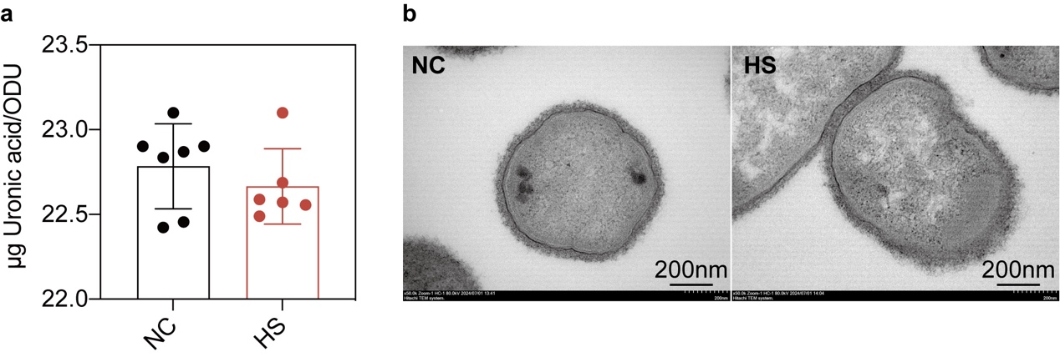a, Quantification of capsular production of untreated bacteria and heat-treated bacteria. Capsular production was measured using the uronic acid method and expressed as the amount of uronic acid per OD600. Data are presented as the mean ± s.d. from six independent biological replicates. b, Detection of bacterial capsular structure by transmission electronic microscopy (TEM) before and after heat treatment. This data corresponds to the results discussed in Fig.4 of the main text, showing the production and structure of the bacterial capsule remained unchanged.
Extended Data Fig. 6. Impact of pspA mutations on bacterial survival and phage resistance.
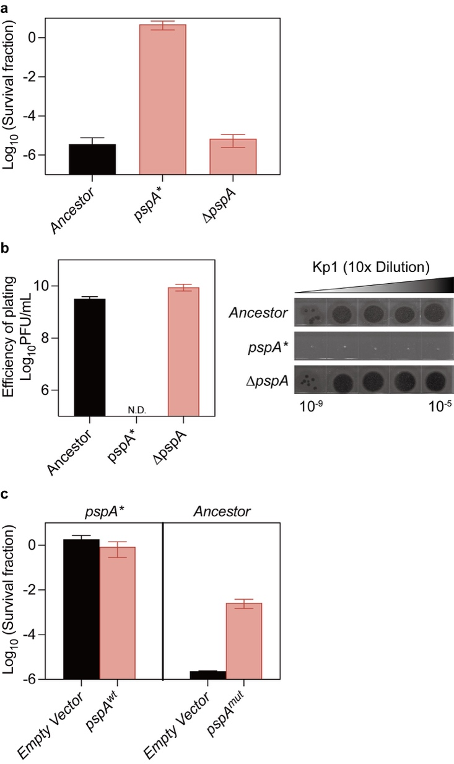
a.b, The pspA knockout strain did not display the phenotype associated with the pspA mutation in survival (a) and efficiency of plating (b) when exposed to phage Kp11. c, Reintroduction of wild-type PspA into the mutant strain did not restore the original phenotype; However, overexpression of the mutant PspA enhanced survival during phage infection. Data are presented as the mean ± s.d. from three biological replicates. This data corresponds to the results discussed in Fig.5 of the main text, showing the mutant in gene pspA was a gain-of-function mutation.
Extended Data Fig. 7. Superior protection of un-treated ancestral strain ATCC 43816 against immune clearance of septic infection.
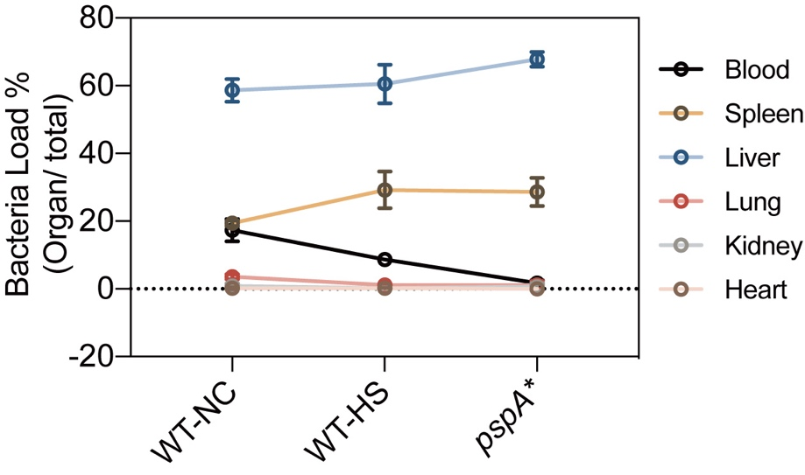
Female ICR mice were intravenously (i.v.) infected with approximately 10⁶ CFU of the ancestral strain ATCC 43816, with and without heat treatment, and the pspA* mutant. CFU counts in the blood and major organs were determined at 30 minutes post-infection. Data are presented as the mean ± s.d. from three independent biological replicates. This data corresponds to the results discussed in Fig.6 of the main text, showing a significant reduction in immune evasion capacity both in pspA* and heat-treated ancestral strain.

