Supplementary Fig. 1 Scatter and forest plots of the direction and magnitude of each SNP's effect on AD and CF.
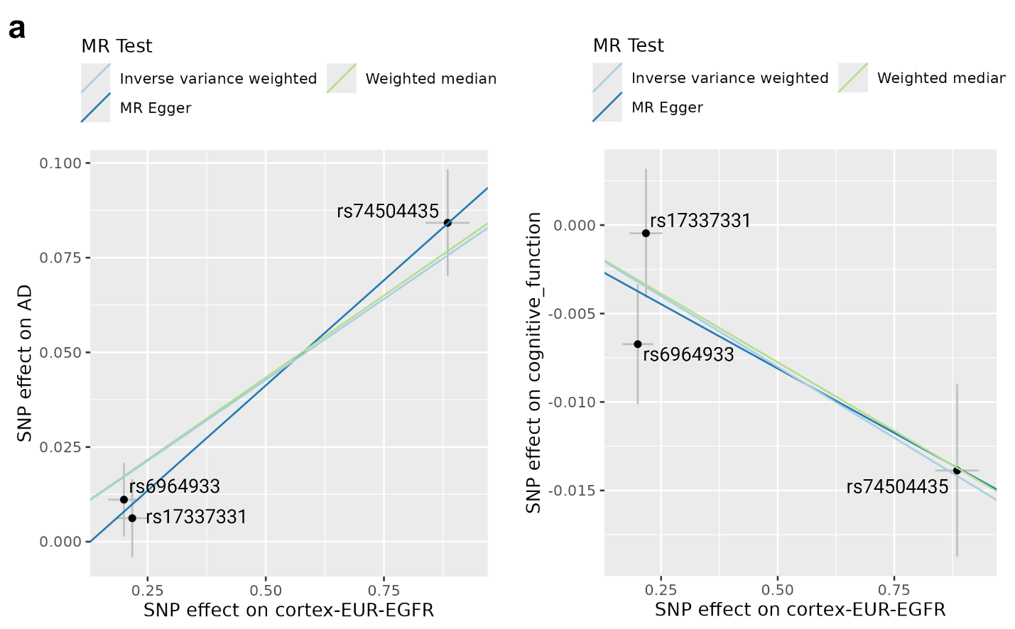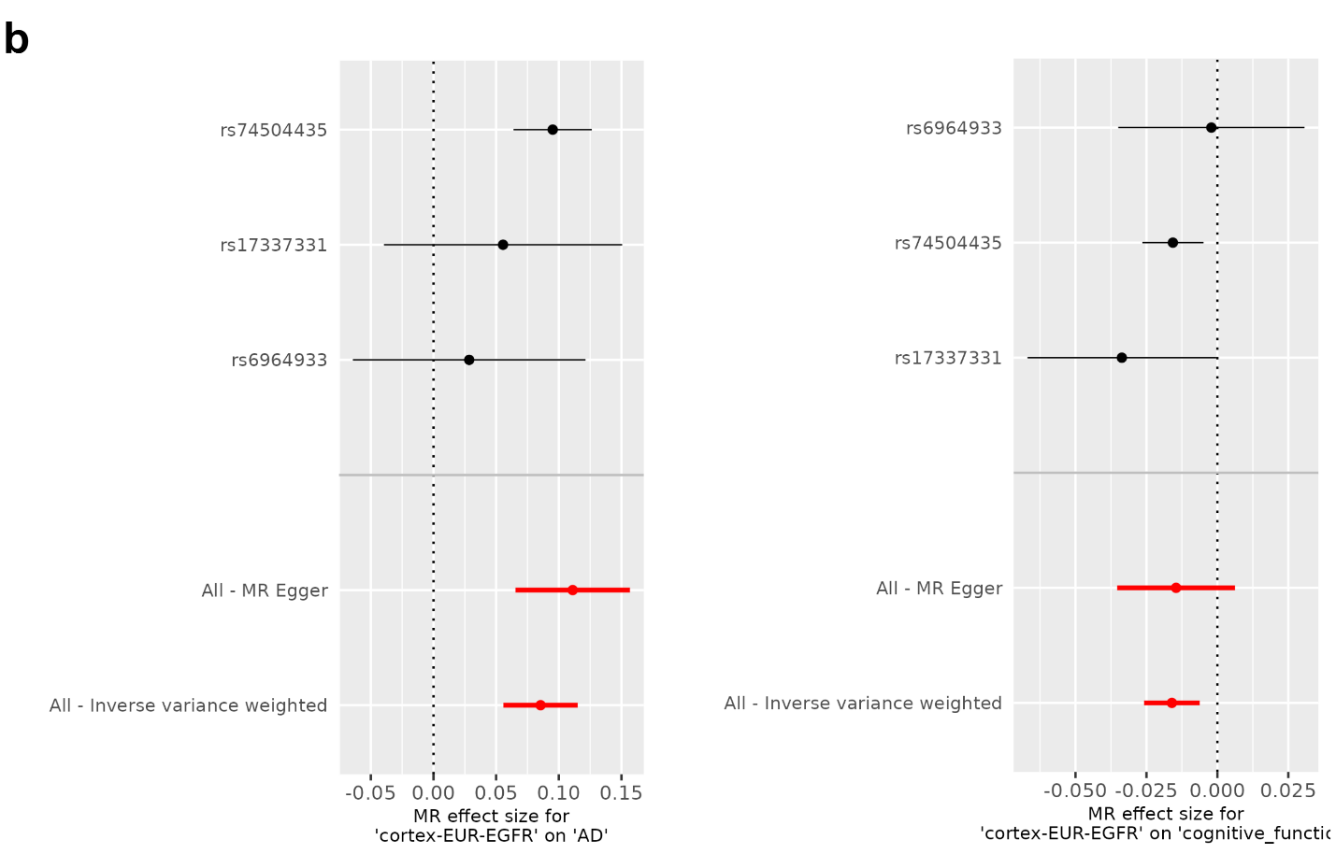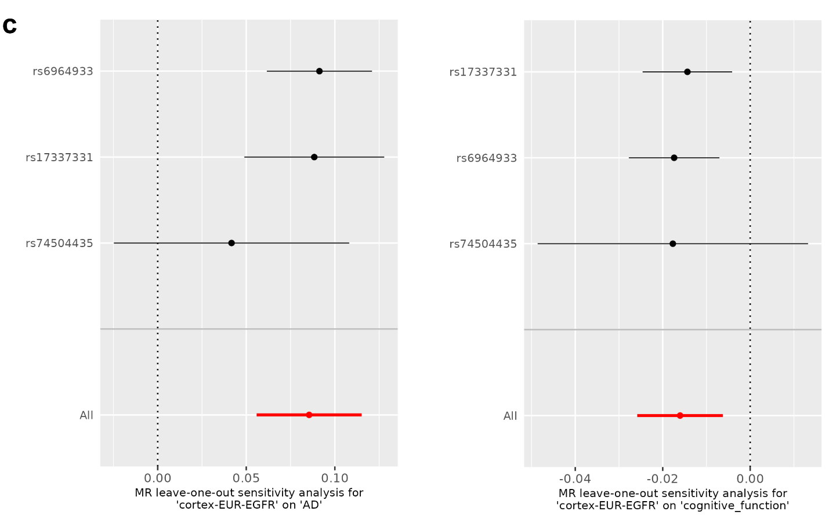
(a) Scatter plots for MR analysis (IVW, Weighted Median, and MR Egger) of the causal effect of EGFR expression on AD or CF decline. The x-axis shows MR analysis of IVs on EGFR expression. In the scatter plot, the slopes of each line represent the causal association for different MR methods. The x-axis shows MR analysis of IVs on AD (Left) or CF (Right). Our results indicate that higher EGFR expression is associated with increased risk for AD (slope > 0, Left) and cognitive decline (slope < 0, Right).
(b) Results of the single and multiple-SNP MR analysis for the effect of EGFR expression on the risk for AD (Left) or CF decline (Right). The black lines in the forest plot visualize the results of the single SNP analyses; the red lines visualize the results of the multiple SNP analysis.
(c)The leave-one-out sensitivity analysis for the effect of EGFR expression on AD (Left) or CF decline (Right). In the plot, removal of rs74504435, but not the other two SNPs, substantially change the effect estimates for both outcomes, suggesting that rs74504435 was the leading IV. The overall effect remains significant (the red line does not include 0), indicating that the MR results are robust.

