Supplementary Tables and Figures

Table of Contents

Item | Name | Page
Supplementary Tables
Table 1 | Input Data – Rates and Numbers | 2
Table 2 | Drug Use by Area Data – Mean NDSHS 2010, 2013 | 7
Table 3 | Significant of rises of Supplementary Figure 1 | 8
Table 4 | 2x2 Table Analysis Output by Defect and Defect Class | 9
Table 5 | Regression Coefficients and Significance Levels for Defects against Tobacco, Alcohol and Cannabis Use Ordered by Significance of Regression on Cannabis | 14
Table 6 | Regression Coefficients and Significance Levels for Defects against Tobacco, Alcohol and Cannabis Use Ordered by Significance of Regression on Tobacco | 17
Table 7 | Regression Coefficients and Significance Levels for Defects against Tobacco, Alcohol and Cannabis Use Ordered by Significance of Regression on Alcohol | 20
Table 8 | Significant Outcomes from Additive Linear Modelling of 3 Drug Exposure – P<0.05 | 23
Table 9 | Expanded Outcomes from Additive Linear Modelling of 3 Drug Exposure – P<0.3 | 24
Table 10 | Linear Interactive Final Models | 26
Table 11 | Additive Spatially Lagged Spatial Models | 28
Table 12 | Interactive Spatially Lagged Spatial Models | 30
Table 13 | Final Mixed Effects Model Regressoin Results | 35
Supplementary Figures
Figure 1 | Trend Analysis | 38
Figure 2 | Congenital Anomalies A-C | 39
Figure 3 | Congenital Anomalies C-P | 40
Figure 4 | Congenital Anomalies R-Z | 41
Figure 5 | Chromosomal Defects | 42
Figure 6 | Rare Congenital Defects – Confidence Intervals by Cannabis Relationship | 43
Figure 7 | Comparative Rates of Congenital Anomalies NNSW v QLD | 44
Figure 8 | Relative Ratio of NNSW to QLD Congenital Anomalies by Relationship to Cannabis | 45
Figure 9 | Log (Relative Ratio) of NNSW to QLD Congenital Anomalies by Relationship to Cannabis | 46
Figure 10 | Prevalence Ratios NNSW to QLD by Cannabis Relationship | 47
Figure 11 | Attributable Fraction in the Population NNSW to QLD by Cannabis Relationship | 48
Figure 12 | P-Values for PR’s NNSW to QLD by Cannabis Relationship | 49
Figure 13 | Selected Major Defect Classes by Drug Exposure | 50
Figure 14 | Congenital Anomaly Rate by Cigarette Use Rate – Ordered by Regression Slope | 51
Figure 15 | Congenital Anomaly Rate by Risky Alcohol Use Rate – Ordered by Regression Slope | 52
Figure 16 | Geospatial Links –Edited and Final | 53

Supplementary Table 1.: Input Data – Rates and Numbers

Defect | CanRel | IttRt | QLDRt | Diffc | Ratio | Interstate Numbers | Normal Interstate Births | QLD Numbers | Normal QLD  Births
Defect
Exomphalos | Related | 1.5 | 0.2 | 1.3 | 7.50 | 7 | 4793 | 118 | 508970
Gastroschisis | Related | 3.3 | 0.6 | 2.7 | 5.50 | 16 | 4784 | 290 | 508789
Trisomy 18 | Related | 2.3 | 0.5 | 1.8 | 4.60 | 11 | 4789 | 259 | 508825
Stenosis/atresia small intestine | Related | 1.3 | 0.3 | 1 | 4.33 | 6 | 4794 | 161 | 508928
Diaphragmatic hernia | Related | 1.3 | 0.3 | 1 | 4.33 | 6 | 4794 | 144 | 508945
Tetralogy of Fallot | Related | 1.7 | 0.4 | 1.3 | 4.25 | 8 | 4792 | 185 | 508902
Transposition of great vessels | Related | 2.5 | 0.6 | 1.9 | 4.17 | 12 | 4788 | 274 | 508809
Turner syndrome | Related | 0.8 | 0.2 | 0.6 | 4.00 | 4 | 4796 | 115 | 508976
Patent Ductus Arteriosus | Related | 21.3 | 6.5 | 14.8 | 3.28 | 102 | 4698 | 3149 | 505844
Atrial Septal Defects | Related | 16.9 | 5.4 | 11.5 | 3.13 | 81 | 4719 | 2624 | 506390
Ventricular Septal Defect | Related | 10.8 | 4.7 | 6.1 | 2.30 | 52 | 4748 | 2323 | 506720
Anencephalus | Related | 1 | 0.5 | 0.5 | 2.00 | 5 | 4795 | 242 | 508848
Encephalocoele | Related | 0.2 | 0.1 | 0.1 | 2.00 | 1 | 4799 | 47 | 509047
Anotia, microtia | Related | 0.4 | 0.2 | 0.2 | 2.00 | 2 | 4798 | 110 | 508983
Tracheo-oesophageal fistula, oesophageal atresia/s | Related | 0.6 | 0.3 | 0.3 | 2.00 | 3 | 4797 | 172 | 508920
Trisomy 13 | Related | 0.4 | 0.2 | 0.2 | 2.00 | 2 | 4798 | 97 | 508996
Reduction deformities Upper and/or lower limbs | Related | 1.3 | 0.7 | 0.6 | 1.86 | 6 | 4794 | 329 | 508760
Neural tube defects | Related | 2.3 | 1.3 | 1 | 1.77 | 11 | 4789 | 623 | 508461
Down syndrome | Related | 3.5 | 2 | 1.5 | 1.75 | 17 | 4783 | 987 | 508091
Spina Bifida | Related | 1 | 0.6 | 0.4 | 1.67 | 5 | 4795 | 274 | 508816
Renal agenesis or dysgenesis | Related | 2.1 | 1.3 | 0.8 | 1.62 | 10 | 4790 | 657 | 508428
Microcephaly | Related | 0.8 | 0.5 | 0.3 | 1.60 | 4 | 4796 | 263 | 508828
Cleft Palate/Cleft lip | Related | 2.5 | 1.9 | 0.6 | 1.32 | 12 | 4788 | 959 | 508124
Stenosis/atresia anus | Related | 0.4 | 0.4 | 0 | 1.00 | 2 | 4798 | 202 | 508891
Syndactyly | Related | 1 | 1 | 0 | 1.00 | 5 | 4795 | 496 | 508594
Polydactyly | Related | 0.4 | 1.2 | -0.8 | 0.33 | 2 | 4798 | 589 | 508504
Pyloric Stenosis | Related | 0.4 | 1.3 | -0.9 | 0.31 | 2 | 4798 | 657 | 508436
Cystic Kidney disease | Not Related | 1 | 0.3 | 0.7 | 3.33 | 5 | 4795 | 159 | 508931
Congenital hydrocephalus (excl. those with NTD) | Not Related | 1.9 | 0.6 | 1.3 | 3.17 | 9 | 4791 | 292 | 508794
Coarctation of Aorta | Not Related | 1.9 | 0.6 | 1.3 | 3.17 | 9 | 4791 | 284 | 508802
Choanal Atresia | Not Related | 0.6 | 0.2 | 0.4 | 3.00 | 3 | 4797 | 122 | 508970
Microphthalmia | Not Related | 0.2 | 0.1 | 0.1 | 2.00 | 1 | 4799 | 48 | 509046
Disorders of amino acid transport and metabolism | Not Related | 0.4 | 0.2 | 0.2 | 2.00 | 2 | 4798 | 122 | 508971
Disorders of carbohydrate transport and metabolism | Not Related | 0.2 | 0.1 | 0.1 | 2.00 | 1 | 4799 | 53 | 509041
Branchial Remnants | Not Related | 0.8 | 0.5 | 0.3 | 1.60 | 4 | 4796 | 245 | 508846
Developmental dysplasia of hip | Not Related | 5.6 | 3.8 | 1.8 | 1.47 | 27 | 4773 | 1864 | 507204
Congenital cataract and lens anomalies | Not Related | 0.4 | 0.3 | 0.1 | 1.33 | 2 | 4798 | 159 | 508934
Undescended Testis (treated) | Not Related | 8.8 | 8.8 | 0 | 1.00 | 42 | 4758 | 4371 | 504682
Craniosynostosis | Not Related | 1 | 1 | 0 | 1.00 | 5 | 4795 | 479 | 508611
Obstructive defects renal pelvis | Not Related | 2.3 | 2.8 | -0.5 | 0.82 | 11 | 4789 | 1375 | 507709
Hypospadias | Not Related | 2.7 | 4.1 | -1.4 | 0.66 | 13 | 4787 | 2020 | 507062
Talipes | Not Related | 8.5 | 16.1 | -7.6 | 0.53 | 41 | 4759 | 8027 | 501027
Other anomalies of ureter | Not Related | 0.2 | 0.5 | -0.3 | 0.40 | 1 | 4799 | 259 | 508835
Birth marks, nevus | Not Related | 1.9 | 7.7 | -5.8 | 0.25 | 9 | 4791 | 3858 | 505228
Defect Class
CHROMOSOMAL DEFECTS | Related | 9.8 | 4.5 | 5.3 | 2.18 | 47 | 4753 | 2191 | 506857
CARDIOVASCULAR DEFECTS | Related | 38.1 | 17.8 | 20.3 | 2.14 | 183 | 4617 | 8747 | 500165
NERVOUS SYSTEM DEFECTS | Related | 7.5 | 4.2 | 3.3 | 1.79 | 36 | 4764 | 2051 | 507008
CONGENITAL ANOMALIES OF EAR, FACE AND NECK | Related | 4.2 | 3.2 | 1 | 1.31 | 20 | 4780 | 1610 | 507465
GASTRO-INTESTINAL DEFECTS | Related | 22.3 | 26.9 | -4.6 | 0.83 | 107 | 4693 | 13414 | 495574
RESPIRATORY SYSTEM DEFECTS | Not Related | 7.5 | 4.7 | 2.8 | 1.60 | 36 | 4764 | 2332 | 506727
CONGENITAL ANOMALIES OF EYE | Not Related | 2.3 | 2 | 0.3 | 1.15 | 11 | 4789 | 992 | 508092
URI-GENITAL DEFECTS | Not Related | 18.3 | 20.4 | -2.1 | 0.90 | 88 | 4712 | 10156 | 498851
MUSCULO-SKELETAL DEFECTS | Not Related | 32.3 | 38.2 | -5.9 | 0.85 | 155 | 4645 | 19007 | 489933
CONGENITAL ANOMALIES OF INTEGUMENT | Not Related | 7.1 | 17.2 | -10.1 | 0.41 | 34 | 4766 | 8603 | 500458

Defect | Interstate Lower C.I. | Interstate Upper C.I. | QLD Lower C.I. | QLD Upper C.I.
Defect
Exomphalos | 0.7 | 3 | 0.2 | 0.3
Gastroschisis | 2.1 | 5.4 | 0.5 | 0.7
Trisomy 18 | 1.3 | 4.1 | 0.5 | 0.6
Stenosis/atresia small intestine | 0.6 | 2.7 | 0.3 | 0.4
Diaphragmatic hernia | 0.6 | 2.7 | 0.3 | 0.4
Tetralogy of Fallot | 0.8 | 3.3 | 0.3 | 0.4
Transposition of great vessels | 1.4 | 4.4 | 0.5 | 0.6
Turner syndrome | 0.3 | 2.1 | 0.2 | 0.3
Patent Ductus Arteriosus | 17.5 | 25.7 | 6.3 | 6.7
Atrial Septal Defects | 13.6 | 20.9 | 5.2 | 5.6
Ventricular Septal Defect | 8.3 | 14.2 | 4.5 | 4.9
Anencephalus | 0.4 | 2.4 | 0.4 | 0.6
Encephalocoele | 0 | 1.2 | 0.1 | 0.1
Anotia, microtia | 0.1 | 1.5 | 0.2 | 0.3
Tracheo-oesophageal fistula, oesophageal atresia/s | 0.2 | 1.8 | 0.3 | 0.4
Trisomy 13 | 0.1 | 1.5 | 0.2 | 0.2
Reduction deformities Upper and/or lower limbs | 0.6 | 2.7 | 0.6 | 0.7
Neural tube defects | 1.3 | 4.1 | 1.2 | 1.4
Down syndrome | 2.2 | 5.7 | 1.9 | 2.1
Spina Bifida | 0.4 | 2.4 | 0.5 | 0.6
Renal agenesis or dysgenesis | 1.1 | 3.8 | 1.2 | 1.4
Microcephaly | 0.3 | 2.1 | 0.5 | 0.6
Cleft Palate/Cleft lip | 1.4 | 4.4 | 1.8 | 2.1
Stenosis/atresia anus | 0.1 | 1.5 | 0.4 | 0.5
Syndactyly | 0.4 | 2.4 | 0.9 | 1.1
Polydactyly | 0.1 | 1.5 | 1.1 | 1.3
Pyloric Stenosis | 0.1 | 1.5 | 1.2 | 1.4
Cystic Kidney disease | 0.4 | 2.4 | 0.3 | 0.4
Congenital hydrocephalus (excl. those with NTD) | 1 | 3.6 | 0.5 | 0.7
Coarctation of Aorta | 1 | 3.6 | 0.5 | 0.7
Choanal Atresia | 0.2 | 1.8 | 0.2 | 0.3
Microphthalmia | 0 | 1.2 | 0.1 | 0.1
Disorders of amino acid transport and metabolism | 0.1 | 1.5 | 0.2 | 0.3
Disorders of carbohydrate transport and metabolism | 0 | 1.2 | 0.1 | 0.1
Branchial Remnants | 0.3 | 2.1 | 0.4 | 0.6
Developmental dysplasia of hip | 3.9 | 8.2 | 3.6 | 3.9
Congenital cataract and lens anomalies | 0.1 | 1.5 | 0.3 | 0.4
Undescended Testis (treated) | 6.5 | 11.8 | 8.5 | 9.1
Craniosynostosis | 0.4 | 2.4 | 0.9 | 1.1
Obstructive defects renal pelvis | 1.3 | 4.1 | 2.6 | 2.9
Hypospadias | 1.6 | 4.6 | 3.9 | 4.2
Talipes | 6.3 | 11.6 | 15.7 | 16.4
Other anomalies of ureter | 0 | 1.2 | 0.5 | 0.6
Birth marks, nevus | 1 | 3.6 | 7.5 | 8
Defect Class
CHROMOSOMAL DEFECTS | 7.4 | 13 | 4.3 | 4.6
CARDIOVASCULAR DEFECTS | 33.1 | 43.9 | 17.4 | 18.2
NERVOUS SYSTEM DEFECTS | 5.4 | 10.4 | 4 | 4.3
CONGENITAL ANOMALIES OF EAR, FACE AND NECK | 2.7 | 6.4 | 3.1 | 3.4
GASTRO-INTESTINAL DEFECTS | 18.5 | 26.9 | 26.5 | 27.4
RESPIRATORY SYSTEM DEFECTS | 5.4 | 10.4 | 4.5 | 4.9
CONGENITAL ANOMALIES OF EYE | 1.3 | 4.1 | 1.9 | 2.1
URO-GENITAL DEFECTS | 14.9 | 22.5 | 20 | 20.8
MUSCULO-SKELETAL DEFECTS | 27.7 | 37.7 | 37.7 | 38.7
CONGENITAL ANOMALIES OF INTEGUMENT | 5.1 | 9.9 | 16.9 | 17.6

Supplementary Table 2.: Drug Use by Area Data – Mean NDSHS 2010, 2013

Area | Daily Cigarette Use | Risk Alcohol Use | Cannabis Use, Annual | Tobacco Ranking | Binge Alcohol Ranking | Cannabis Ranking
Richmond.Tweed | 15.5 | 29.1 | 18.6 | 11 | 13 | 1
Cairns | 20.15 | 29.45 | 16.5 | 4 | 11 | 2
Brisbane Inner City | 9.5 | 36.75 | 16.1 | 19 | 4 | 3
Townsville | 22.85 | 42.35 | 13.9 | 2 | 1 | 4
Gold Coast | 14.5 | 33 | 12.3 | 14 | 7 | 5
Brisbane.South | 10.55 | 28.05 | 11.4 | 18 | 14 | 6
Sunshine Coast | 12.5 | 29.15 | 11.2 | 16 | 12 | 7
Wide Bay | 23.55 | 27.65 | 11.2 | 1 | 16 | 8
Brisbane.East | 12.4 | 33 | 11.0 | 17 | 8 | 9
Central Queensland | 19.65 | 39.9 | 10.9 | 6 | 2 | 10
Central Queensland | 19.65 | 39.9 | 10.9 | 7 | 3 | 11
Logan.Beaudesert | 20.05 | 27.65 | 10.5 | 5 | 17 | 12
Australia | 13.95 | 28 | 10.3 | 15 | 15 | 13
Moreton Bay.South | 15.85 | 33.85 | 10.0 | 10 | 5 | 14
Brisbane.West | 7.45 | 30.8 | 9.3 | 21 | 9 | 15
Ipswich | 18.9 | 23.25 | 8.8 | 8 | 21 | 16
Moreton Bay.North | 17.25 | 30.55 | 8.6 | 9 | 10 | 17
Toowoomba | 14.65 | 26.75 | 7.0 | 13 | 19 | 18
Queensland.Outback | 15.5 | 33.6 | 6.2 | 12 | 6 | 19
Darling Downs.Maranoa | 20.85 | 24.85 | 5.6 | 3 | 20 | 20
Brisbane.North | 8.95 | 26.8 | 5.5 | 20 | 18 | 21

In this Table Richmond Tweed refers to the Northern New South Wales Area.
Supplementary Table 3.: Significant of rises of Supplementary Figure 1

Anomaly / Group | Chi Squared | df | P
Cardiovascular Defects | 96.415 | 7 | 9.31E-23
Atrial septal Defect | 70.943 | 7 | 9.53E-13
Ventricular Septal Defect | 29.162 | 7 | 1.52E-04
Patent Ductus Arteriosus | 23.755 | 7 | 1.26E-03
Respiratory System Defects | 149.840 | 7 | 1.88E-34
Gastrointestinal System Defects | 1210.600 | 7 | 3.03E-265

Supplementary Table 4.: 2x2 Table Analysis Output by Defect and Defect Class

Defect | CanRel | Interstate Numbers | Normal Interstate Births | QLD Numbers | Normal QLD  Births | PR | PR_LCI | PR_UCI
Defect
Exomphalos | Related | 7 | 4793 | 118 | 508970 | 6.29 | 2.94 | 13.48
Gastroschisis | Related | 16 | 4784 | 290 | 508789 | 5.85 | 3.54 | 9.67
Trisomy 18 | Related | 11 | 4789 | 259 | 508825 | 4.50 | 2.46 | 8.23
Stenosis/atresia small intestine | Related | 6 | 4794 | 161 | 508928 | 3.95 | 1.75 | 8.92
Diaphragmatic hernia | Related | 6 | 4794 | 144 | 508945 | 4.42 | 1.95 | 10.00
Tetralogy of Fallot | Related | 8 | 4792 | 185 | 508902 | 4.59 | 2.26 | 9.30
Transposition of great vessels | Related | 12 | 4788 | 274 | 508809 | 4.65 | 2.61 | 8.28
Turner syndrome | Related | 4 | 4796 | 115 | 508976 | 3.69 | 1.36 | 9.99
Patent Ductus Arteriosus | Related | 102 | 4698 | 3149 | 505844 | 3.43 | 2.84 | 4.17
Atrial Septal Defects | Related | 81 | 4719 | 2624 | 506390 | 3.27 | 2.63 | 4.08
Ventricular Septal Defect | Related | 52 | 4748 | 2323 | 506720 | 2.37 | 1.81 | 3.12
Anencephalus | Related | 5 | 4795 | 242 | 508848 | 2.19 | 0.90 | 5.31
Encephalocoele | Related | 1 | 4799 | 47 | 509047 | 2.26 | 0.31 | 16.36
Anotia, microtia | Related | 2 | 4798 | 110 | 508983 | 1.93 | 0.48 | 7.80
Tracheo-oesophageal fistula, oesophageal atresia/s | Related | 3 | 4797 | 172 | 508920 | 1.85 | 0.59 | 5.79
Trisomy 13 | Related | 2 | 4798 | 97 | 508996 | 2.19 | 0.54 | 8.87
Reduction deformities Upper and/or lower limbs | Related | 6 | 4794 | 329 | 508760 | 1.93 | 0.86 | 4.33
Neural tube defects | Related | 11 | 4789 | 623 | 508461 | 1.87 | 1.03 | 3.39
Down syndrome | Related | 17 | 4783 | 987 | 508091 | 1.83 | 1.13 | 2.95
Spina Bifida | Related | 5 | 4795 | 274 | 508816 | 1.94 | 0.80 | 4.68
Renal agenesis or dysgenesis | Related | 10 | 4790 | 657 | 508428 | 1.61 | 0.87 | 3.01
Microcephaly | Related | 4 | 4796 | 263 | 508828 | 1.61 | 0.60 | 4.33
Cleft Palate/Cleft lip | Related | 12 | 4788 | 959 | 508124 | 1.33 | 0.75 | 2.34
Stenosis/atresia anus | Related | 2 | 4798 | 202 | 508891 | 1.05 | 0.26 | 4.23
Syndactyly | Related | 5 | 4795 | 496 | 508594 | 1.07 | 0.44 | 2.58
Polydactyly | Related | 2 | 4798 | 589 | 508504 | 0.36 | 0.09 | 1.44
Pyloric Stenosis | Related | 2 | 4798 | 657 | 508436 | 0.32 | 0.08 | 1.29
Cystic Kidney disease | Not Related | 5 | 4795 | 159 | 508931 | 3.34 | 1.37 | 8.12
Congenital hydrocephalus (excl. those with NTD) | Not Related | 9 | 4791 | 292 | 508794 | 3.27 | 1.69 | 6.34
Coarctation of Aorta | Not Related | 9 | 4791 | 284 | 508802 | 3.36 | 1.73 | 6.52
Choanal Atresia | Not Related | 3 | 4797 | 122 | 508970 | 2.61 | 0.83 | 8.20
Microphthalmia | Not Related | 1 | 4799 | 48 | 509046 | 2.21 | 0.31 | 16.00
Disorders of amino acid transport and metabolism | Not Related | 2 | 4798 | 122 | 508971 | 1.74 | 0.43 | 7.03
Disorders of carbohydrate transport and metabolism | Not Related | 1 | 4799 | 53 | 509041 | 0.20 | 0.03 | 1.42
Branchial Remnants | Not Related | 4 | 4796 | 245 | 508846 | 1.73 | 0.65 | 4.65
Developmental dysplasia of hip | Not Related | 27 | 4773 | 1864 | 507204 | 1.54 | 1.05 | 2.24
Congenital cataract and lens anomalies | Not Related | 2 | 4798 | 159 | 508934 | 1.33 | 0.33 | 5.38
Undescended Testis (treated) | Not Related | 42 | 4758 | 4371 | 504682 | 1.02 | 0.75 | 1.38
Craniosynostosis | Not Related | 5 | 4795 | 479 | 508611 | 1.11 | 0.46 | 2.67
Obstructive defects renal pelvis | Not Related | 11 | 4789 | 1375 | 507709 | 4.01 | 2.20 | 7.32
Hypospadias | Not Related | 13 | 4787 | 2020 | 507062 | 0.68 | 0.40 | 1.18
Talipes | Not Related | 41 | 4759 | 8027 | 501027 | 0.54 | 0.40 | 0.74
Other anomalies of ureter | Not Related | 1 | 4799 | 259 | 508835 | 6.53 | 3.95 | 10.81
Birth marks, nevus | Not Related | 9 | 4791 | 3858 | 505228 | 0.25 | 0.13 | 0.48
NOT_CANNABIS_RELATED | Not Related | 185 | 4615 | 23737 | 485358 | 0.83 | 0.72 | 0.95
CANNABIS_RELATED | Related | 394 | 4406 | 16346 | 497155 | 2.56 | 2.32 | 2.81
Defect Class
CHROMOSOMAL DEFECTS | Related | 47 | 4753 | 2191 | 506857 | 2.27 | 1.71 | 3.03
CARDIOVASCULAR DEFECTS | Related | 183 | 4617 | 8747 | 500165 | 2.22 | 1.92 | 2.56
NERVOUS SYSTEM DEFECTS | Related | 36 | 4764 | 2051 | 507008 | 1.86 | 0.34 | 2.58
CONGENITAL ANOMALIES OF EAR, FACE AND NECK | Related | 20 | 4780 | 1610 | 507465 | 1.32 | 0.85 | 2.05
GASTRO-INTESTINAL DEFECTS | Related | 107 | 4693 | 13414 | 495574 | 0.85 | 0.70 | 1.02
RESPIRATORY SYSTEM DEFECTS | Not Related | 36 | 4764 | 2332 | 506727 | 1.64 | 1.18 | 2.27
CONGENITAL ANOMALIES OF EYE | Not Related | 11 | 4789 | 992 | 508092 | 1.18 | 0.65 | 2.13
URO-GENITAL DEFECTS | Not Related | 88 | 4712 | 10156 | 498851 | 0.92 | 0.75 | 1.13
MUSCULO-SKELETAL DEFECTS | Not Related | 155 | 4645 | 19007 | 489933 | 0.86 | 0.74 | 1.01
CONGENITAL ANOMALIES OF INTEGUMENT | Not Related | 34 | 4766 | 8603 | 500458 | 0.85 | 0.70 | 1.02
NOT_CANNABIS_RELATED | Not Related | 324 | 4476 | 41090 | 468005 | 0.84 | 0.75 | 0.93
CANNABIS_RELATED | Related | 393 | 4407 | 28013 | 481082 | 1.49 | 1.35 | 1.64

Defect | AFE | AFE_LCI | AFE_UCI | AFP | AFP_LCI | AFP_UCI | P
Defect
Exomphalos | 84.11 | 65.95 | 92.58 | 4.71 | 0.55 | 8.69 | 2.83E-08
Gastroschisis | 82.91 | 71.75 | 89.66 | 4.34 | 1.79 | 6.82 | 5.62E-15
Trisomy 18 | 77.80 | 59.43 | 87.85 | 3.17 | 0.76 | 5.52 | 8.13E-08
Stenosis/atresia small intestine | 74.70 | 42.88 | 88.79 | 2.68 | -0.21 | 5.49 | 3.53E-04
Diaphragmatic hernia | 77.37 | 48.82 | 90.00 | 3.09 | -0.12 | 6.21 | 9.45E-05
Tetralogy of Fallot | 78.20 | 55.78 | 89.25 | 3.24 | 0.36 | 6.04 | 3.51E-06
Transposition of great vessels | 78.48 | 61.66 | 87.92 | 3.29 | 0.92 | 5.61 | 9.65E-09
Turner syndrome | 72.89 | 26.57 | 89.99 | 2.45 | -0.87 | 5.66 | 5.90E-03
Patent Ductus Arteriosus | 70.89 | 64.61 | 76.05 | 2.22 | 1.62 | 2.82 | 3.30E-39
Atrial Septal Defects | 69.45 | 61.96 | 75.47 | 2.08 | 1.43 | 2.72 | 3.85E-29
Ventricular Septal Defect | 57.88 | 44.63 | 67.95 | 1.27 | 0.67 | 1.86 | 1.83E-10
Anencephalus | 54.37 | -10.58 | 81.17 | 1.10 | -0.69 | 2.86 | 0.0748
Encephalocoele | 55.71 | -220.97 | 93.89 | 1.16 | -3.00 | 5.16 | 0.4075
Anotia, microtia | 48.13 | -109.94 | 87.19 | 0.86 | -1.65 | 3.30 | 0.3488
Tracheo-oesophageal fistula, oesophageal atresia/s | 45.94 | -69.20 | 82.73 | 0.79 | -1.17 | 2.71 | 0.2831
Trisomy 13 | 54.27 | -85.41 | 88.72 | 1.10 | -1.74 | 3.85 | 0.2613
Reduction deformities Upper and/or lower limbs | 48.30 | -15.86 | 76.93 | 0.87 | -0.58 | 2.29 | 0.1028
Neural tube defects | 46.54 | 3.04 | 70.53 | 0.81 | -0.22 | 1.83 | 0.0362
Down syndrome | 45.26 | 11.66 | 66.08 | 0.77 | -0.04 | 1.57 | 0.0123
Spina Bifida | 48.33 | -25.07 | 78.65 | 0.87 | -0.72 | 2.42 | 0.1361
Renal agenesis or dysgenesis | 38.05 | -15.60 | 66.80 | 0.57 | -0.37 | 1.50 | 0.1289
Microcephaly | 38.01 | -66.34 | 76.90 | 0.57 | -0.91 | 2.03 | 0.3377
Cleft Palate/Cleft lip | 24.65 | -33.06 | 57.33 | 0.30 | -0.40 | 1.00 | 0.3279
Stenosis/atresia anus | 4.77 | -283.27 | 76.34 | 0.05 | -1.33 | 1.40 | 0.9436
Syndactyly | 6.47 | -125.60 | 61.22 | 0.06 | -0.82 | 0.94 | 0.8821
Polydactyly | -177.67 | -1012.54 | 30.70 | -0.60 | -1.08 | -0.13 | 0.1320
Pyloric Stenosis | -209.73 | -1140.68 | 22.68 | -0.64 | -1.06 | -0.21 | 0.0925
Cystic Kidney disease | 70.02 | 27.01 | 87.68 | 2.13 | -0.56 | 4.75 | 0.0049
Congenital hydrocephalus (excl. those with NTD) | 69.41 | 40.65 | 84.23 | 2.08 | 0.11 | 4.00 | 2.08E-04
Coarctation of Aorta | 70.25 | 42.06 | 84.67 | 2.16 | 0.14 | 4.13 | 1.42E-04
Choanal Atresia | 61.66 | -20.50 | 87.80 | 1.48 | -1.27 | 4.15 | 0.0884
Microphthalmia | 54.74 | -227.81 | 93.75 | 1.12 | -2.96 | 5.03 | 0.4204
Disorders of amino acid transport and metabolism | 42.49 | -132.52 | 85.77 | 0.69 | -1.58 | 2.90 | 0.4318
Disorders of carbohydrate transport and metabolism | -399.24 | -3449.99 | 29.79 | -0.75 | -1.13 | -0.38 | 0.0741
Branchial Remnants | 42.25 | -55.04 | 78.49 | 0.68 | -0.91 | 2.24 | 0.2699
Developmental dysplasia of hip | 34.91 | 4.92 | 55.43 | 0.50 | -0.04 | 1.04 | 0.0253
Congenital cataract and lens anomalies | 25.04 | -202.24 | 81.41 | 0.31 | -1.43 | 2.02 | 0.6846
Undescended Testis (treated) | 1.87 | -32.80 | 27.49 | 0.02 | -0.27 | 0.31 | 0.9025
Craniosynostosis | 9.67 | -117.90 | 62.56 | 0.10 | -0.81 | 1.00 | 0.8213
Obstructive defects renal pelvis | 75.09 | 54.55 | 86.35 | 2.74 | 0.58 | 4.86 | 9.62E-07
Hypospadias | -46.51 | -152.57 | 15.01 | -0.30 | -0.65 | 0.05 | 0.1664
Talipes | -84.61 | -150.58 | -36.00 | -0.43 | -0.59 | -0.27 | 6.10E-05
Other anomalies of ureter | 84.69 | 74.65 | 90.75 | 4.93 | 2.09 | 7.68 | 4.30E-17
Birth marks, naevus | -301.81 | -672.35 | -109.04 | -0.70 | -0.86 | -0.55 | 5.93E-06
NOT_CANNABIS_RELATED | -20.99 | -39.41 | -4.98 | -0.16 | -0.27 | -0.05 | 0.0081
CANNABIS_RELATED | 60.88 | 56.95 | 64.46 | 1.43 | 1.21 | 1.66 | 6.01E-84
Defect Class
CHROMOSOMAL DEFECTS | 56.04 | 41.40 | 67.03 | 1.18 | 0.58 | 1.77 | 9.11E-09
CARDIOVASCULAR DEFECTS | 54.92 | 47.96 | 60.95 | 1.13 | 0.83 | 1.42 | 2.65E-28
NERVOUS SYSTEM DEFECTS | 46.28 | 25.41 | 61.81 | 0.80 | 0.23 | 1.36 | 1.68E-04
CONGENITAL ANOMALIES OF EAR, FACE AND NECK | 24.10 | -17.86 | 51.12 | 0.30 | -0.24 | 0.83 | 0.2182
GASTRO-INTESTINAL DEFECTS | -18.22 | -42.69 | 2.05 | -0.14 | -0.29 | 0.00 | 8.01E-02
RESPIRATORY SYSTEM DEFECTS | 38.92 | 15.21 | 56.00 | 0.59 | 0.09 | 1.09 | 5.62E-15
CONGENITAL ANOMALIES OF EYE | 14.97 | -53.94 | 53.03 | 0.16 | -0.49 | 0.81 | 0.5921
URO-GENITAL DEFECTS | -8.83 | -33.98 | 11.60 | -0.08 | -0.25 | 0.10 | 0.4244
MUSCULO-SKELETAL DEFECTS | -15.65 | -35.11 | 1.00 | -0.13 | -0.25 | 0.00 | 0.0658
CONGENITAL ANOMALIES OF INTEGUMENT | -18.22 | -42.69 | 2.05 | -0.14 | -0.29 | 0.00 | 1.39E-06
NOT_CANNABIS_RELATED | -19.57 | -32.88 | -7.59 | -0.15 | -0.24 | -0.07 | 8.17E-04
CANNABIS_RELATED | 32.79 | 26.07 | 38.91 | 0.45 | 0.32 | 0.59 | 5.39E-16

Supplementary Table 5.: Regression Coefficients and Significance Levels for Defects against Tobacco, Alcohol and Cannabis Use

Ordered by Significance of Regression on Cannabis

Defect | Tobacco Estimate | Tobacco P-value | Alcohol Estimate | Alcohol P-value | Cannabis Estimate | Cannabis P-Value
Small_Intestinal_Stenosis_Atresia | 0.0022 | 0.8560 | -0.0013 | 0.9970 | 0.0339 | 0.0059
Turner_Syndrome | -0.0004 | 0.9600 | -0.1990 | 0.5120 | 0.0258 | 0.0102
Tetralogy_Fallot | 0.0048 | 0.7460 | 0.1310 | 0.7740 | 0.0397 | 0.0107
Hypospadias | -0.0231 | 0.0476 | -0.0904 | 0.8160 | -0.0319 | 0.0176
Gastroschisis | 0.0041 | 0.8340 | 0.0557 | 0.9270 | 0.0487 | 0.0206
Atrial_Septal_Defects | 0.0065 | 0.7710 | 0.1340 | 0.8460 | 0.0536 | 0.0272
Congenital_hydrocephalus | 0.0085 | 0.5310 | 0.1640 | 0.7200 | 0.0319 | 0.0280
Transposition_Great_Vessels | -0.0125 | 0.5300 | -0.4590 | 0.4630 | 0.0497 | 0.0338
Diaphragmatic_Hernia | 0.0059 | 0.6780 | 0.0908 | 0.8370 | 0.0299 | 0.0596
Anophthalmia | 0.0038 | 0.7090 | 0.1100 | 0.8080 | 0.0131 | 0.0629
Patent_Ductus_Arteriosus | 0.0038 | 0.8570 | -0.3800 | 0.5570 | 0.0398 | 0.0928
Cystic_Kidney_Disease | 0.0027 | 0.8450 | -0.2050 | 0.6540 | 0.0249 | 0.0994
Exomphalos | -0.0077 | 0.6410 | -0.3150 | 0.5660 | 0.0315 | 0.1160
CVS_Defects | 0.0067 | 0.6540 | 0.0567 | 0.9040 | 0.0261 | 0.1290
CNS_Defects | 0.0161 | 0.2410 | 0.2270 | 0.6020 | 0.0243 | 0.1300
CHROMOSOMAL_Defects | -0.0162 | 0.3390 | -0.5930 | 0.2560 | 0.0277 | 0.1590
Syndactyly | -0.0113 | 0.4510 | -0.1110 | 0.8180 | -0.0236 | 0.1850
Anotia_Microtia | 0.0029 | 0.7120 | -0.3020 | 0.2420 | 0.0131 | 0.1860
Down_Syndrome | -0.0065 | 0.6950 | -0.9350 | 0.0534 | 0.0253 | 0.1880
Trisomy_13 | -0.0068 | 0.2660 | -0.0236 | 0.9130 | 0.0101 | 0.2090
Spina_Bifida | 0.0202 | 0.2220 | 0.3400 | 0.5150 | 0.0212 | 0.2820
Trisomy_18 | -0.0174 | 0.3490 | -0.3290 | 0.6040 | 0.0229 | 0.2900
Pyloric_Stenosis | 0.0083 | 0.6650 | -0.5270 | 0.4100 | -0.0228 | 0.3000
Neural_tube_defects | 0.0234 | 0.1860 | 0.0759 | 0.8940 | 0.0212 | 0.3200
Ventricular_Septal_Defect | -0.0148 | 0.4200 | -0.0323 | 0.9550 | 0.0206 | 0.3400
Polydactyly | -0.0117 | 0.4730 | -0.2990 | 0.5880 | -0.0178 | 0.3470
Limb_Reduction | -0.0123 | 0.3630 | 0.0985 | 0.8310 | -0.0144 | 0.3610
Birth_Marks | -0.0886 | 0.0162 | -2.3600 | 0.0456 | -0.0425 | 0.3740
Renal_Pelvis_Obstruction | -0.0017 | 0.9180 | 0.2450 | 0.6240 | 0.0158 | 0.4040
SKIN_Defects | -0.0498 | 0.0721 | -1.3200 | 0.1320 | -0.0273 | 0.4280
Ureteric_Anomalies | 0.0106 | 0.5140 | 0.2990 | 0.6020 | 0.0155 | 0.4510
Talipes | -0.0205 | 0.3860 | -0.3140 | 0.6720 | -0.0197 | 0.4850
Congenital cataract | 0.0073 | 0.3320 | -0.0694 | 0.7970 | 0.0061 | 0.5250
GUT_Defects | -0.0062 | 0.3110 | -0.0829 | 0.6680 | -0.0047 | 0.5270
MUSCULOSKELETAL_Defects | -0.0172 | 0.3160 | -0.3990 | 0.4570 | -0.0129 | 0.5320
FACE_Defects | -0.0157 | 0.3200 | -0.4290 | 0.3830 | -0.0117 | 0.5380
Hip_Dysplasia | -0.0367 | 0.1380 | -0.8920 | 0.2530 | -0.0185 | 0.5420
Carbohydrate_Disorders | 0.0029 | 0.4470 | -0.0638 | 0.6680 | 0.0027 | 0.5530
Coarctation_Aorta | -0.0018 | 0.9140 | 0.0001 | 1.0000 | 0.0109 | 0.5660
Branchial_Remnants | -0.0049 | 0.6070 | 0.1230 | 0.6750 | 0.0066 | 0.5800
Microcephaly | 0.0082 | 0.6520 | 0.5990 | 0.2800 | -0.0119 | 0.5950
Amino_Acid_Disorders | -0.0017 | 0.8470 | -0.0652 | 0.8220 | -0.0045 | 0.6560
TracheoEsophageal_Fistula | -0.0015 | 0.8490 | -0.5360 | 0.0348 | 0.0042 | 0.6600
GIT_Defects | -0.0261 | 0.1540 | 0.0334 | 0.9550 | -0.0092 | 0.6830
Undescended_Testis | -0.0054 | 0.5650 | -0.2890 | 0.3180 | 0.0045 | 0.6860
Anal_Stenosis_Atresia | 0.0124 | 0.1880 | -0.6760 | 0.0225 | -0.0042 | 0.7090
EYE_Defects | 0.0041 | 0.8320 | -0.5100 | 0.3840 | 0.0084 | 0.7110
Anencephalus | 0.0123 | 0.3690 | -0.0286 | 0.9470 | 0.0060 | 0.7140
Renal_Agenesis | -0.0063 | 0.6500 | 0.2160 | 0.6130 | -0.0060 | 0.7140
Microphthalmia | 0.0010 | 0.8600 | -0.4150 | 0.0317 | -0.0022 | 0.7400
Cleft_Palate&Lip | 0.0034 | 0.7440 | -0.2340 | 0.4640 | -0.0035 | 0.7740
RESPIRATORY Defects | -0.0202 | 0.0907 | -0.6590 | 0.0736 | -0.0043 | 0.7750
Craniosynostosis | 0.0128 | 0.3150 | -0.0110 | 0.9780 | -0.0043 | 0.7810
Encephalocoele | -0.0008 | 0.8240 | 0.1220 | 0.3180 | 0.0014 | 0.7830
Choanal_Atresia | -0.0093 | 0.2370 | -0.4030 | 0.1130 | 0.0014 | 0.8920

Supplementary Table 6.: Regression Coefficients and Significance Levels for Defects against Tobacco, Alcohol and Cannabis Use

Ordered by Significance of Regression on Tobacco

Defect | Tobacco Estimate | Tobacco P-value | Alcohol Estimate | Alcohol P-value | Cannabis Estimate | Cannabis P-Value
Birth_Marks | -0.0886 | 0.0162 | -2.3600 | 0.0456 | -0.0425 | 0.3740
Hypospadias | -0.0231 | 0.0476 | -0.0904 | 0.8160 | -0.0319 | 0.0176
SKIN_Defects | -0.0498 | 0.0721 | -1.3200 | 0.1320 | -0.0273 | 0.4280
RESPIRATORY_Defects | -0.0202 | 0.0907 | -0.6590 | 0.0736 | -0.0043 | 0.7750
Hip_Dysplasia | -0.0367 | 0.1380 | -0.8920 | 0.2530 | -0.0185 | 0.5420
GIT_Defects | -0.0261 | 0.1540 | 0.0334 | 0.9550 | -0.0092 | 0.6830
Neural_tube_defects | 0.0234 | 0.1860 | 0.0759 | 0.8940 | 0.0212 | 0.3200
Anal_Stenosis_Atresia | 0.0124 | 0.1880 | -0.6760 | 0.0225 | -0.0042 | 0.7090
Spina_Bifida | 0.0202 | 0.2220 | 0.3400 | 0.5150 | 0.0212 | 0.2820
Choanal_Atresia | -0.0093 | 0.2370 | -0.4030 | 0.1130 | 0.0014 | 0.8920
CNS_Defects | 0.0161 | 0.2410 | 0.2270 | 0.6020 | 0.0243 | 0.1300
Trisomy_13 | -0.0068 | 0.2660 | -0.0236 | 0.9130 | 0.0101 | 0.2090
GUT_Defects | -0.0062 | 0.3110 | -0.0829 | 0.6680 | -0.0047 | 0.5270
Craniosynostosis | 0.0128 | 0.3150 | -0.0110 | 0.9780 | -0.0043 | 0.7810
MUSCULOSKELETAL_Defects | -0.0172 | 0.3160 | -0.3990 | 0.4570 | -0.0129 | 0.5320
FACE_Defects | -0.0157 | 0.3200 | -0.4290 | 0.3830 | -0.0117 | 0.5380
Congenital cataract | 0.0073 | 0.3320 | -0.0694 | 0.7970 | 0.0061 | 0.5250
CHROMOSOMAL_Defects | -0.0162 | 0.3390 | -0.5930 | 0.2560 | 0.0277 | 0.1590
Trisomy_18 | -0.0174 | 0.3490 | -0.3290 | 0.6040 | 0.0229 | 0.2900
Limb_Reduction | -0.0123 | 0.3630 | 0.0985 | 0.8310 | -0.0144 | 0.3610
Anencephalus | 0.0123 | 0.3690 | -0.0286 | 0.9470 | 0.0060 | 0.7140
Talipes | -0.0205 | 0.3860 | -0.3140 | 0.6720 | -0.0197 | 0.4850
Ventricular_Septal_Defect | -0.0148 | 0.4200 | -0.0323 | 0.9550 | 0.0206 | 0.3400
Carbohydrate_Disorders | 0.0029 | 0.4470 | -0.0638 | 0.6680 | 0.0027 | 0.5530
Syndactyly | -0.0113 | 0.4510 | -0.1110 | 0.8180 | -0.0236 | 0.1850
Polydactyly | -0.0117 | 0.4730 | -0.2990 | 0.5880 | -0.0178 | 0.3470
Ureteric_Anomalies | 0.0106 | 0.5140 | 0.2990 | 0.6020 | 0.0155 | 0.4510
Transposition_Great_Vessels | -0.0125 | 0.5300 | -0.4590 | 0.4630 | 0.0497 | 0.0338
Congenital_hydrocephalus | 0.0085 | 0.5310 | 0.1640 | 0.7200 | 0.0319 | 0.0280
Undescended_Testis | -0.0054 | 0.5650 | -0.2890 | 0.3180 | 0.0045 | 0.6860
Branchial_Remnants | -0.0049 | 0.6070 | 0.1230 | 0.6750 | 0.0066 | 0.5800
Exomphalos | -0.0077 | 0.6410 | -0.3150 | 0.5660 | 0.0315 | 0.1160
Renal_Agenesis | -0.0063 | 0.6500 | 0.2160 | 0.6130 | -0.0060 | 0.7140
Microcephaly | 0.0082 | 0.6520 | 0.5990 | 0.2800 | -0.0119 | 0.5950
CVS_Defects | 0.0067 | 0.6540 | 0.0567 | 0.9040 | 0.0261 | 0.1290
Pyloric_Stenosis | 0.0083 | 0.6650 | -0.5270 | 0.4100 | -0.0228 | 0.3000
Diaphragmatic_Hernia | 0.0059 | 0.6780 | 0.0908 | 0.8370 | 0.0299 | 0.0596
Down_Syndrome | -0.0065 | 0.6950 | -0.9350 | 0.0534 | 0.0253 | 0.1880
Anophthalmia | 0.0038 | 0.7090 | 0.1100 | 0.8080 | 0.0131 | 0.0629
Anotia_Microtia | 0.0029 | 0.7120 | -0.3020 | 0.2420 | 0.0131 | 0.1860
Cleft_Palate&Lip | 0.0034 | 0.7440 | -0.2340 | 0.4640 | -0.0035 | 0.7740
Tetralogy_Fallot | 0.0048 | 0.7460 | 0.1310 | 0.7740 | 0.0397 | 0.0107
Atrial_Septal_Defects | 0.0065 | 0.7710 | 0.1340 | 0.8460 | 0.0536 | 0.0272
Encephalocoele | -0.0008 | 0.8240 | 0.1220 | 0.3180 | 0.0014 | 0.7830
EYE_Defects | 0.0041 | 0.8320 | -0.5100 | 0.3840 | 0.0084 | 0.7110
Gastroschisis | 0.0041 | 0.8340 | 0.0557 | 0.9270 | 0.0487 | 0.0206
Cystic_Kidney_Disease | 0.0027 | 0.8450 | -0.2050 | 0.6540 | 0.0249 | 0.0994
Amino_Acid_Disorders | -0.0017 | 0.8470 | -0.0652 | 0.8220 | -0.0045 | 0.6560
TracheoEsophageal_Fistula | -0.0015 | 0.8490 | -0.5360 | 0.0348 | 0.0042 | 0.6600
Small_Intestinal_Stenosis_Atresia | 0.0022 | 0.8560 | -0.0013 | 0.9970 | 0.0339 | 0.0059
Patent_Ductus_Arteriosus | 0.0038 | 0.8570 | -0.3800 | 0.5570 | 0.0398 | 0.0928
Microphthalmia | 0.0010 | 0.8600 | -0.4150 | 0.0317 | -0.0022 | 0.7400
Coarctation_Aorta | -0.0018 | 0.9140 | 0.0001 | 1.0000 | 0.0109 | 0.5660
Renal_Pelvis_Obstruction | -0.0017 | 0.9180 | 0.2450 | 0.6240 | 0.0158 | 0.4040
Turner_Syndrome | -0.0004 | 0.9600 | -0.1990 | 0.5120 | 0.0258 | 0.0102

Supplementary Table 7.: Regression Coefficients and Significance Levels for Defects against Tobacco, Alcohol and Cannabis Use

Ordered by Significance of Regression on Alcohol

Defect | Tobacco Estimate | Tobacco P-value | Alcohol Estimate | Alcohol P-value | Cannabis Estimate | Cannabis P-Value
Anal_Stenosis_Atresia | 0.0124 | 0.1880 | -0.6760 | 0.0225 | -0.0042 | 0.7090
Microphthalmia | 0.0010 | 0.8600 | -0.4150 | 0.0317 | -0.0022 | 0.7400
TracheoEsophageal_Fistula | -0.0015 | 0.8490 | -0.5360 | 0.0348 | 0.0042 | 0.6600
Birth_Marks | -0.0886 | 0.0162 | -2.3600 | 0.0456 | -0.0425 | 0.3740
Down_Syndrome | -0.0065 | 0.6950 | -0.9350 | 0.0534 | 0.0253 | 0.1880
RESPIRATORY_Defects | -0.0202 | 0.0907 | -0.6590 | 0.0736 | -0.0043 | 0.7750
Choanal_Atresia | -0.0093 | 0.2370 | -0.4030 | 0.1130 | 0.0014 | 0.8920
SKIN_Defects | -0.0498 | 0.0721 | -1.3200 | 0.1320 | -0.0273 | 0.4280
Anotia_Microtia | 0.0029 | 0.7120 | -0.3020 | 0.2420 | 0.0131 | 0.1860
Hip_Dysplasia | -0.0367 | 0.1380 | -0.8920 | 0.2530 | -0.0185 | 0.5420
CHROMOSOMAL_Defects | -0.0162 | 0.3390 | -0.5930 | 0.2560 | 0.0277 | 0.1590
Microcephaly | 0.0082 | 0.6520 | 0.5990 | 0.2800 | -0.0119 | 0.5950
Undescended_Testis | -0.0054 | 0.5650 | -0.2890 | 0.3180 | 0.0045 | 0.6860
Encephalocoele | -0.0008 | 0.8240 | 0.1220 | 0.3180 | 0.0014 | 0.7830
FACE_Defects | -0.0157 | 0.3200 | -0.4290 | 0.3830 | -0.0117 | 0.5380
EYE_Defects | 0.0041 | 0.8320 | -0.5100 | 0.3840 | 0.0084 | 0.7110
Pyloric_Stenosis | 0.0083 | 0.6650 | -0.5270 | 0.4100 | -0.0228 | 0.3000
MUSCULOSKELETAL_Defects | -0.0172 | 0.3160 | -0.3990 | 0.4570 | -0.0129 | 0.5320
Transposition_Great_Vessels | -0.0125 | 0.5300 | -0.4590 | 0.4630 | 0.0497 | 0.0338
Cleft_Palate&Lip | 0.0034 | 0.7440 | -0.2340 | 0.4640 | -0.0035 | 0.7740
Turner_Syndrome | -0.0004 | 0.9600 | -0.1990 | 0.5120 | 0.0258 | 0.0102
Spina_Bifida | 0.0202 | 0.2220 | 0.3400 | 0.5150 | 0.0212 | 0.2820
Patent_Ductus_Arteriosus | 0.0038 | 0.8570 | -0.3800 | 0.5570 | 0.0398 | 0.0928
Exomphalos | -0.0077 | 0.6410 | -0.3150 | 0.5660 | 0.0315 | 0.1160
Polydactyly | -0.0117 | 0.4730 | -0.2990 | 0.5880 | -0.0178 | 0.3470
CNS_Defects | 0.0161 | 0.2410 | 0.2270 | 0.6020 | 0.0243 | 0.1300
Ureteric_Anomalies | 0.0106 | 0.5140 | 0.2990 | 0.6020 | 0.0155 | 0.4510
Trisomy_18 | -0.0174 | 0.3490 | -0.3290 | 0.6040 | 0.0229 | 0.2900
Renal_Agenesis | -0.0063 | 0.6500 | 0.2160 | 0.6130 | -0.0060 | 0.7140
Renal_Pelvis_Obstruction | -0.0017 | 0.9180 | 0.2450 | 0.6240 | 0.0158 | 0.4040
Cystic_Kidney_Disease | 0.0027 | 0.8450 | -0.2050 | 0.6540 | 0.0249 | 0.0994
GUT_Defects | -0.0062 | 0.3110 | -0.0829 | 0.6680 | -0.0047 | 0.5270
Carbohydrate_Disorders | 0.0029 | 0.4470 | -0.0638 | 0.6680 | 0.0027 | 0.5530
Talipes | -0.0205 | 0.3860 | -0.3140 | 0.6720 | -0.0197 | 0.4850
Branchial_Remnants | -0.0049 | 0.6070 | 0.1230 | 0.6750 | 0.0066 | 0.5800
Congenital_hydrocephalus | 0.0085 | 0.5310 | 0.1640 | 0.7200 | 0.0319 | 0.0280
Tetralogy_Fallot | 0.0048 | 0.7460 | 0.1310 | 0.7740 | 0.0397 | 0.0107
Congenital cataract | 0.0073 | 0.3320 | -0.0694 | 0.7970 | 0.0061 | 0.5250
Anophthalmia | 0.0038 | 0.7090 | 0.1100 | 0.8080 | 0.0131 | 0.0629
Hypospadias | -0.0231 | 0.0476 | -0.0904 | 0.8160 | -0.0319 | 0.0176
Syndactyly | -0.0113 | 0.4510 | -0.1110 | 0.8180 | -0.0236 | 0.1850
Amino_Acid_Disorders | -0.0017 | 0.8470 | -0.0652 | 0.8220 | -0.0045 | 0.6560
Limb_Reduction | -0.0123 | 0.3630 | 0.0985 | 0.8310 | -0.0144 | 0.3610
Diaphragmatic_Hernia | 0.0059 | 0.6780 | 0.0908 | 0.8370 | 0.0299 | 0.0596
Atrial_Septal_Defects | 0.0065 | 0.7710 | 0.1340 | 0.8460 | 0.0536 | 0.0272
Neural_tube_defects | 0.0234 | 0.1860 | 0.0759 | 0.8940 | 0.0212 | 0.3200
CVS_Defects | 0.0067 | 0.6540 | 0.0567 | 0.9040 | 0.0261 | 0.1290
Trisomy_13 | -0.0068 | 0.2660 | -0.0236 | 0.9130 | 0.0101 | 0.2090
Gastroschisis | 0.0041 | 0.8340 | 0.0557 | 0.9270 | 0.0487 | 0.0206
Anencephalus | 0.0123 | 0.3690 | -0.0286 | 0.9470 | 0.0060 | 0.7140
GIT_Defects | -0.0261 | 0.1540 | 0.0334 | 0.9550 | -0.0092 | 0.6830
Ventricular_Septal_Defect | -0.0148 | 0.4200 | -0.0323 | 0.9550 | 0.0206 | 0.3400
Craniosynostosis | 0.0128 | 0.3150 | -0.0110 | 0.9780 | -0.0043 | 0.7810
Small_Intestinal_Stenosis_Atresia | 0.0022 | 0.8560 | -0.0013 | 0.9970 | 0.0339 | 0.0059
Coarctation_Aorta | -0.0018 | 0.9140 | 0.0001 | 1.0000 | 0.0109 | 0.5660

Supplementary Table 8.: Significant Outcomes from Additive Linear Modelling of 3 Drug Exposure – P<0.05

Defect | Term | Estimate | Std.Error | Statistic | P.value | P_Holm | P_Bonf | P_BY | P_FDR | P_Hommel
lm(Rate ~ Tobacco + Binge_Alcohol + Cannabis)
Anal_Stenosis_Atresia | Binge_Alcohol | -0.816 | 0.218 | -3.75 | 0.0032 | 0.0322 | 0.0322 | 0.0669 | 0.0228 | 0.0290
Turner_Syndrome | Cannabis | 0.0305 | 0.00783 | 3.9 | 0.0046 | 0.0411 | 0.0457 | 0.0669 | 0.0228 | 0.0342
Small_Intestinal_Stenosis_Atresia | Cannabis | 0.0372 | 0.0116 | 3.21 | 0.0075 | 0.0601 | 0.0752 | 0.0734 | 0.0251 | 0.0444
Anal_Stenosis_Atresia | Tobacco | 0.0204 | 0.00672 | 3.04 | 0.0112 | 0.0783 | 0.1120 | 0.0819 | 0.0280 | 0.0444
Transposition_Great_Vessels | Cannabis | 0.0595 | 0.0205 | 2.9 | 0.0157 | 0.0943 | 0.1570 | 0.0834 | 0.0285 | 0.0444
Tetralogy_Fallot | Cannabis | 0.0422 | 0.0153 | 2.77 | 0.0171 | 0.0943 | 0.1710 | 0.0834 | 0.0285 | 0.0444
Gastroschisis | Cannabis | 0.0529 | 0.0211 | 2.51 | 0.0273 | 0.109 | 0.2730 | 0.1140 | 0.0391 | 0.0444
Down_Syndrome | Binge_Alcohol | -1.04 | 0.434 | -2.39 | 0.0343 | 0.109 | 0.3430 | 0.1250 | 0.0428 | 0.0444
Atrial_Septal_Defects | Cannabis | 0.0571 | 0.0247 | 2.32 | 0.0391 | 0.109 | 0.3910 | 0.1270 | 0.0434 | 0.0444
TracheoEsophageal_Fistula | Binge_Alcohol | -0.567 | 0.247 | -2.3 | 0.0444 | 0.109 | 0.4440 | 0.1300 | 0.0444 | 0.0444

Supplementary Table 9.: Expanded Outcomes from Additive Linear Modelling of 3 Drug Exposure – P<0.3

Defect | Term | Estimate | Std.Error | t | P | P_Holm | P_Bonf | P_BY | P_FDR | P_Hommel
Anal_Stenosis_Atresia | Binge_Alcohol | -0.8160 | 0.2180 | -3.7500 | 0.0032 | 0.1510 | 0.1510 | 0.4770 | 0.1070 | 0.1480
Turner_Syndrome | Cannabis | 0.0305 | 0.0078 | 3.9000 | 0.0046 | 0.2100 | 0.2150 | 0.4770 | 0.1070 | 0.1990
Small_Intestinal_Stenosis_Atresia | Cannabis | 0.0372 | 0.0116 | 3.2100 | 0.0075 | 0.3380 | 0.3530 | 0.5230 | 0.1180 | 0.2710
Anal_Stenosis_Atresia | Tobacco | 0.0204 | 0.0067 | 3.0400 | 0.0112 | 0.4920 | 0.5260 | 0.5830 | 0.1310 | 0.2950
Transposition_Great_Vessels | Cannabis | 0.0595 | 0.0205 | 2.9000 | 0.0157 | 0.6760 | 0.7390 | 0.5940 | 0.1340 | 0.2950
Tetralogy_Fallot | Cannabis | 0.0422 | 0.0153 | 2.7700 | 0.0171 | 0.7180 | 0.8030 | 0.5940 | 0.1340 | 0.2950
Gastroschisis | Cannabis | 0.0529 | 0.0211 | 2.5100 | 0.0273 | 1 | 1 | 0.7770 | 0.1750 | 0.2950
Down_Syndrome | Binge_Alcohol | -1.0400 | 0.4340 | -2.3900 | 0.0343 | 1 | 1 | 0.7770 | 0.1750 | 0.2950
Atrial_Septal_Defects | Cannabis | 0.0571 | 0.0247 | 2.3200 | 0.0391 | 1 | 1 | 0.7770 | 0.1750 | 0.2950
TracheoEsophageal_Fistula | Binge_Alcohol | -0.5670 | 0.2470 | -2.3000 | 0.0444 | 1 | 1 | 0.7770 | 0.1750 | 0.2950
CHROMOSOMAL_Defects | Cannabis | 0.0396 | 0.0183 | 2.1700 | 0.0512 | 1 | 1 | 0.7770 | 0.1750 | 0.2950
Hypospadias | Cannabis | -0.0264 | 0.0122 | -2.1600 | 0.0514 | 1 | 1 | 0.7770 | 0.1750 | 0.2950
Congenital_hydrocephalus | Cannabis | 0.0321 | 0.0149 | 2.1500 | 0.0547 | 1 | 1 | 0.7770 | 0.1750 | 0.2950
Microphthalmia | Binge_Alcohol | -0.4140 | 0.1860 | -2.2300 | 0.0611 | 1 | 1 | 0.7770 | 0.1750 | 0.2950
Exomphalos | Cannabis | 0.0417 | 0.0196 | 2.1200 | 0.0628 | 1 | 1 | 0.7770 | 0.1750 | 0.2950
Down_Syndrome | Cannabis | 0.0342 | 0.0167 | 2.0500 | 0.0629 | 1 | 1 | 0.7770 | 0.1750 | 0.2950
Birth_Marks | Tobacco | -0.0711 | 0.0347 | -2.0500 | 0.0633 | 1 | 1 | 0.7770 | 0.1750 | 0.2950
Diaphragmatic_Hernia | Cannabis | 0.0309 | 0.0167 | 1.8500 | 0.0884 | 1 | 1 | 0.9410 | 0.2120 | 0.2950
Patent_Ductus_Arteriosus | Cannabis | 0.0445 | 0.0243 | 1.8300 | 0.0926 | 1 | 1 | 0.9410 | 0.2120 | 0.2950
Anophthalmia | Cannabis | 0.0187 | 0.0064 | 2.9200 | 0.1000 | 1 | 1 | 0.9410 | 0.2120 | 0.2950
Cystic_Kidney_Disease | Cannabis | 0.0280 | 0.0157 | 1.7800 | 0.1030 | 1 | 1 | 0.9410 | 0.2120 | 0.2950
Anotia_Microtia | Binge_Alcohol | -0.4360 | 0.2370 | -1.8400 | 0.1030 | 1 | 1 | 0.9410 | 0.2120 | 0.2950
Trisomy_13 | Cannabis | 0.0136 | 0.0077 | 1.7800 | 0.1130 | 1 | 1 | 0.9410 | 0.2120 | 0.2950
Anotia_Microtia | Cannabis | 0.0161 | 0.0091 | 1.7700 | 0.1150 | 1 | 1 | 0.9410 | 0.2120 | 0.2950
Turner_Syndrome | Binge_Alcohol | -0.3580 | 0.2030 | -1.7600 | 0.1160 | 1 | 1 | 0.9410 | 0.2120 | 0.2950
Hypospadias | Tobacco | -0.0179 | 0.0106 | -1.6900 | 0.1170 | 1 | 1 | 0.9410 | 0.2120 | 0.2950
Birth_Marks | Binge_Alcohol | -1.6700 | 1.0400 | -1.6100 | 0.1330 | 1 | 1 | 1 | 0.2320 | 0.2950
Trisomy_18 | Cannabis | 0.0341 | 0.0218 | 1.5600 | 0.1460 | 1 | 1 | 1 | 0.2370 | 0.2950
Trisomy_13 | Tobacco | -0.0093 | 0.0058 | -1.6100 | 0.1460 | 1 | 1 | 1 | 0.2370 | 0.2950
Choanal_Atresia | Binge_Alcohol | -0.3960 | 0.2580 | -1.5400 | 0.1590 | 1 | 1 | 1 | 0.2490 | 0.2950
RESPIRATORY_Defects | Binge_Alcohol | -0.5280 | 0.3610 | -1.4600 | 0.1690 | 1 | 1 | 1 | 0.2540 | 0.2950
GIT_Defects | Tobacco | -0.0291 | 0.0203 | -1.4400 | 0.1760 | 1 | 1 | 1 | 0.2540 | 0.2950
CVS_Defects | Cannabis | 0.0264 | 0.0185 | 1.4300 | 0.1790 | 1 | 1 | 1 | 0.2540 | 0.2950
RESPIRATORY_Defects | Tobacco | -0.0165 | 0.0121 | -1.3700 | 0.1970 | 1 | 1 | 1 | 0.2690 | 0.2950
SKIN_Defects | Tobacco | -0.0390 | 0.0288 | -1.3500 | 0.2010 | 1 | 1 | 1 | 0.2690 | 0.2950
CHROMOSOMAL_Defects | Tobacco | -0.0213 | 0.0159 | -1.3400 | 0.2060 | 1 | 1 | 1 | 0.2690 | 0.2950
Trisomy_18 | Tobacco | -0.0246 | 0.0190 | -1.3000 | 0.2220 | 1 | 1 | 1 | 0.2750 | 0.2950
Ventricular_Septal_Defect | Cannabis | 0.0291 | 0.0226 | 1.2900 | 0.2230 | 1 | 1 | 1 | 0.2750 | 0.2950
CHROMOSOMAL_Defects | Binge_Alcohol | -0.5690 | 0.4750 | -1.2000 | 0.2540 | 1 | 1 | 1 | 0.2940 | 0.2950
CNS_Defects | Cannabis | 0.0201 | 0.0169 | 1.1900 | 0.2560 | 1 | 1 | 1 | 0.2940 | 0.2950
Ventricular_Septal_Defect | Tobacco | -0.0232 | 0.0197 | -1.1800 | 0.2620 | 1 | 1 | 1 | 0.2940 | 0.2950
Craniosynostosis | Tobacco | 0.0166 | 0.0142 | 1.1700 | 0.2650 | 1 | 1 | 1 | 0.2940 | 0.2950
Pyloric_Stenosis | Cannabis | -0.0268 | 0.0230 | -1.1600 | 0.2690 | 1 | 1 | 1 | 0.2940 | 0.2950
Transposition_Great_Vessels | Tobacco | -0.0192 | 0.0166 | -1.1500 | 0.2760 | 1 | 1 | 1 | 0.2940 | 0.2950
Syndactyly | Cannabis | -0.0214 | 0.0192 | -1.1200 | 0.2880 | 1 | 1 | 1 | 0.2940 | 0.2950
Hip_Dysplasia | Tobacco | -0.0300 | 0.0270 | -1.1100 | 0.2880 | 1 | 1 | 1 | 0.2940 | 0.2950
Neural_tube_defects | Tobacco | 0.0215 | 0.0196 | 1.1000 | 0.2950 | 1 | 1 | 1 | 0.2950 | 0.2950

Supplementary Table 10.: Linear Interactive Final Models

Parameter |  |  |  |  | Model
Parameter | Estimate | Std. Error | t value | P | Adj R-Squared | F | Degrees Freedom, 1,2 | Model P
lm(Rate ~ Cigarettes * Binge_Alcohol * Cannabis)
Anal Stenosis / Atresia
Binge_Alcohol: Cannabis | -0.2121 | 0.0589 | -3.599 | 0.0042 | 0.4564 | 4.918 | 3,11 | 0.0209
Cannabis | 0.6173 | 0.1888 | 3.269 | 0.0075
Tobacco: Binge_Alcohol: Cannabis | 0.0015 | 0.0005 | 2.914 | 0.0141
Anotia / Microtia
Cannabis | 0.2122 | 0.0706 | 3.005 | 0.0198 | 0.422 | 3.008 | 4,7 | 0.0970
Binge_Alcohol: Cannabis | -0.0778 | 0.0261 | -2.975 | 0.0207
Congenital Hydrocephalus
Cannabis | 0.0498 | 0.0200 | 2.495 | 0.0268 | 0.2719 | 6.227 | 1,13 | 0.0268
Exomphalos
Binge_Alcohol: Cannabis | 0.0468 | 0.0237 | 1.975 | 0.0765 | 0.1536 | 2.089 | 2,10 | 0.1746
Tobacco: Binge_Alcohol: Cannabis | -0.0019 | 0.0010 | -1.961 | 0.0783
Microphthalmia
Tobacco: Binge_Alcohol: Cannabis | -0.0024 | 0.0009 | -2.629 | 0.0302 | 0.3375 | 3.547 | 2,8 | 0.0789
Tobacco: Cannabis | 0.0082 | 0.0032 | 2.591 | 0.0321
Transposition_Great_Vessels
Binge_Alcohol: Cannabis | 0.0268 | 0.0111 | 2.427 | 0.0336 | 0.2761 | 3.479 | 2,11 | 0.0675
Turner_Syndrome
Binge_Alcohol: Cannabis | 0.0249 | 0.0050 | 4.955 | 0.0008 | 0.6937 | 13.46 | 2,9 | 0.0020
Binge_Alcohol | -1.4604 | 0.4542 | -3.216 | 0.0106
Trisomy_13
Tobacco: Binge_Alcohol | -0.0056 | 0.0022 | -2.519 | 0.0328 | 0.2917 | 3.265 | 2,9 | 0.0859
Tobacco: Binge_Alcohol: Cannabis | 0.0003 | 0.0001 | 2.219 | 0.0537

Supplementary Table 11.: Additive Spatially Lagged Spatial Models

Parameters |  |  |  |  | Model
Parameter | Estimate | Std. Error | t value | P-Value | Parameters | Value | P-Value
spreml(Atrial_Septal_Defects ~ DlyCigs + RiskAlc + Cannabis)
Atrial Septal Defect
Cannabis | 0.0427 | 0.0160 | 2.6611 | 0.0078 | phi | 0.0706 | NA
 |  |  |  |  | psi | 4.4E-05 | 0.9999
 |  |  |  |  | rho | 0.0373 | 0.9400
 |  |  |  |  | lambda | -0.8526 | 0.0291
CHROMOSOMAL Defects
Cannabis | 0.0395 | 0.0174 | 2.2782 | 0.0227 | phi | 0.0072 | 0.9998
Tobacco | -0.0282 | 0.0138 | -2.0499 | 0.0404 | psi | 2.1E-05 | 0.9999
 |  |  |  |  | rho | 0.2018 | 0.7175
 |  |  |  |  | lambda | -0.2621 | 0.6308
Diaphragmatic_Hernia
Cannabis | 0.0580 | 0.0262 | 2.2136 | 0.0269 | phi | 0.0135 | 0.9994
 |  |  |  |  | psi | 1.4E-05 | 1.0000
 |  |  |  |  | rho | 0.6731 | 0.0333
 |  |  |  |  | lambda | -0.7513 | 0.0436
Downs Syndrome
Cannabis | 0.0928 | 0.0221 | 4.1940 | 2.7E-05 | phi | 0.0135 | NA
Binge_Alcohol | -2.0179 | 0.6732 | -2.9973 | 0.0027 | psi | -2.0E-05 | 0.9999
 |  |  |  |  | rho | -0.7249 | 0.1285
 |  |  |  |  | lambda | 0.0633 | 0.8845
Gastroschisis
Cannabis | 0.0681 | 0.0229 | 2.9752 | 0.0029 | phi | 0.0116 | 0.9996
 |  |  |  |  | psi | -2.6E-05 | 0.9999
 |  |  |  |  | rho | -0.2004 | 0.7327
 |  |  |  |  | lambda | -0.0568 | 0.9039
Hypospadias
Cannabis | -0.0936 | 0.0320 | -2.9271 | 0.0034 | phi | 0.2884 | NA
 |  |  |  |  | psi | -0.0001 | 0.9996
 |  |  |  |  | rho | 0.0213 | 0.9665
 |  |  |  |  | lambda | -0.6716 | 0.0760
Patent Ductus Arteriosus
Cannabis | 0.0284 | 0.0136 | 2.0917 | 0.0365 | phi | 0.1043 | 0.9957
 |  |  |  |  | psi | 2.1E-05 | 0.9999
 |  |  |  |  | rho | -0.5223 | 0.4700
 |  |  |  |  | lambda | -0.76625 | 0.1705
Tetralogy Fallot
Cannabis | 0.0836 | 0.0240 | 3.4890 | 0.0005 | phi | 0.1269 | NA
 |  |  |  |  | psi | -0.0001 | 0.9998
 |  |  |  |  | rho | 0.5305 | 0.1006
 |  |  |  |  | lambda | -0.3621 | 0.4032
Ventricular Septal Defect
Tobacco | -0.0258 | 0.0108 | -2.3952 | 0.0166 | phi | 0.0068 | 0.9995
 |  |  |  |  | psi | 4.4E-06 | 1.0000
 |  |  |  |  | rho | -0.9832 | 0.0135
 |  |  |  |  | lambda | -0.3843 | 0.3813

Technical Abbreviations:
phi: idiosyncratic component of the spatial error term
psi: individual time-invariant component of the spatial error term
rho: spatial autoregressive parameter
lambda: spatial autocorrelation coefficient

Supplementary Table 12.: Interactive Spatially Lagged Spatial Models

Parameters |  |  |  |  | Model
Parameter | Estimate | Std. Error | t value | P-Value | Parameters | Value | P-Value
spreml(Atrial_Septal_Defects ~ Tobacco * Binge_Alcohol * Cannabis)
Atrial_Septal_Defect
Cannabis | 0.0427 | 0.0160 | 2.6611 | 0.0078 | phi | 0.0706 | NA
 |  |  |  |  | psi | 4.4E-05 | 0.9999
 |  |  |  |  | rho | 0.0373 | 0.9400
 |  |  |  |  | lambda | -0.8526 | 0.0291
CHROMOSOMAL_Defects
Tobacco: Cannabis | 0.0130 | 0.0053 | 2.4523 | 0.0142 | phi | 0.0380 | 0.9971
Tobacco: Binge_Alcohol: Cannabis | -0.0034 | 0.0015 | -2.2630 | 0.0236 | psi | 2.1E-05 | 0.9999
 |  |  |  |  | rho | -0.9999 | 0.0256
 |  |  |  |  | lambda | 0.5894 | 0.0866
Diaphragmatic_Hernia
Cannabis | 0.0580 | 0.0262 | 2.2136 | 0.0269 | phi | 0.0135 | 0.9994
 |  |  |  |  | psi | 1.4E-05 | 1.0000
 |  |  |  |  | rho | 0.6731 | 0.0333
 |  |  |  |  | lambda | -0.7513 | 0.0436
Downs Syndrome
Binge_Alcohol: Cannabis | 0.0274 | 0.0066 | 4.1627 | 3.1E-05 | phi | 0.0158 | NA
Binge_Alcohol | -2.3280 | 0.6932 | -3.3584 | 0.0008 | psi | -2.8E-05 | 0.9999
 |  |  |  |  | rho | -0.7121 | 0.1372
 |  |  |  |  | lambda | 0.0716 | 0.8688
Gastroschisis
Cannabis | 0.0681 | 0.0229 | 2.9752 | 0.0029 | phi | 0.0116 | 0.9996
 |  |  |  |  | psi | -2.6E-05 | 0.9999
 |  |  |  |  | rho | -0.2004 | 0.7327
 |  |  |  |  | lambda | -0.0568 | 0.9039
Hypospadias
Tobacco: Cannabis | -0.1221 | 0.0418 | -2.9187 | 0.0035 | phi | 0.2455 | NA
Tobacco: Binge_Alcohol: Cannabis | 0.0348 | 0.0124 | 2.8083 | 0.0050 | psi | -0.0002 | 0.9994
Tobacco: Binge_Alcohol | -0.3315 | 0.1406 | -2.3578 | 0.0184 | rho | 0.0263 | 0.9544
Tobacco | 1.0896 | 0.4687 | 2.3247 | 0.0201 | lambda | -0.4710 | 0.1431
Patent_Ductus_Arteriosus
Cannabis | 0.2626 | 0.1136 | 2.3114 | 0.0208 | phi | 0.0100 | 0.9992
Binge_Alcohol: Cannabis | -0.0694 | 0.0327 | -2.1208 | 0.0339 | psi | 1.7E-07 | 1.0000
 |  |  |  |  | rho | -0.4196 | 0.5496
 |  |  |  |  | lambda | -0.8473 | 0.1166
Tetralogy_Fallot
Cannabis | 0.0836 | 0.0240 | 3.4890 | 0.0005 | phi | 0.1269 | NA
 |  |  |  |  | psi | -5.2E-05 | 0.9998
 |  |  |  |  | rho | 0.5305 | 0.1006
 |  |  |  |  | lambda | -0.3621 | 0.4032
Ventricular_Septal_Defect
Cannabis | 0.0499 | 0.0239 | 2.0858 | 0.0370 | phi | 0.0105 | 0.9993
Tobacco: Cannabis | -0.0024 | 0.0012 | -2.0340 | 0.0420 | psi | 4.3E-06 | 1.0000
 |  |  |  |  | rho | -0.9997 | 0.0360
 |  |  |  |  | lambda | -0.2285 | 0.6320

Technical Abbreviations:
phi: idiosyncratic component of the spatial error term
psi: individual time-invariant component of the spatial error term
rho: spatial autoregressive parameter
lambda: spatial autocorrelation coefficient

Supplementary Table 13.: Final Mixed Effects Model Regression Results

Parameter | Estimate (95%C.I.) | P-Value
Cardiovascular
Atrial_Septal_Defect
Cannabis | 0.053 (0.011, 0.096) | 0.0280
PDA
Cannabis | 0.039 (-0.004, 0.082) | 0.0974
Tetralogy_Fallot
Cannabis | 0.079 (0.024, 0.133) | 0.0135
GIT
Cigarettes: Alcohol: Cannabis | 0.022 (0.004, 0.041) | 0.0362
Cigarettes | 0.759 (0.064, 1.455) | 0.0581
Cigarettes: Alcohol | -0.219 (-0.424, -0.013) | 0.0637
Cigarettes: Cannabis | -0.082 (-0.145, -0.019) | 0.0285
Small_Intestinal_Stenosis_Atresia
Alcohol: Cannabis | 0.02 (0.008, 0.032) | 0.0059
GUT_Defects
Cigarettes | 0.278 (0.043, 0.513) | 0.0405
Cigarettes: Alcohol | -0.085 (-0.156, -0.015) | 0.0370
Cigarettes: Alcohol: Cannabis | 0.008 (0.002, 0.014) | 0.0295
Cigarettes: Cannabis | -0.027 (-0.048, -0.006) | 0.0289
Chromsomal
Chromosomal
Cannabis | 0.084 (0.019, 0.149) | 0.0253
Cigarettes: Alcohol: Cannabis | -0.001 (-0.002, 0) | 0.0701
Downs_Syndrome
Cigarettes | 0.208 (0.024, 0.392) | 0.0464
Cigarettes: Alcohol: Cannabis | 0.001 (0, 0.001) | 0.0636
Cigarettes: Alcohol | -0.071 (-0.124, -0.018) | 0.0231
Body Wall
Musculoskeletal
Cannabis | 2.686 (0.671, 4.701) | 0.0241
Cigarettes: Alcohol: Cannabis | 0.038 (0.01, 0.067) | 0.0236
Alcohol: Cannabis | -0.79 (-1.385, -0.195) | 0.0246
Cigarettes: Cannabis | -0.131 (-0.228, -0.034) | 0.0228
Gastroschisis
Cannabis | 0.065 (0.016, 0.115) | 0.0207
Exomphalos
Alcohol: Cannabis | 0.042 (0.002, 0.082) | 0.0596
Cigarettes: Cannabis | -0.006 (-0.011, 0) | 0.0874

Supplementary Figures

Supplementary Figure 1.: Trend Analysis

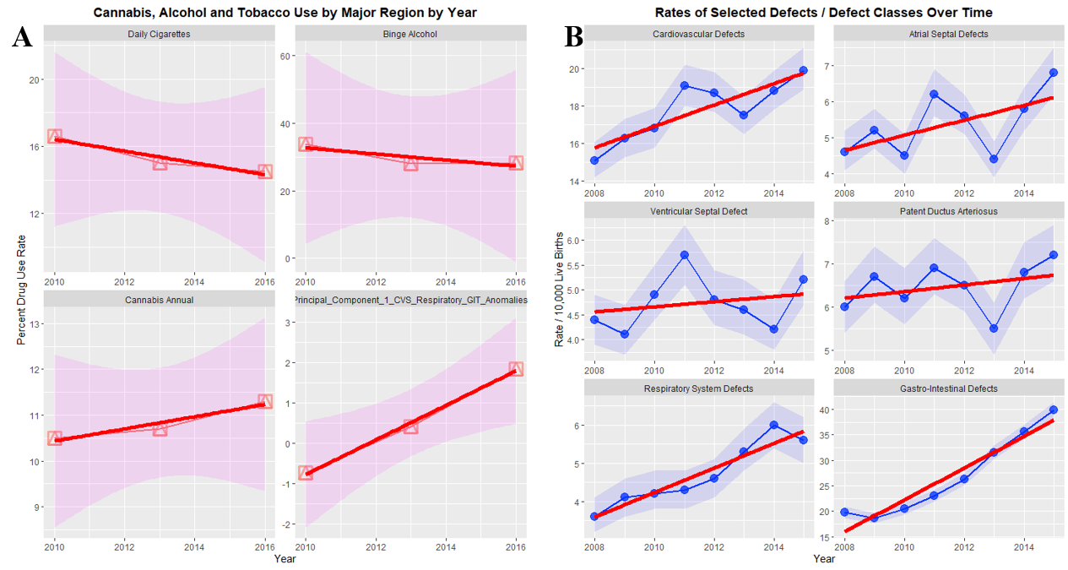

Supplementary Figure 2.: Congenital Anomalies A-C

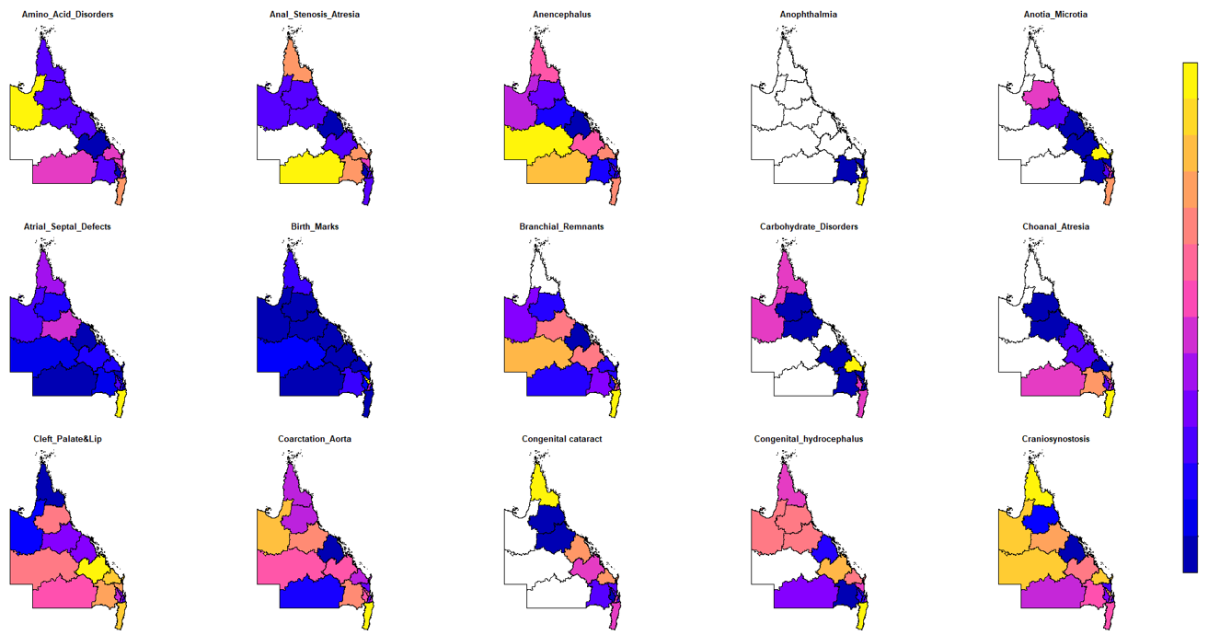

Supplementary Figure 3.: Congenital Anomalies C-P

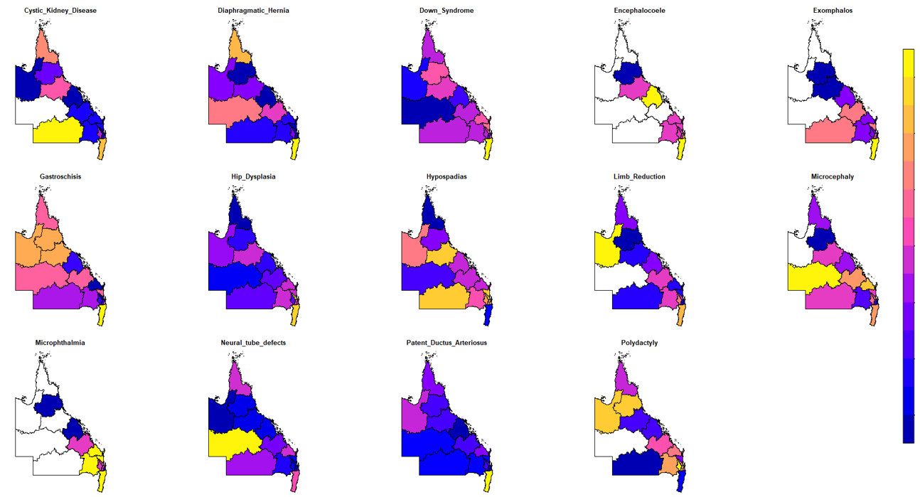

Supplementary Figure 4.: Congenital Anomalies R-Z

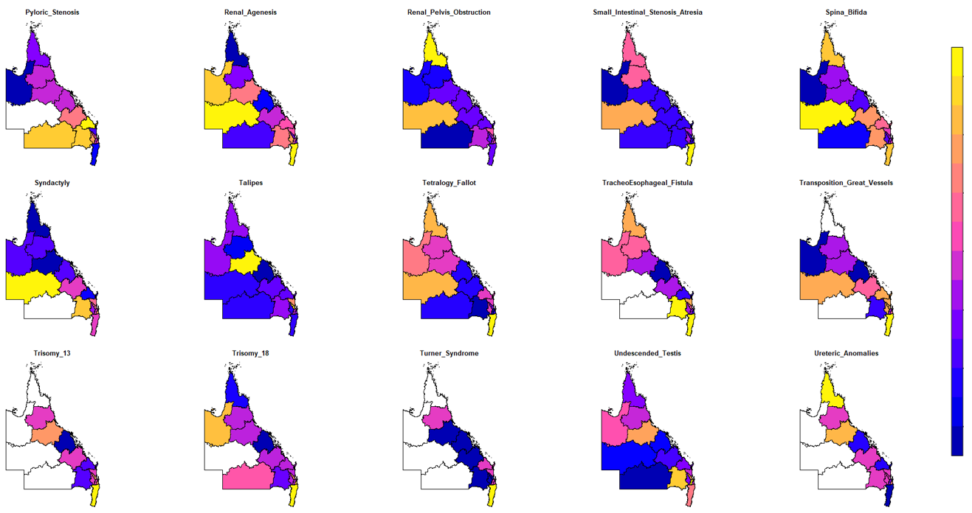

Supplementary Figure 5.: Chromosomal Defects

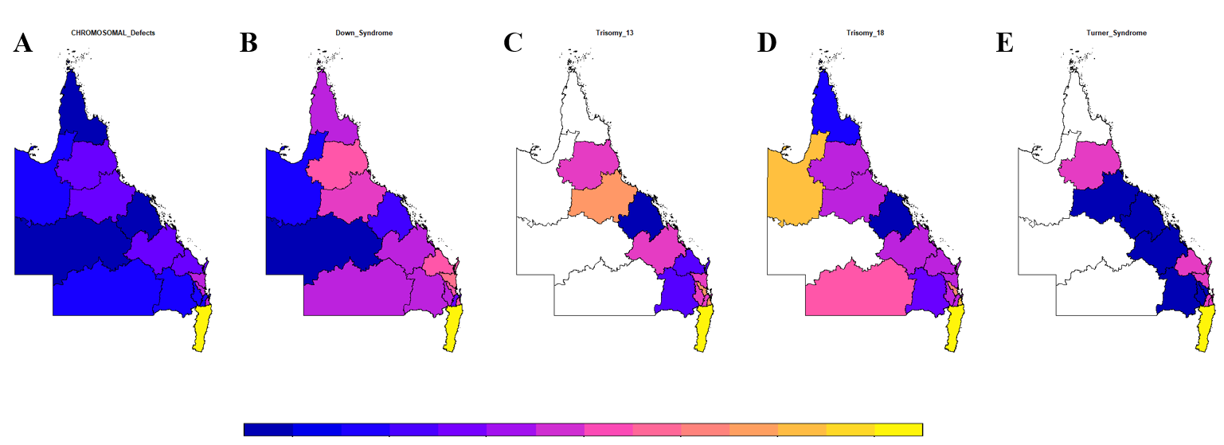

Supplementary Figure 6.: Rare Congenital Defects – Confidence Intervals by Cannabis Relationship

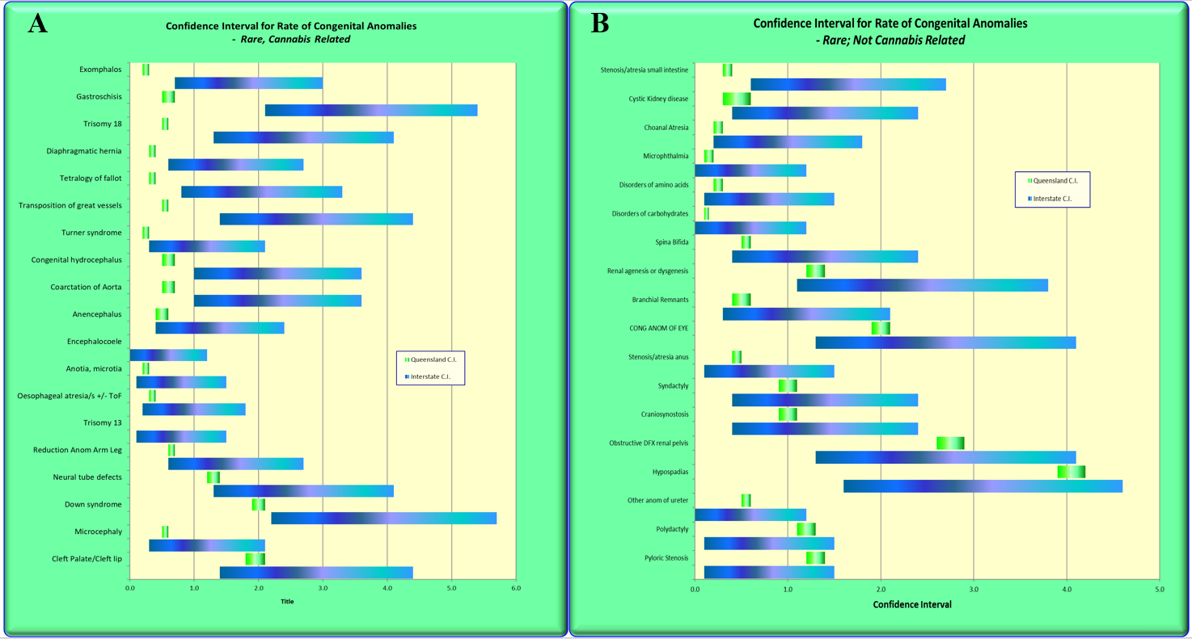

Supplementary Figure 7.: Comparative Rates of Congenital Anomalies NNSW v QLD

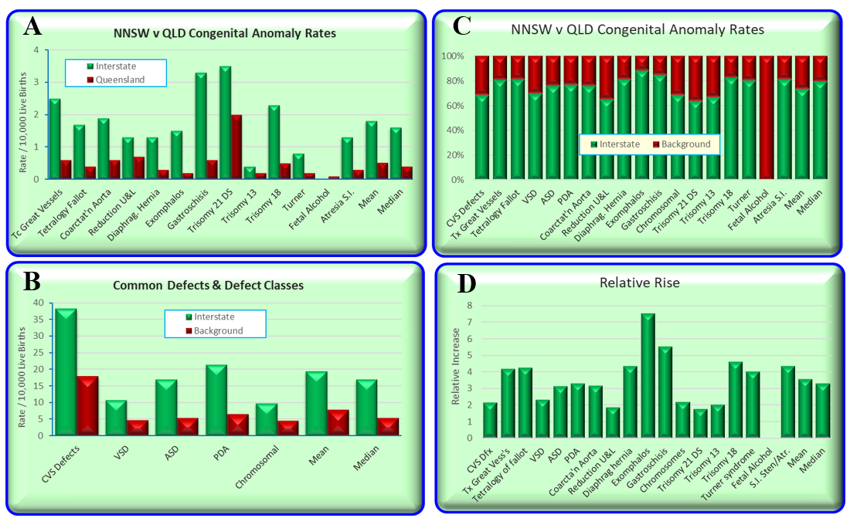

Supplementary Figure 8.: Relative Ratio of NNSW to QLD Congenital Anomalies

by Relationship to Cannabis

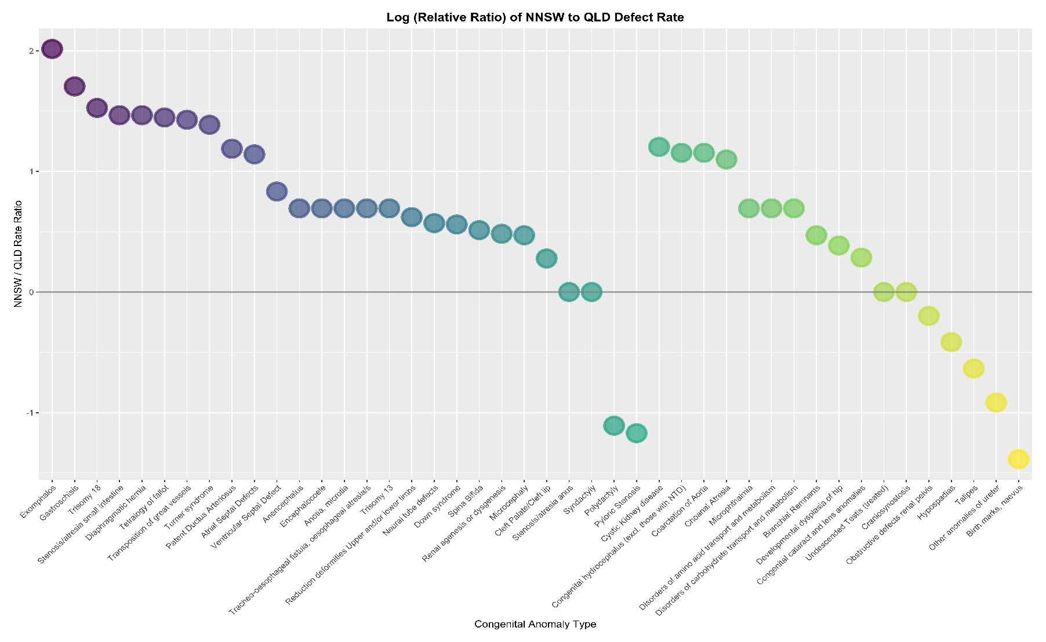

Supplementary Figure 9.: Log (Relative Ratio) of NNSW to QLD Congenital Anomalies

by Relationship to Cannabis

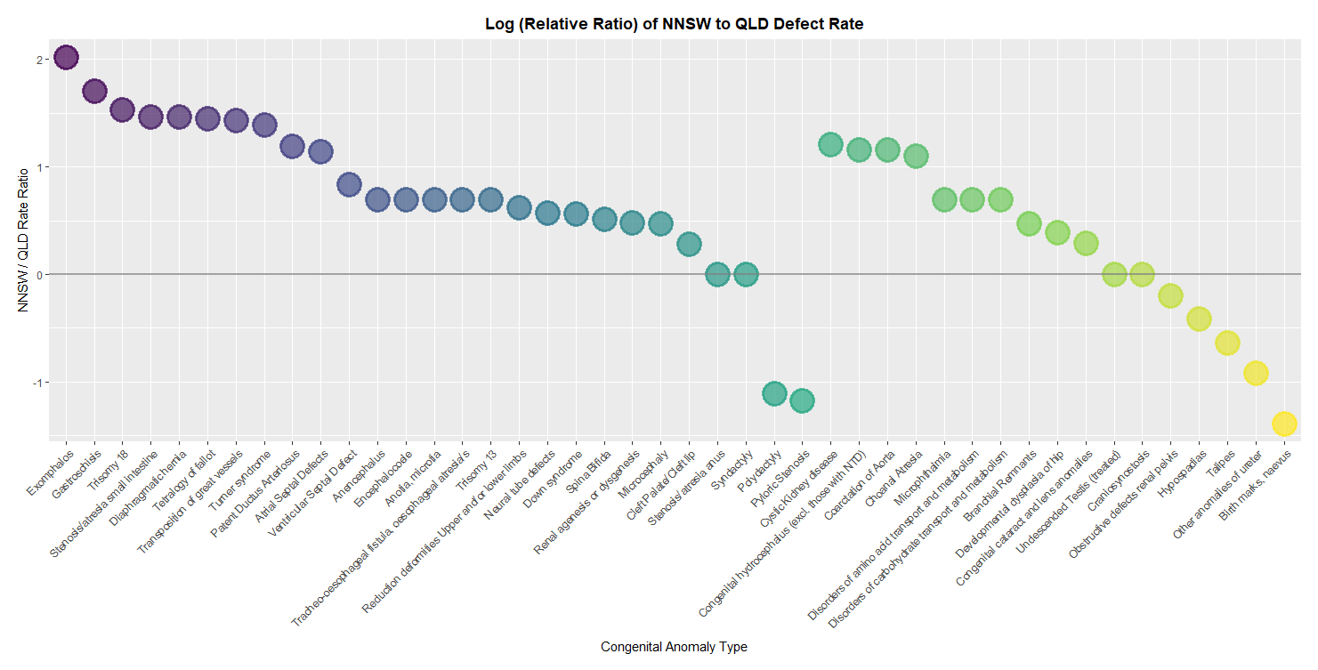

Supplementary Figure 10.: Prevalence Ratios NNSW to QLD by Cannabis Relationship

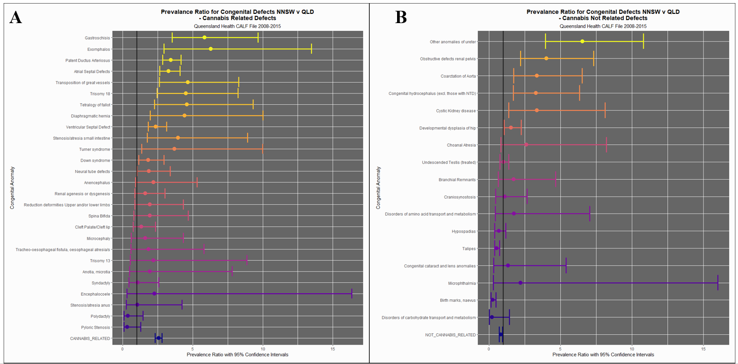

Supplementary Figure 11.: Attributable Fraction in the Population
NNSW to QLD by Cannabis Relationship

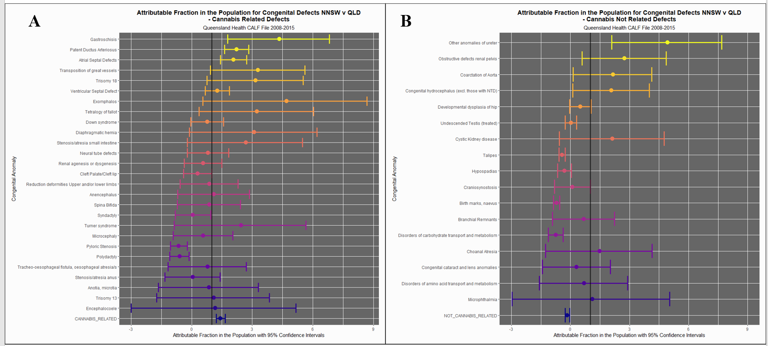

Supplementary Figure 12.: P-Values for PR’s NNSW to QLD by Cannabis Relationship

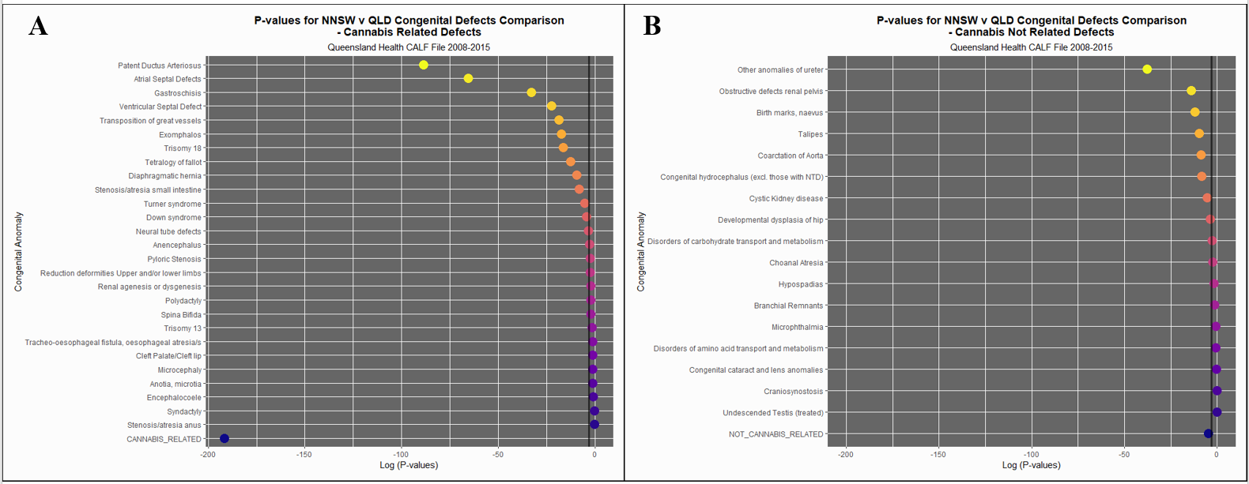

Supplementary Figure 13.: Selected Major Defect Classes by Drug Exposure

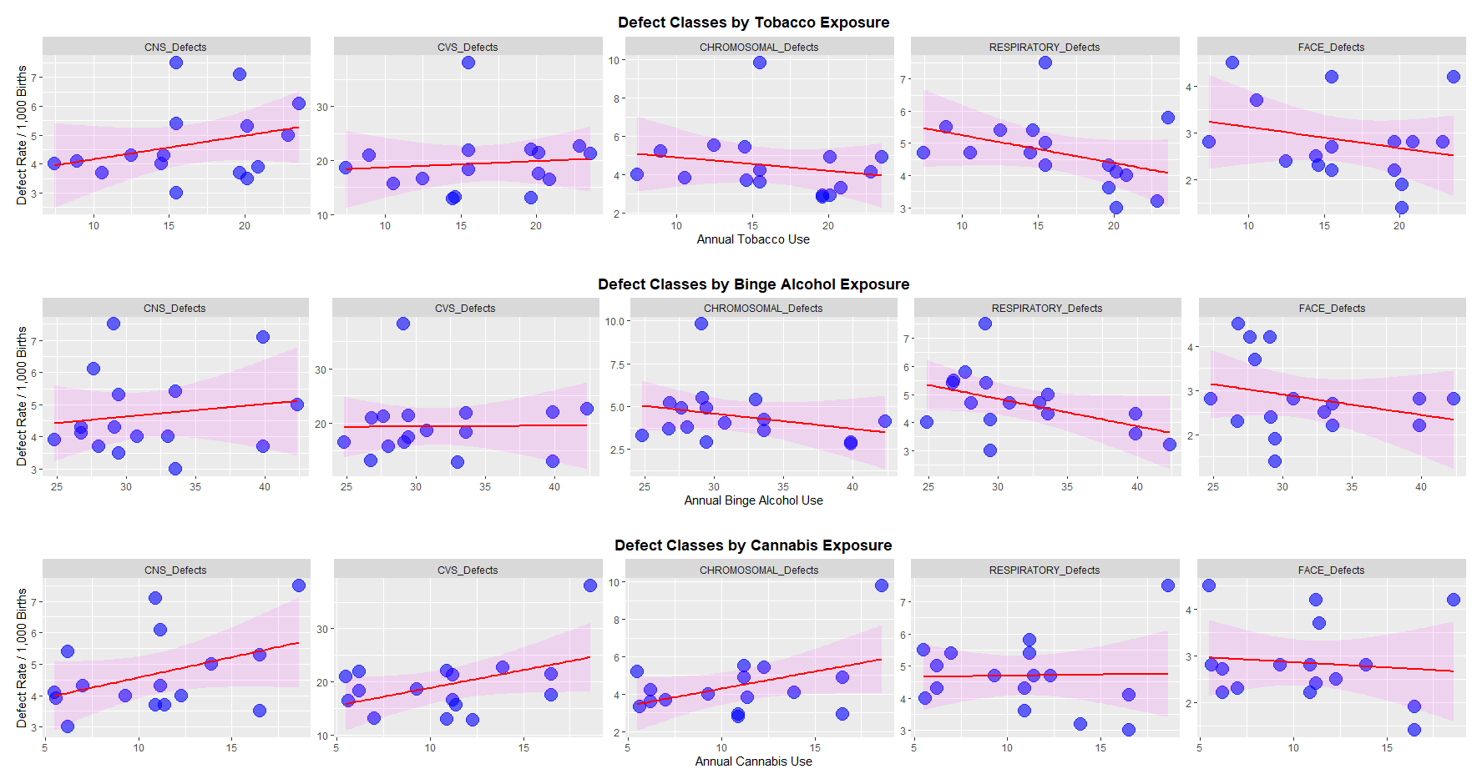

Supplementary Figure 14.: Congenital Anomaly Rate by Cigarette Use Rate – Ordered by Regression Slope
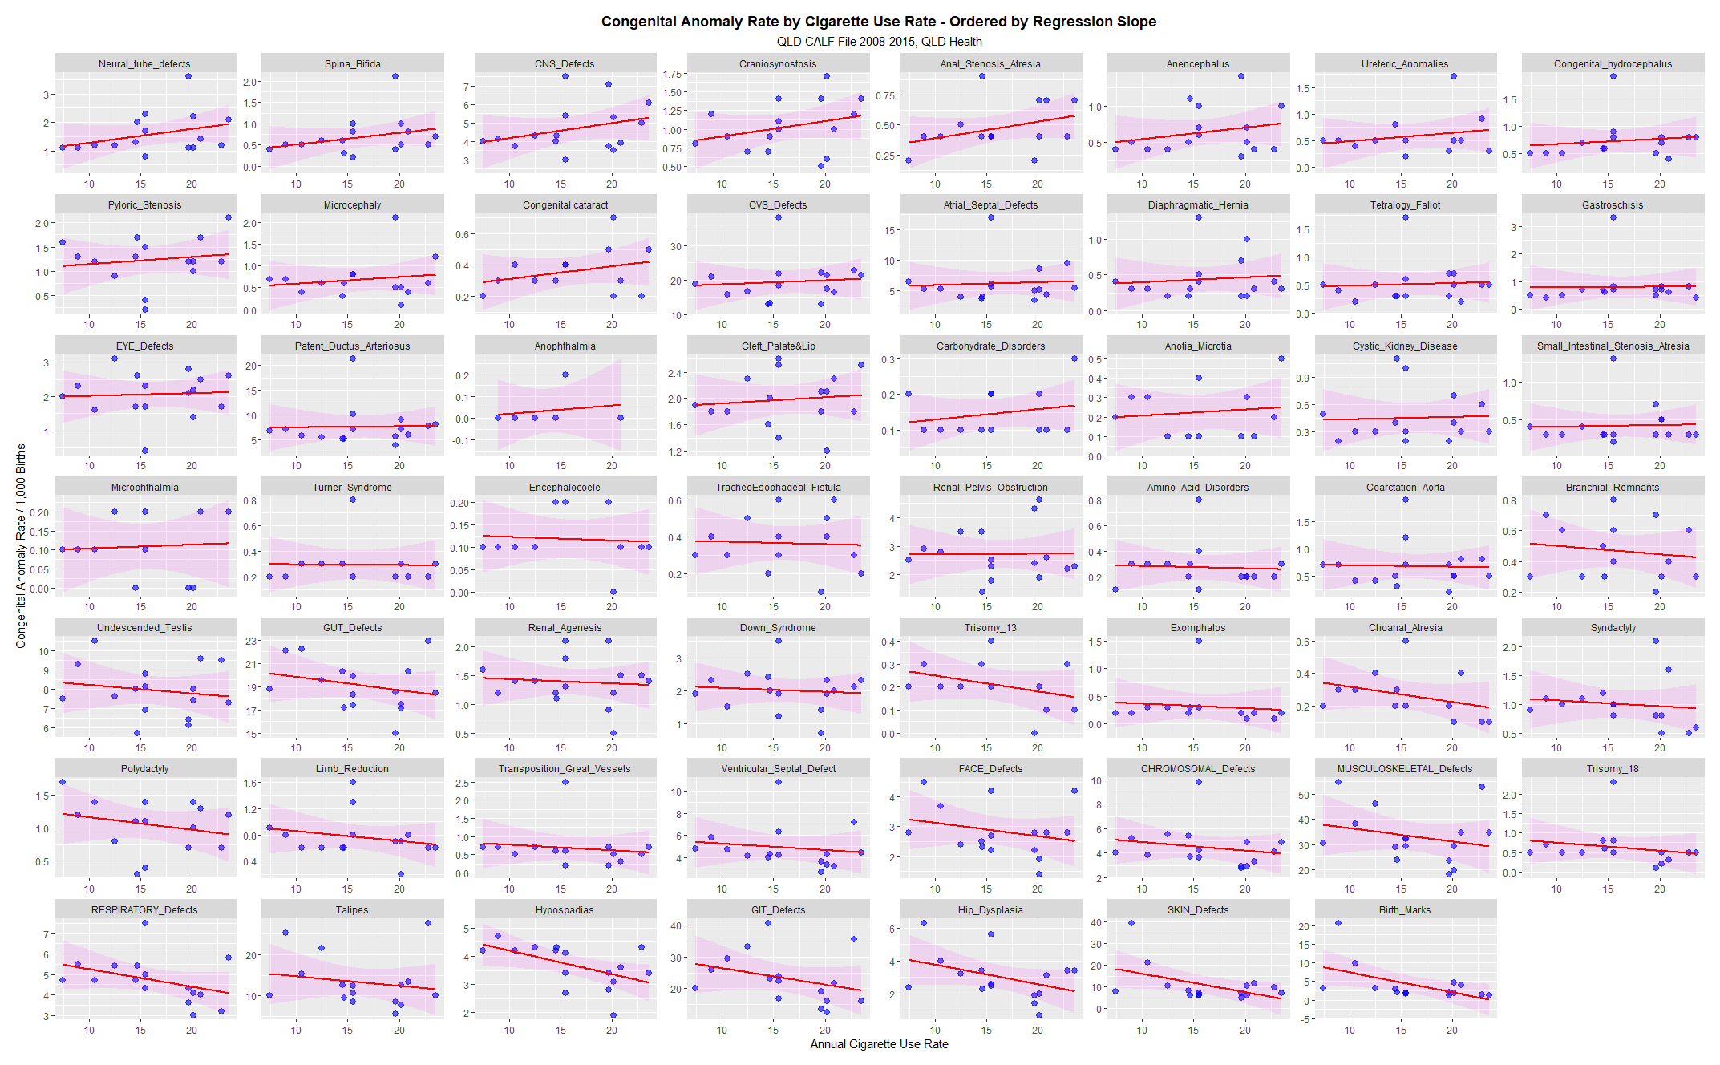
Supplementary Figure 15.: Congenital Anomaly Rate by Risky Alcohol Use Rate – Ordered by Regression Slope
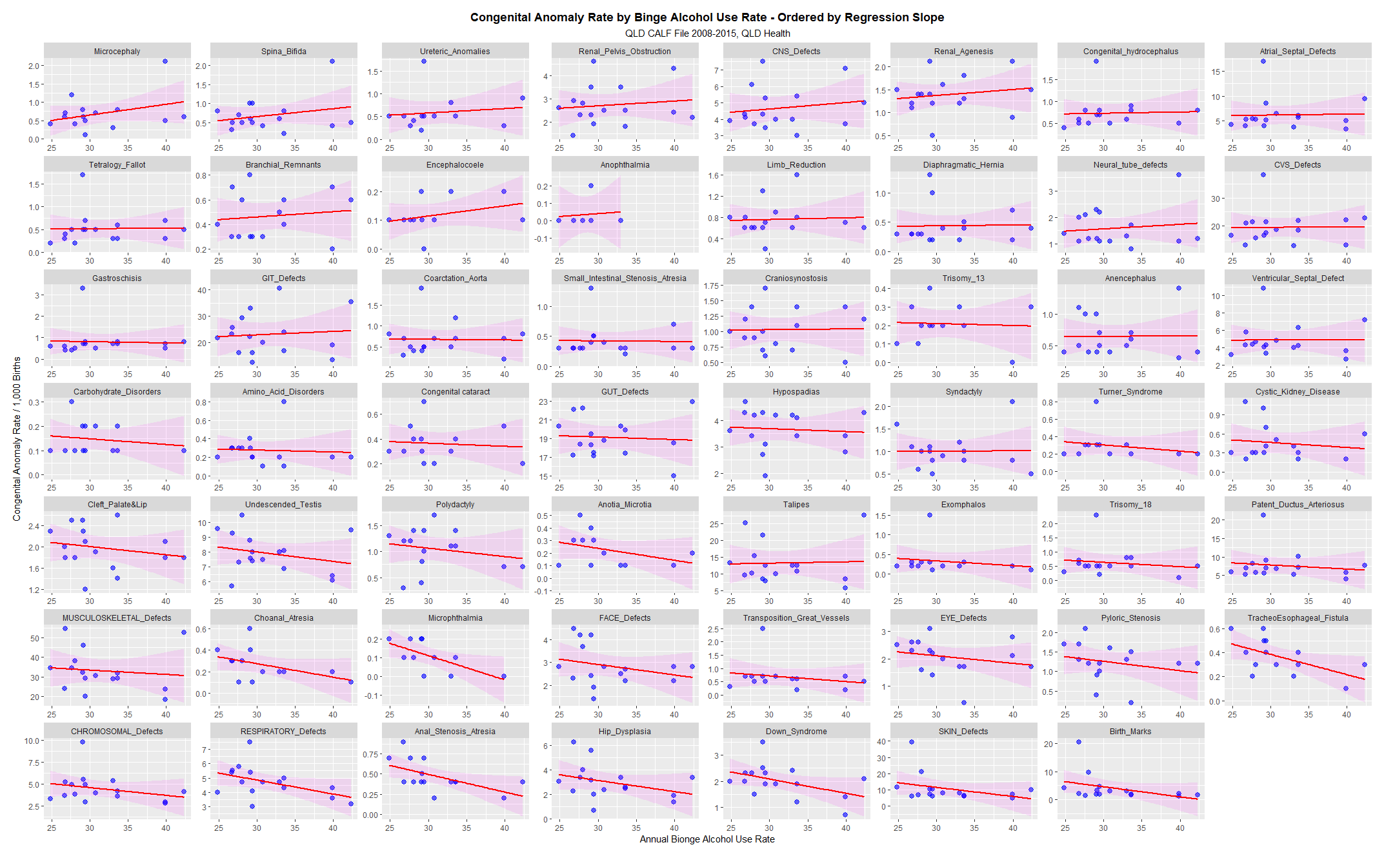
Supplementary Figure 16.: Geospatial Links –Edited and Final

