Online Resources 1
The Prototype of CoIEP Built Using Flowise
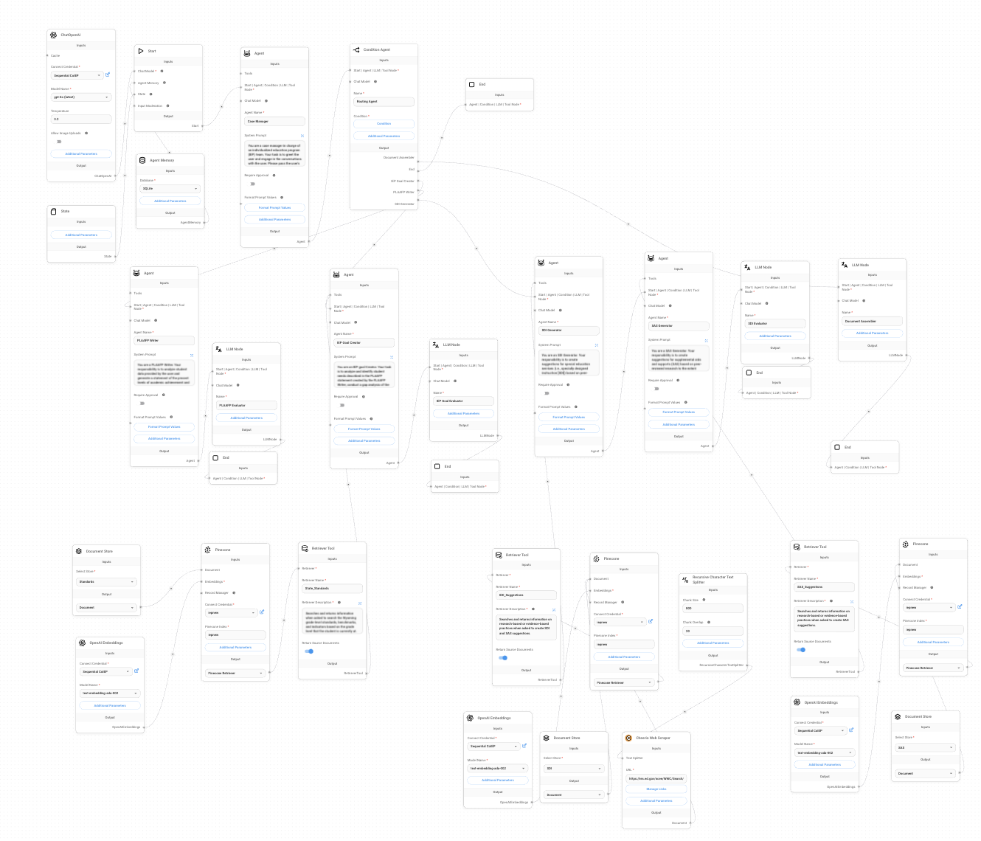
Note. The figure shows a screenshot of the prototype of the CoIEP system built using Flowise, an open-source platform. The system has a user-friendly interface with a series of nodes and connectors that represent different agents and their workflows. The top section of the figure illustrates the Case Manager agent, which is responsible for coordinating the workflow of the system. The Case Manager node is connected to seven other nodes, representing the PLAAFP Writer and Evaluator, IEP Goal Creator and Evaluator, ISS Generators (including SDI and SAS Generators) and Evaluator, and Document Assembler. The bottom section of the figure shows the extended workflow of the IEP Goal Creator and ISS Generator agents. These agents are prompted to external tools using RAG techniques, allowing them to retrieve information from the state content standards, SDI, and SAS Libraries.

