The Output of Case Study 2
The initial prompt:

“Please create an IEP for the student with the following data.” (see detailed data in Online Resource 4).

The system generated an initial statement and then was requested to revise it based on the following suggestions and highlight the need for executive function skills

“Yes, please include qualitative descriptions from teacher assessments or parent reports to provide a more comprehensive view of Student X's performance, describe current accommodations or modifications in place to support Student X's access to the general curriculum, and discuss goals from the most recent IEP to provide context on progress and areas needing continued focus in the PLAAFP statement. Please also highlight the student's need to strengthen executive function skills.”

The following is the revised PLAAFP statement:

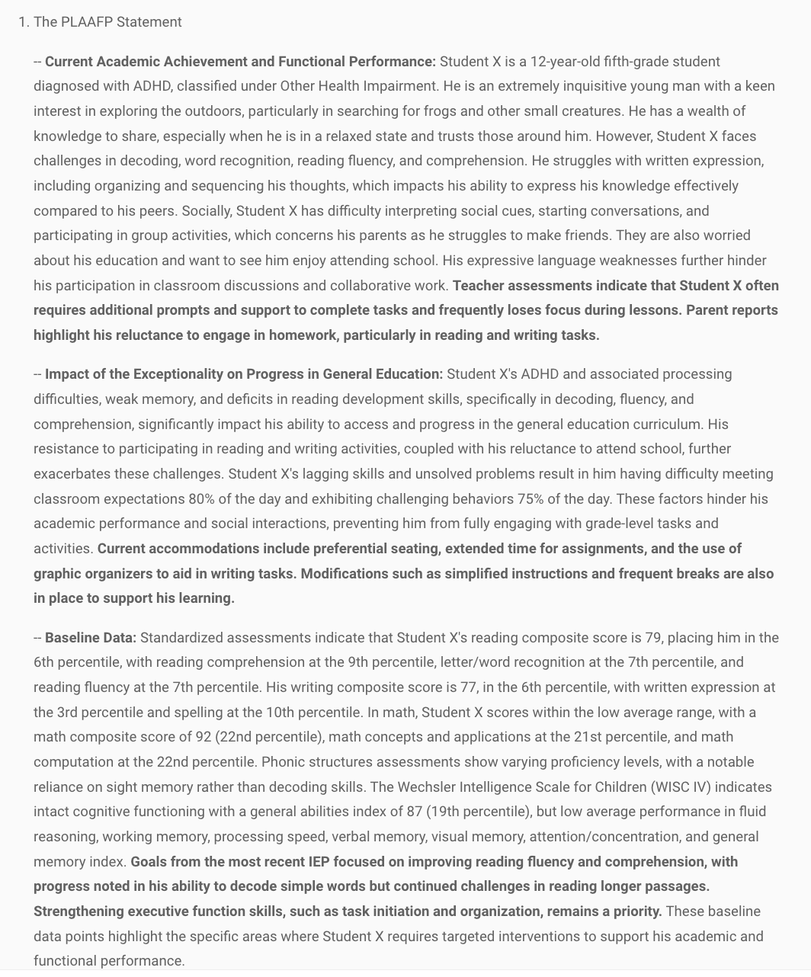

Output generated by the PLAAFP Evalutor

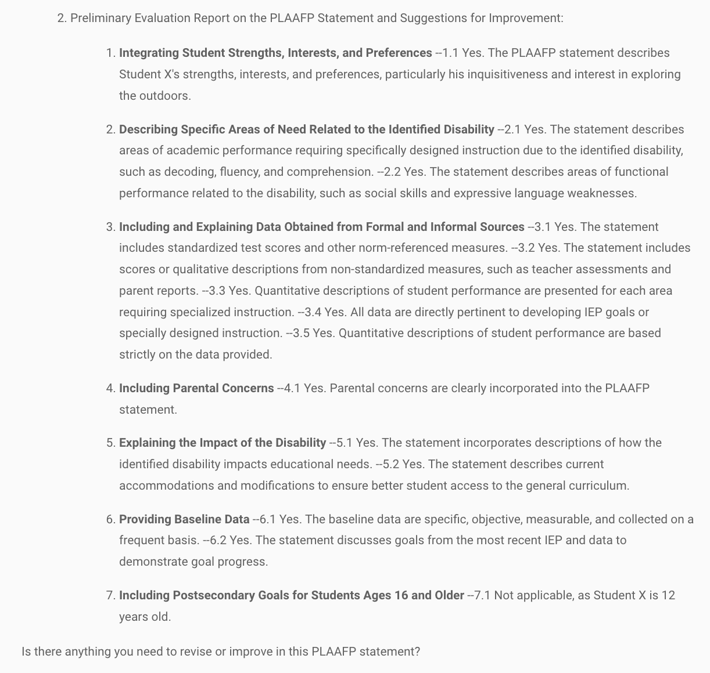

Then the system was asked to create IEP goals. The system did not generate IEP goals for executive function, so it was prompted to add such goals:

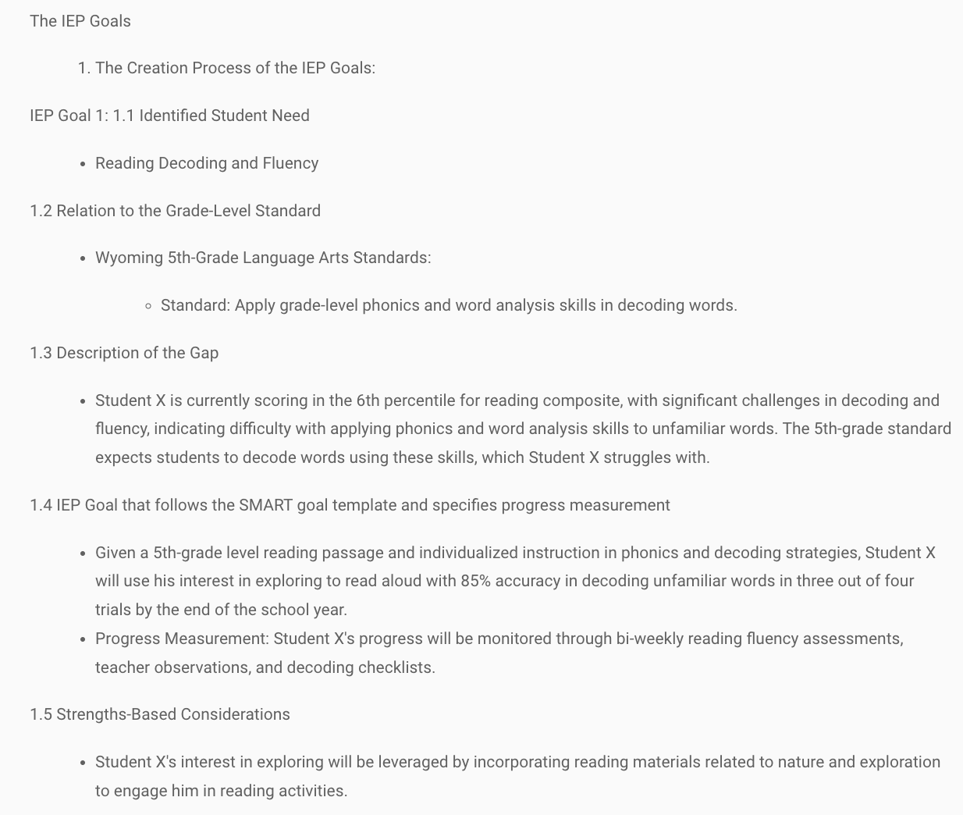

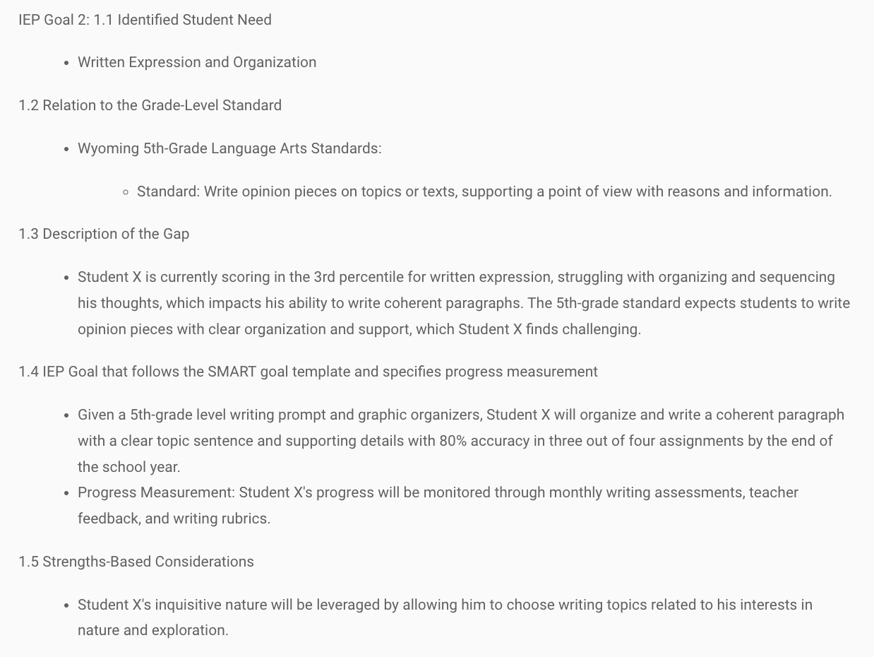
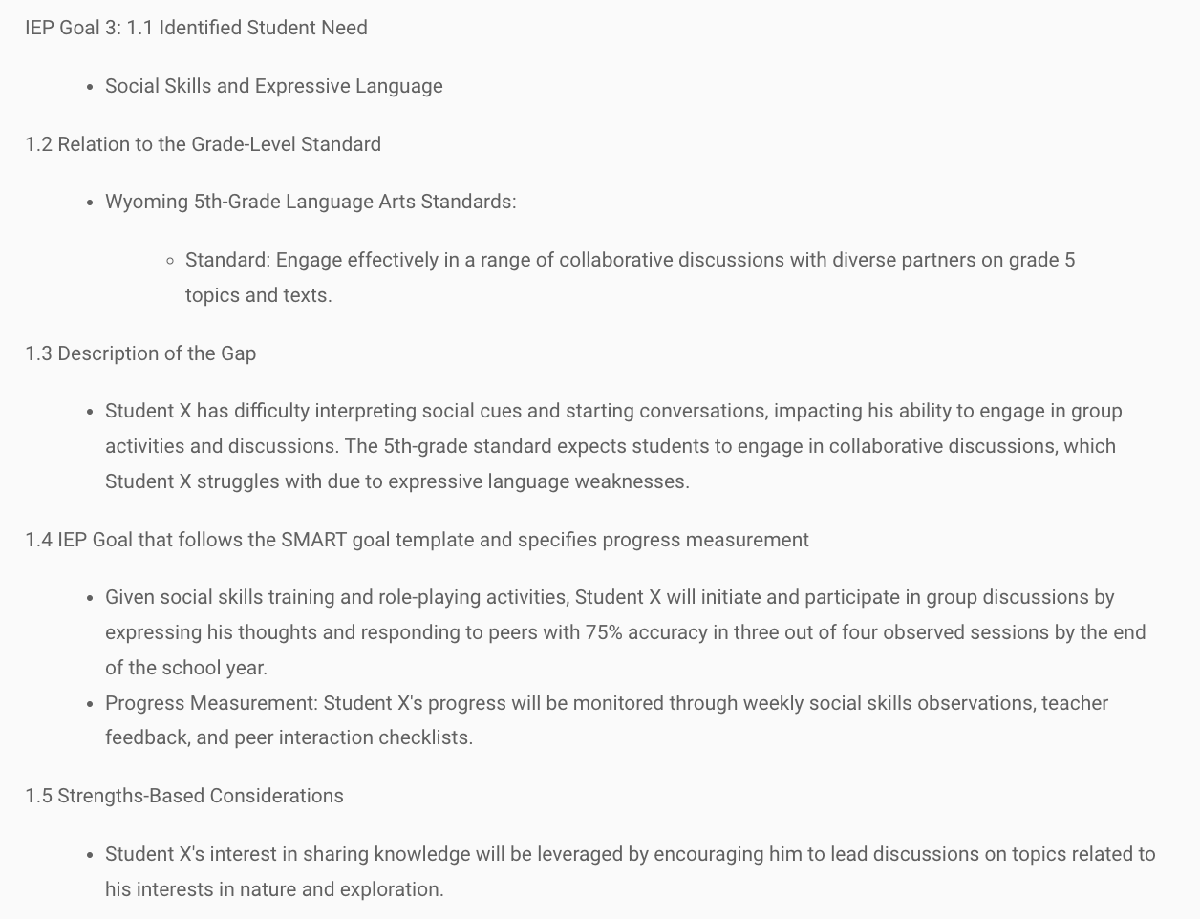
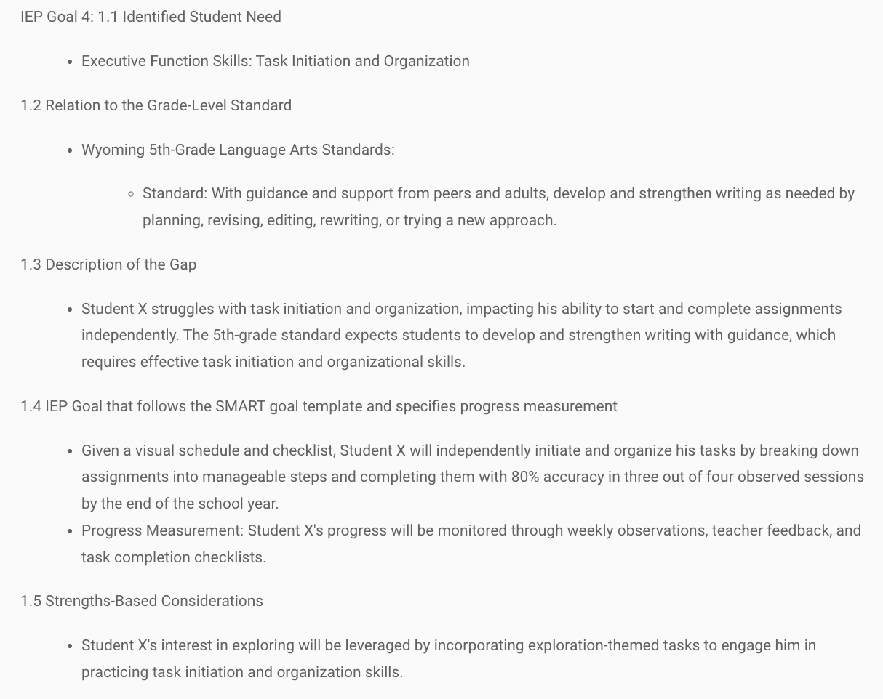
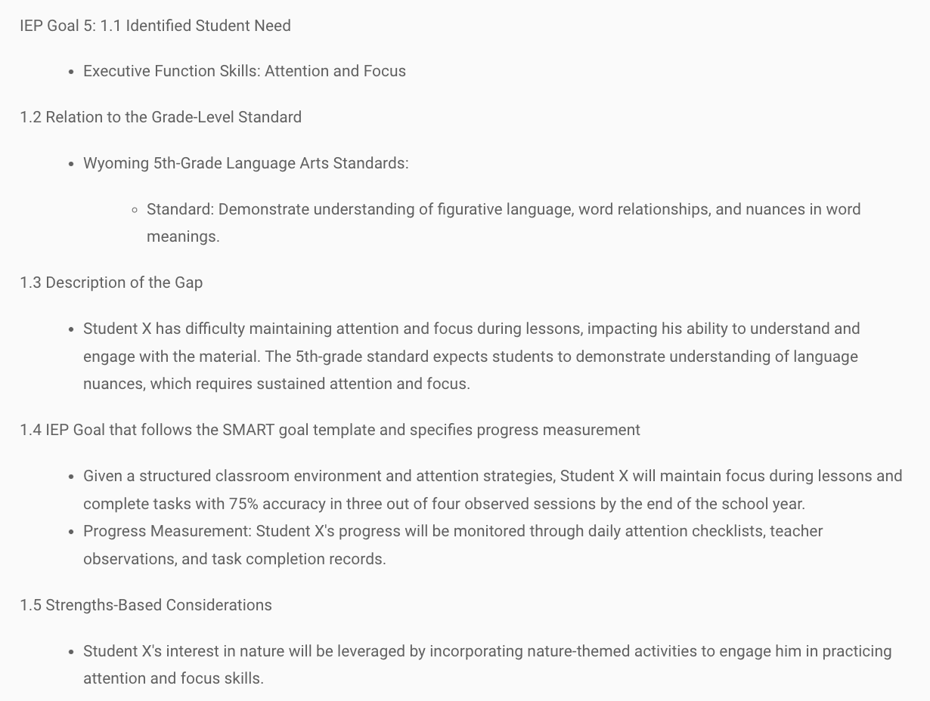

Output generated by the IEP Goal Evaluator
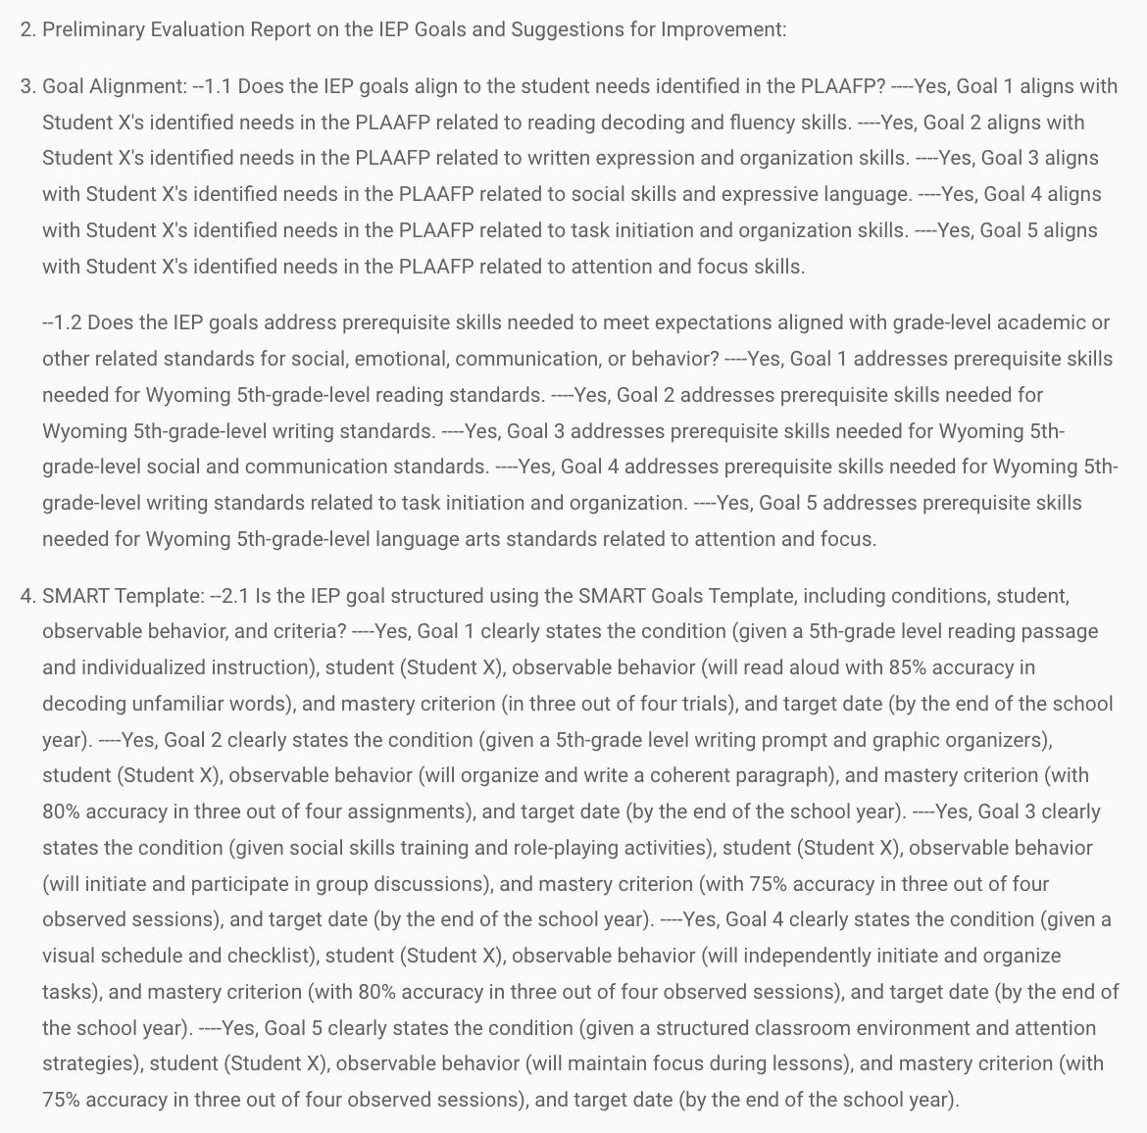
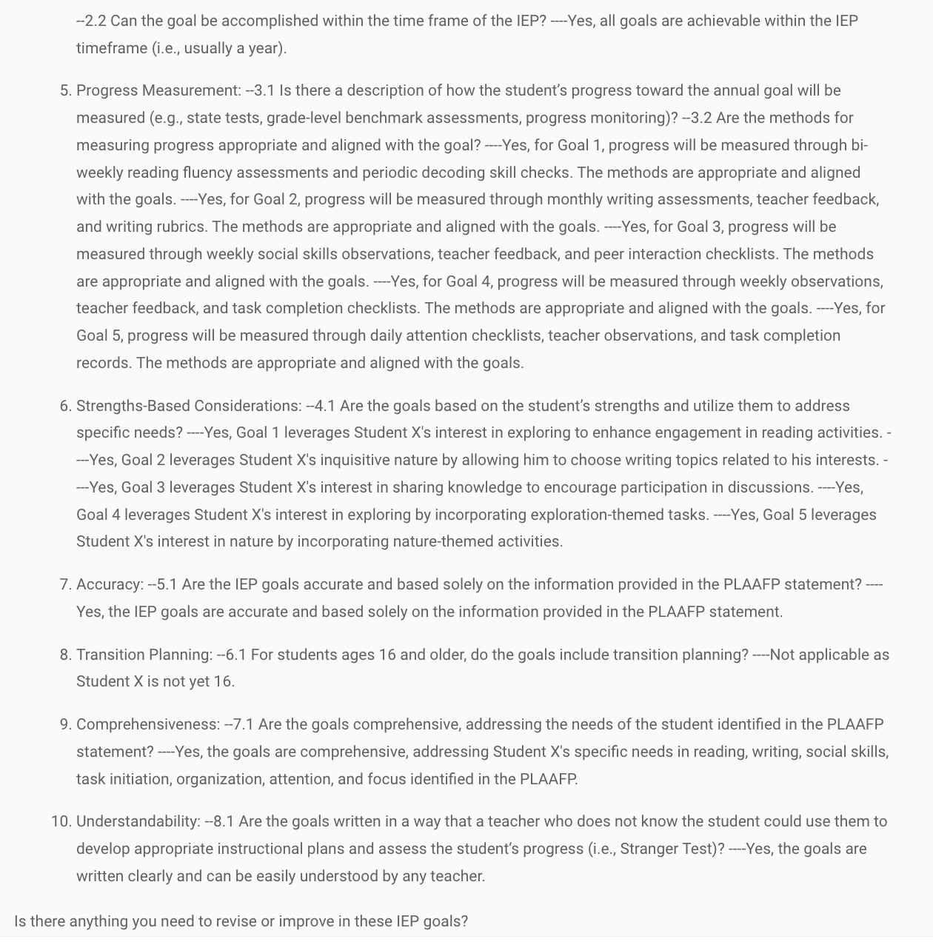

Then, the system was asked to create SDI and SAS.
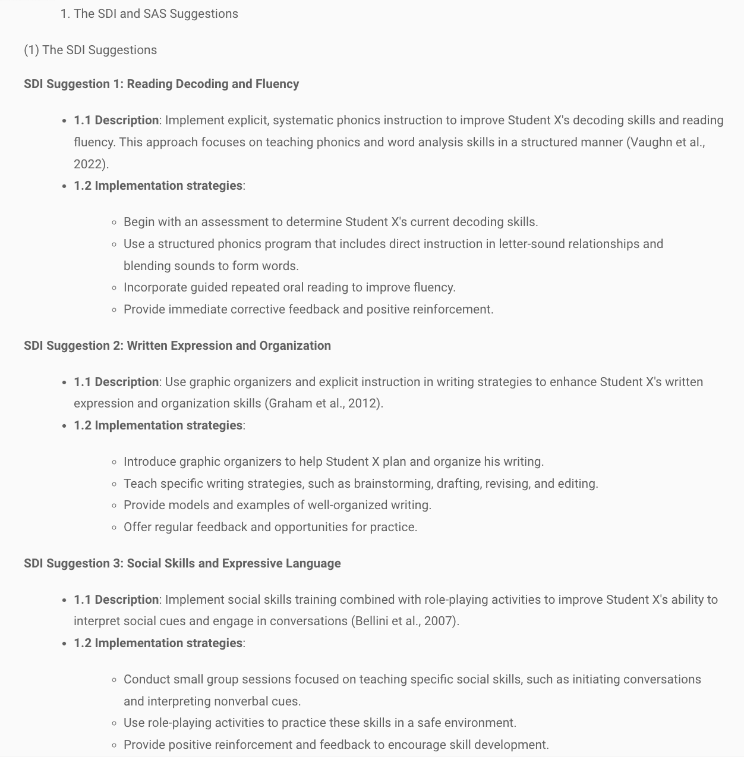
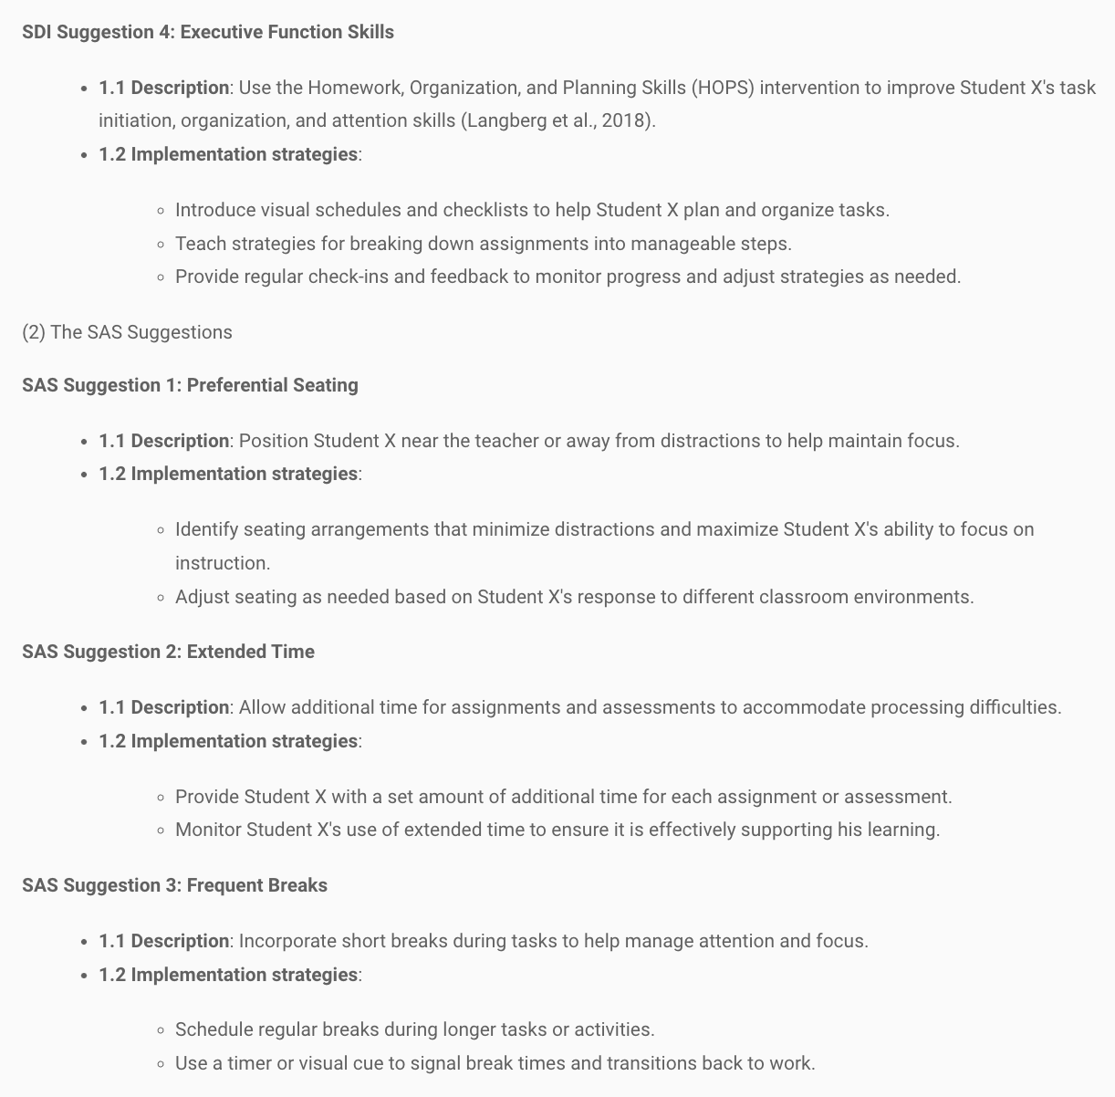

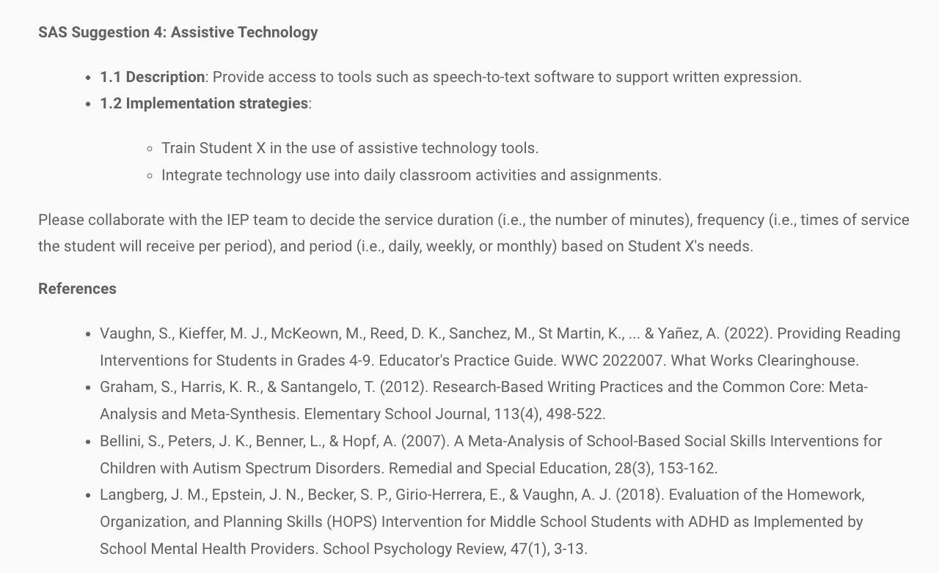

Output generated by the ISS Evaluator
