Supplementary Information Depicting Awareness Round (1) and Consensus Round (2) Results Regarding Items/Quality Indicators that Non-Pharma Stakeholders Believe Should Constitute Rare Disease Patient Registries (RDRs)
Round 1 |  |  |  |  |  | Interaction |  |  |  | Round 2
A | Awareness | (n) | % | Total (n) | Total (%) | I | Prompting | (n) | % | C | Consensus | (n) | % | Total (n) | Total (%)
A | Awareness Index AI  (f item/ fmax item) |  |  |  |  |  | Abs difference between AI and CI | (n) | % | C | Consensus Index CI (n support/n total)
1 | Complete | 1 | 1.3 | 10 | 12.5 | 1 | Prompt -: nil | 2 | 2.5 | 1 | Complete | 33 | 41.3 | 78 | 97.5
1 | AI=1.00 |  |  |  |  |  |  |  |  |  | CI=1.00
2 | Partial + | 9 | 11.3 | 10 | 12.5 | 1 | Abs difference between AI and CI < 0.05 (no difference) | 2 | 2.5 | 2 | Consensus + | 454 | 56.3 | 78 | 97.5
2 | 1.00>AI>=0.51 |  |  |  |  |  |  |  |  |  | 1>CI>=0.51
3 | Partial - | 56 | 70.0 | 70 | 87.5 | 2 | Prompt +: relative | 78 | 97.5 | 3 | Consensus - | 2 | 2.5 | 2 | 2.5
3 | 0.50=>AI>(f/fmin) |  |  |  |  |  |  |  |  |  | 0.50=>CI>0
4 | Minimal | 14 | 17.5 | 70 | 87.5 | 2 | Abs difference between AI and CI > 0.05 (difference) | 78 | 97.5 | 4 | No consensus | 0 | 0.0 | 2 | 2.5
4 | AI=f/fmin |  |  |  |  |  |  |  |  |  | CI=0.00
5 | No awareness | 0 | 0.0 | 0 | 0.0 | 3 | Prompt +: absolute | 0 | 0.0 | Sub Awareness threshold to Above Consensus threshold |  |  |  | 78 | 97.5
5 | Item not suggested in R1 |  |  |  |  |  | Abs difference between AI and CI=CI
Total |  |  |  | 80 | 100.0 |  | Total | 80 | 100.0 | Total |  |  |  | 80 | 100.0

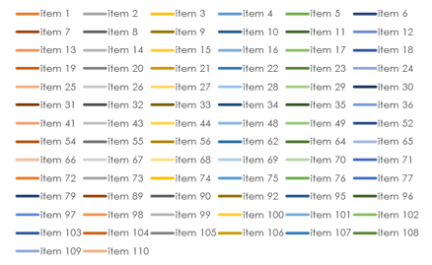
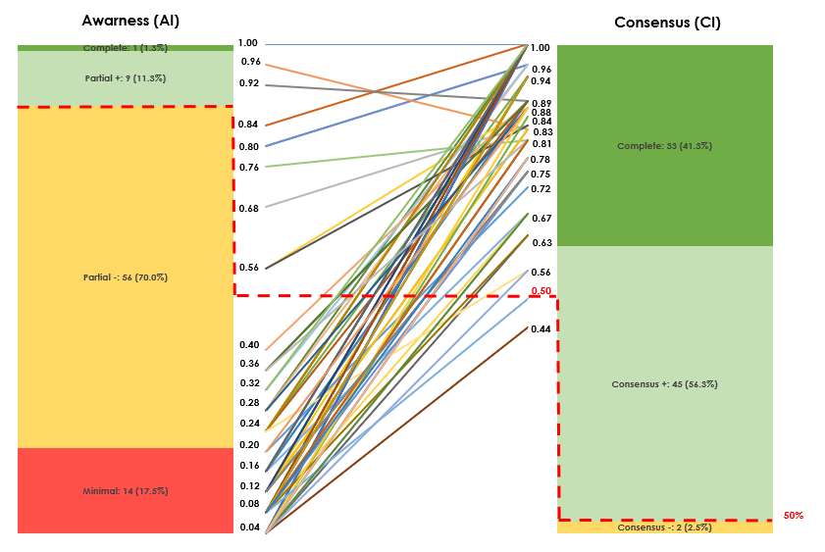

Non-pharma
Item | Statement | A | C
item 1 | Collects disease- relevant data | 3 | 1
item 2 | Collects patient relevant [reported] outcomes [symptoms] | 2 | 2
item 3 | Collects prescriber relevant outcomes | 3 | 2
item 4 | Collects data on quality of life | 3 | 2
item 5 | Collects data on disease burden | 3 | 2
item 6 | Collects data on tests | 3 | 1
item 7 | Collects information on all available treatments | 3 | 1
item 8 | Does not mandate any specific data | 4 | 2
item 9 | Contributes to awareness of prevalence and incidence | 3 | 2
item 10 | Generates a large number of publications | 3 | 1
item 11 | Generates high quality of publications | 3 | 1
item 12 | Allows sites to access their own data | 2 | 2
item 13 | Maximises recruitment of eligible patient population of interest | 2 | 2
item 14 | Achieves a representative demographic of the population of interest | 2 | 2
item 15 | Achieves a meaningful sample size for analysis | 2 | 2
item 16 | Maximises implementation over wide geography [number of countries] | 3 | 2
item 17 | Maximises recruitment from all available centres | 3 | 2
item 18 | Funds dedicated data manager/ research nurse | 4 | 2
item 19 | Implements data management procedures (edit checks for accuracy) | 2 | 1
item 20 | Implements data quality procedures (completeness) | 2 | 2
item 21 | Sponsor engages skilled CRO to implement it | 3 | 1
item 22 | Sponsor funds provides appropriate level of funding | 3 | 2
item 23 | Stores data with high a high level of security | 3 | 1
item 24 | Utilises patient information days ot increase recruitment | 3 | 2
item 25 | Reflects clear rationale and objectives in its design | 3 | 2
item 26 | Offers site specific support | 4 | 1
item 27 | Contributes to understanding of disease | 4 | 1
item 28 | Engages with patients [organisations] and gains their buy-in | 3 | 2
item 29 | Liases with local IT services | 3 | 1
item 30 | Engages with prescribers and gains their buy-in | 3 | 1
item 31 | Engages with non- prescribers involved in patient care | 4 | 3
item 32 | Utilises data entry forms that at easy to use | 2 | 2
item 33 | Funds data entry | 3 | 2
item 34 | Utilises online electronic data capture tool | 4 | 1
item 35 | Engages with regulators and gains their buy-in | 3 | 1
item 36 | Engages with payors and gains their buy-in | 3 | 1
item 41 | Includes a core data set as part of outcomes | 3 | 2
item 43 | Recruits a significant number of individual sites | 4 | 2
item 44 | Recruits a significant number of patients | 3 | 2
item 48 | Declares sponsorship in a clear and transparent manner | 3 | 1
item 49 | Allows patients to access their own data | 2 | 2
item 52 | Reports on data quality (completeness) | 3 | 1
item 54 | Clear timetable for evidence generation | 3 | 2
item 55 | Informs on natural history disease | 3 | 1
item 56 | Incorporates clear and transparent governance processes | 3 | 1
item 62 | Utilises validated endpoints and instruments | 4 | 1
item 64 | Includes a comprehensive data set | 3 | 2
item 65 | Reports consistently on variables which affect prognosis | 3 | 1
item 66 | Collects demographic data | 3 | 1
item 67 | Collects data on symptomology at diagnosis | 3 | 1
item 68 | Reports on adverse events | 3 | 2
item 69 | Collects disease severity data | 3 | 1
item 70 | Collects resource utilisation data | 3 | 1
item 71 | Frequency of reporting on Qol | 3 | 1
item 72 | Includes long term follow up | 3 | 1
item 73 | Achieves low dropout rates | 3 | 2
item 74 | Up to date disease definitions used in development | 3 | 2
item 75 | Promotion of registry to demonstration benefits to current and future patients | 1 | 1
item 76 | Enables expansion of fields as knowledge progresses | 4 | 2
item 77 | Adheres to ethical norms | 4 | 1
item 79 | Impacts on standard of care | 3 | 1
item 89 | Roles assigned to stakeholder groups | 3 | 1
item 90 | Declaration of Collaborators | 3 | 1
item 92 | Broad inclusion criteria | 3 | 2
item 95 | Linkage with NHS medical records | 3 | 2
item 96 | Appropriate engagement with caregivers and data collected about them | 3 | 2
item 97 | Data collection innovation | 3 | 2
item 98 | Independently validated data | 3 | 2
item 99 | Patients can input their own qualitative data | 3 | 2
item 100 | Designated Individual in the event of loss of capacity | 4 | 2
item 101 | Currency referenced | 3 | 3
item 102 | Data sharing agreement with other registries | 3 | 1
item 103 | Addresses double counting of patients | 3 | 2
item 104 | Registry allows follow up with patients | 3 | 2
item 105 | Transparency in audit trail for data analysed | 3 | 2
item 106 | Specific attention paid to outliers | 3 | 2
item 107 | Patient cultures accommodated in materials | 3 | 2
item 108 | Data held by an independent organisation | 4 | 2
item 109 | Materials translated into multiple languages | 4 | 2
item 110 | Include non-disease specific and disease specific tools | 4 | 2

