Supplementary Information Depicting Awareness Round (1) and Consensus Round (2) Results Regarding Items/Quality Indicators that Pharma Stakeholders Believe Should Constitute Rare Disease Patient Registries (RDRs)
Round 1 |  |  |  |  |  | Interaction |  |  |  | Round 2
A | Awareness | (n) | % | Total (n) | Total (%) | I | Prompting | (n) | % | C | Consensus | (n) | % | Total (n) | Total (%)
A | Awareness Index AI (f item/ fmax item) |  |  |  |  |  | Abs difference between AI and CI | (n) | % | C | Consensus Index CI (n support/n total)
1 | Complete | 1 | 1.3 | 5 | 6.5 | 1 | Prompt - : nil | 0 | 0.0 | 1 | Complete | 5 | 6.5 | 64 | 83.1
1 | AI=1.00 |  |  |  |  |  |  |  |  |  | CI=1.00
2 | Partial + | 4 | 5.2 | 5 | 6.5 | 1 | Abs difference between AI and CI < 0.05 (no difference) | 0 | 0.0 | 2 | Consensus + | 59 | 76.6 | 64 | 83.1
2 | 1.00>AI>=0.51 |  |  |  |  |  |  |  |  |  | 1>CI>=0.51
3 | Partial - | 60 | 77.9 | 72 | 93.5 | 2 | Prompt +: relative | 77 | 100.0 | 3 | Consensus - | 13 | 16.9 | 13 | 16.9
3 | 0.50=>AI>(f/fmin) |  |  |  |  |  |  |  |  |  | 0.50=>CI>0
4 | Minimal | 12 | 15.6 | 72 | 93.5 | 2 | Abs difference between AI and CI > 0.05 (difference) | 77 | 100.0 | 4 | No consensus | 0 | 0.0 | 13 | 16.9
4 | AI=f/fmin |  |  |  |  |  |  |  |  |  | CI=0.00
5 | No awareness | 0 | 0.0 | 0 | 0.0 | 3 | Prompt +: absolute | 0 | 0.0 | Sub Awareness threshold to Above Consensus threshold |  |  |  | 64 | 83.1
5 | Item not suggested in R1 |  |  |  |  |  | Abs difference between AI and CI=CI
Total |  |  |  | 77 | 100.0 |  | Total | 77 | 100.0 | Total |  |  |  | 77 | 100.0

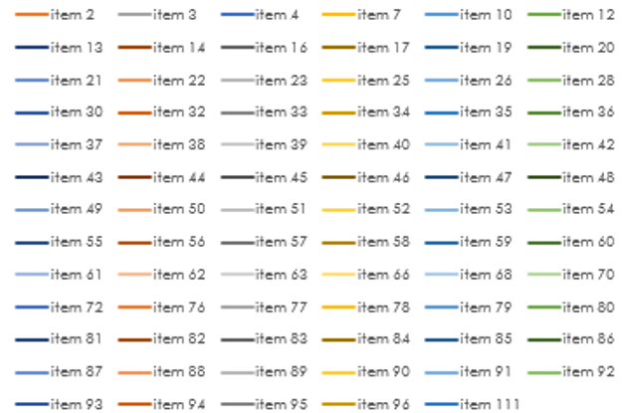
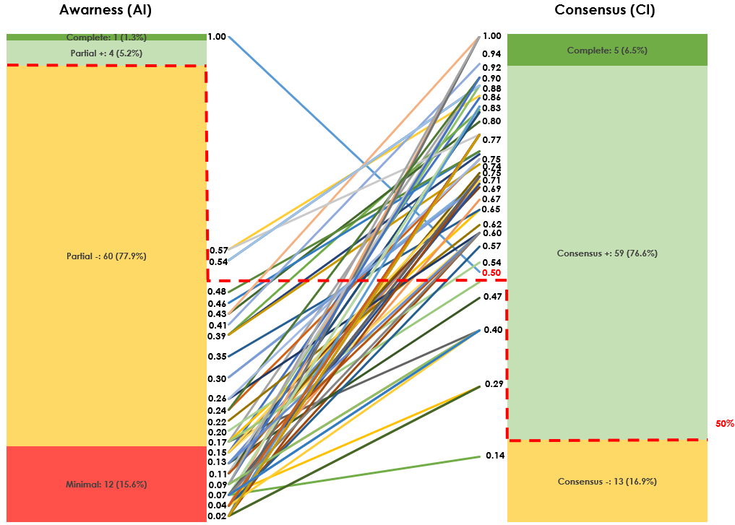

Pharma
Item | Statement | A | C
item 2 | Collects patient relevant [reported] outcomes [symptoms] | 3 | 2
item 3 | Collects prescriber relevant outcomes | 3 | 2
item 4 | Collects data on quality of life | 3 | 2
item 7 | Collects information on all available treatments | 3 | 2
item 10 | Generates a large number of publications | 1 | 2
item 12 | Allows sites to access their own data | 3 | 2
item 13 | Maximises recruitment of eligible patient population of interest | 3 | 2
item 14 | Achieves a representative demographic of the population of interest | 3 | 2
item 16 | Maximises implementation over wide geography [number of countries] | 3 | 3
item 17 | Maximises recruitment from all available centres | 3 | 2
item 19 | Implements data management procedures (edit checks for accuracy) | 3 | 2
item 20 | Implements data quality procedures (completeness) | 3 | 2
item 21 | Sponsor engages skilled CRO to implement it | 3 | 2
item 22 | Sponsor funds provides appropriate level of funding | 3 | 2
item 23 | Stores data with high a high level of security | 3 | 2
item 25 | Reflects clear rationale and objectives in its design | 2 | 2
item 26 | Offers site specific support | 3 | 2
item 28 | Engages with patients [organisations] and gains their buy-in | 3 | 2
item 30 | Engages with prescribers and gains their buy-in | 2 | 2
item 32 | Utilises data entry forms that at easy to use | 3 | 2
item 33 | Funds data entry | 4 | 2
item 34 | Utilises online electronic data capture tool | 3 | 2
item 35 | Engages with regulators and gains their buy-in | 3 | 2
item 36 | Engages with payors and gains their buy-in | 3 | 2
item 37 | Utilises a protocol methodology | 3 | 2
item 38 | Collects prescriber relevant outcomes | 3 | 1
item 39 | Collects payor-relevant outcomes | 2 | 2
item 40 | Collects commercial- relevant outcomes | 3 | 2
item 41 | Includes a core data set as part of outcomes | 2 | 2
item 42 | Implements in a high proportion of countries available | 3 | 2
item 43 | Recruits a significant number of individual sites | 3 | 2
item 44 | Recruits a significant number of patients | 3 | 2
item 45 | Monitors if data is being entered | 3 | 2
item 46 | Monitors frequency with which data is being entered | 3 | 2
item 47 | Generates publications that impacts decision making | 3 | 2
item 48 | Declares sponsorship in a clear and transparent manner | 3 | 3
item 49 | Allows patients to access their own data | 3 | 2
item 50 | Enables mapping of current treatment pathways | 3 | 1
item 51 | Informs on clinical effectiveness of current therapies | 3 | 2
item 52 | Reports on data quality (completeness) | 3 | 2
item 53 | Data collection convenient to clinical practice | 4 | 1
item 54 | Clear timetable for evidence generation | 3 | 3
item 55 | Informs on natural history disease | 3 | 2
item 56 | Incorporates clear and transparent governance processes | 3 | 2
item 57 | Achieves recruitment targets | 4 | 1
item 58 | Collects data on current care pathways | 4 | 2
item 59 | Informs payors of unmet needs of current treatment options | 4 | 2
item 60 | Collects costs and accessibility data on current therapies | 3 | 2
item 61 | Collects regulator- relevant data | 3 | 2
item 62 | Utilises validated endpoints and instruments | 4 | 2
item 63 | Reports on risk of bias | 4 | 2
item 66 | Collects demographic data | 3 | 2
item 68 | Reports on adverse events | 3 | 2
item 70 | Collects resource utilisation data | 3 | 2
item 72 | Includes long term follow up | 3 | 2
item 76 | Enables expansion of fields as knowledge progresses | 3 | 3
item 77 | Adheres to ethical norms | 3 | 1
item 78 | Considers future label expansion | 3 | 3
item 79 | Impacts on standard of care | 4 | 2
item 80 | Displays rapid rate of patient recruitment | 3 | 3
item 81 | Presents data at major congresses | 3 | 2
item 82 | Collects data on comorbidities | 4 | 2
item 83 | Impacts on payor negotiations | 3 | 2
item 84 | Displays rapid rate of site initiation | 4 | 3
item 85 | Involvement of independent steering committee | 3 | 2
item 86 | Soliciting regular feedback from key opinion leaders | 4 | 3
item 87 | Safeguards in place to protect patient anonymity | 3 | 2
item 88 | Declaration of Data Owner (Controller) | 3 | 2
item 89 | Roles assigned to stakeholder groups | 3 | 3
item 90 | Declaration of Collaborators | 3 | 3
item 91 | Monitoring of 'lost to follow up' data | 3 | 3
item 92 | Broad inclusion criteria | 3 | 3
item 93 | Strategies to maximise investigator and patient retention | 3 | 2
item 94 | Regular review and update to site operating procedures | 3 | 2
item 95 | Linkage with NHS medical records | 3 | 2
item 96 | Appropriate engagement with caregivers and data collected about them | 4 | 2
item 111 | Engages with researchers and gains their buy-in | 3 | 3

