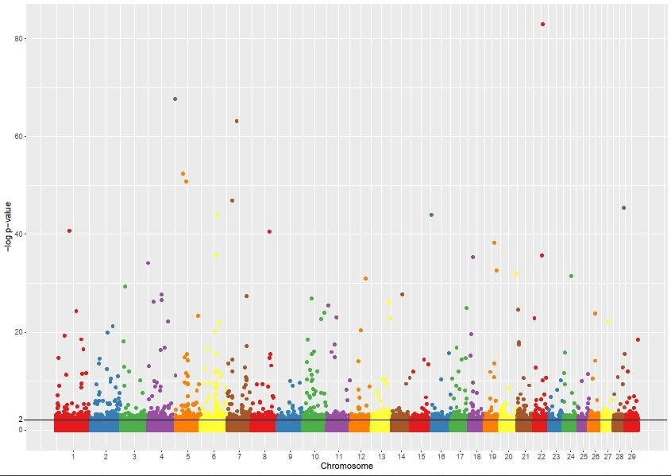
Fig. S1. Manhattan plot for locus wise F_{ST} estimates obtained from Arlequin software along with a horizontal threshold line at P<0.01 (-log₁₀ p value =2). X axis denotes the chromosomal position and Y axis denotes the –log p-value of F_{ST}

