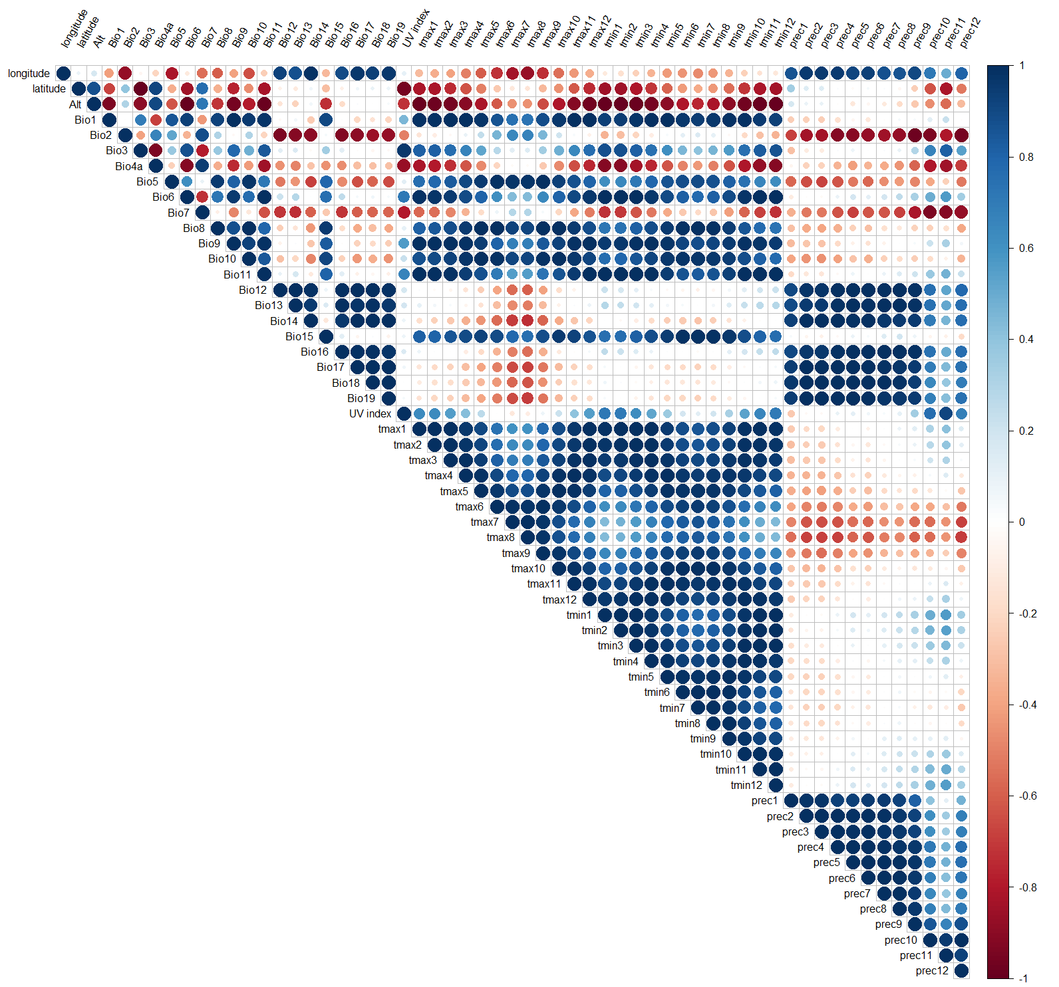

Fig. S4. Correlation plot of 59 environmental variables obtained from four sampling locations for 46 samples of four different breeds of cattle

