Supplementary Materials for
Relating satellite NO₂ tropospheric columns to near-surface concentrations: implications from ground-based MAX-DOAS NO₂ vertical profile observations
Bowen Chang ^{1,6}, Haoran Liu ^{1,}*^{,6}, Chengxin Zhang ^{2,}*, Chengzhi Xing ³, Wei Tan ³, Cheng Liu ^{2,3,4,5,}*
¹ Information Materials and Intelligent Sensing Laboratory of Anhui Province, Institutes of Physical Science and Information Technology, Anhui University, Hefei 230601, China
² Department of Precision Machinery and Precision Instrumentation, University of Science and Technology of China, Hefei, 230026, China
³ Key Lab of Environmental Optics and Technology, Anhui Institute of Optics and Fine Mechanics, Hefei Institutes of Physical Science, Chinese Academy of Sciences, Hefei 230031, China
⁴ Center for Excellence in Regional Atmospheric Environment, Institute of Urban Environment, Chinese Academy of Sciences, Xiamen 361021, China
⁵ Key Laboratory of Precision Scientific Instrumentation of Anhui Higher Education Institutes, University of Science and Technology of China, Hefei 230026, China
*Correspondence: Haoran Liu (hrl@ahu.edu.cn); Chengxin Zhang (zcx2011@ustc.edu.cn); Cheng Liu (chliu81@ustc.edu.cn)
⁶ These authors contributed equally to this work.

Supplementary tables
Table S1. Meteorological factors considered in this study and their description in ERA5
Type | Name | Abbreviation | Units | Description
Hourly data on pressure levels (850hPa) | Fraction of cloud cover | FCC | Dimensionless | This parameter is the proportion of a grid box covered by cloud (liquid or ice) and varies between zero and one. This parameter is available on multiple levels through the atmosphere.
Hourly data on pressure levels (850hPa) | Relative humidity | RH | % | This parameter is the water vapour pressure as a percentage of the value at which the air becomes saturated (the point at which water vapour begins to condense into liquid water or deposition into ice). For temperatures over 0°C (273.15 K) it is calculated for saturation over water. At temperatures below -23°C it is calculated for saturation over ice. Between -23°C and 0°C this parameter is calculated by interpolating between the ice and water values using a quadratic function.
Hourly data on pressure levels (850hPa) | Temperature | T | K | This parameter is the temperature in the atmosphere. It has units of kelvin (K). Temperature measured in kelvin can be converted to degrees Celsius (°C) by subtracting 273.15. This parameter is available on multiple levels through the atmosphere.
Hourly data on pressure levels (850hPa) | Vertical velocity | VV | Pa/s | This parameter is the speed of air motion in the upward or downward direction. The ECMWF Integrated Forecasting System (IFS) uses a pressure based vertical co-ordinate system and pressure decreases with height, therefore negative values of vertical velocity indicate upward motion. Vertical velocity can be useful to understand the large-scale dynamics of the atmosphere, including areas of upward motion/ascent (negative values) and downward motion/subsidence (positive values). Note that absolute values of vertical velocity are used in this study.
Hourly data on single levels | Boundary layer height | BLH | m | This parameter is the depth of air next to the Earth's surface which is most affected by the resistance to the transfer of momentum, heat or moisture across the surface. The boundary layer height can be as low as a few tens of metres, such as in cooling air at night, or as high as several kilometres over the desert in the middle of a hot sunny day. When the boundary layer height is low, higher concentrations of pollutants (emitted from the Earth's surface) can develop. The boundary layer height calculation is based on the bulk Richardson number (a measure of the atmospheric conditions) following the conclusions of a 2012 review.
Hourly data on single levels | Mean sea level pressure | MSLP | Pa | This parameter is the pressure (force per unit area) of the atmosphere at the surface of the Earth, adjusted to the height of mean sea level. It is a measure of the weight that all the air in a column vertically above a point on the Earth's surface would have, if the point were located at mean sea level. It is calculated over all surfaces - land, sea and inland water. Maps of mean sea level pressure are used to identify the locations of low and high pressure weather systems, often referred to as cyclones and anticyclones. Contours of mean sea level pressure also indicate the strength of the wind. Tightly packed contours show stronger winds. The units of this parameter are pascals (Pa). Mean sea level pressure is often measured in hPa and sometimes is presented in the old units of millibars, mb (1 hPa = 1 mb = 100 Pa).

Table S2. Ground station information used in this study
Region | City | Station | Longitude | Latitude
BTH | Beijing | BEIJING-CAPITAL INTERNATIONAL AIRPORT | 116.585 | 40.080
SCB | Chongqing | JIANGBEI | 106.506 | 29.604
Other | Hong Kong | LAU FAU SHAN | 113.983 | 22.467
 |  | TA KWU LING | 114.150 | 22.533

Supplementary figures
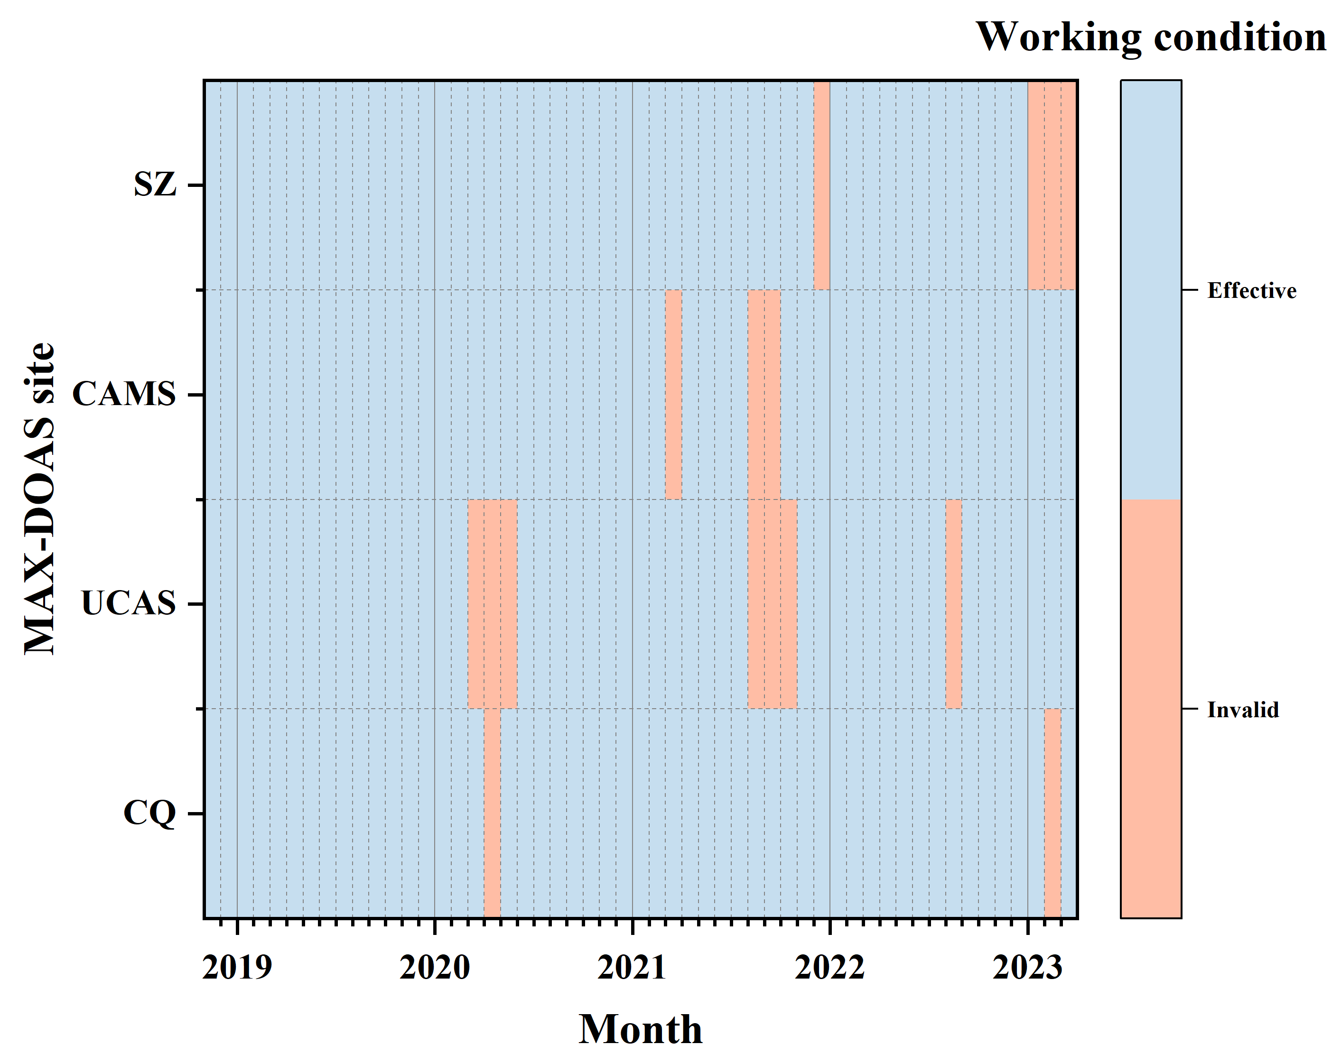
Figure S1. MAX-DOAS effective working time statistics for typical sites between November 2018 and March 2023. Blue representing effective and red representing invalid.

Figure S2. Results of linear fitting of C_{NO2}-S_{NO2} correlation and meteorological factors. The red line is the fit line, y is the fit equation, R is the correlation coefficient characterizing the effect of meteorological factors, and N is the number of data points. Where (a) fraction of cloud cover, (b) relative humidity, (c) temperature, (d) vertical velocity (absolute value), (e) boundary layer height, and (f) mean sea level pressure.

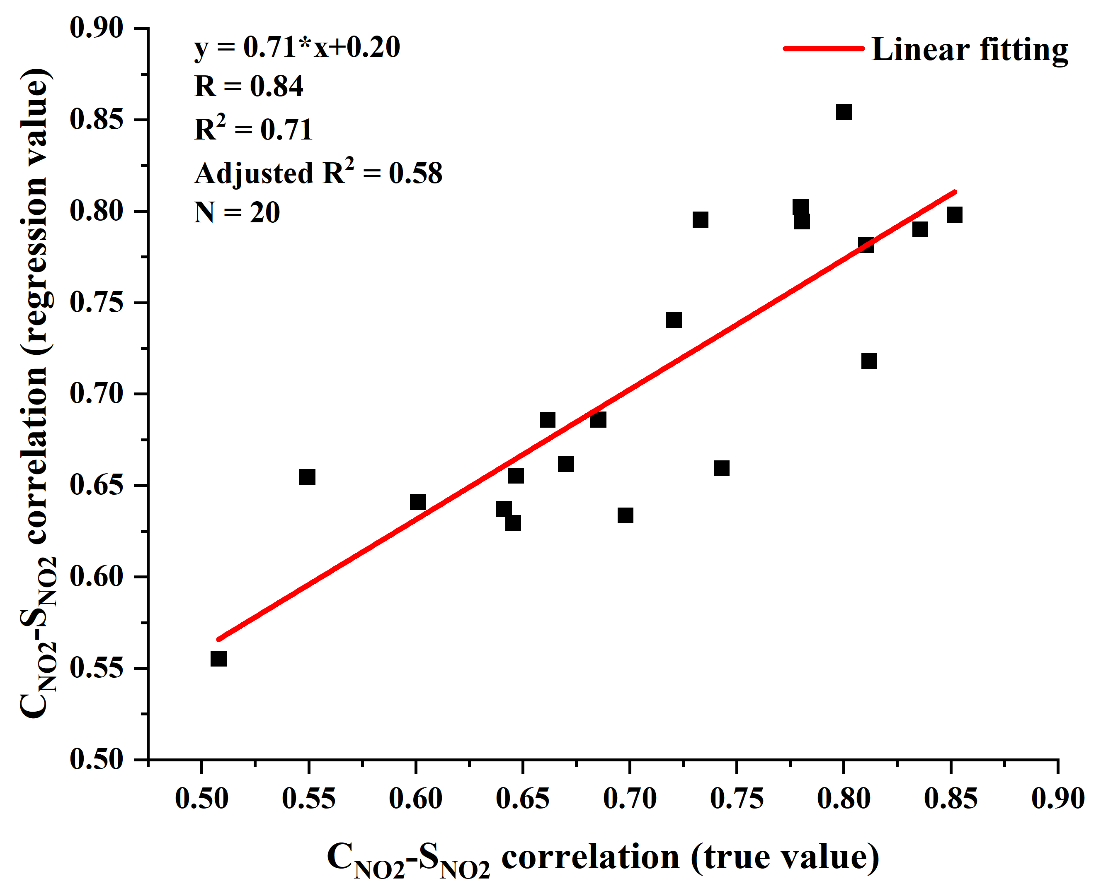
Figure S3. Linear fit of C_{NO2}-S_{NO2} correlation. The horizontal axis represents the true values, and the vertical axis shows the results from a multivariate linear fit of six meteorological factors. The red line indicates the fitted line, where y is the fitting equation, R is the correlation coefficient, R² is the coefficient of determination, and N is the number of data points.

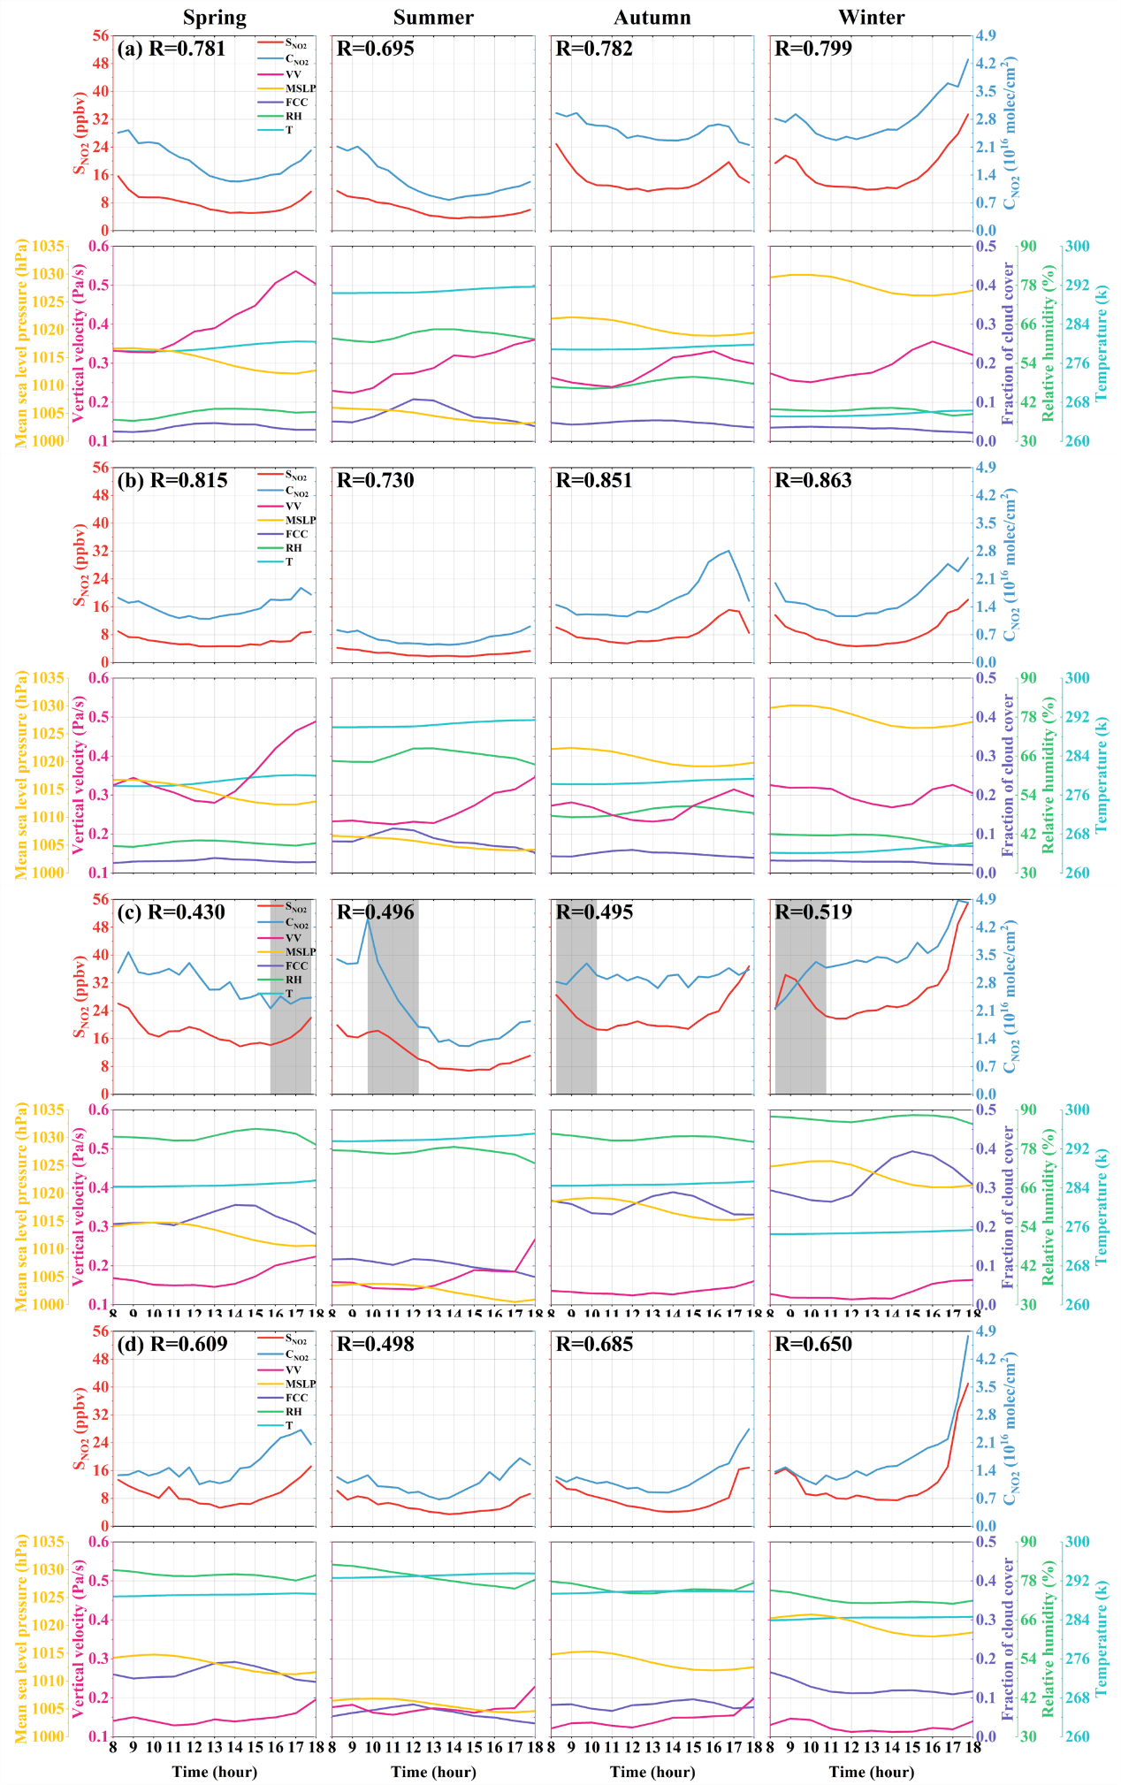
Figure S4. Daily variations of C_{NO2}-S_{NO2} and meteorological factors across seasons at selected sites. (a) CAMS northern urban, (b) UCAS northern suburban, (c) CQ southwestern urban, and (d) SZ southwestern suburban. The first row of each subplot shows NO₂ concentration, with the red line representing S_{NO2}, the blue line representing C_{NO2}, and R indicating the C_{NO2}-S_{NO2} correlation. The second row displays meteorological factors, where warm-colored lines denote positive influences (VV in magenta, MSLP in yellow) and cool-colored lines represent negative influences (FCC in purple, RH in green, T in cyan). The shaded area marks periods of significant inconsistency in C_{NO2}-S_{NO2} changes.

