Pinyon Jays (Gymnorhinus cyanocephalus) And Clark’s Nutcrackers (Nucifraga columbiana) Can Discriminate Between Pilfering And Non-Pilfering Conspecifics, But Not Between Heterospecifics

Alizée Vernouillet^{1*}, Nanxi Huang², Debbie Kelly ^{1,2}
- Department of Biological Sciences, University of Manitoba
- Department of Psychology, University of Manitoba

All correspondence should be addressed to Alizée Vernouillet, alizee.vernouillet@gmail.com
Alizée Vernouillet ORCID: https://orcid.org/0000-0003-2525-2936
Nanxi Huang ORCID: https://orcid.org/0000-0001-8351-0003
Debbie M. Kelly ORCID: https://orcid.org/0000-0003-0575-1447

Supplementary Results
Table S1. Factors evaluated to explain the number of pine seeds eaten by pinyon jays and by Clark’s nutcrackers during the Caching phase. Significant factors are indicated in bold and with an asterisk.
 | χ² | d.f. | p
Sex | 2.348 | 1 | 0.126
Condition | 4.666 | 3 | 0.198
Block* | 6.017 | 2 | 0.049*
Species | 3.538 | 1 | 0.060
Condition x Block* | 17.780 | 6 | 0.007*
Condition x Species | 2.297 | 3 | 0.513
Block x Species | 0.573 | 2 | 0.751
Condition x Block x Species | 10.781 | 6 | 0.095

Table S2. Factors evaluated to explain the number of pine seeds cached by pinyon jays and by Clark’s nutcrackers during the Caching phase. Significant factors are indicated in bold and with an asterisk.
 | χ² | d.f. | p
Sex | 0.069 | 1 | 0.794
Tray | 0.135 | 1 | 0.713
Condition* | 7.877 | 3 | 0.049*
Block* | 11.657 | 2 | 0.003*
Species* | 6.609 | 1 | 0.010*
Tray x Condition | 11.524 | 6 | 0.073
Tray x Block* | 13.269 | 4 | 0.010*
Tray x Species* | 7.626 | 2 | 0.022*
Condition x Block | 8.308 | 6 | 0.216
Condition x Species | 7.261 | 3 | 0.064
Block x Species | 1.333 | 2 | 0.312
Tray x Condition x Species* | 17.194 | 6 | 0.009*
Tray x Condition x Block | 11.246 | 12 | 0.508
Tray x Block x Species | 1.575 | 4 | 0.813
Condition x Block x Species | 5.107 | 6 | 0.530
Tray x Condition x Block x Species | 8.766 | 12 | 0.723

Table S3. Factors evaluated to explain the number of pine seeds cached outside the trays by pinyon jays and by Clark’s nutcrackers during the Caching phase. Significant factors are indicated in bold and with an asterisk.
 | χ² | d.f. | p
Sex | 1.683 | 1 | 0.195
Condition | 1.417 | 3 | 0.702
Block | 0.080 | 2 | 0.961
Species | 0.001 | 1 | 0.975
Condition x Block | 5.340 | 6 | 0.501
Condition x Species | 7.500 | 3 | 0.058
Block x Species | 0.419 | 2 | 0.811
Condition x Block x Species* | 15.299 | 6 | 0.018*

Table S4. Factors evaluated to explain the amount of time pinyon jays and by Clark’s nutcrackers spent on the caching trays during the Caching phase. Significant factors are indicated in bold and with an asterisk.
 | χ² | d.f. | p
Sex | 3.733 | 1 | 0.053
Tray* | 4.359 | 1 | 0.037*
Condition* | 14.307 | 3 | 0.003*
Block* | 7.695 | 2 | 0.021*
Species | 0.028 | 1 | 0.867
Tray x Condition | 7.095 | 6 | 0.312
Tray x Block* | 15.020 | 4 | 0.005*
Tray x Species | 1.724 | 2 | 0.422
Condition x Block | 3.077 | 6 | 0.799
Condition x Species | 3.342 | 3 | 0.342
Block x Species | 3.009 | 2 | 0.222
Tray x Condition x Species | 3.866 | 6 | 0.695
Tray x Condition x Block | 5.030 | 12 | 0.957
Tray x Block x Species | 4.205 | 4 | 0.379
Condition x Block x Species | 3.238 | 6 | 0.778
Tray x Condition x Block x Species | 9.968 | 12 | 0.619

Table S5. Factors evaluated to explain the proportion of pine seeds re-cached by pinyon jays and by Clark’s nutcrackers during the Re-Caching phase. Significant factors are indicated in bold and with an asterisk.
 | χ² | d.f. | p
Sex* | 7.562 | 1 | 0.006*
Tray* | 5.846 | 1 | 0.016*
Condition* | 41.296 | 3 | < 0.001*
Block* | 10.915 | 2 | 0.004*
Species | 2.203 | 1 | 0.138
Tray x Condition* | 50.031 | 6 | < 0.001*
Tray x Block* | 13.126 | 4 | 0.011*
Tray x Species | 4.106 | 2 | 0.128
Condition x Block* | 14.436 | 6 | 0.025*
Condition x Species | 0.281 | 3 | 0.963
Block x Species* | 16.350 | 2 | < 0.001*
Tray x Condition x Species | 9.338 | 6 | 0.155
Tray x Condition x Block | 11.726 | 12 | 0.468
Tray x Block x Species | 4.958 | 4 | 0.292
Condition x Block x Species | 8.351 | 6 | 0.214
Tray x Condition x Block x Species* | 25.380 | 12 | 0.013*

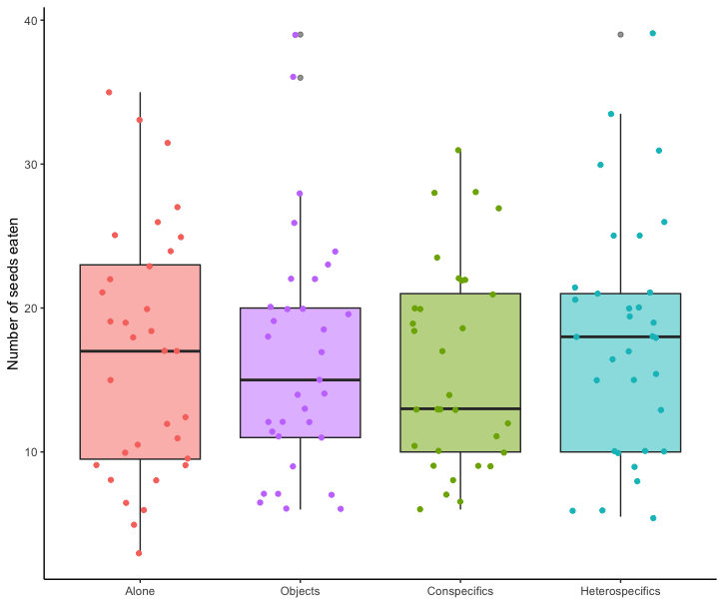
Fig. S1. Boxplot with the number of pine seeds eaten by Clark’s nutcrackers and by pinyon jays during the Caching phase. Birds ate significantly more seeds during the Alone and during the Heterospecifics conditions in comparison to the Conspecifics condition (p = 0.013 and p = 0.002, respectively).

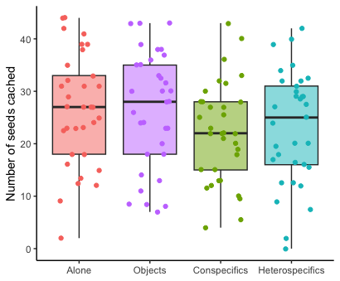
Fig. S2. Boxplot with the total number of pine seeds cached by Clark’s nutcrackers and by pinyon jays combined during the Caching phase. Birds cached significantly less pine seeds during the conspecifics condition in comparison to the alone condition (p = 0.026).

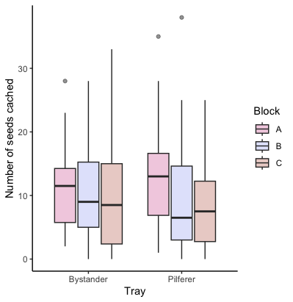
Fig. S3. Boxplot with the number of pine seeds cached in each tray (Bystander – given to the non-pilfering birds or object; Pilfere – given to the pilfering birds or object) across blocks by Clark’s nutcrackers and by pinyon jays combined during the Caching phase. Birds cached significantly less pine seeds in the tray given to the pilfering birds or object during the second block and the third block in comparison to the first block.

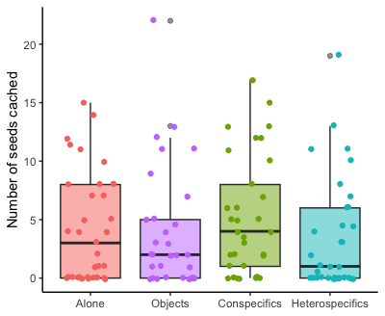
Fig. S4. Boxplot with the number of pine seeds cached outside of the caching trays across conditions by Clark’s nutcrackers and by pinyon jays during the Caching phase. There were no significant differences in the number of seeds placed outside the trays between conditions (p = 0.058).

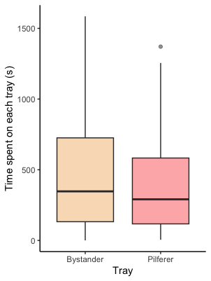
Fig. S5. Boxplot with the amount of time spent on each tray (Bysta – given to the non-pilfering birds or object; Thief – given to the pilfering birds or object) by Clark’s nutcrackers and by pinyon jays during the Caching phase Birds spent significantly more time caching on the tray given to the non-pilfering bird or object than on the tray given to the pilfering bird or object (p = 0.037).

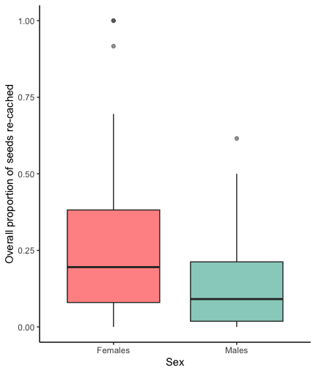
Fig. S6. Boxplot with the overall proportion of seeds re-cached between males and females Clark’s nutcrackers and pinyon jays during the Re-caching phase Females recached significantly more than males (p = 0.006).

