Supplementary Figures

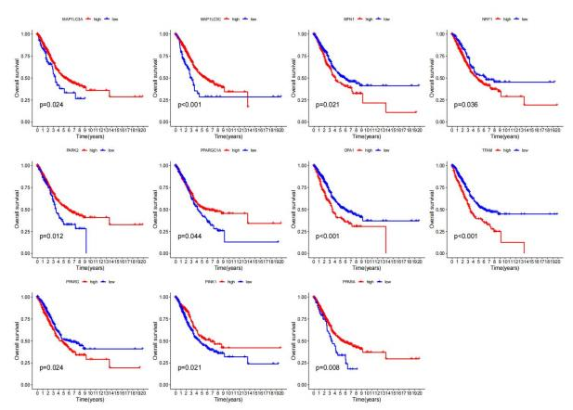
Figure S1 KM curve results of LUAD patients with different MQRGs expression.

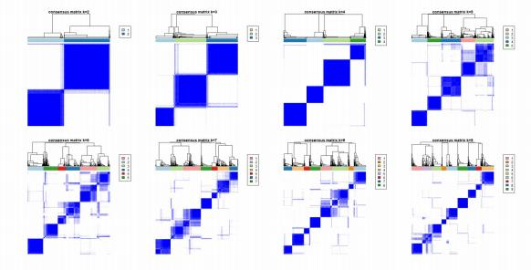
Figure S2 Consensus matrix heatmaps and unsupervised clustering of associated with MQRGcluster for k = 2-9.

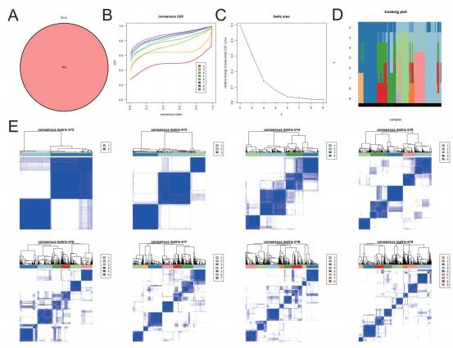
Figure S3 Two MQRG subtypes in the LUAD cohort were identified as gene subtypes based on
DEGs. (A) 660 MQRG subtype-related DEGs. (B) For each tested k, the CDF displays the cumulative fraction of every sample co-clustering at the specified consensus index (1.0 = co-clustered 100% of the time). (C) The consensus clustering delta area curve, which shows how the area under the CDF curve changes relative to k - 1 for each category number k. The vertical axis shows the relative change in the area under the CDF curve, while the horizontal axis displays the category number k. (D) Tracking plot. (E) Consensus matrix heatmaps and unsupervised clustering of associated with MQRG genecluster for k = 2-9.DEGs, differentially expressed genes; CDF, cumulative distribution function.

Table S1

Type | MQRG
Gene | PPARGC1A, PPARA, PPARG, NRF1, NFE2L2, TFAM, ESRRA, MFN1, MFN2, OPA1, MFF, FIS1, MIEF2, MIEF1, PINK1, PRKN, SQSTM1, MAP1LC3A, MAP1LC3B, MAP1LC3C

